|  |  |
| --- | --- |
| DATE | 20th April 2023 |
| TEAM ID | NM2023TMID02636 |
| PROJECT NAME | JOB APPLICATION TRACKING SYSTEM |
| TEAM LEATER | ABIRAMI K |
| Team Member | AGNISHA G |
| PAVUNIYA M |
| JOHN G |

1.INTRODUCTION

1.1.Overview

An applicant tracking system (ATS) is software for recruiters and employers to track candidates throughout the recruiting and hiring process.

1.2.Purpose

Their main purpose is to streamline certain tasks and increase efficiency when hiring or interviewing a large group of job candidates.

An ATS allows the hiring manager to list job descriptions manage applications,choose interview candidates and move forward with the hiring process.

2.PROBLEM DEFINITION & DESING THINKING

2.1.Empathy map

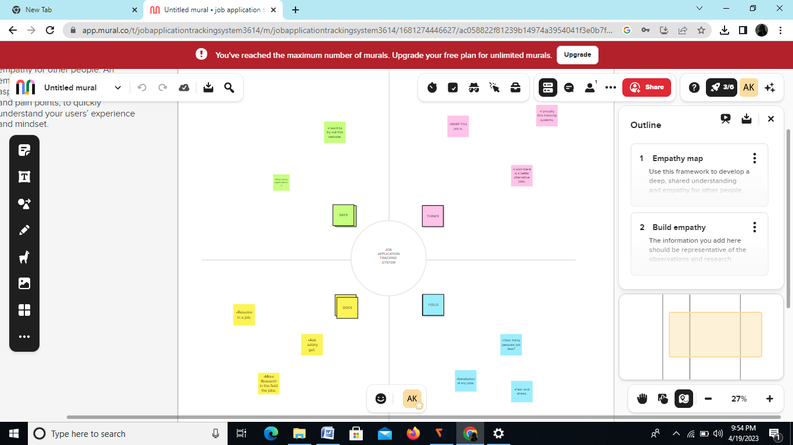

2.2.Ideation & Brainstorming Map

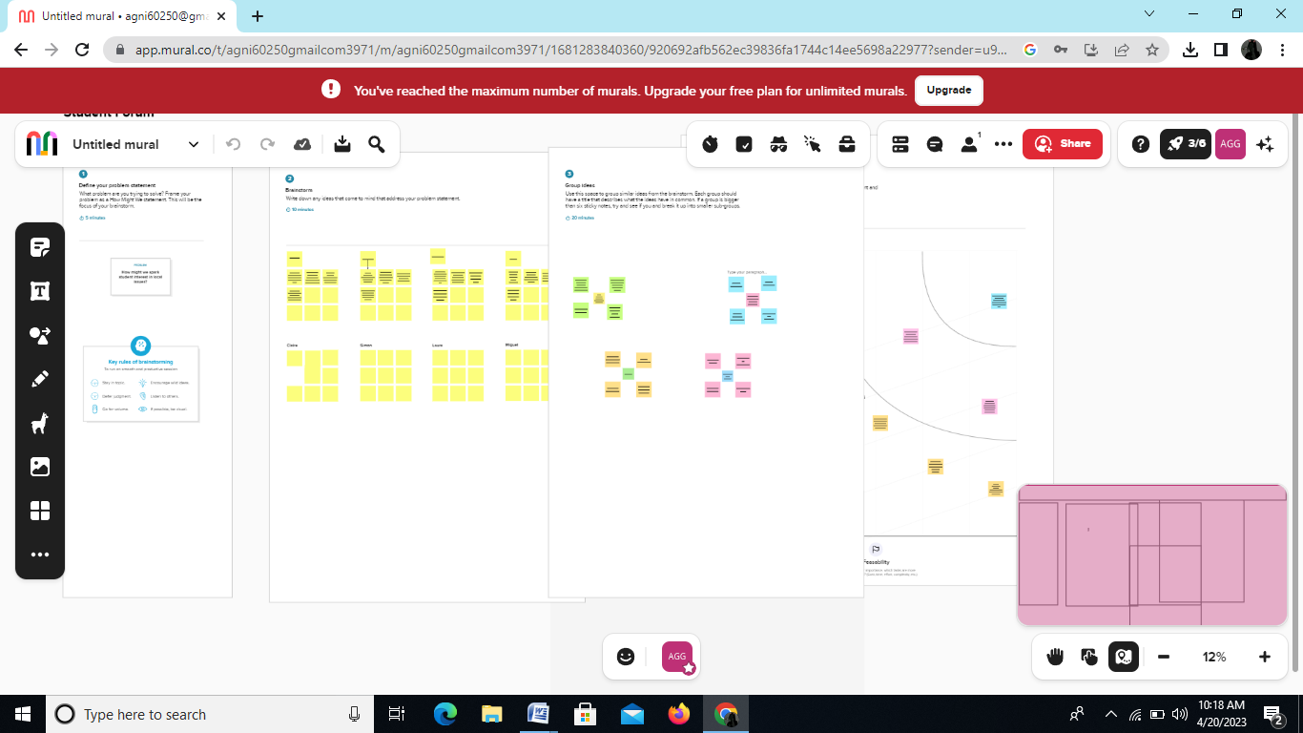

3.RESULT

3.1.RESULT

|  |  |  |
| --- | --- | --- |
| Object Name | Fields in the object | |
| Field Lable | Data Type |
| Recruiter | Job Tittle | Text |
| Jobs | Recruiter | Text |
| Description | Description | Text |
| Location | Location | Text |
| Tabs    Profile | Tabs  Profile | Text  Text |

3.2.Activity & Screenshot

MILESTONE 1:

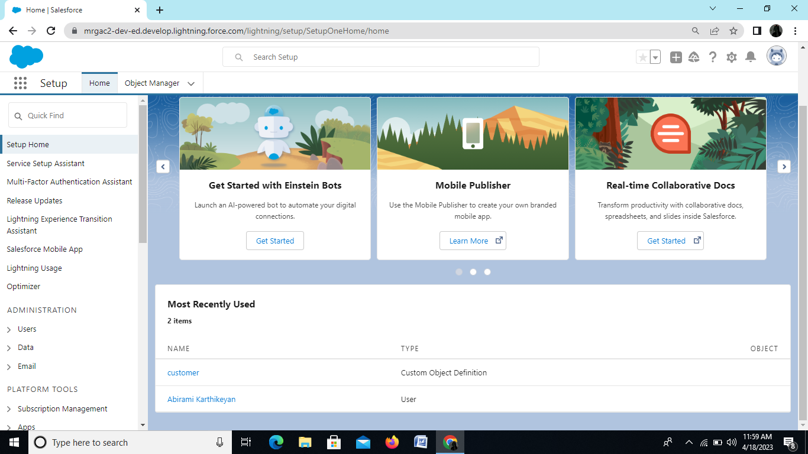

MILESTONE 2:

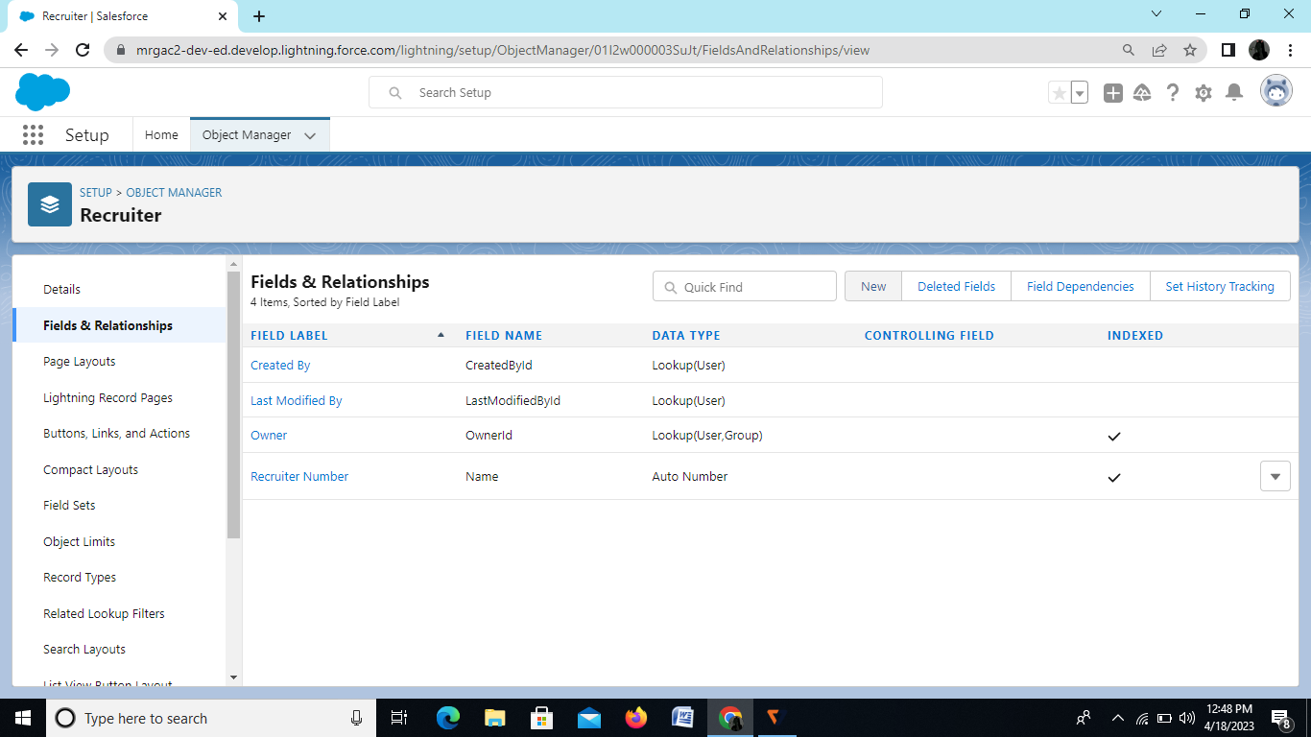

MILESTONE 3:

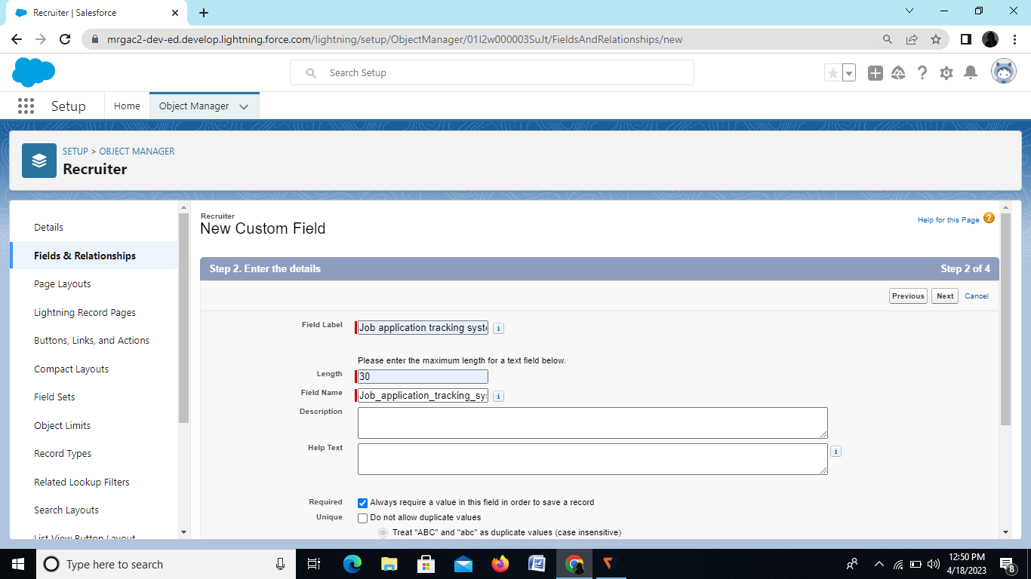

MILESTONE 4:

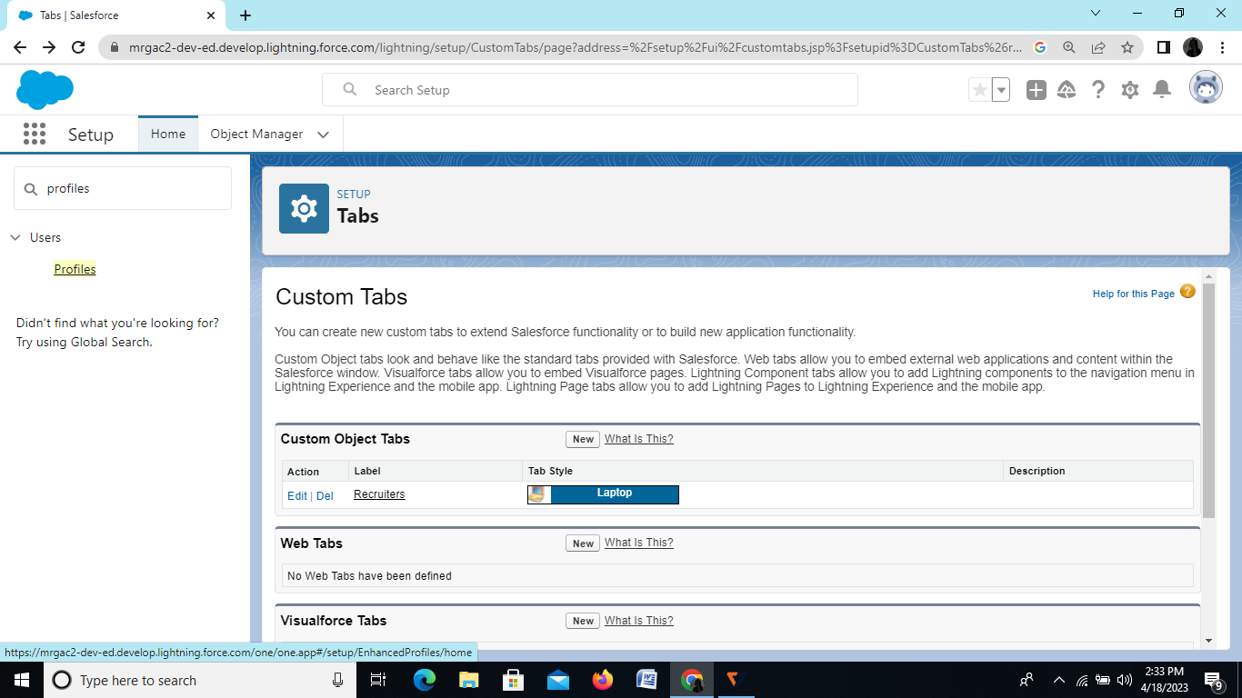

MILESTONE 5:

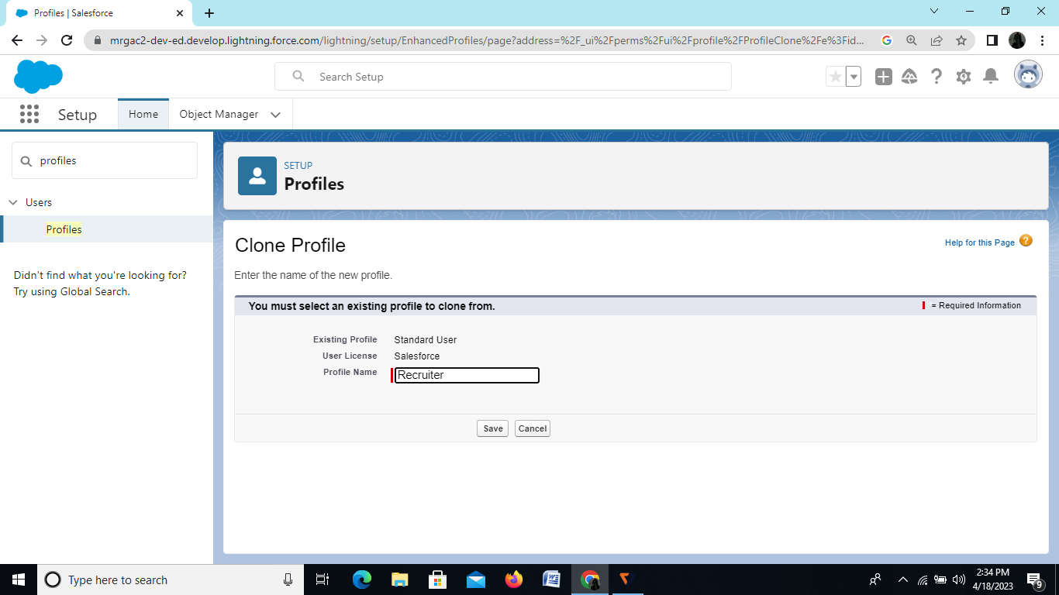

MILESTONE 6:

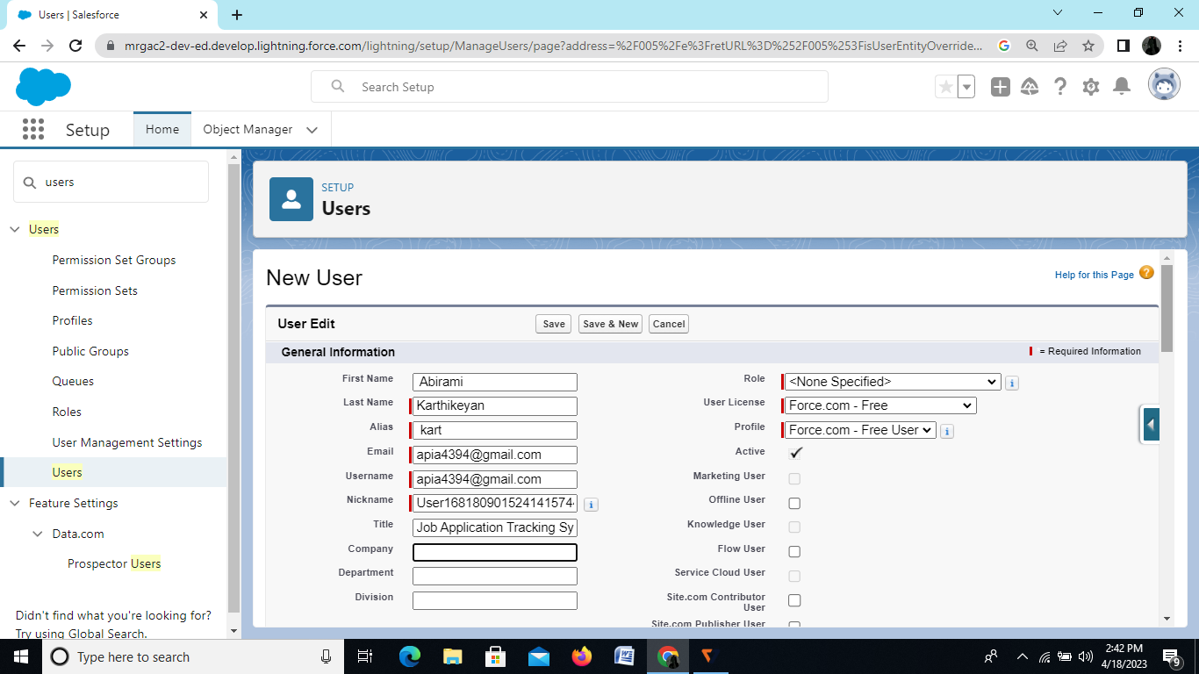

MILESTONE 7:

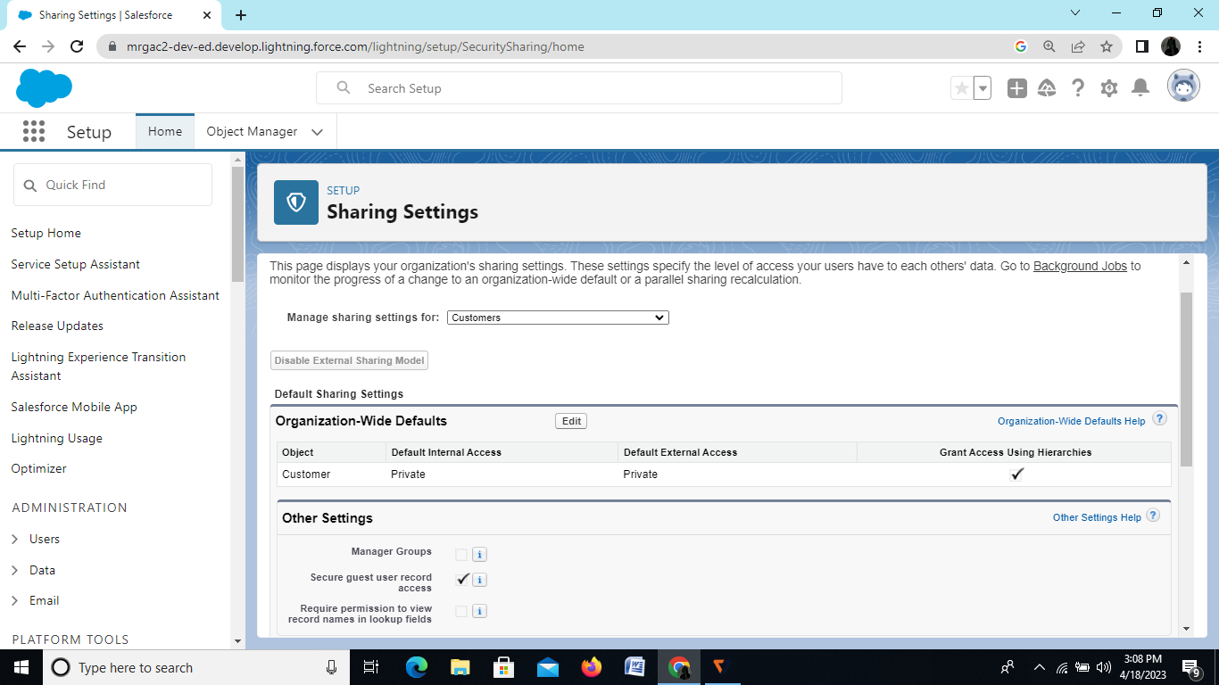

MILESTONE 8:

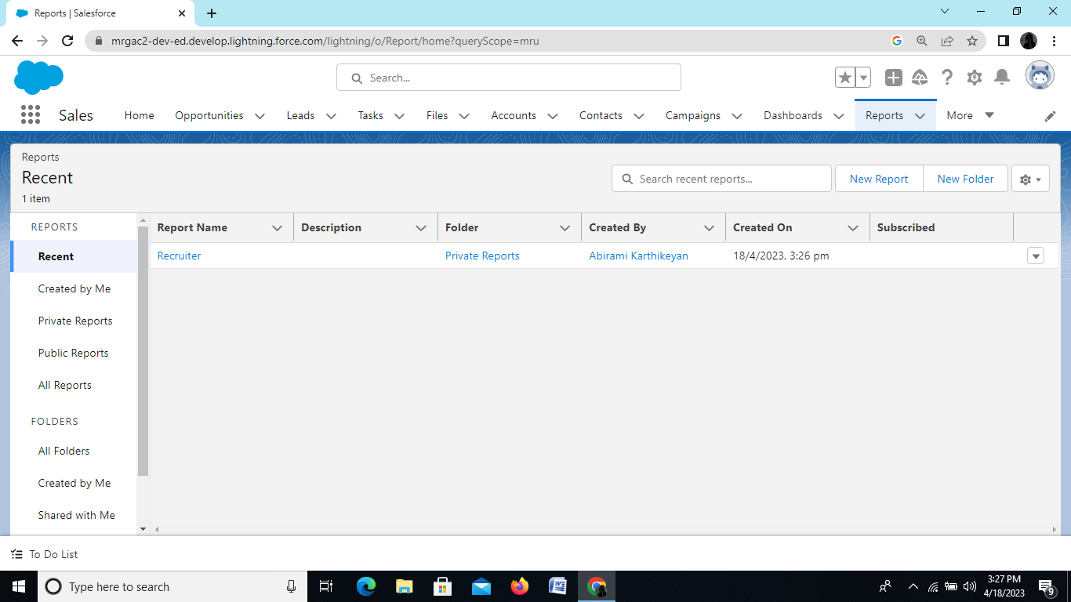

4.TRAILHEAD PROFILE PUBLIC URL

Team lead- <http://trailblazer.me/id/akarthikeyan14>

Team member 1-http://trailblazer.me/id/agobalakrishnan

Team member2-http://trailblazer.me/id/pmurugaiyan1

Team member3-http://trailblazer.me/id/jganesan9

5.ADVANTAGES & DISADVANTAGE

Advantages:

Reduces time Spent on admin tasks:

ATS software allows you to automate various tasks of the hiring process that can save you a lot of time and free up your recruiting personal for other high value tasks

RESUME and CV Screening:

With recruiters receving loos of resumes per role,even scanning can take a lot of time.

The number of resumes a recruiters needs to review can be reduced drastically using pre-screening questions or word searches within resumes.

Once,again a recruiter time can be redirected to higher value items of the business.

Speeds up the recruitment cycle:

Having candidates information centralized on a single platform gives recruiters access to organized information allowing them to reviw and compare candidate more easily and quickly which leads to lower cost-per-hire.

Improves the quality of hire:

First,you were able to cast a wider net by posting on job boards with standardized messaging to attract more candidate.

Second you used automated matching and fitering weed out unqualified candidates.

Both benefits saved you or your recruiter the time necessary an gather more insightful information.

DISADVANTAGES:

Could filter out good candidates

When “programming” your recruiting software to recognize common keywords around roles and responsibities,you could end up filtering out good candidates.

This can happen with manual review an well,so automation in most situations,has a net benefit.

Communications can be less personalized:

When automating response to candidate,your messaging will be less personalized and can come off as robotic.

6.APPLICATION

When applicants apply for a job online,their contact information,experience,educational background ,resume and cover letters are uploaded into the database.

7.CONCLUSION

Hiring managers and recruiters reply on their ATS software to shortlist a handful of candidate from hundreds of applications they may receive for a single job posting.

An applicant tracking system can benefit in many ways,such as,

~Save time

~Filters candidates

~Facilitates collaborative hiring

~Ensure betters tracking

~Increases quality of hire

8.FUTURE SCOPE

ATS value comes from being agile to rapidly push out of job descriptions to free and paid boards.