Linux Commands and File Management Assignment

Part A: System Exploration:
Commands Used:
whoami – Displays the username of the currently logged-in user. hostname – Displays the hostname (computer name) of the system. date – Displays the current system date and time.
pwd – Displays the present working directory.
uname -a – Displays detailed information about the Linux kernel and operating system.
sudo -l – Lists the commands that the current user is allowed to execute with administrator (sudo) privileges.
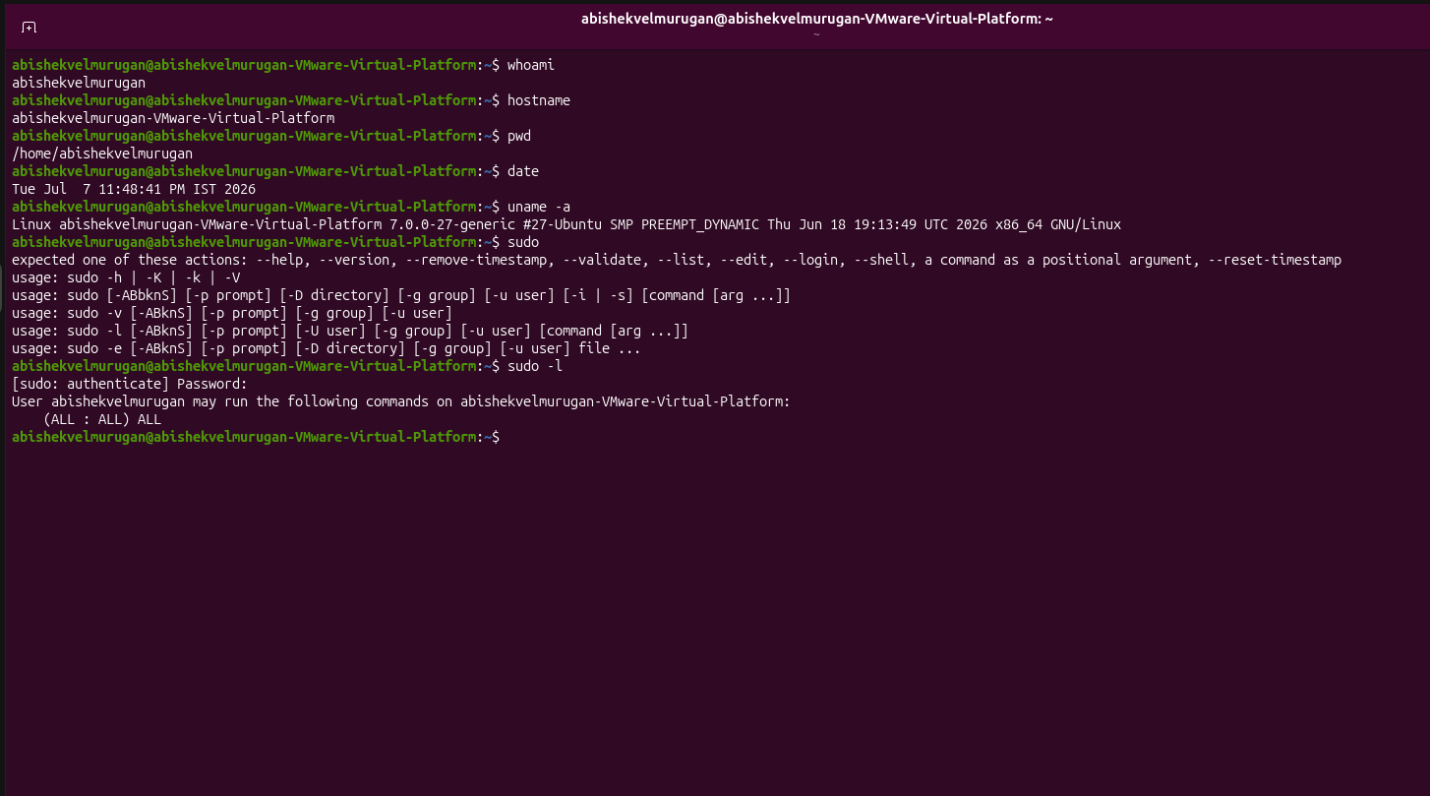

Part B – File and Directory Operations Commands Used:
mkdir – Creates new directories.
touch – Creates empty files.
cp – Copies files from one location to another.
mv – Renames or moves files.
rm – Deletes files.

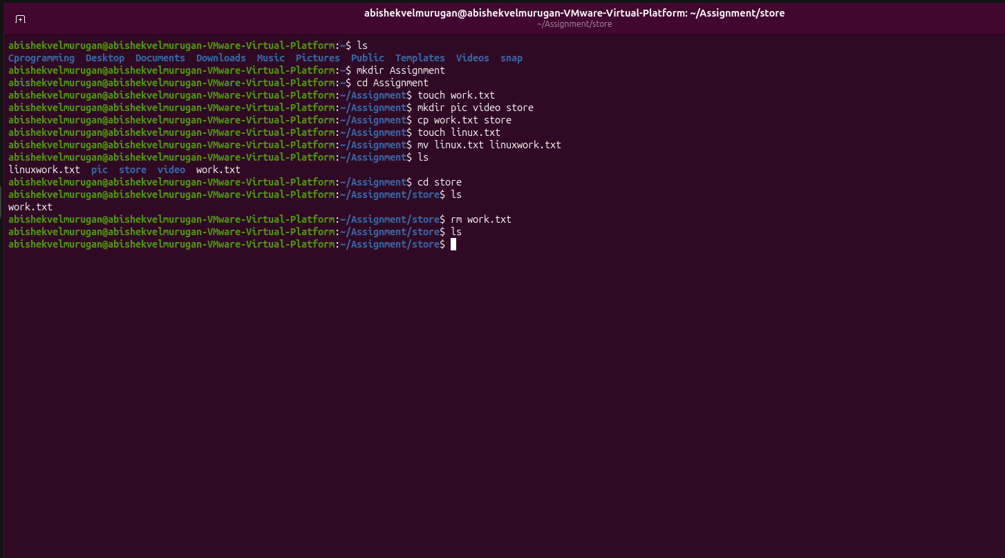

Part C – Navigation Commands:

pwd – Displays the current working directory (your current location).
ls – Lists the files and folders in the current directory.
ls -l – Lists files and folders with detailed information (permissions, owner, size, date).
ls -a – Lists all files and folders, including hidden files.
cd – Changes the current directory to another directory.
tree – Displays the directory structure in a tree-like format.

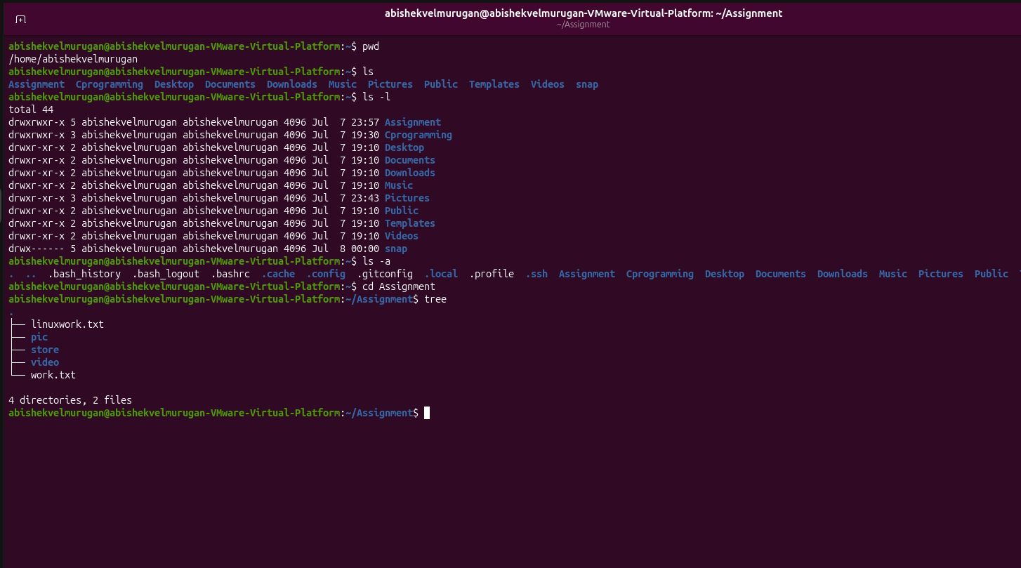

Part D: File Viewing Commands: Commands Used:
cat – Displays the entire contents of a file.
more – Displays the file one page at a time.
less – Allows interactive viewing of a file with forward and backward navigation.
head – Displays the first few lines of a file (default 10; here, the first 5 lines).
tail – Displays the last few lines of a file (default 10; here, the last 3 lines).

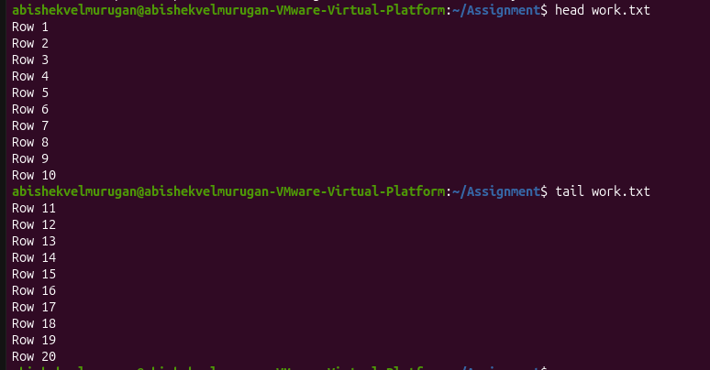
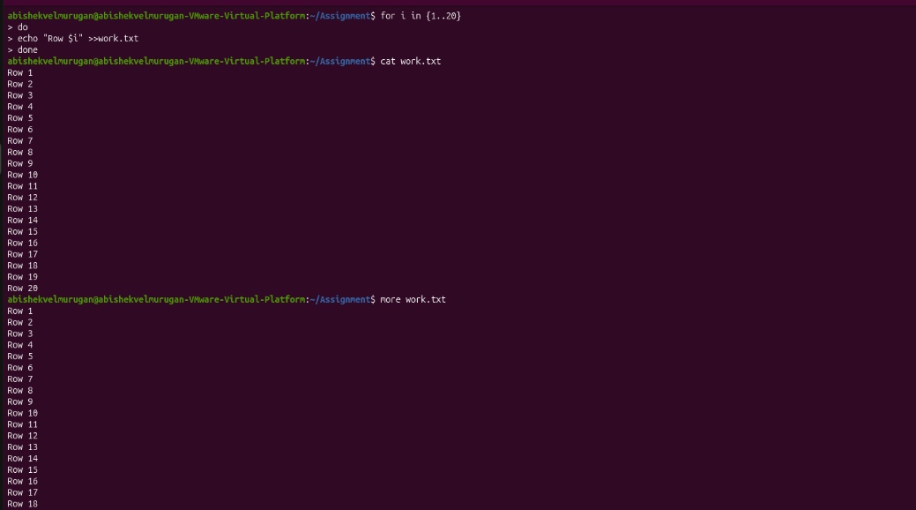

Part E: Help Commands:
Commands Used:
man – Displays the manual page of a command. whatis – Displays a short description of a command. which – Shows the location of an executable command.
--help – Displays the usage information and available options of a command.

