**Establishing STP and RSTP**

This document outlines the commands and their purposes for establishing Spanning Tree Protocol (STP) and Rapid Spanning Tree Protocol (RSTP) on a Linux system.

**\*** These utilities should be installed on your system**: bridge-utils (for the brctl command) and mstpd (for the mstpctl command)**

* Check if Bridge-utils supported or not for your board if not you can add it manually and add bridge-utils binary.

*If not supported then :*

Add ***"bridge-utils"*** and ***"mstpd"*** from Yocto Build System

**Creating a Bridge , Enabling STP and RSTP**

1) Creates a new bridge interface with the specified name (e.g., br0).

***$brctl addbr <bridge_name>***

2)Brings the newly created bridge interface into an active state.

***$ifconfig <bridge_name> up***

3)Enables STP on the specified bridge.

***$brctl stp <bridge_name> on***

4)Adds a physical network interface (e.g., eth0, eth1) to the bridge

***$brctl addif <bridge_name> <interface_name>***

5)Displays information about all bridges currently configured on the system

***$brctl show***

6) Checks the current operational state of STP on the bridge (e.g., BLOCKING, LISTENING, LEARNING, FORWARDING).

***$brctl showstp br0***

7)Enable rstp from stp

***$mstpctl setforcevers br0 rstp***

8) Add bridge

***$mstpctl addbridge br0***

9) Show bridge status

***$mstpctl showbridge br0***

10) Ethernet forward or disable

***$mstpctl showport br0***

**If RSTP does not work in PC use below commands :-**

1)To enable **RSTP** on a bridge interface (br0)

***$sudo ip link set br0 type bridge stp_state 1***

2)open the MSTP configuration file (mstpd.conf) for editing

***$sudo nano /etc/mstpd/mstpd.conf***

3)Add the following configuration:

**forceVersion=2**  # Force RSTP (Version 2 of STP)

**logFile=/var/log/mstpd.log**  # Log file location

**helloTime=2**  # Time between "Hello" packets

**maxAge=20** # Maximum age for topology changes

**forwardDelay=15** # Time to wait before changing port states

1. After editing the configuration, restart the **MSTP daemon** to apply the changes:

***$sudo systemctl restart mstpd.***

**Testing Procedure**

Connection Diagram For Testing Purpose.

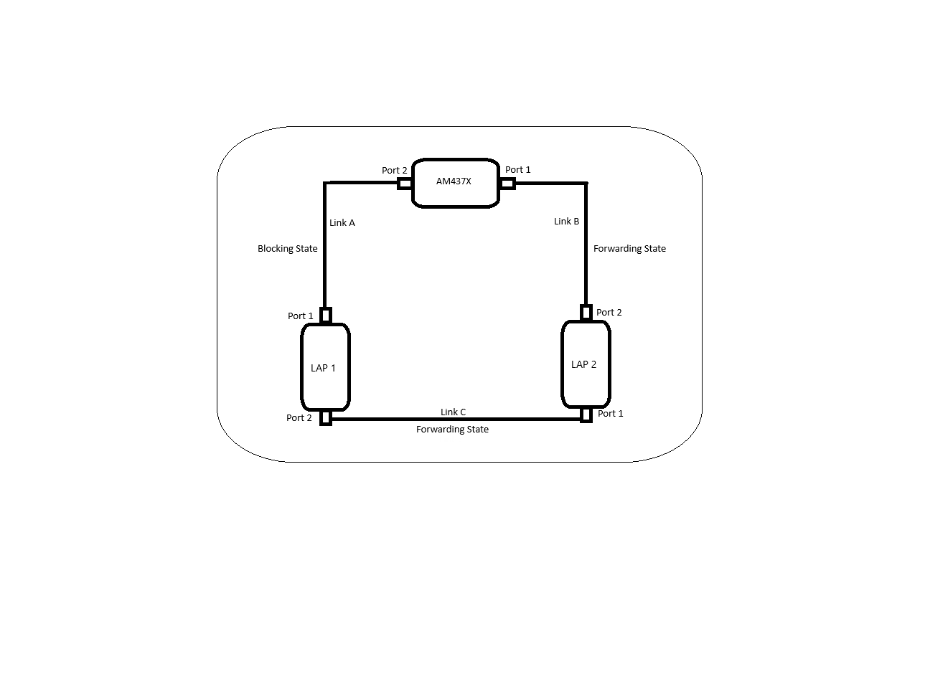

* Take two pc and one AM4376 board .Connect the ethernet port like above with Ethernet Cables.

**Assign Static IP Address to the bridge By using Following Cammands :-**

For AM437X **"$ifconfig br0 192.168.100.10"**

For LAP 1 **"$ifconfig br0 192.168.100.11"**

For LAP 2 **"$ifconfig br0 192.168.100.12"**

In This Document **"->"** Represents **"PING"**

***To Ping From One Device to Another Device Use this Cammand***

*Example:-*

Pinging from ***AM4376 to LAP 1*** in AM4376 give command as

**ping 192.168.100.11**

**Assigned IP Addresses are :-**

AM4376 *192.168.100.10*

LAP 1 *192.168.100.11*

LAP 2 *192.168.100.12*

**Without Disconnecting the Link**

AM4376 -> LAP 1 => YES LAP 1 -> AM4376 => YES LAP 2 -> AM4376 => YES

AM4376 -> LAP 2 => YES LAP 1 -> LAP 2 => YES LAP 2 -> LAP 1 => YES

**Disconnecting Link A**

AM4376 -> LAP 1 => YES LAP 1 -> AM4376 => YES LAP 2 -> AM4376 => YES

AM4376 -> LAP 2 => YES LAP 1 -> LAP 2 => YES LAP 2 -> LAP 1 => YES

**{Reconnect The Link A}**

**Disconnecting Link B**

AM4376 -> LAP 1 => YES LAP 1 -> AM4376 => YES LAP 2 -> AM4376 => YES

AM4376 -> LAP 2 => YES LAP 1 -> LAP 2 => YES LAP 2 -> LAP 1 => YES

**{Reconnect The Link B}**

**Disconnecting Link C**

AM4376 -> LAP 1 => YES LAP 1 -> AM4376 => YES LAP 2 -> AM4376 => YES

AM4376 -> LAP 2 => YES LAP 1 -> LAP 2 => YES LAP 2 -> LAP 1 => YES

**{Reconnect The Link C}**

**Disconnecting Link A and B**

AM4376 -> LAP 1 => NO LAP 1 -> AM4376 => NO LAP 2 -> AM4376 => NO

AM4376 -> LAP 2 => NO LAP 1 -> LAP 2 => YES LAP 2 -> LAP 1 => YES

**{Reconnect The Link A and B}**

**Disconnecting Link B and C**

AM4376 -> LAP 1 => YES LAP 1 -> AM4376 => YES LAP 2 -> AM4376 => YES

AM4376 -> LAP 2 => NO LAP 1 -> LAP 2 => NO LAP 2 -> LAP 1 => NO

**{Reconnect The Link B and C}**

**Disconnecting Link C and A**

AM4376 -> LAP 1 => NO LAP 1 -> AM4376 => NO LAP 2 -> AM4376 => YES

AM4376 -> LAP 2 => YES LAP 1 -> LAP 2 => NO LAP 2 -> LAP 1 => NO

**{Reconnect The Link C and A}**

**Legends :-**

**YES :-** Ping is Successful

**NO :-** Ping Failed