Build and Flash in IMX93 AMT

# PROPRIETARY NOTICE:

This document contains proprietary material for the sole use of the intended recipient(s). Do not read this document if you are not the intended recipient. Any review, use, distribution or disclosurenot the intended recipient (or authorized to receive for the recipient), you are herebynotified that any disclosure, copying distribution or use of any of the information contained within this document is STRICTLY PROHIBITED.

Thank you.

# Table of Contents

INTRODUCTION 3

Building the Yocto source ....................................................................................... 4

Board Setup7

Guide to flashing the Yocto Source8

Custom Wake-Word Creation10

# INTRODUCTION

**Purpose and Scope**

This document is intended to assist the engineer in programming the compiled binaries onto the IMX93 AMT board and in validating the peripherals and functionalities associated with the IMX93 AMT.

#### Acronyms

The following acronyms will be used throughout the document

|  |  |
| --- | --- |
| Acronym | Abbreviation |
| USB | Universal Serial Bus |
| UUU | Universal Update Utility |
| GB | GigaByte |
| OS | Operating System |
| SOM | System On Module |
| eMMC | embedded Multi-Media Card |
| RAM | Random Access Memory |

# Building the IMX93 AMT Source code

**Step 1: Install host OS:-**

* To build the Yocto source files, use a computer running a Linux OS."The recommended version is Ubuntu **18.04** (64-bit)."

Minimum system requirements:

* 200 GB free disk space
* 16 GB RAM

**Step 2:Install Required Packages**

* Use apt-get to install the necessary packages on Ubuntu. The following command will install the required tools:

**$ sudo apt install gawk wget git diffstat unzip texinfo gcc build-essential chrpath socat cpio python3 python3-pip python3-pexpect xz-utils debianutils iputils-ping python3-git python3-jinja2 libegl1-mesa libsdl1.2-dev python3-subunit mesa-common-dev zstd liblz4-tool file locales -y**

**$ sudo locale-gen en_US.UTF-8**

**Step 3 : Setting up the repo utility**

To install the “repo” utility, perform these steps:

* Create a bin folder in the home directory.

**$ mkdir ~/bin (this step may not be needed if the bin folder already exists)**

**$ curl https://storage.googleapis.com/git-repo-downloads/repo > ~/bin/repo**

**$ chmod a+x ~/bin/repo**

* Add the following line to the .bashrc file to ensure that the ~/bin folder is in your PATH variable.

**$ export PATH=~/bin:$PATH**

**Step 4: Yocto Project Setup**

* First, make sure that Git is set up properly with the commands below:

**$ git config --global user.name "Your Name"**

**$ git config --global user.email "Your Email"**

**$ git config --list**

* The following example shows how to download the i.MX Yocto Project Community BSP recipe layers.

**$ mkdir imx-yocto-bsp**

**$ cd imx-yocto-bsp**

**$ repo init -u <https://github.com/nxp-imx/imx-manifest> -b imx-linux-nanbield -m imx-6.6.3-1.0.0.xml**

**$ repo sync**

**Step 5: Update the Latest yocto source**

* The following command to update the latest source patch in the IMX93 AMT board.

**$ cd imx-yocto-bsp**

**$ rm -rf sources**

* Download the below link to get the latest yocto source code.

<https://drive.google.com/file/d/1KKAbrw4DC9olnLKctWJKctOcZYE-fkUl/view?usp=sharing>

Extract the sources.tar.gz and Replace the source directory into the imx-yocto-bsp directory.

**Step 6: Build the yocto source**

* Setup the MACHINE environment

**$ MACHINE=imx93evk DISTRO=fsl-imx-xwayland source ./imx-setup-release.sh -b bld-imx93evk**

* The following command to build the full image

**$ bitbake imx-image-full**

**Step 7: Build the kernel-dtb source**

* The following command to build the linux kernel alone.

**$ bitbake -C compile linux-imx**

**Step 8: Generated WIC image**

* After compilation process was completed successfully .The following below path having the WIC image generated for flashing the latest image in the IMX93 AMT.

File path: imx-yocto-bsp/bld-imx93evk/tmp/deploy/images/imx93evk

WIC image : imx-image-full-imx93evk.rootfs-20241003132705.wic.zst

* Extract the file using the below command to change the extenstion from .wic.zst to .wic.

**$ zstd -d imx-image-full-imx93evk.rootfs-20241003132705.wic.zst**

**Step 8: Generated Kernel DTB**

* After compilation process was completed successfully .The following below path having the files for flashing the kernel & the device tree blob.
* The below reference path is for the Kernel file.

Kernel Image path: imx-yocto-bsp/bld-imx93evk/tmp/work/imx93evk-poky-linux/linux-imx/6.6.3+git/build/arch/arm64/boot/

Kernel file: Image

* The below reference path is for the dtb file:

Device tree blob path: imx-yocto-bsp/bld-imx93evk/tmp/work/imx93evk-poky-linux/linux-imx/6.6.3+git/build/arch/arm64/boot/dts/freescale

DTB file : imx93-11x11-evk.dtb

# Flashing the IMX93 AMT

1. **Download the Board requirements package**

* Download the Flashing package utility from the below link.

<https://github.com/nxp-imx/mfgtools/releases>

* Select the below version by the following below screenshot.

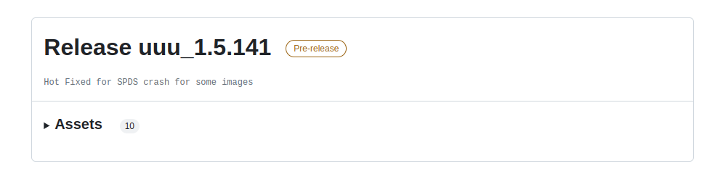

* Select the below version by the following below screenshot.

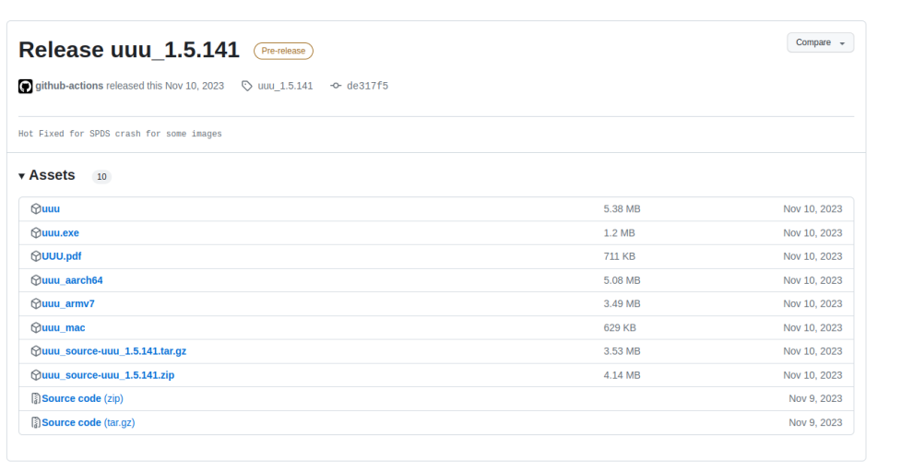

* Download the 1st line of “uuu” & copy into your Image downloaded location.

# Yocto Image build Procedure

* Follow the below link to setup the IMX93 EVK source code setup.

<https://docs.nxp.com/bundle/GUIGUIDERUG/page/topics/yocto.html>

* Follow the below link to download the IMX93 AMT binary.

https://drive.google.com/file/d/1b5tNff70gPk5cEGlevf6f9fiCElv9Q8R/view?usp=sharing

Requirements to flashing the WIC image in the IMX93 AMT board

* uuu
* imx-boot-imx93-11x11-lpddr4x-evk-sd.bin-flash_singleboot
* imx-image-full-imx93evk.rootfs-20241001074934.wic

# Flashing the Image

* Configure the board switches to the **Flash mode** using the below screenshot.

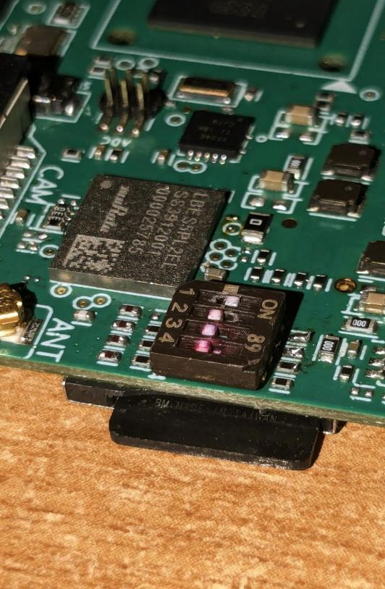

* Before flashing you need to connect the **USB ”C”** cable between the PC & Device.
* Go to the following path of your installed package folder ”/home/<UserName>/DownloadedPath>”.
* Run the following command to flash the image

**$ cd /home/<PC UserName>/<DownloadedPath>**

**$ chmod 777 uuu**

**$ sudo ./uuu -b emmc_all imx-boot-imx93-11x11-lpddr4x-evk-sd.bin-flash_singleboot <Downloaded Path>/imx-image-full-imx93evk.rootfs-20241001074934.wic**

# Booting

* Once the flashing got completed, Power off the board, Follow the below image & select the **eMMC** mode.

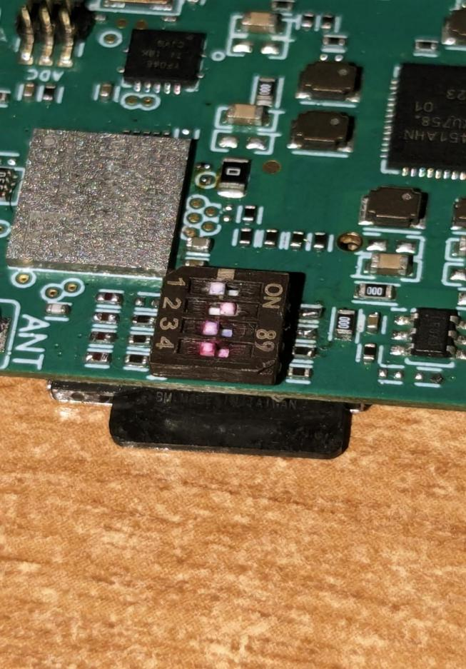

* Then Power on board and boot the board using the **USB “C”** cable between the board & PC along with the serial communication.