**PROJECT DESIGN**

1. **Entity-Relationship Model**

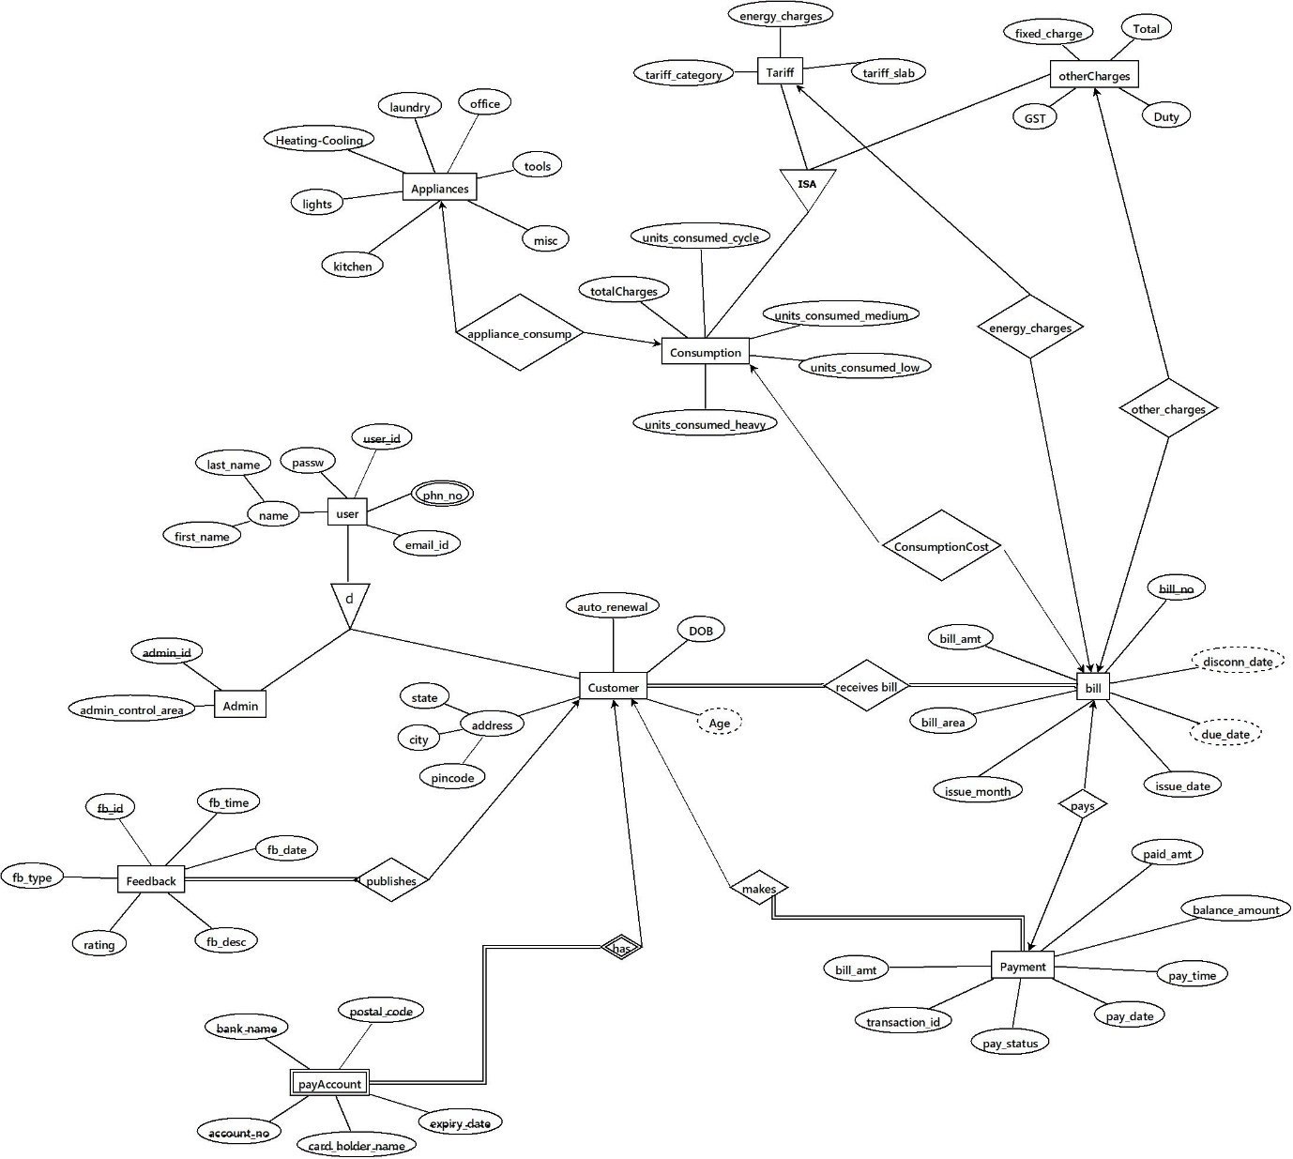

**Schema Diagram**

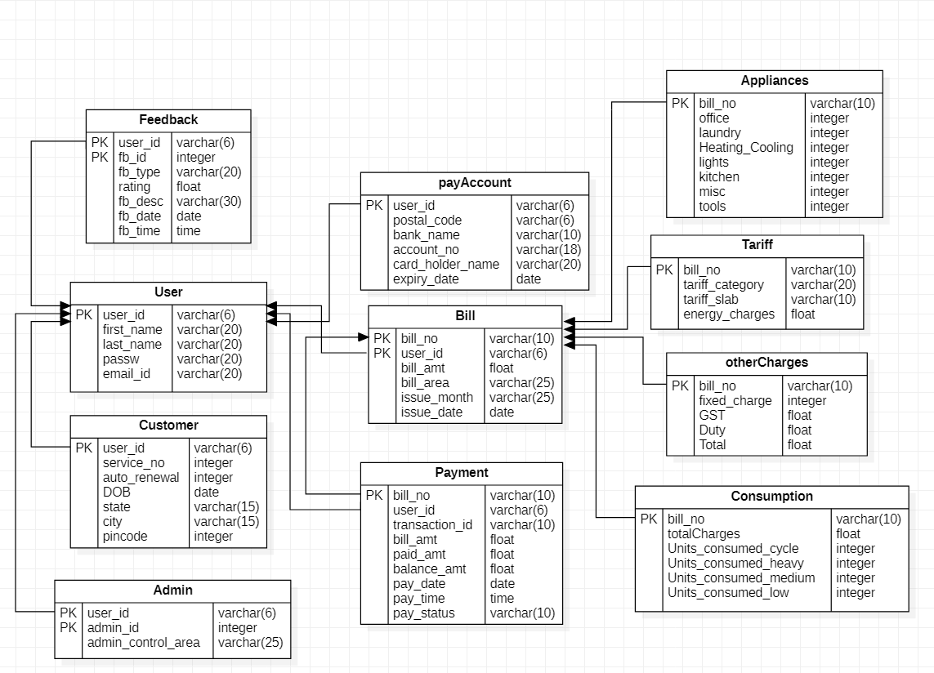

1. **Database Schema before Normalization**

* User(user_id, first_name, last_name, passw, email_id, phone_no)
* Admin(user_id, admin_id, admin_control_area);
* Customer(user_id, service_no, auto_renewal, DOB, state, city, pincode);
* Feedback(user_id, fb_id, fb_time, fb_date, fb_desc, rating, fb_type)
* Bill(user_id, bill_no, bill_amt, bill_area, issue_month, issue_date)
* Payment(user_id, bill_no, bill_amt, paid_amt, balance_amount, pay_time, pay_date, pay_status, transaction_id)
* payAccount(user_id, postal_code, bank_name, expiry_date, card_holder_name, account_no)
* Tariff(bill_no, tarrif_category, tariff_slab, energy_charges)
* otherCharges(bill_no, fixed_charge, GST, duty, Total)
* Consumption(bill_no, totalCharges, units_consumed_cycle, units_consumed_heavy, units_consumed_medium, units_consumed_low)
* Appliances(bill_no, office, tools, misc, kitchen, lights, Heating-Cooling, laundry)

**NORMALISATION**

1. **Normalisation Procedure**

**Master Schema:**

ElectricityBill(user_id, admin_id, fb_id, bill_no, passw, last_name, first_name, phone_no, email_id, admin_control_area, service_no, auto_renewal, DOB, state, city, pincode, fb_type, rating, fb_desc, fb_date, fb_time, bill_amt, bill_area, issue_month, issue_date, paid_amt, bill_amt, transaction_id, pay_status, pay_date, pay_time, balance_amount, postal_code, bank_name, account_no, card_holder_name, expiry_date, units_consumed_cycle, totalCharges, units_consumed_heavy, units_consumed_medium, units_consumed_low, energy_charges, tarrif_category, tariff_slab, fixed_charges, Total, Duty, GST, office, laundry, Heating-Cooling, lights, kitchen, misc, tools)

**1NF:**

1. The relation has primary keys.
2. phn_no is a multivalued attribute, so it can be flattened out.
3. There are no repeating groups.

**Functional dependencies:**

* user_id, phone_no → first_name, last_name, passw, email_id, phone_no
* user_id → service_no, auto_renewal, DOB, state, city, pincode, postal_code, bank_name, expiry_date, card_holder_name, account_no
* admin_id, user_id → admin_control_area
* city, state → pincode
* pincode → city, state
* fb_id, user_id → fb_time, fb_date, fb_desc, rating, fb_type
* bill_no, user_id → bill_amt, bill_area, issue_month, issue_date, paid_amt, balance_amount, pay_time, pay_date, pay_status, transaction_id
* bill_no → tarrif_category, tariff_slab, energy_charges, fixed_charge, GST, duty, Total, totalCharges, units_consumed_cycle, units_consumed_heavy, units_consumed_medium, units_consumed_low, office, tools, misc, kitchen, lights, Heating-Cooling, laundry
* transaction_id → pay_time, pay_date, pay_status, bill_amt , paid_amt, balance_amount

**2NF:**

1. The table is in 1NF.
2. Partial dependencies exist.

Master schema can be decomposed as:

Customer(user_id, pincode, service_no, auto_renewal, DOB, postal_code, bank_name, account_no, card_holder_name, expiry_date, city, state), with FDs:  
pincode --> state, city  
city, state --> pincode  
user_id --> pincode, service_no, auto_renewal, DOB, postal_code, bank_name, account_no, card_holder_name, expiry_date

User (user_id, phone_no, first_name, last_name, passw, email_id), with FDs:  
phone_no, user_id --> first_name, last_name, passw, email_id

Bill(bill_no, units_consumed_cycle, totalCharges, units_consumed_heavy, units_consumed_medium, units_consumed_low, energy_charges, tarrif_category, tariff_slab, fixed_charges, Total, Duty, GST, office, laundry, Heating-Cooling, lights, kitchen, misc, tools), with FDs:  
bill_no --> units_consumed_cycle, totalCharges, units_consumed_heavy, units_consumed_medium, units_consumed_low, energy_charges, tarrif_category, tariff_slab, fixed_charges, Total, Duty, GST, office, laundry, Heating-Cooling, lights, kitchen, misc, tools  
  
Payment(bill_no, user_id, transaction_id, bill_area, issue_month, issue_date, paid_amt, bill_amt, pay_status, pay_date, pay_time, balance_amount), with FDs:  
bill_no, user_id --> transaction_id, bill_area, issue_month, issue_date  
transaction_id --> paid_amt, bill_amt, pay_status, pay_date, pay_time, balance_amount

Admin (admin_id, user_id, admin_control_area), with FDs:  
admin_id, user_id --> admin_control_area

Feedback (fb_id, user_id, fb_type, rating, fb_desc, fb_date, fb_time), with FDs:  
fb_id, user_id --> fb_type, rating, fb_desc, fb_date, fb_time  
  
rel[13] = (user_id,admin_id,fb_id,bill_no, phone_no), with FDs:

**3NF:**

1. All relations are in 2NF.
2. Transitive dependencies exist in Customer and Payment relations.

Customer table can be decomposed as:

Address (pincode, city, state), with FDs:  
pincode --> state, city  
city, state --> pincode  
  
customer_details (user_id, pincode, service_no, auto_renewal, DOB, postal_code, bank_name, account_no, card_holder_name, expiry_date), with FDs:  
user_id --> pincode, service_no, auto_renewal, DOB, postal_code, bank_name, account_no, card_holder_name, expiry_date

Payment table can be decomposed as:

Payment_details (transaction_id, paid_amt, bill_amt, balance_amount, pay_status, pay_date, pay_time), with FDs:  
transaction_id --> paid_amt, bill_amt, balance_amount, pay_status, pay_date, pay_time  
  
Bill_details (bill_no, user_id, transaction_id, bill_area, issue_month, issue_date), with FDs:  
bill_no,user_id --> transaction_id, bill_area, issue_month, issue_date

**BCNF – Boyce-Codd normal form:**

1. All relations are in 3NF.
2. In each relation, it can be observed that the super key determines all other attributes in
3. the relation.
4. Hence, all relations are in BCNF.
5. **Database schema after normalisation:**

* User (user_id, phone_no, first_name, last_name, passw, email_id)
* customer_details (user_id, pincode, service_no, auto_renewal, DOB, postal_code, bank_name, account_no, card_holder_name, expiry_date)
* Admin (admin_id, user_id, admin_control_area)
* Address (pincode, city, state)
* Bill(bill_no, units_consumed_cycle, totalCharges, units_consumed_heavy, units_consumed_medium, units_consumed_low, energy_charges, tarrif_category, tariff_slab, fixed_charges, Total, Duty, GST, office, laundry, Heating-Cooling, lights, kitchen, misc, tools)
* Payment_details (transaction_id, paid_amt, bill_amt, balance_amount, pay_status, pay_date, pay_time)
* Bill_details (bill_no, user_id, transaction_id, bill_area, issue_month, issue_date)
* Feedback (fb_id, user_id, fb_type, rating, fb_desc, fb_date, fb_time)