**BACKEND DESIGN**

1. **Table Creation Commands**
2. **User_details**

CREATE TABLE User_details(user_id varchar(6), phone_no varchar(10), first_name varchar(20), last_name varchar(20), passw varchar(20), email_id varchar(20), CONSTRAINT PK_Customer PRIMARY KEY(user_id, phone_no));

insert into User_details values('abc090','9728910006','Parag','Agarwal','parry142w','para011@gmail.com');

insert into User_details values('qrs044','9940596886','Rohit','Saravanan','rohitrage198','rsa902@gmail.com');

insert into User_details values('xyz011','9952985913','Amit','Rawat','am2324wat','amitwat011@gmail.com');

insert into User_details values('lmn011','2928710106','Ajun','Kapoor','junu444','kapoor601@gmail.com');

insert into User_details values('ijk681','8989367615','Shivaji','Rao','rao1212','gaikwa1212@gmail.com');

insert into User_details values('zxc011','9278467283','Akshita','Luffy','luffy01','akshita01@gmail.com');

insert into User_details values('bnm090','9652738946','Abi','Sadhashivam','abi0308','abi08@gmail.com');

insert into User_details values('asd044','9037352947','Arav','Suresh','arav0308','aravind126@gmail.com');

insert into User_details values('bar011','9879273973','Arav','B','barav123','barvind@gmail.com');

select *from User_details;

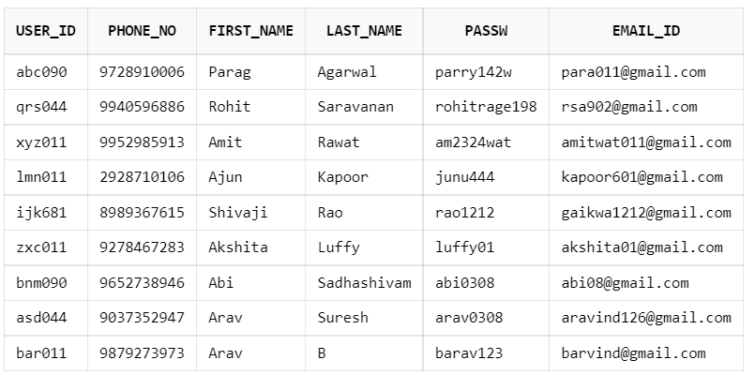

1. **Address**

CREATE TABLE Address(pincode integer, city varchar(15), state varchar(15), CONSTRAINT PK_Address PRIMARY KEY(pincode));

insert into Address values('599118','Bangalore','Karnataka');

insert into Address values('600001','Chennai','Tamilnadu');

insert into Address values('110001','Delhi','Haryana');

insert into Address values('230532','Mumbai','Maharashtra');

insert into Address values('560091','Hyderabad','Andrapradesh');

insert into Address values('682222','Chennai','Tamilnadu');

insert into Address values('983432','Hyderabad','Andrapradesh');

insert into Address values('680021','Mumbai','Maharashtra');

insert into Address values('692323','Mumbai','Maharashtra');

select *from Address;

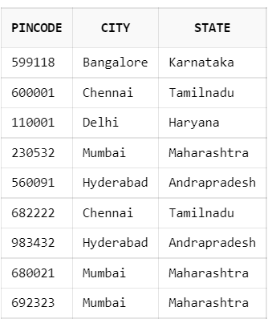

1. **customer_details**

CREATE TABLE customer_details(user_id varchar(6), pincode integer, auto_renewal INTEGER, DOB date, postal_code varchar(6), bank_name varchar(10), account_no varchar(18), card_holder_name varchar(20), expiry_date date, CONSTRAINT PK_cust PRIMARY KEY(user_id, CONSTRAINT FK_cust FOREIGN KEY(pincode) REFERENCES Address(pincode));

insert into customer_details values('lmn090', 230532, 1,'25-DEC-02','090','SBI','22334451678901823','Arjun Kapoor','10-OCT-24');

insert into customer_details values('qrs044', 599118, 1,'15-JUL-00','044','ICICI','91984678223100566','Rohit Saravanan','20-JAN-27');

insert into customer_details values('ijk011', 110001, 0,'01-APR-02','011','CUB','6198885324001266','Shivaji Rao','19-NOV-23');

insert into customer_details values('abc090', 682222, 1,'05-OCT-99','090','SBI','22090977781236674','Parag Agarwal','11-MAR-25');

insert into customer_details values('xyz011', 692323, 0,'01-OCT-02','011','UCO','12890345667786233','Amit Rawat','07-DEC-22');

insert into customer_details values('bar011', 680021, 0,'03-OCT-02','011','PNB','839572839026','B Arvind','23-DEC-22');

select *from customer_details;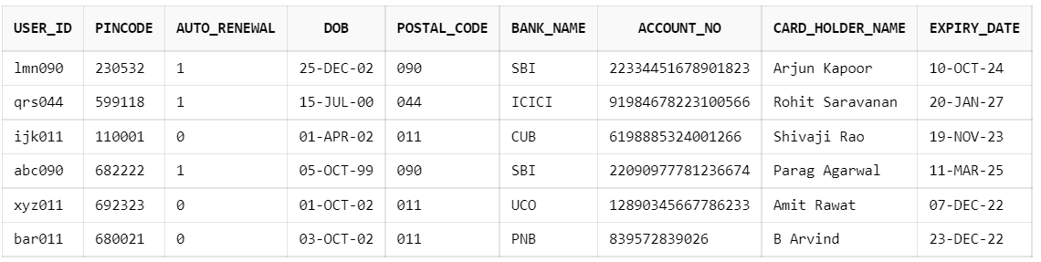

1. **Admin_details**

CREATE TABLE Admin_details(admin_id varchar(6), user_id varchar(6), admin_control_area INTEGER, CONSTRAINT PK_Admin PRIMARY KEY(admin_id, user_id));

insert into Admin_details values('zxc011','xyz011',011);

insert into Admin_details values('zxc011','ijk011',011);

insert into Admin_details values('zxc011','bar011',011);

insert into Admin_details values('bnm090','abc090',090);

insert into Admin_details values('bnm090','lmn090',090);

insert into Admin_details values('asd044','qrs044',044);

select *from Admin_details;

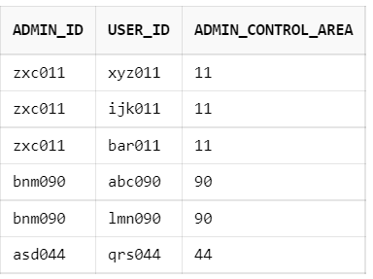

1. **Bill**

CREATE TABLE Bill(bill_no varchar(10), units_consumed_cycle integer, totalCharges float, units_consumed_heavy integer, units_consumed_medium integer, units_consumed_low integer, energy_charges float, tariff_category varchar(20), tariff_slab varchar(10), fixed_charges integer, Total float, Duty float, GST float, office integer, laundry integer, Heating_Cooling integer, lights integer, kitchen integer, misc integer, tools integer, CONSTRAINT PK_Bill PRIMARY KEY(bill_no));

insert into Bill values('8302270274',10,4000.89,6,2,2,2500.89,'Domestic','1-A',500,1500,200,800,0,2,3,2,2,1,0);

insert into Bill values('2342342342',20,8132.87,8,2,2,6132.87,'Domestic','1-B',500,2000,500,1000,5,2,3,2,2,1,5);

insert into Bill values('6743744247',15,6300.32,4,2,2,5300.32,'Domestic','1-A',500,500,200,300,3,2,3,2,2,1,2);



1. **Payment_details**

CREATE TABLE Payment_details(transaction_id varchar(10), bill_amt float, pay_status varchar(10), pay_date date, pay_time timestamp, CONSTRAINT PK_Payment PRIMARY KEY(transaction_id));

insert into Payment_details values('782738905672',4000.89, 'Payment Successful','22-DEC-21','22-DEC-21 03:23:08 PM');

insert into Payment_details values('82953643277',0,'Payment Failed','02-NOV-21','02-NOV-21 01:13:18 PM');

insert into Payment_details values('873048905672',8132.87 ,'Payment Successful','18-NOV-21','18-NOV-21 10:45:45 AM');

select *from Payment_details;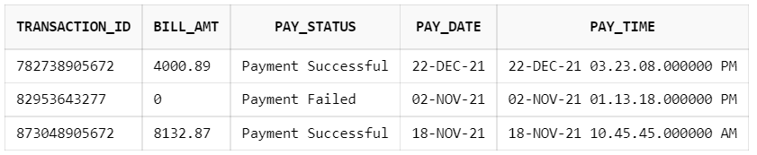

1. **Bill_details**

CREATE TABLE Bill_details(bill_no varchar(10), user_id varchar(6), transaction_id varchar(10), bill_area integer, issue_month varchar(9), issue_date date, CONSTRAINT PK_billDet PRIMARY KEY(bill_no, user_id), FOREIGN key(bill_no) REFERENCES Bill(bill_no), FOREIGN key(user_id) REFERENCES customer_details(user_id), FOREIGN KEY(transaction_id) REFERENCES Payment_details(transaction_id));

insert into Bill_details values('8302270274','abc090','782738905672',090,'DEC','05-DEC-21');

insert into Bill_details values('2342342342','qrs044','82953643277',044,'NOV','18-OCT-21');

insert into Bill_details values('6743744247','xyz011','873048905672',011,'DEC','06-DEC-21');

select *from Bill_details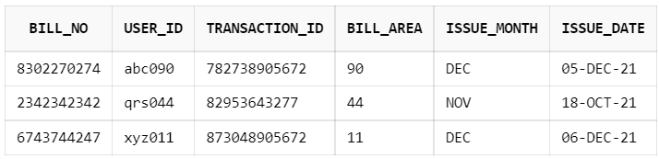

1. **Feedback**

CREATE TABLE Feedback(fb_id number, user_id varchar(6), fb_type varchar(20), rating float, fb_desc varchar(50), fb_date date, fb_time timestamp, Constraint PK_Feedback PRIMARY KEY(fb_id, user_id), FOREIGN KEY(user_id) REFERENCES customer_details(user_id));

insert into Feedback values('15151','abc090','Bill Generation',3.0, 'I was able to view the generated bill easily','22-DEC-21','22-DEC-21 03:28:08 PM');

insert into Feedback values('12365','qrs044','Bill Payment',2.7, 'My payment got rejected the first time I tried','02-NOV-21','02-NOV-21 01:18:18 PM');

insert into Feedback values('98723','xyz011','Analysis',4.5, 'The analysis was very informative, Thank you','18-NOV-21','18-NOV-21 10:48:45 AM');

select *from Feedback

