FoDS – Lab Evaluation 1 - SET 2

CB.EN.U4CSE20202

ABIRAMI S

Q1. Import Data and save it in disk -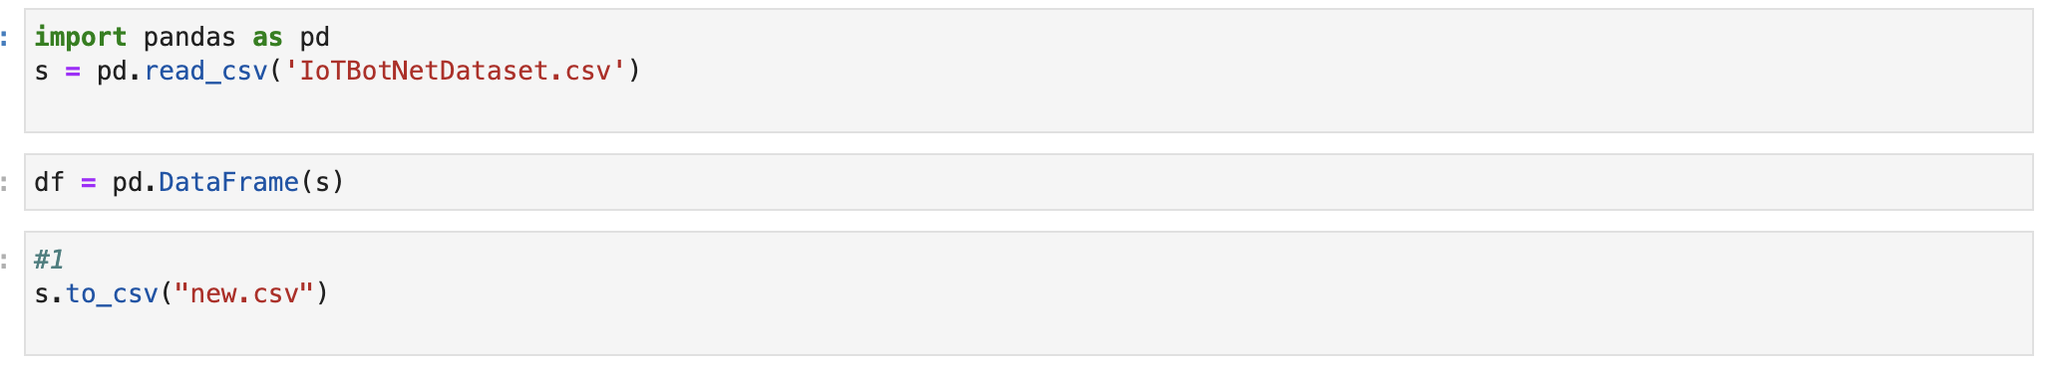

Q2. Drop unnecessary columns -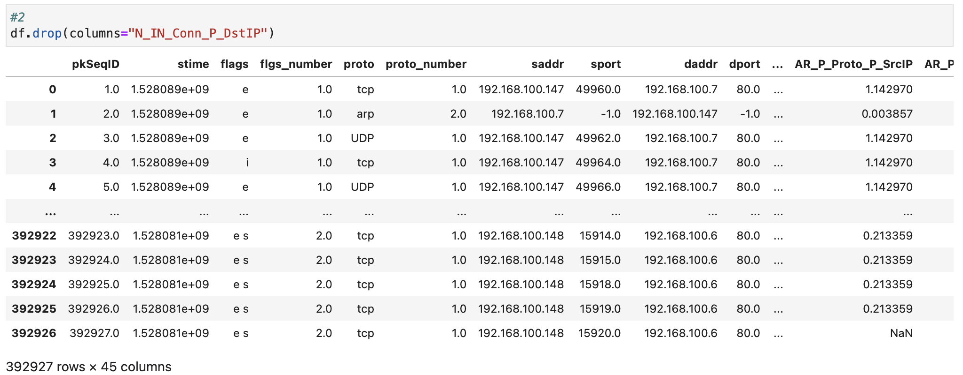

Q3. Missing Value Analysis and perform appropriate steps -

Dropping NaN values for missing data.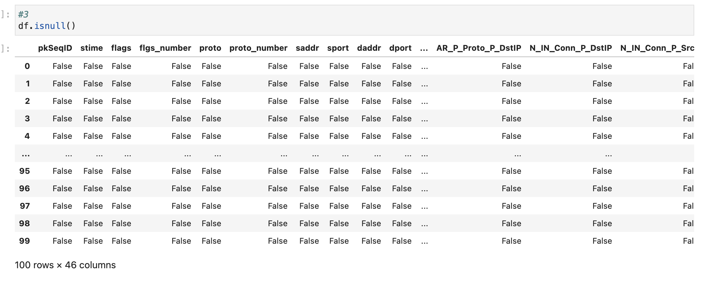

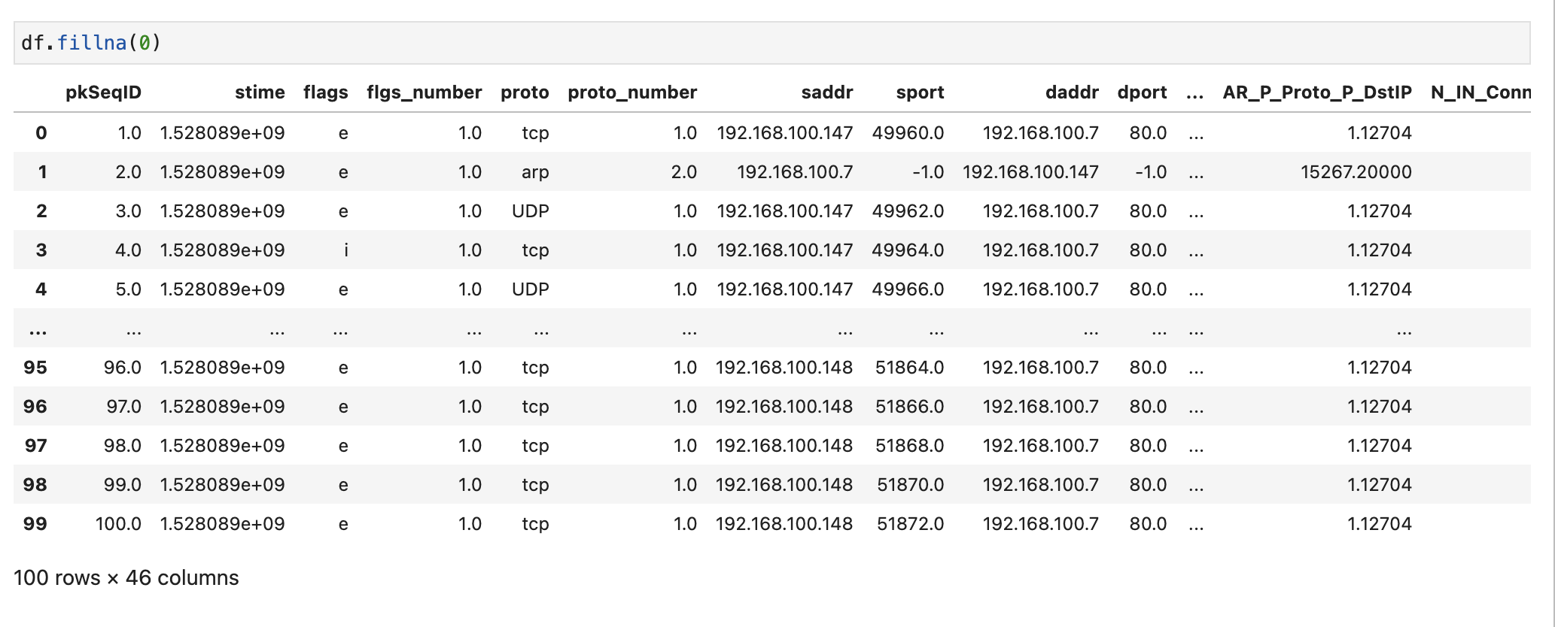

Q4. Outlier analysis (2 Cols) -

The values that are way far from the cluster of data are outliers.

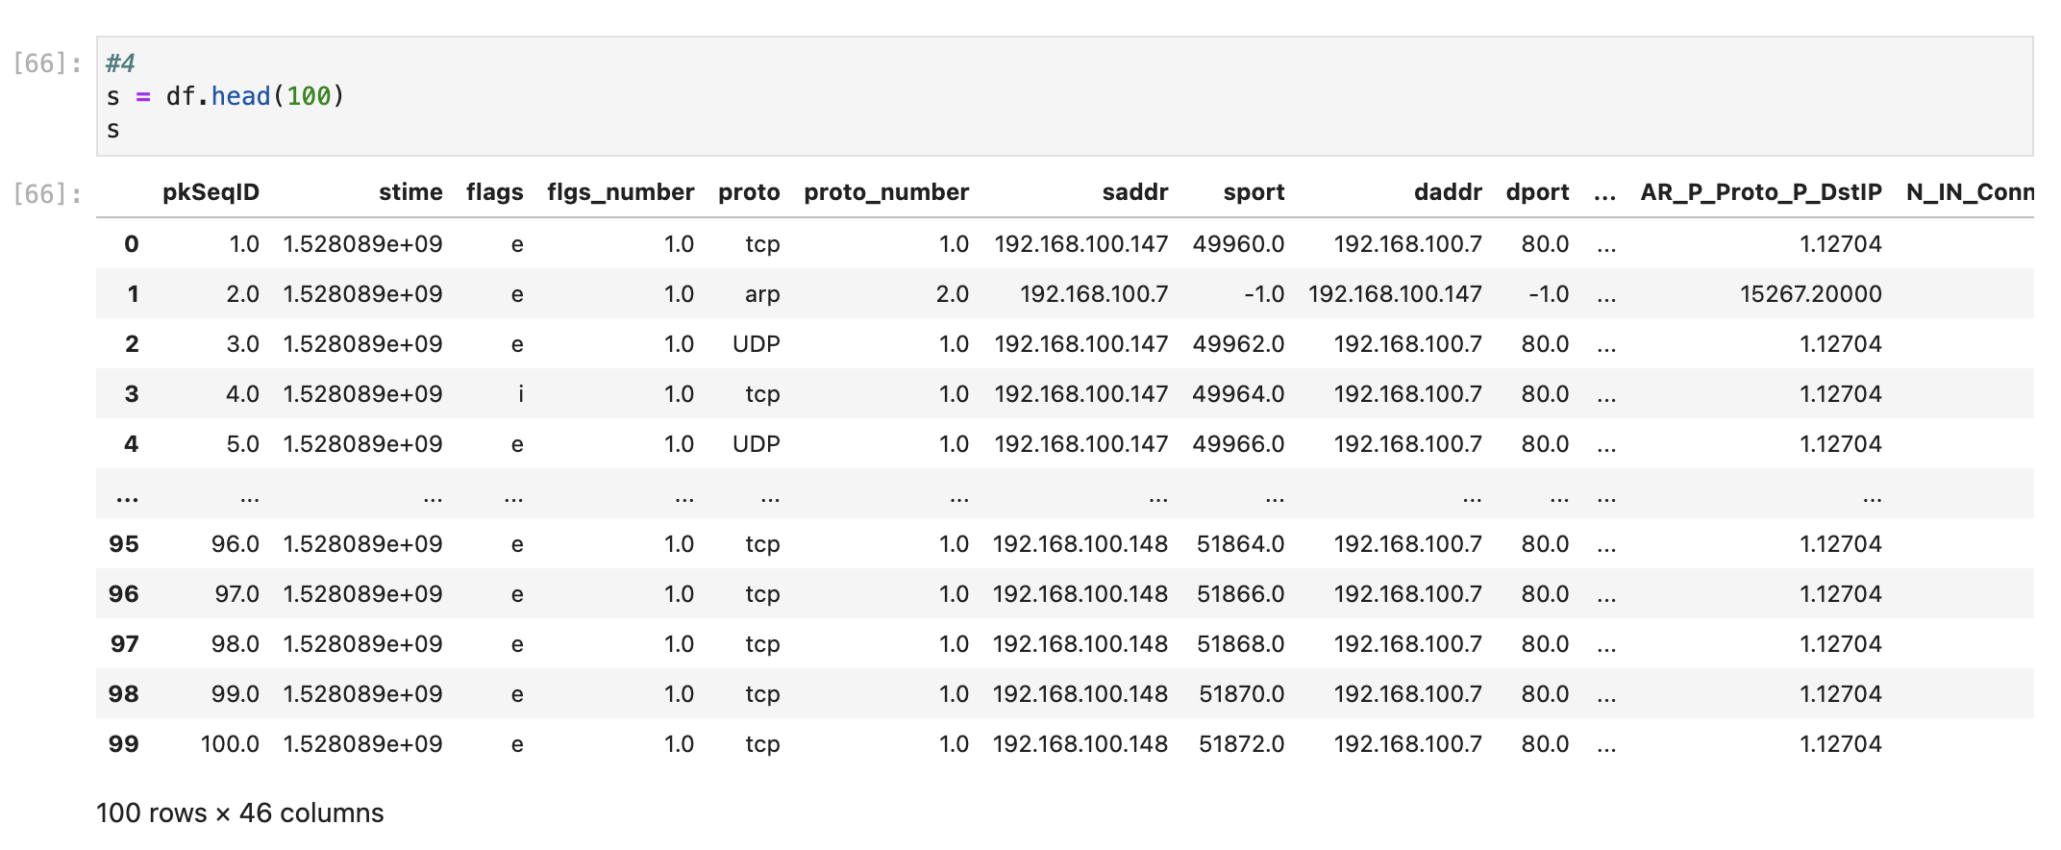

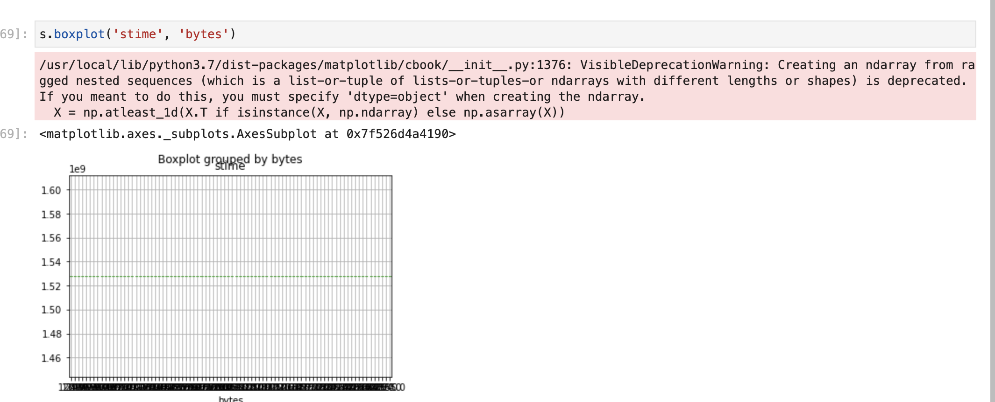

Q5. Correlation analysis (2 Vars)-

Graph 2 and 3 shows the correlation between the Columns sbytes and dbytes.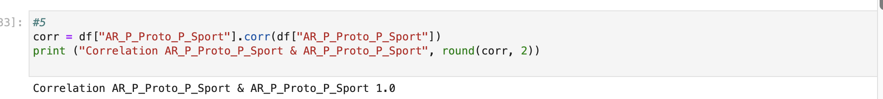

Q6. Describe data -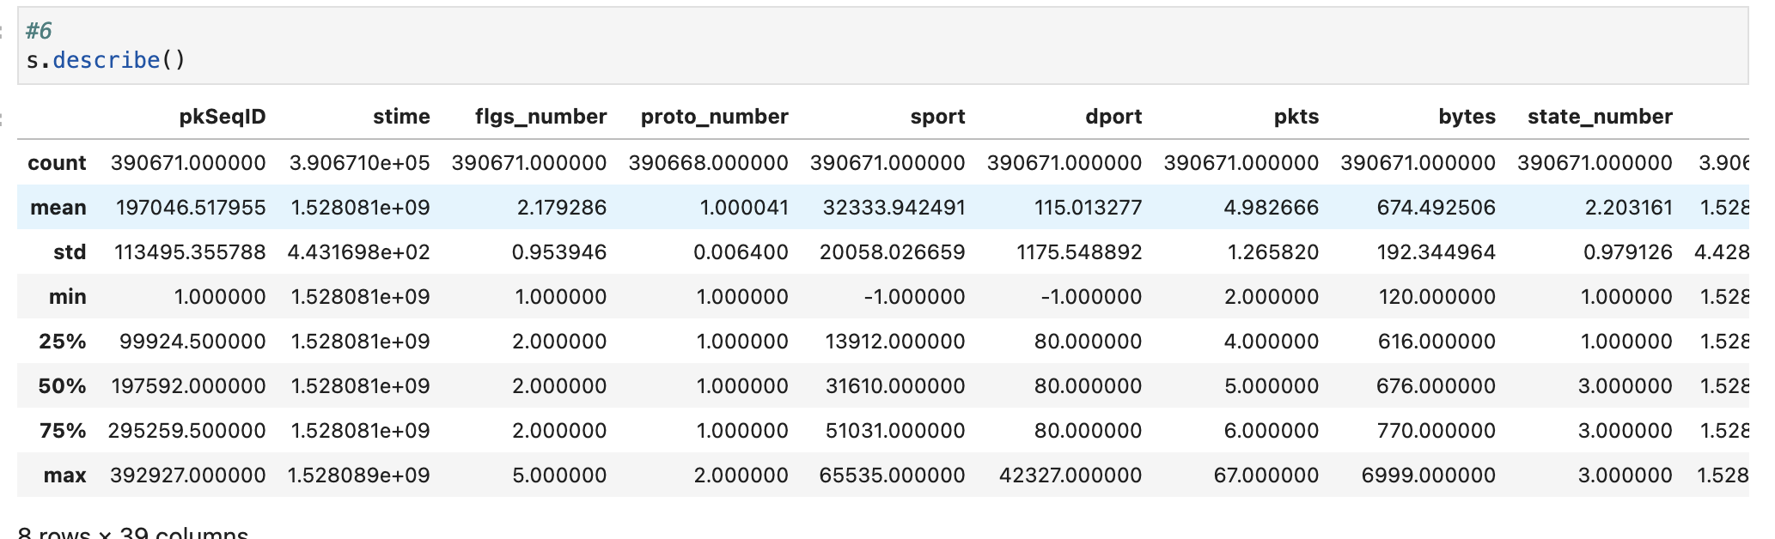

Q7. Display first 3 rows -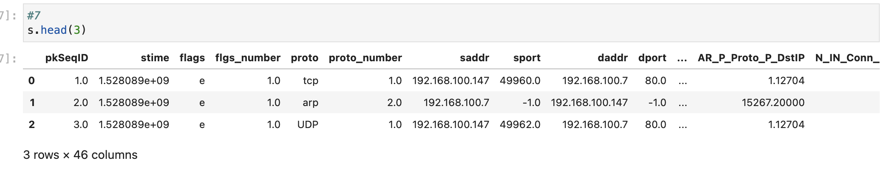

Q8. Display last 4 rows -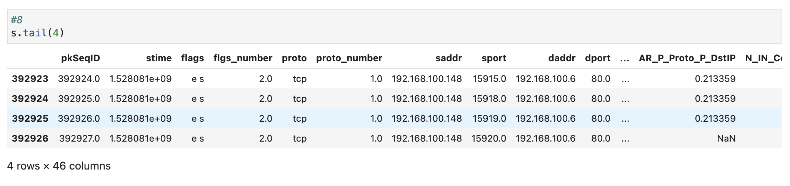

Q9. Locate First Row corresponding to proto as UDP -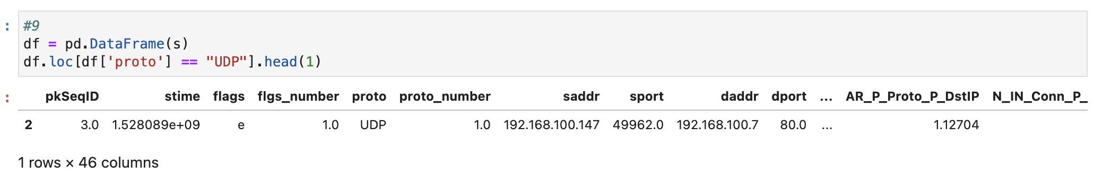

Q10. How many rows of data do you have? -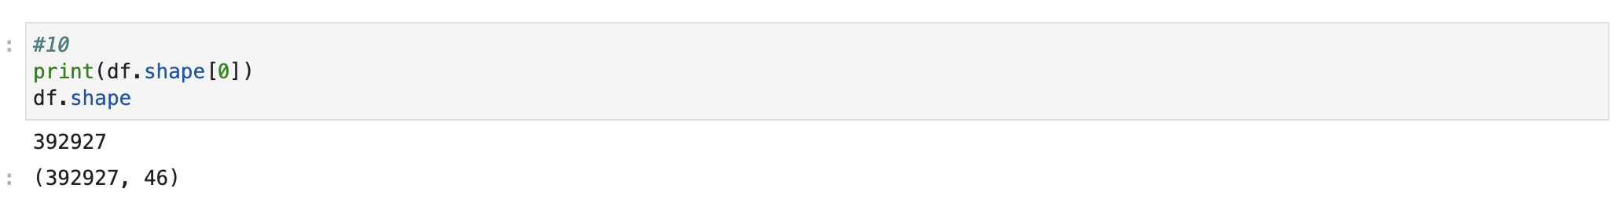

Q11. Display first 5 columns of the first row -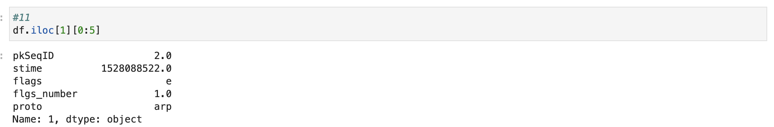

Q12. Count the number of packets affected by the flag “i” -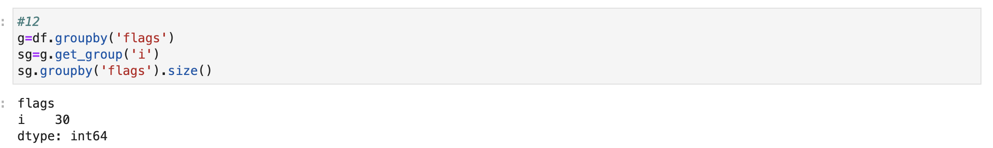

Q13. Split traffic based on Group 1 pkts<=10 and Group 2 pkts>10 -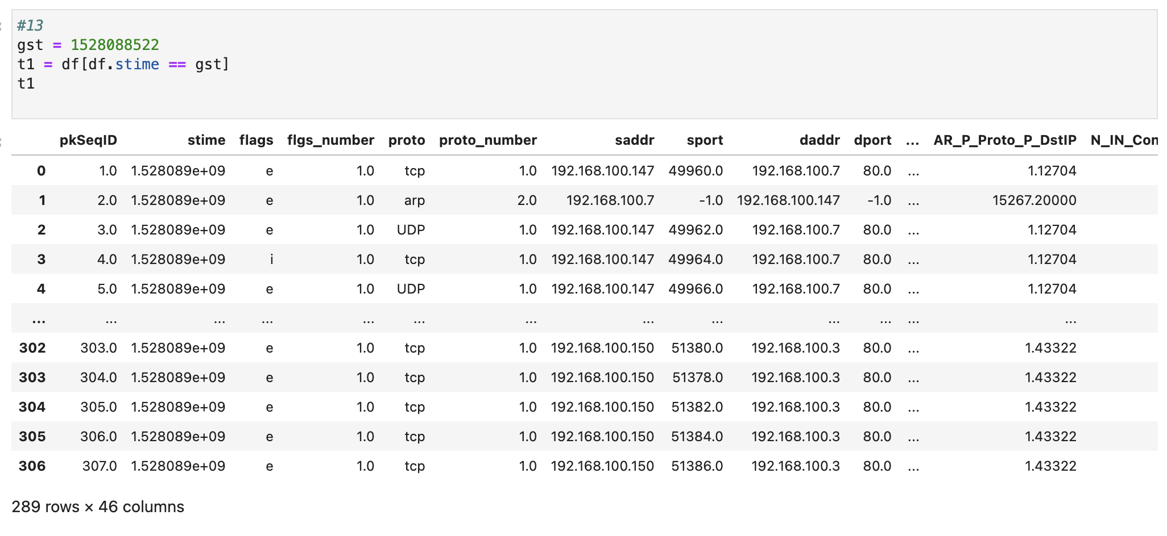

Q13. (a) Mean and deviation of packets –

(b) Mean and deviation of sbytes –

(c) Mean and deviation of dbytes –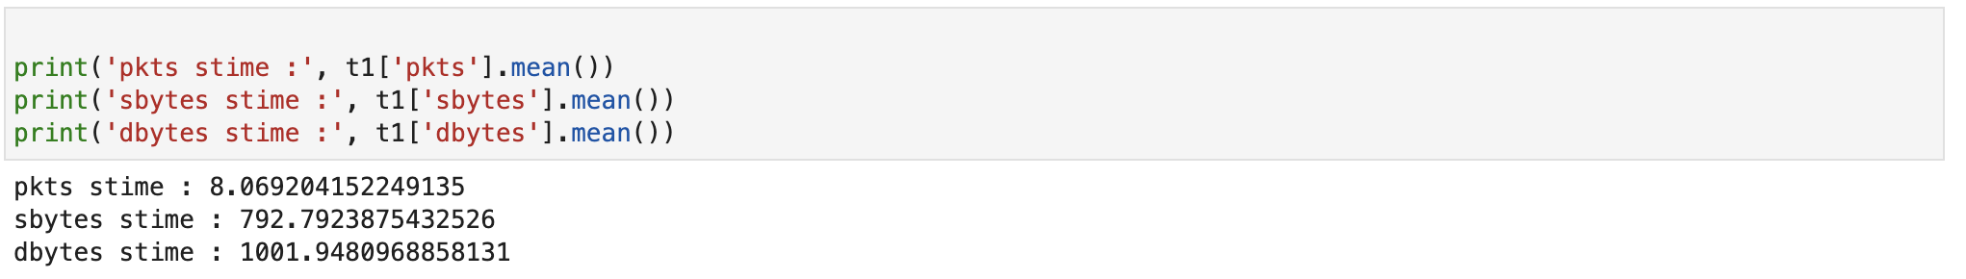

Q14. Mean and Variance of Pkts_P_State_P_Protocol_P_DestIP for HTTP and TCP -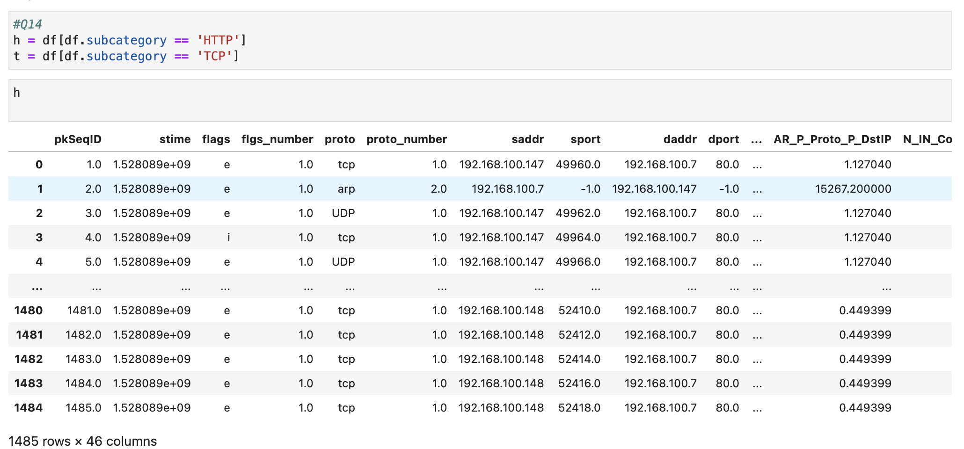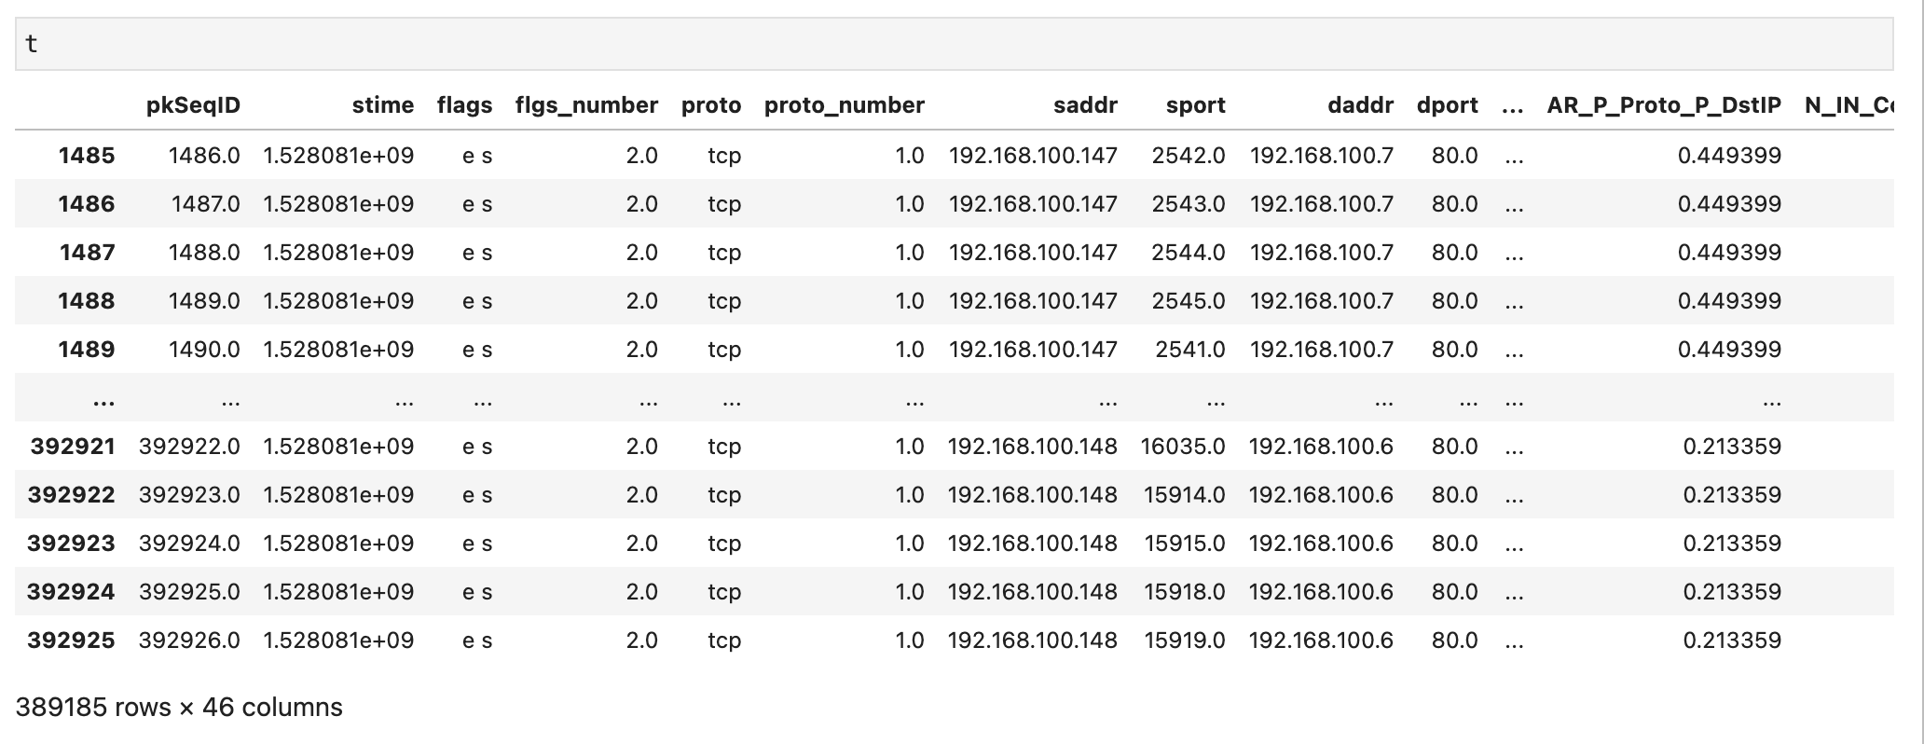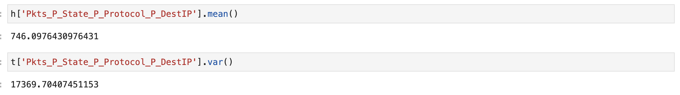

Q15. Draw histogram -