CSA1717 – ARTIFICIAL INTELLIGENCE
LAB EXPERIMENT: MINIMAX ALGORITHM
Name: Abinaya Sri J
Register No: 192524429

AIM
To implement the Minimax algorithm in Python for selecting the best move in a two-player game.
OBJECTIVE
- To understand the Minimax decision-making algorithm.
- To evaluate game states using a game tree.
- To select the best move for the MAX player, assuming the opponent is the MIN player.
- To implement Minimax using recursion.

ALGORITHM
Step 1: Start.
Step 2: Represent the game tree with MAX and MIN nodes.
Step 3: Define the minimax() function.
Step 4: If the current node is a terminal node, return its utility value.
Step 5: If the current player is MAX:
- Evaluate all child nodes.
- Select the maximum value.
Step 6: If the current player is MIN:
- Evaluate all child nodes.
- Select the minimum value.
Step 7: Return the selected value to the parent node.
Step 8: At the root MAX node, select the child having the highest Minimax value.
Step 9: Display the best move and its value.
Step 10: Stop.
FLOW CHART
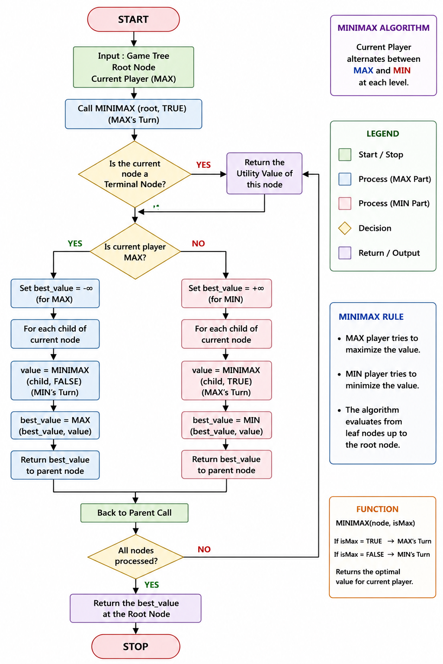
SOURCE CODE
# Minimax Algorithm
# Game Tree
# MAX
# / \
# MIN MIN
# / | \ / | \
# 3 5 6 9 1 2
game_tree = {
'A': ['B', 'C'], # A is MAX
'B': ['D', 'E', 'F'], # B is MIN
'C': ['G', 'H', 'I'], # C is MIN
'D': 3,
'E': 5,
'F': 6,
'G': 9,
'H': 1,
'I': 2
}
def minimax(node, maximizing_player, depth=0):
"""
Minimax recursively evaluates the game tree.
"""
# Terminal node
if node not in game_tree:
return game_tree[node]
# MAX player
if maximizing_player:
best_value = float('-inf')
for child in game_tree[node]:
value = minimax(child, False, depth + 1)
best_value = max(best_value, value)
return best_value
# MIN player
else:
best_value = float('inf')
for child in game_tree[node]:
value = minimax(child, True, depth + 1)
best_value = min(best_value, value)
return best_value
def find_best_move(root):
"""
Finds the best move for MAX from the root node.
"""
best_move = None
best_value = float('-inf')
print("Evaluating moves from MAX:\n")
for child in game_tree[root]:
value = minimax(child, False)
print("Move:", child, "-> Minimax Value:", value)
if value > best_value:
best_value = value
best_move = child
return best_move, best_value
# Driver Code
print("=" * 50)
print(" MINIMAX ALGORITHM")
print("=" * 50)
best_move, best_value = find_best_move('A')
print("\n" + "=" * 50)
print("FINAL RESULT")
print("=" * 50)
print("Best Move for MAX :", best_move)
print("Minimax Value :", best_value)
OUTPUT
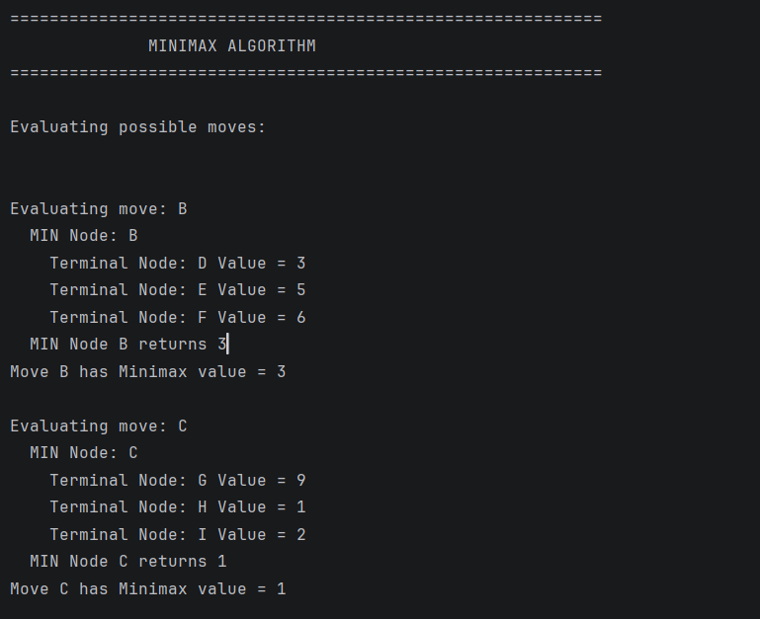
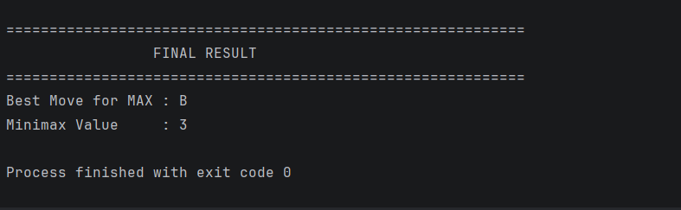

RESULT
The Minimax algorithm was successfully implemented in Python using recursive game-tree evaluation. The algorithm evaluated the possible moves for both MAX and MIN players and selected B as the best move for MAX, with a final Minimax value of 3.
CONCLUSION
The experiment demonstrates how Minimax can be used for decision-making in two-player games. The MAX player tries to maximize the score, while the MIN player tries to minimize the score. By recursively evaluating the game tree, the algorithm selects the best possible move assuming that both players play optimally.

