CSA1717 – ARTIFICIAL INTELLIGENCE
LAB EXPERIMENT: MISSIONARIES AND CANNIBALS PROBLEM
Name: Abinaya Sri J
Register No: 192524429

AIM
To implement the Missionaries and Cannibals Problem in Python using the Breadth-First Search (BFS) algorithm and find a safe sequence of states that transfers all missionaries and cannibals from the starting bank to the destination bank without violating the problem constraints.

OBJECTIVE
- To understand the Missionaries and Cannibals state-space problem.
- To represent each situation as a state.
- To apply BFS to search the state space.
- To ensure that missionaries are never outnumbered by cannibals on either bank.
- To find a valid sequence of boat movements from the initial state to the goal state.

PROBLEM STATEMENT
There are 3 missionaries and 3 cannibals on the left bank of a river.
A boat is available to transport them to the right bank.
The following conditions must be satisfied:
- The boat can carry a maximum of 2 people.
- The boat must carry at least 1 person.
- The boat can carry missionaries, cannibals, or both.
- On either bank, if missionaries are present, they must not be fewer than the cannibals.
- The objective is to safely transfer all 3 missionaries and 3 cannibals to the right bank.
The problem can be solved as a state-space search problem.

STATE REPRESENTATION
A state is represented as:
(M, C, B)
Where:
- M = Number of missionaries on the left bank.
- C = Number of cannibals on the left bank.
- B = Position of the boat.
We use:
- B = 0 → Boat is on the left bank.
- B = 1 → Boat is on the right bank.
Initial State
(3, 3, 0)
This means:
- 3 missionaries on left
- 3 cannibals on left
- Boat on left
Goal State
(0, 0, 1)
This means:
- 0 missionaries on left
- 0 cannibals on left
- Boat on right
Therefore, everyone has reached the right bank.
CONSTRAINTS
A state is valid only when:
Left Bank
If missionaries are present:
M = 0 OR M ≥ C
Right Bank
The number of missionaries on the right bank is:
3 - M
The number of cannibals on the right bank is:
3 - C
Therefore:
3 - M = 0 OR (3 - M) ≥ (3 - C)
These conditions ensure that cannibals never outnumber missionaries on either bank when missionaries are present.

ALGORITHM
Step 1:
Start.
Step 2:
Represent the initial state as (3, 3, 0).
Step 3:
Represent the goal state as (0, 0, 1).
Step 4:
Create a queue for BFS and insert the initial state.
Step 5:
Maintain a set of visited states to avoid revisiting the same state.
Step 6:
Generate all possible boat movements:
- 1 Missionary
- 2 Missionaries
- 1 Cannibal
- 2 Cannibals
- 1 Missionary and 1 Cannibal
Step 7:
Move the boat according to its current position.
Step 8:
Check whether the new state is valid.
A state is valid only if missionaries are not outnumbered by cannibals on either bank.
Step 9:
If the state is valid and has not been visited, add it to the BFS queue.
Step 10:
Continue the process until the goal state (0, 0, 1) is reached.
Step 11:
Store the parent of every state and reconstruct the solution path.
Step 12:
Display the sequence of states and boat movements.
Step 13:
Stop.

FLOW CHART

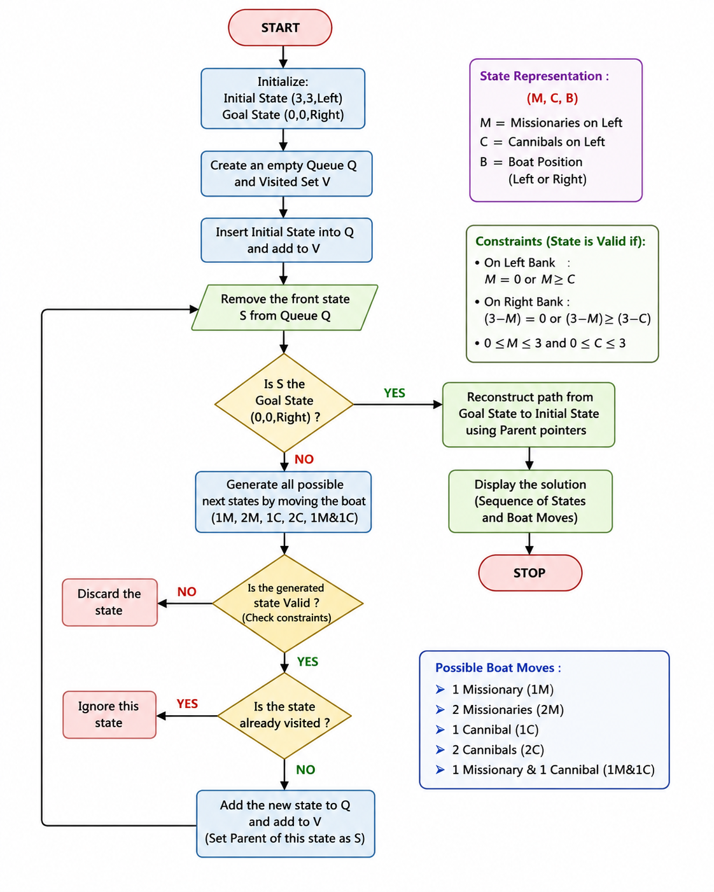

SOURCE CODE
from collections import deque
# Total number of missionaries and cannibals
TOTAL_MISSIONARIES = 3
TOTAL_CANNIBALS = 3
# Boat capacity
BOAT_CAPACITY = 2
# Initial state: (Missionaries on Left, Cannibals on Left, Boat Position)
# 0 = Left Bank
# 1 = Right Bank
INITIAL_STATE = (3, 3, 0)
# Goal state
GOAL_STATE = (0, 0, 1)
# ---------------------------------------------------------
# Function to check whether a state is valid
# ---------------------------------------------------------
def is_valid(state):
missionaries_left, cannibals_left, boat = state
# Check limits
if not (0 <= missionaries_left <= 3):
return False
if not (0 <= cannibals_left <= 3):
return False
# Number of people on the right bank
missionaries_right = TOTAL_MISSIONARIES - missionaries_left
cannibals_right = TOTAL_CANNIBALS - cannibals_left
# Check left bank
if missionaries_left > 0:
if missionaries_left < cannibals_left:
return False
# Check right bank
if missionaries_right > 0:
if missionaries_right < cannibals_right:
return False
return True
# ---------------------------------------------------------
# Generate possible boat movements
# ---------------------------------------------------------
def get_next_states(state):
missionaries_left, cannibals_left, boat = state
# Possible combinations of people in the boat
possible_moves = [
(1, 0), # 1 Missionary
(2, 0), # 2 Missionaries
(0, 1), # 1 Cannibal
(0, 2), # 2 Cannibals
(1, 1) # 1 Missionary and 1 Cannibal
]
next_states = []
for missionaries, cannibals in possible_moves:
# Boat is on the left bank
if boat == 0:
# Check whether enough people are available
if missionaries <= missionaries_left and \
cannibals <= cannibals_left:
new_state = (
missionaries_left - missionaries,
cannibals_left - cannibals,
1
)
if is_valid(new_state):
next_states.append(
(new_state, missionaries, cannibals)
)
# Boat is on the right bank
else:
missionaries_right = TOTAL_MISSIONARIES - missionaries_left
cannibals_right = TOTAL_CANNIBALS - cannibals_left
# Check whether enough people are available
if missionaries <= missionaries_right and \
cannibals <= cannibals_right:
new_state = (
missionaries_left + missionaries,
cannibals_left + cannibals,
0
)
if is_valid(new_state):
next_states.append(
(new_state, missionaries, cannibals)
)

return next_states
# ---------------------------------------------------------
# BFS Algorithm
# ---------------------------------------------------------
def bfs():
queue = deque()
# Store state and path
queue.append((INITIAL_STATE, [INITIAL_STATE]))
# Store visited states
visited = set()
visited.add(INITIAL_STATE)
while queue:
current_state, path = queue.popleft()
# Goal test
if current_state == GOAL_STATE:
return path
# Generate next valid states
for next_state, missionaries, cannibals in get_next_states(
current_state):
if next_state not in visited:
visited.add(next_state)
new_path = path + [next_state]
queue.append((next_state, new_path))
return None
# ---------------------------------------------------------
# Display Solution
# ---------------------------------------------------------
def display_solution(path):
print("=" * 70)
print(" MISSIONARIES AND CANNIBALS PROBLEM")
print(" BFS STATE-SPACE SEARCH")
print("=" * 70)
print("\nInitial State:")
print("(3 Missionaries, 3 Cannibals, Boat on Left)")
print("\nSolution Path:\n")
for i, state in enumerate(path):
missionaries_left, cannibals_left, boat = state
missionaries_right = TOTAL_MISSIONARIES - missionaries_left
cannibals_right = TOTAL_CANNIBALS - cannibals_left
print(f"Step {i}:")
print(
f"Left Bank : M = {missionaries_left}, "
f"C = {cannibals_left}"
)
print(
f"Right Bank : M = {missionaries_right}, "
f"C = {cannibals_right}"
)
if boat == 0:
print("Boat : Left Bank")
else:
print("Boat : Right Bank")
if i < len(path) - 1:
print("Action : Boat moves")
print("-" * 50)
print("\nGoal State Reached!")
print("All missionaries and cannibals are safely on the right bank.")
print("\nTotal Boat Crossings:", len(path) - 1)
# ---------------------------------------------------------
# Main Program
# ---------------------------------------------------------
solution = bfs()
if solution:
display_solution(solution)
else:
print("No solution exists.")
OUTPUT
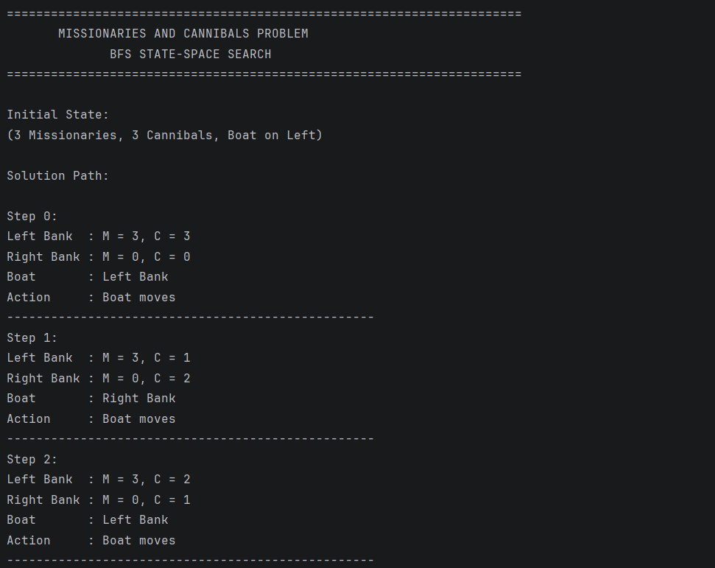
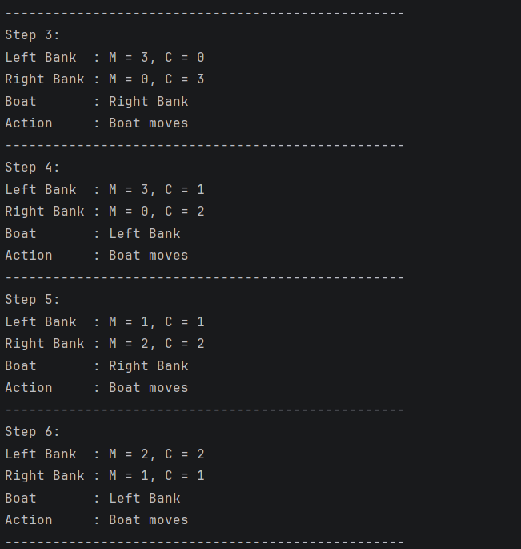
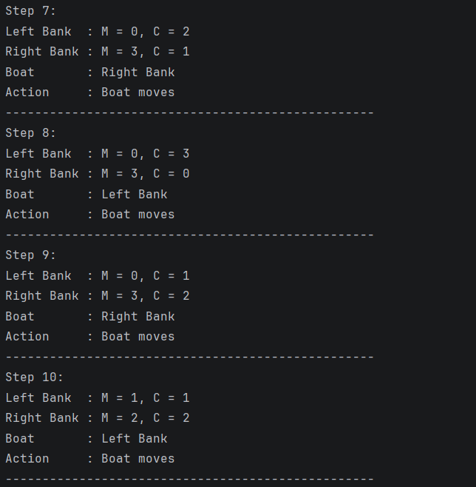
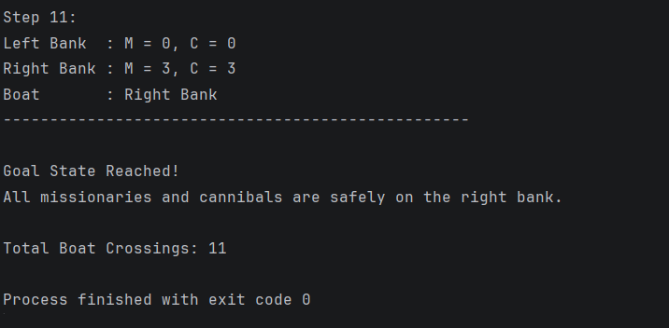

RESULT
The Missionaries and Cannibals Problem was successfully implemented in Python using Breadth-First Search (BFS). The program represented the problem as a state-space search, generated valid boat movements, rejected unsafe states, avoided repeated states, and found a valid sequence for transferring all three missionaries and three cannibals safely to the opposite bank.
CONCLUSION
The Missionaries and Cannibals Problem demonstrates how Artificial Intelligence can solve a problem using state-space search and constraint checking. BFS systematically explores possible states and guarantees a shortest solution in terms of the number of boat crossings when all actions have equal cost. The validity-checking function ensures that missionaries are never outnumbered by cannibals on either bank. Thus, the program demonstrates the practical application of BFS, state representation, constraints, and intelligent search in AI.

