CSA1503-CLOUD COMPUTING AND BIG DATA ANALYTICS
Experiment-14

Create a Virtual Hard Disk and allocate the storage using VM ware Workstation
AIM
To create a Virtual Hard Disk (VMDK) and allocate storage using VMware Workstation (Type 2 Hypervisor).
PROCEDURE
Step 1:
Open VMware Workstation.
Step 2:
Click Create a New Virtual Machine.
Step 3:
Select Typical (Recommended) and click Next.
Step 4:
Choose I will install the operating system later and click Next.
Step 5:
Select the Guest Operating System (e.g., Linux → Ubuntu 64-bit) and click Next.
Step 6:
Enter the Virtual Machine Name and choose the location to save the virtual machine.
Step 7:
In the Specify Disk Capacity window, enter the required disk size (e.g., 15 GB) and choose Store virtual disk as a single file.
Step 8:
Click Customize Hardware (if required) and verify the hardware settings.
Step 9:
Click Finish to create the virtual machine. VMware automatically creates the Virtual Hard Disk (.vmdk) and allocates the specified storage.
Step 10:
Verify that the virtual hard disk has been created by checking the virtual machine folder or the VMware settings.

IMPLEMENTATION
STEP 1: Open VMware Workstation and Click Create a New Virtual Machine.
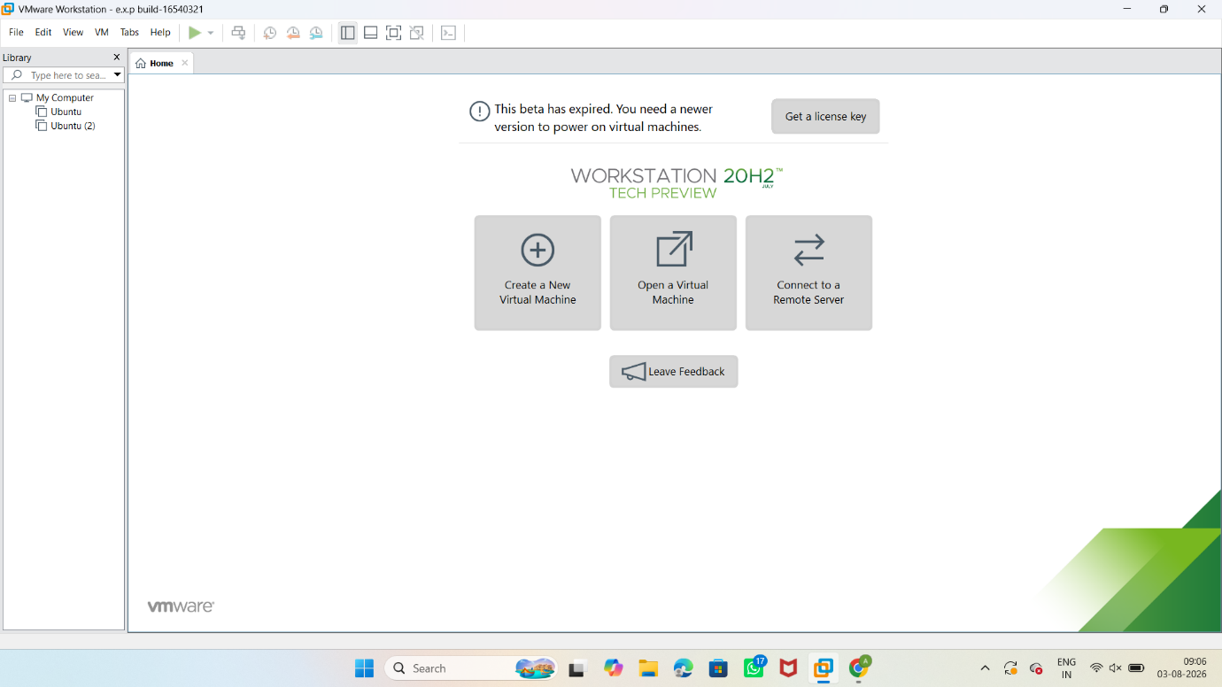

STEP 2: Select Typical (Recommended) and click Next.
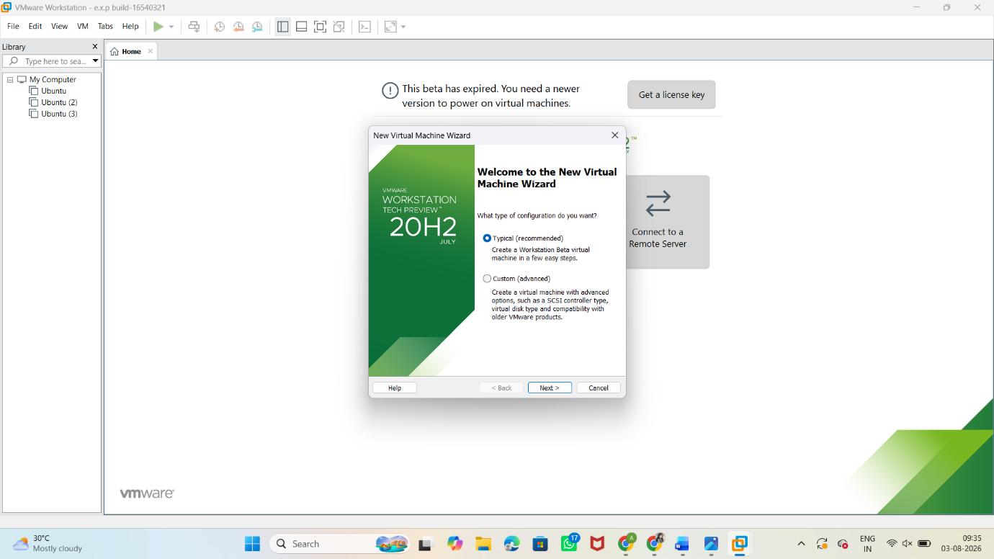

STEP 3: Select the Guest Operating System (e.g., Linux → Ubuntu 64-bit) and click Next.
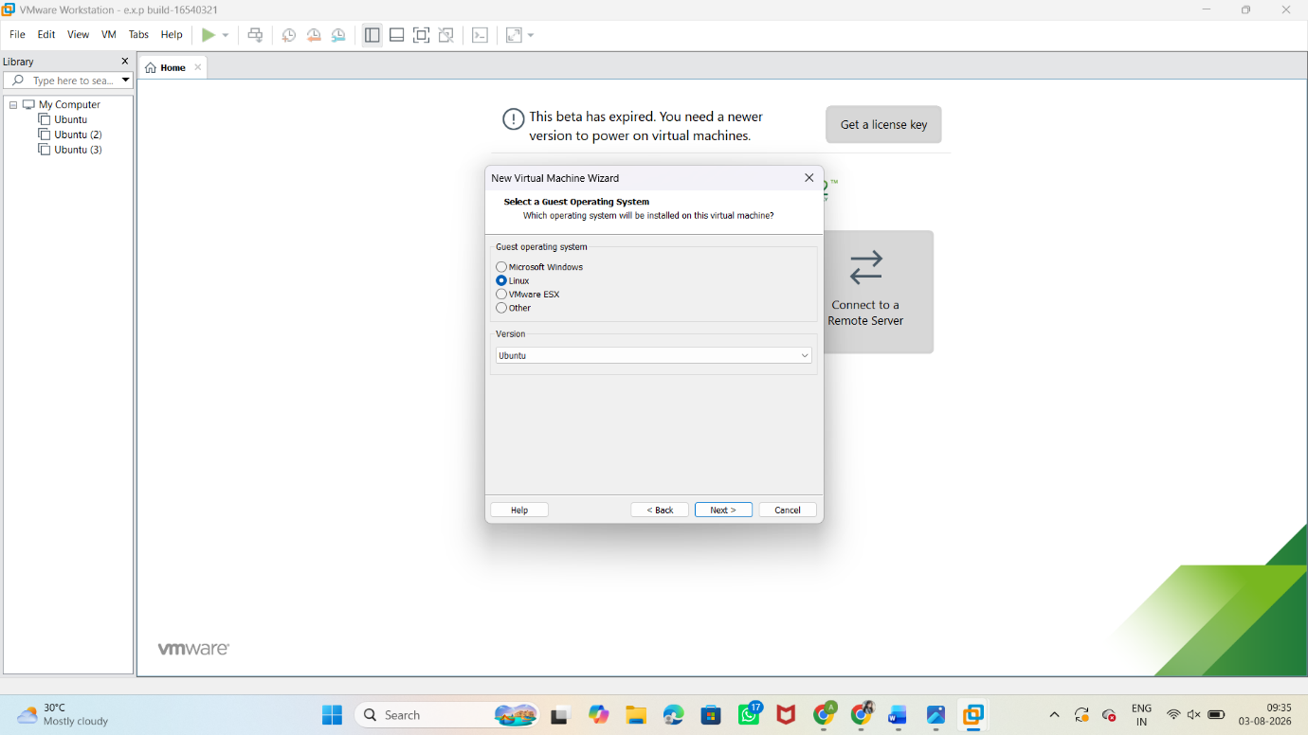

STEP 4: Enter the Virtual Machine Name and choose the location to save the virtual machine.
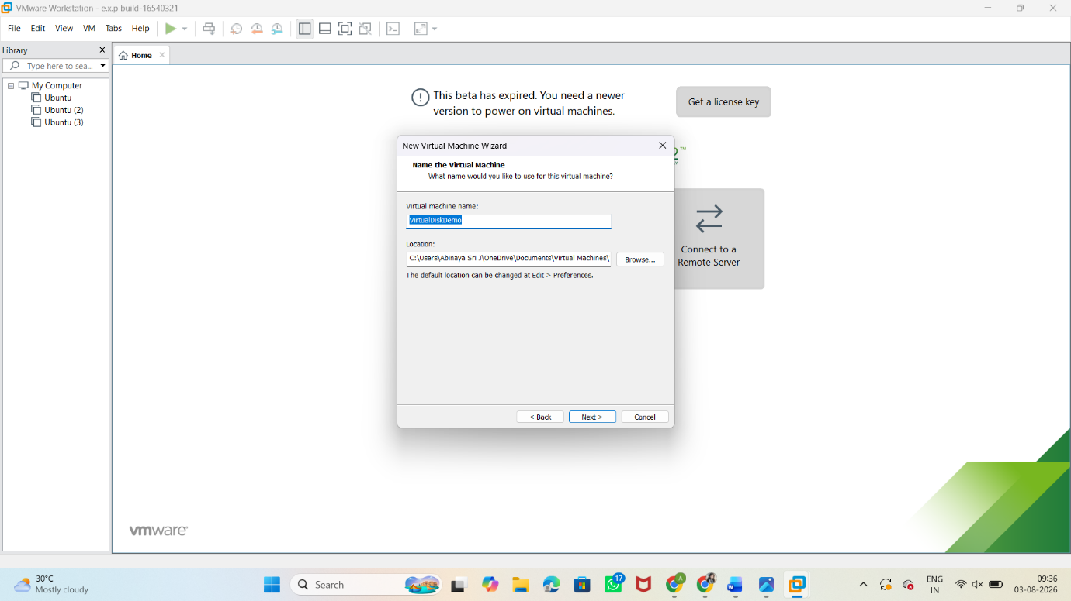
STEP 5: In the Specify Disk Capacity window, enter the required disk size (e.g., 15 GB) and choose Store virtual disk as a single file.

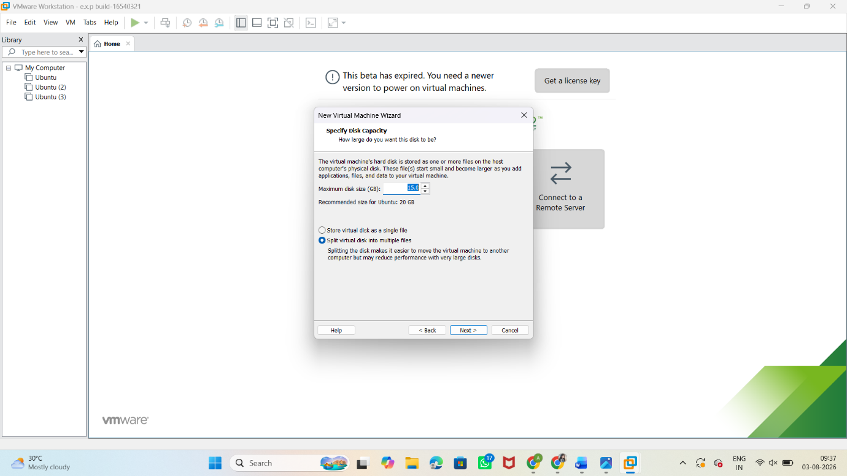

OUTPUT:
