CSA1503-Cloud computing and big data analytics
Experiment-12
12. Demonstrate virtualization by Installing Type-2 Hypervisor in your device, create and configure VM image with a Host Operating system (Either Windows/Linux).
AIM
To demonstrate virtualization by installing VMware Workstation (Type-2 Hypervisor) and creating and configuring a Virtual Machine with a guest operating system (Ubuntu Linux/Windows).
PROCEDURE
Step 1: Install VMware Workstation
- Download VMware Workstation from the official website.
- Run the installer and complete the installation.
- Restart the system if prompted.
Step 2: Open VMware Workstation
- Launch VMware Workstation.
- Click Create a New Virtual Machine.
Step 3: Choose Configuration
- Select Typical (Recommended).
- Click Next.
Step 4: Select Installation Source
- Choose Installer disc image file (ISO).
- Browse and select the Ubuntu (or Windows) ISO file.
- Click Next.
Step 5: Select Guest Operating System
- Choose Linux → Ubuntu 64-bit (or Windows).
- Click Next.
Step 6: Configure the Virtual Machine
- Enter the Virtual Machine name.
- Select the storage location.
- Allocate hardware resources:
  - Processor: 1 CPU
  - Memory: 2 GB RAM
  - Hard Disk: 15 GB
Step 7: Finish the Configuration
- Click Finish.
- The Virtual Machine is created.
Step 8: Install the Guest Operating System
- Power on the Virtual Machine.
- Follow the installation steps of Ubuntu (or Windows).
Step 9: Verify the Virtual Machine
- Log in to the guest operating system.
- Verify that the VM is running successfully.

STEP 1: Click Create a New Virtual Machine.
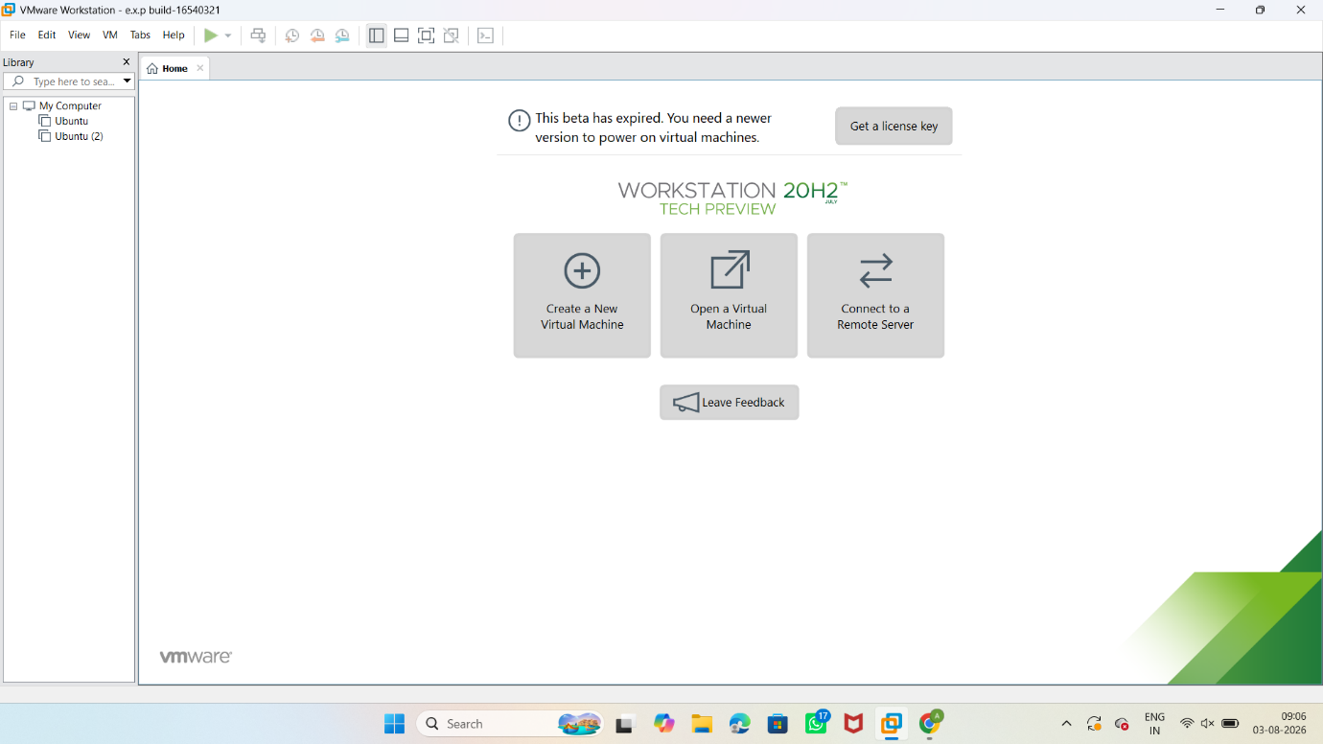

STEP 2: Select Typical (Recommended). Click Next.
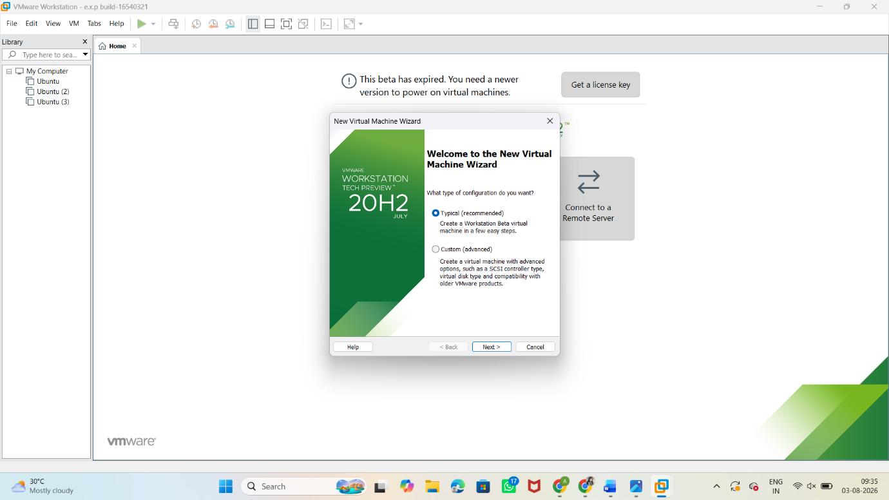
Step 5: Select Guest Operating System
- Choose Linux → Ubuntu 64-bit (or Windows).
- Click Next.
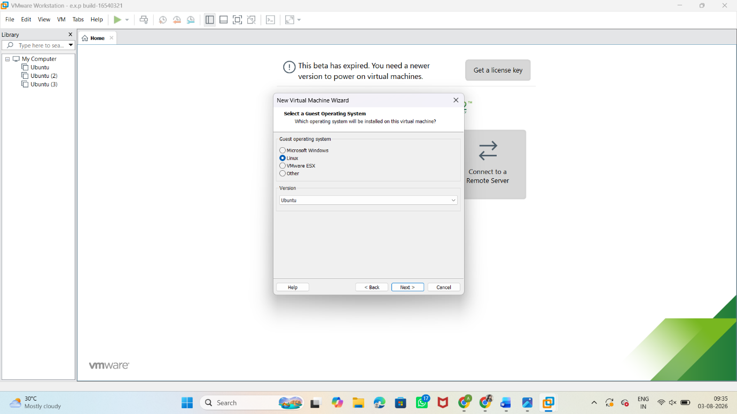

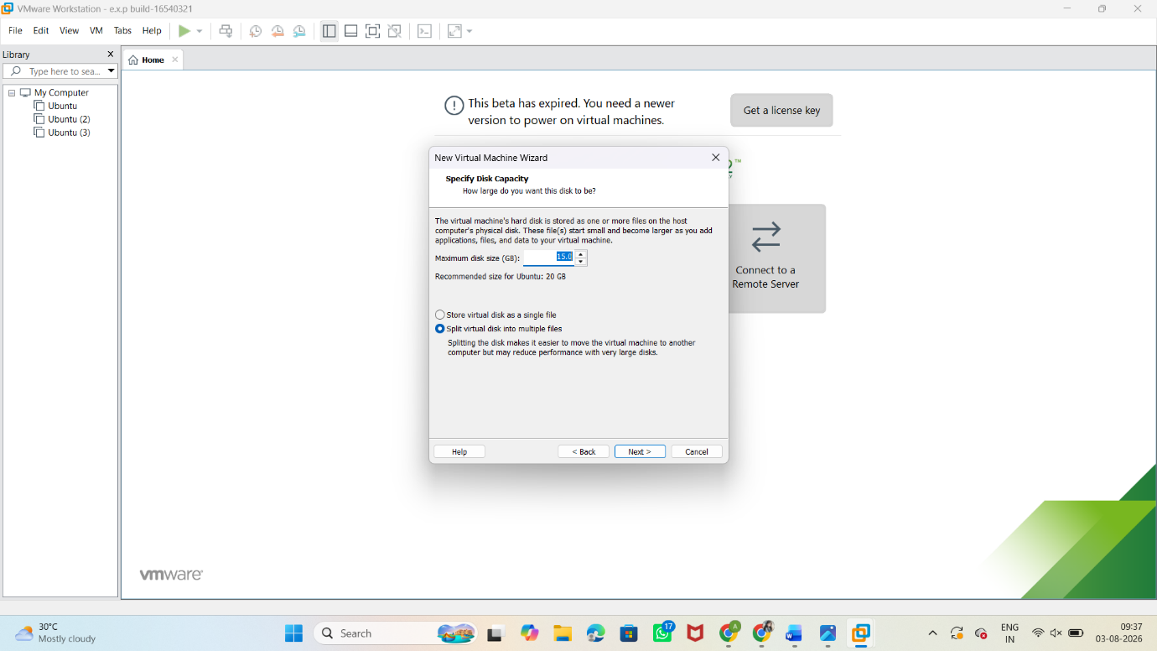
Step 6: Configure the Virtual Machine
- Allocate hardware resources:
  - Processor: 1 CPU
  - Memory: 2 GB RAM
  - Hard Disk: 15 GB
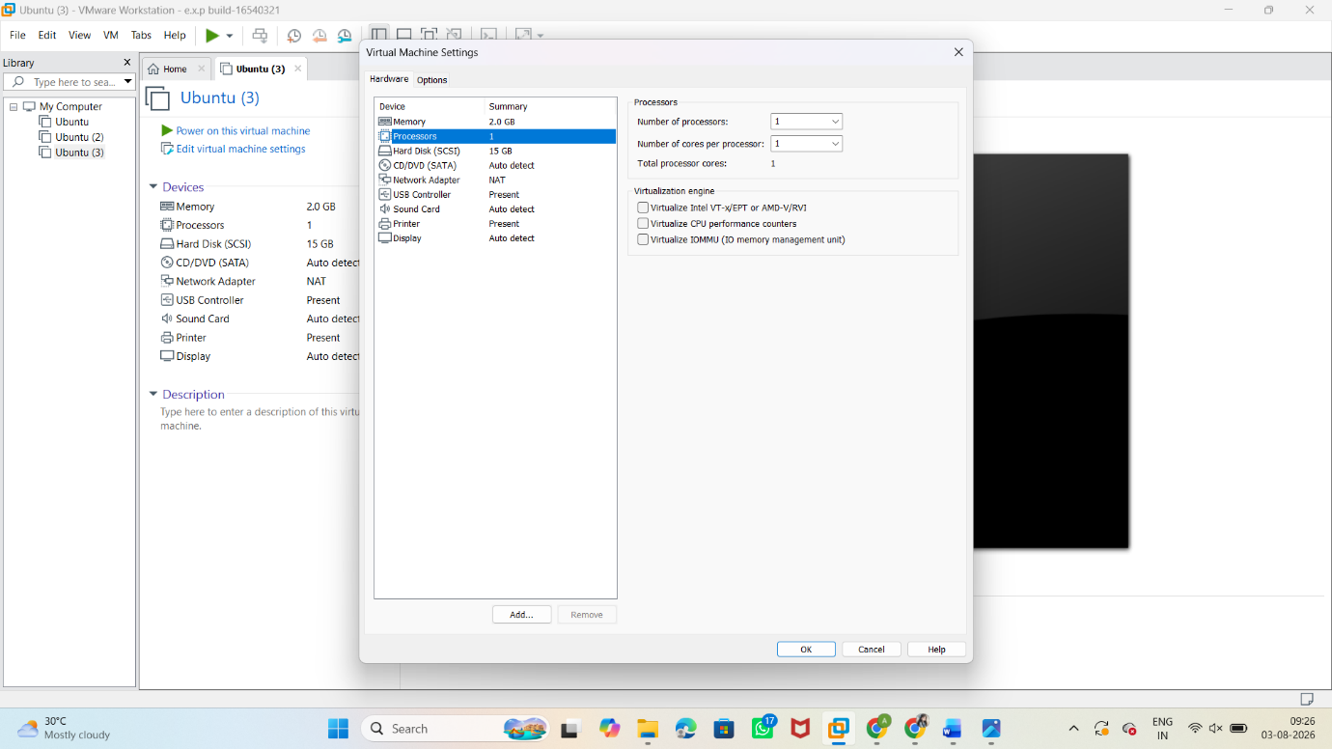



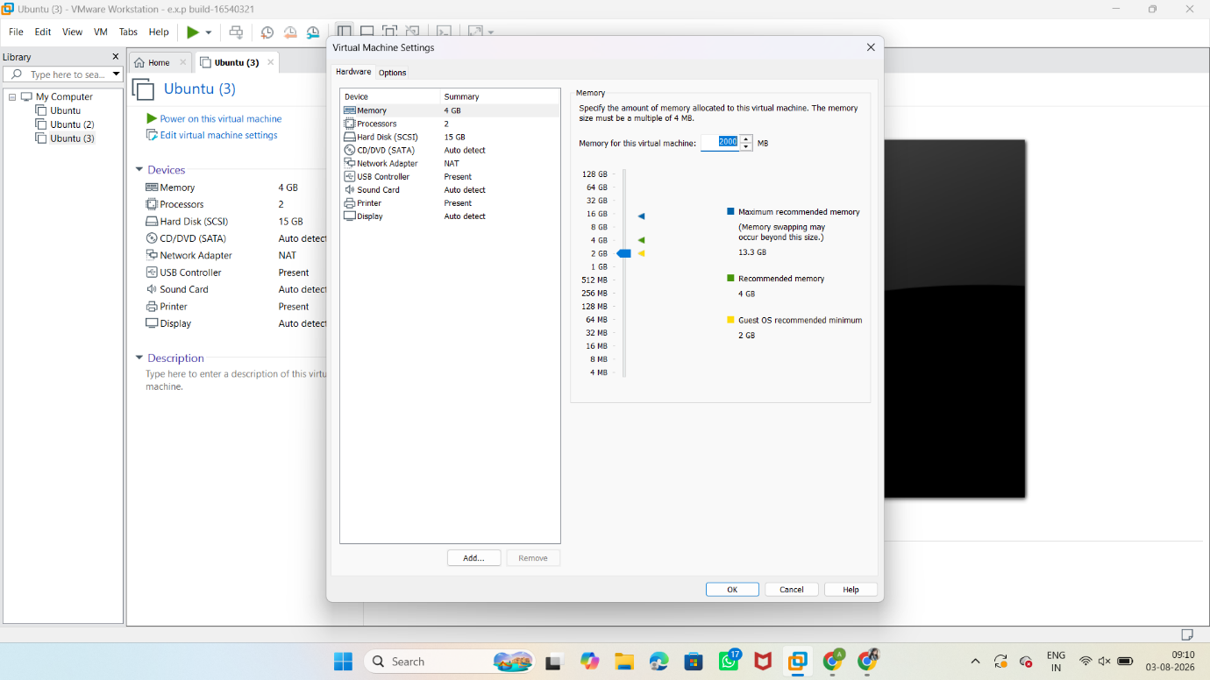

OUTPUT
