Nama: abi ranchman wasril

NIM : 115103015

Prodi: informatika

Tugas DFD

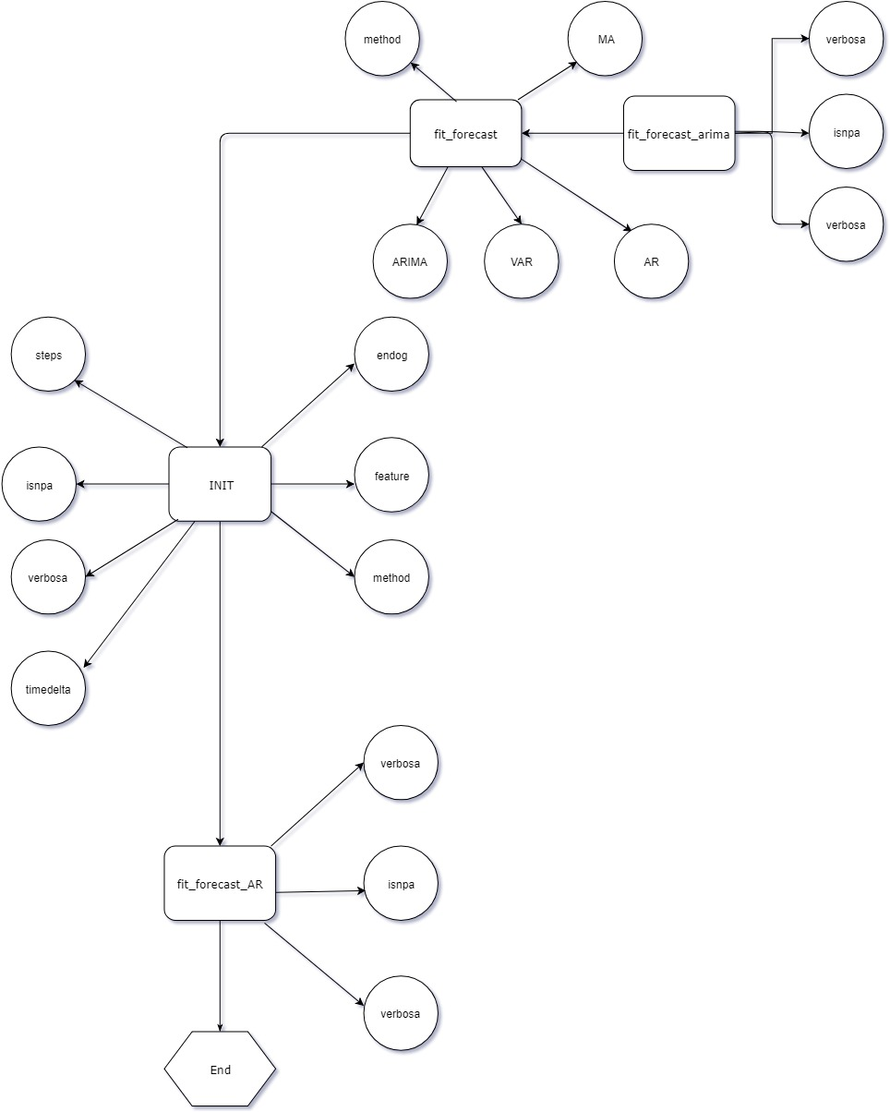

Sumber: https://github.com/THEEJUNG/ITTJ/blob/master/code/arima_test.py