**India’s Agriculture Crop Production Analysis (1997-2021)**

1. **Introduction**
   1. **Overview:**

Agricultural development is one of the most powerful tools to end extreme poverty, boost shared prosperity. In India 95% of peoples are still depends on the agricultural products. Current food systems also threaten the health of people and the planet and generate unsustainable levels of pollution and waste. One third of food produced globally is either lost or wasted.

* 1. **Purpose:**

This project is all about knowing the crop production in India. By this project we can understand the gain and loss in the production from 1997-2021. The population of India mostly depends on agriculture for their livelihood and agriculture contributes to 40 percent of the total GDP of the country.This project also helps to known the advantages and disadvantages that took place by the chemicals in the agricultural land we can also compare the production of the crop products according to the seasons, area and the land.

1. **Problems Definition and Design thinking:**
   1. **Empathy map:**

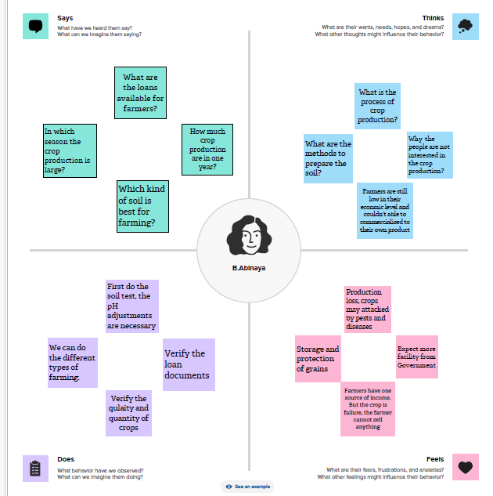

* 1. **Brainstorming map:**

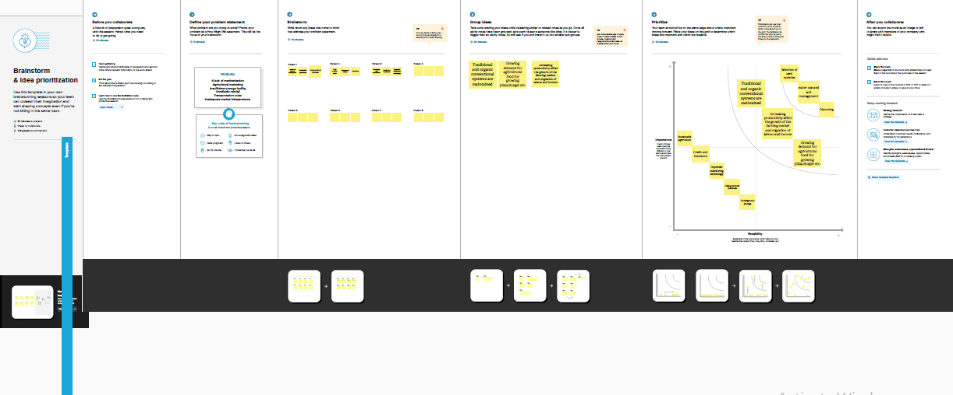

1. **Result:**

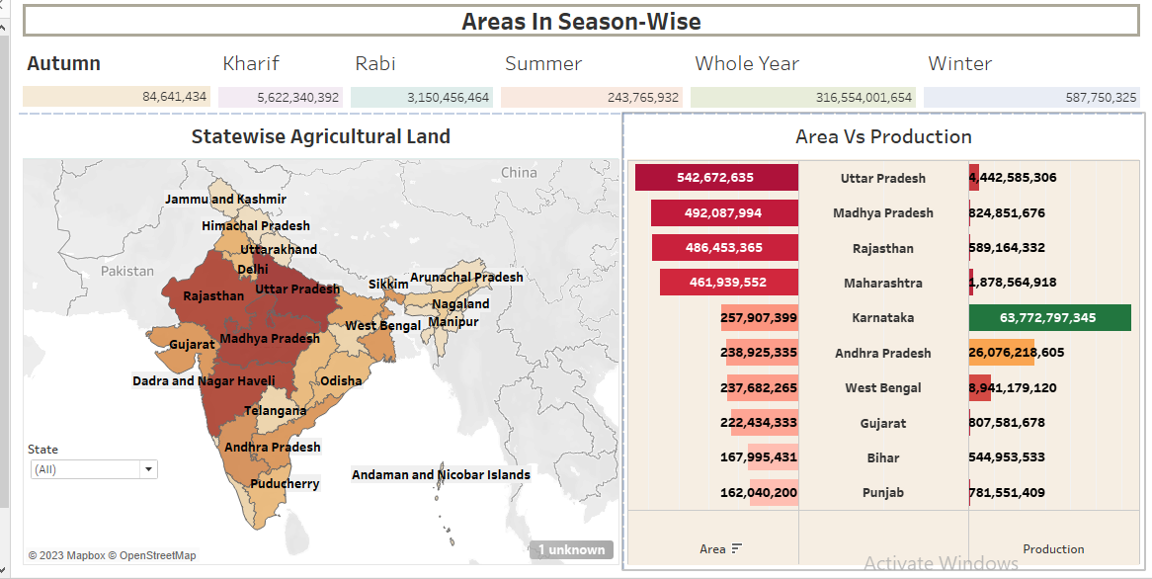

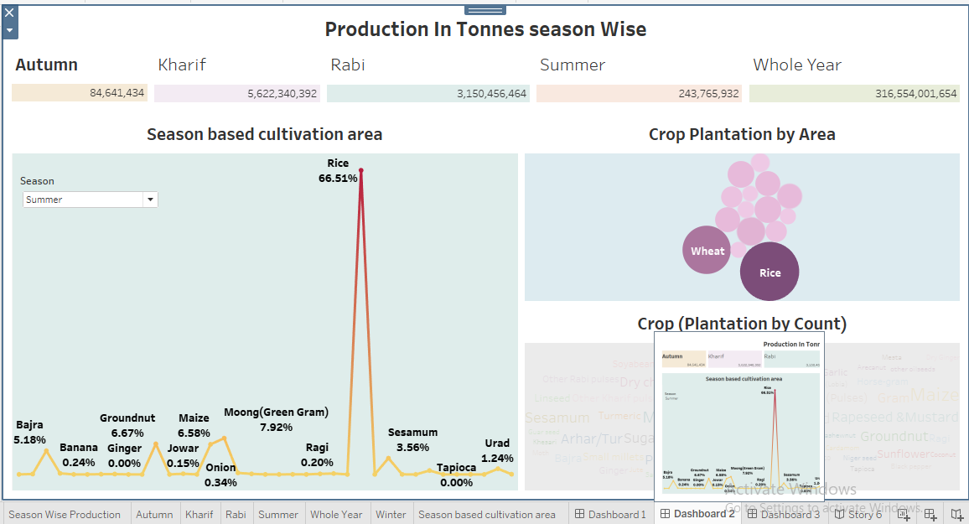

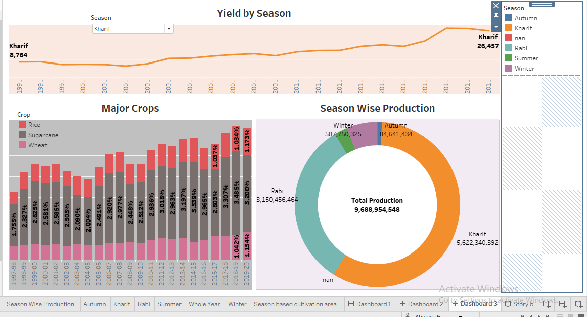

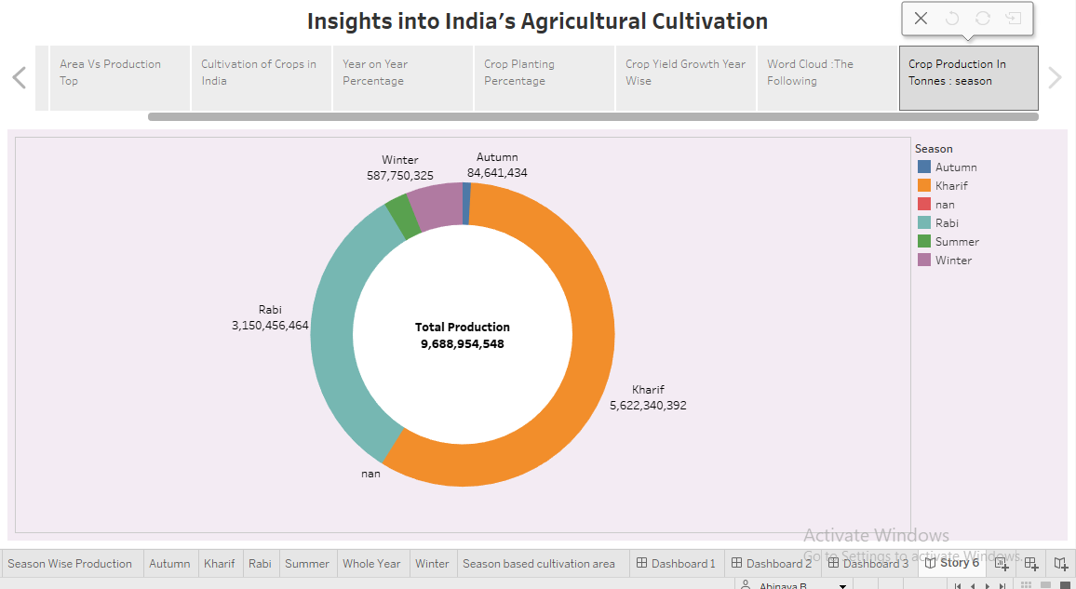

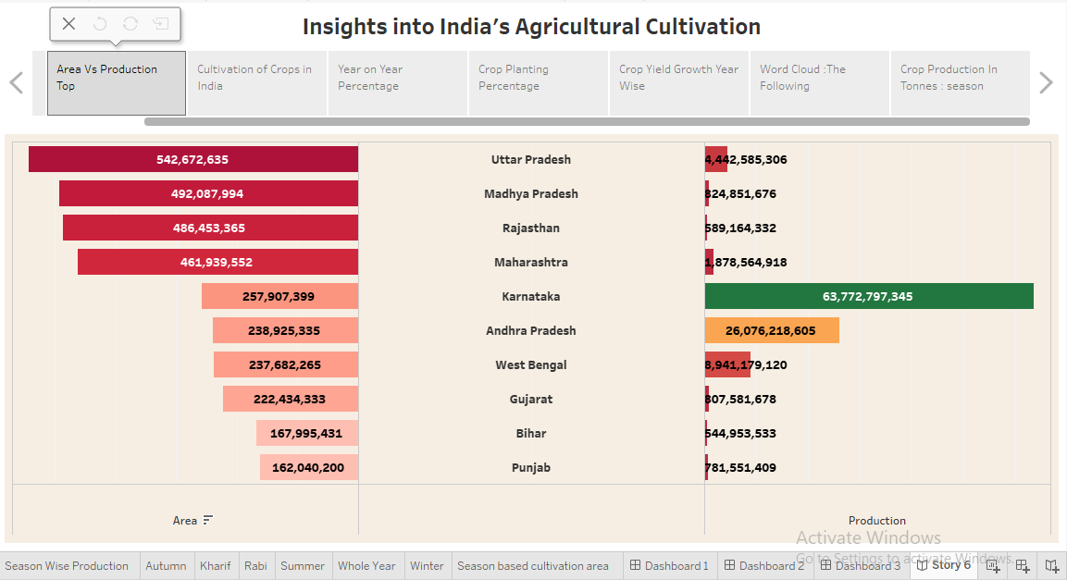

1. **Advantages and Disadvantages:**

**Advantages:**

* Agriculture techniques are designed to be more sustainable, with a focus on reducing waste, conserving resources, and minimizing the use of harmful chemicals.
* It provides employment opportunity to the rural agricultural as well as non-agricultural laborer’s
* Near self-sufficiency of inputs, relatively low labour costs and diverse agro-climatic conditions.
* Indian formers are planted many types of crops.

**Disadvantages:**

* Erosion of soil by heavy rain, floods, insufficient vegetation cover etc., reduces farm productivity.
* Inadequate irrigation facilities and poor management of water resources have led to a great decline in agricultural productivity.
* Farmers are still low in their economic level and couldn't able to commercialised to their own product.
* Production loss, crops may attacked by pests and diseases.

1. **Applications:**

This project can help the farmers as well as insurers. By analyzing data from sensors and samples, agricultural scientists can develop more accurate models of soil behavior. This helps farmers make better irrigation, fertilization, and other soil management practices.

1. **Conclusions:**

The agricultural sector is of vital importance for the region. It is undergoing a process of transition to a market economy with substantial changes in the social, legal structural, productive and supply set-ups as is the case with all other sectors of the economy.

1. **Future Scope**

We can improve our project by adding other countries crop production details to data set and by adding the fertilizer details of every farmers used for their crops.