**Introduction**

Udemy – Educational platform for online video courses

Udemy is an American online learning platform aimed at professional adults and students. Udemy is an online learning and teaching marketplace with over 150000 courses and 24 million students.

Udemy helps organizations of all kinds prepare for the ever-evolving future of work. Our curated collection of top-rated business and technical courses gives companies, governments, and non-profits the power to develop in-house expertise and satisfy employees hunger for learning and development.

**Dataset**

Analyse the dataset that contains above 3000 records on each 4 subjects such as Business Finance, Web Development, Graphic Design, and Musical Instruments from the year 2011 to 2017.

**Insights**

Getting insights about number of courses available for each subjects, how many free and paid courses offered by Udemy, level of courses Udemy have, how the prices differ for each subjects, which subject has higher reviewers and subscribers, what are the trending free and paid courses based upon the subscribers.

**Forecasting**

Based on the insights, forecast which subjects and courses are going to be boom in the upcoming years.

**Analysis**

**Subject Distribution**

This donut chart clearly depicts the number of courses each subjects has.

There is a slight difference between Web Development and Business Finance. Only 5 courses offered more for Web Development than Business Finance.

Musical Instrument and Graphic Design subjects has limited courses.

**Type of courses distribution (Free and Paid)**

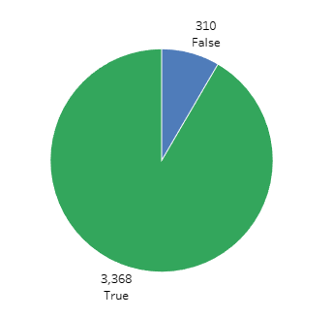False represent free courses, whereas True represents paid courses.

Udemy has limited number of free courses.

Nearly 95 % of courses are paid one.

**Type of course distribution among subject**

Udemy offers very a smaller number of courses for free learning. Mostly offered paid courses in a larger number. Offered 133 free courses in Web Development, 96 in Business Finance, 46 in Musical Instruments, 35 in Graphic Design. Offer 1099 paid courses in Business Finance, 1067 in Web Development, 634 in Musical Instrument, 568 in Graphic Design.

**Duration distribution across type of courses**

Udemy fixed higher duration for a paid course with an average of 3 hours, whereas free courses have an average of 1.5 hours. There is a strong relationship between duration and type of courses. Maximum content duration for paid courses have 78.50 hours, whereas free courses have 21 hours.

**Duration distribution among subject and type of course**

* Each paid courses have long duration than free courses.
* Some of the Web development and Business Finance paid courses have duration of more than 60 hours.
* Some of the Musical Instrument and Graphic Design paid courses have duration of more than 25 hours.
* Free courses of all subjects have an average of 1 to 1.5 hours, whereas paid courses have an average of 2 to 3.5 hours.
* Graphic Design subject has maximum duration of 78.5 hours, followed by Web Development (76.5), Business Finance (71.5), and Musical Instrument (38.0).

**Subject distribution among various level**

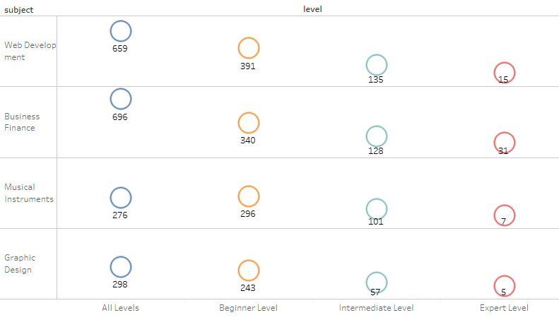

* Udemy offered 4 levels of course across 4 subjects for online learning.
* The above circle chart clearly depicts the count of each level on descending order across 4 levels such as All levels, Beginner level, Intermediate level and Expert level.
* Courses for **All levels** are **larger** in number in Web Development (659) and Business Finance (696) compared to remaining levels.
* Musical Instrument and Graphic Design have nearly equal number of level in All and Beginner.
* **Intermediate level** of course is in **considerable amount** only for all 4 subject categories.
* Udemy offered **Expert level** courses in a **few** numbers.

**Course price distribution**

The below 4 box plot shows the minimum, maximum, and average course price in $ on each 4 subject such as Web Development, Business Finance, Musical Instrument, and Graphic Design.

**Web Development Business Finance**

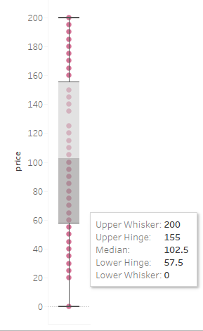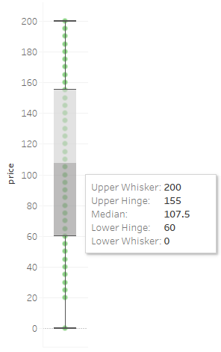

**Musical Instrument Graphic Design**

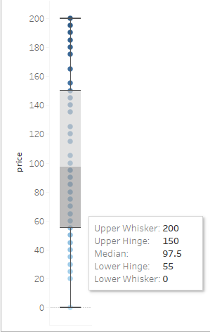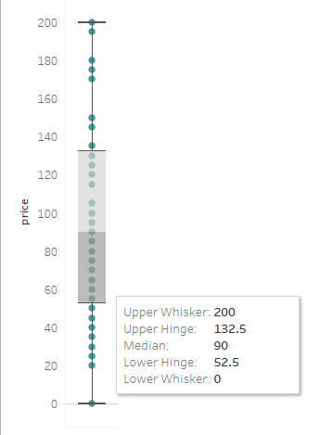

Udemy offers courses from **$20 to $200**. Total average price of each 4 subject is above $90. Lower average price is in the ragne of $52.5 to $60. Whereas upper average price is in the ranage of $132.5 to $150.

Courses are distributed equally among price on Web Development, Graphic Design, and Business Finance. Whereas courses on Musical Instrument are mostly distributed among upper average price only. Costlier courses are less in number.

**Subject distribution based on reviews and subscribers**

The upper row shows number of reviews each subject have on free and paid courses. Whereas The lower row represents number of subscribers. Free courses has less reviews than paid one in all 4 subjects. Web Development have maximum number of subscribers as well as reviews, followed by Business Finance, Graphic Design, and Musical Instrument.

Compared to all other subjects with respect to type of courses (free/paid) **Web Development** has higher number of **subscribers** (above 2 million) in free and (above 5 million) paid courses.

**Top 15 free courses** (based on number of subcribers)

**Top 15 paid courses** (based on number of subscribers)

**Year-wise distribution across subject**

**Forecasting Trend**

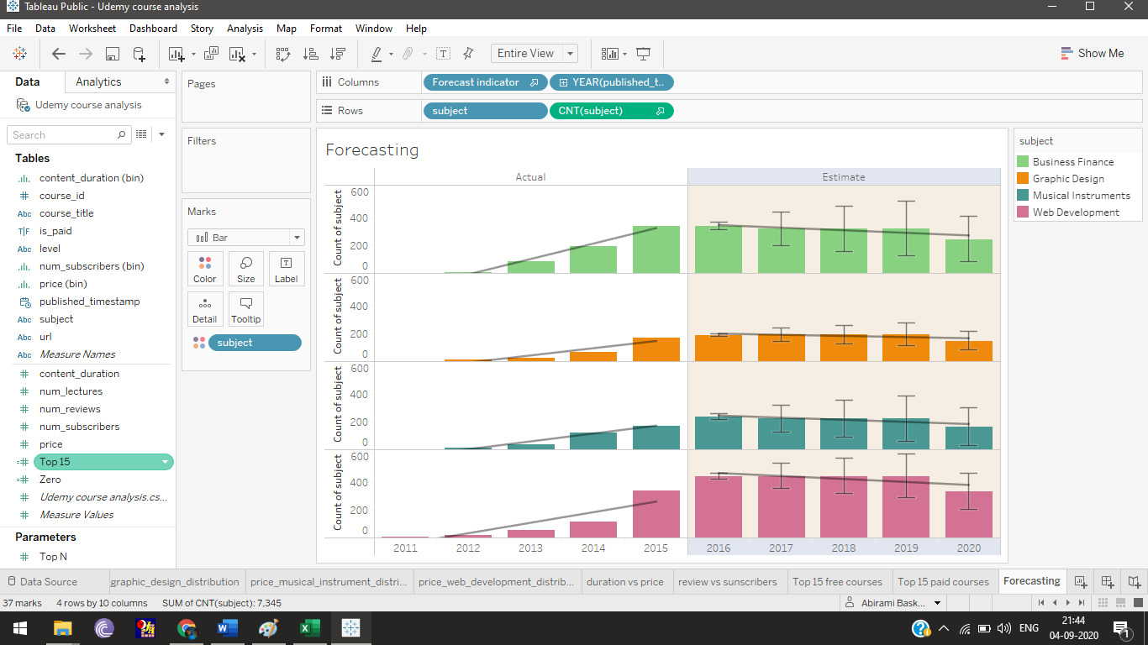

* Year 2011 to 2015 shows the actual data (training data).
* Year 2016 and 2017 are given as test data.
* We clearly see the continuous increasing trend on 4 subjects from 2012 to 2016.
* Web Development had higher level of increase followed by Business Finance, Musical Instrument, and Graphic Design.
* From the year 2017 all the 4 courses on Udemy shows the decreasing trend . This may be the competitive online learning platform numbers are getting increasing year by year. This forecasting shows Udemy course distribution only.

**Summary**

* Udemy courses are mostly expensive in the range of $60 to $160. They offer limited number of free courses only.
* More courses offered in Web Development and Business finance.
* Content duration varies considerably more on paid courses.
* They offer more courses for all level and limited for expert level. Basically, they aimed to cover all level of learners.
* Learners chose courses based on Web Development to learn due to its increasing demands in future.
* Udemy has more over **5M subscribers** and over **9K reviews** in **Web Development** subject, followed by Business Finance. Based on number of subscribers it is clear, learners interested to learn Web Development and Business Finance courses.
* Offer interesting courses in Web Development and Business Finance in an affordable rate will give more subscribers to the Udemy.