**Assignment 9**

**Total Points: 40**

**Description:**

Use assignment 8 as the starting point. In this assignment you will make the following additions:

1. Modify the **login.php** script, to check the account status in the table **users** of the individual logging in. The account status can be either OPEN or LOCKED. By default, when accounts are created with **register.php**, the account is given an OPEN status. If the account is LOCKED, display the appropriate message that indicates to the user their account is locked.
2. When the user logs in, check the admin status flag in the table **users.** If the admin flag is set to N then the user should have the same access as always. However, if the admin flag is set to Y, then the user will see an extra navigation link called ADMIN (See Screenshot). You will probably have to modify your header file to adjust the menu according to whether the individual is logged in and is an admin. Also remember to **prevent** users from getting access to the admin flag by simply typing the URL in. Please code as you have done in previous assignments to prevent this.
3. Create a new php page called **admin.php**. This page will be the page the admin goes too when clicking on the navigation link ADMIN. The page should contain a drop down select list of all the current users (Create a query to pull all users from the **users** table). Once a user is selected, a list of radio options should appear (See Screenshots). Remember to display appropriate messages when making the changes listed below. The radio button options are:

* OPEN – if the account status is currently open, this radio button should already be checked. If the user selects this option, perform an update statement on the table **users** that sets the account status to OPEN.
* LOCKED - if the account status is currently locked, this radio button should already be checked. If the user selects this option, perform an update statement on the table **users** that sets the account status to LOCKED. This will prevent users from logging in.
* Grant/Revoke Administrator Role – This option will make the user in question an admin or it will take away the admin role. If the user is not an admin, the radio button should say Grant Administrator Role, otherwise, it should say Revoke Administrator Role. Based on the text, you will set the admin flag to Y or N in the database. Also if your granting the admin role to someone, unlocked the account as well. Again, this can be done in the same SQL update statement.
* Delect this account – This statement here will do two things. First it will perform a delete statement on the table **users.** The username selected in the drop down list will be deleted from the table. This removes the account completely. The second task that needs to be performed is to delete the user’s folder from the folder users. Remember we create a subdirectory for every new user created. In order to delete the subdirectory and all files inside the user’s directory, you must first remove all the files using the php function unlink($filename). You would loop through the files and do this. After all files are gone, you can then remove the subdirectory using the php function rmdir($subdir).

**Screenshots are below**

**This is the navigation menu if the user is an admin. If not, the admin link should not be visible or accessible.**

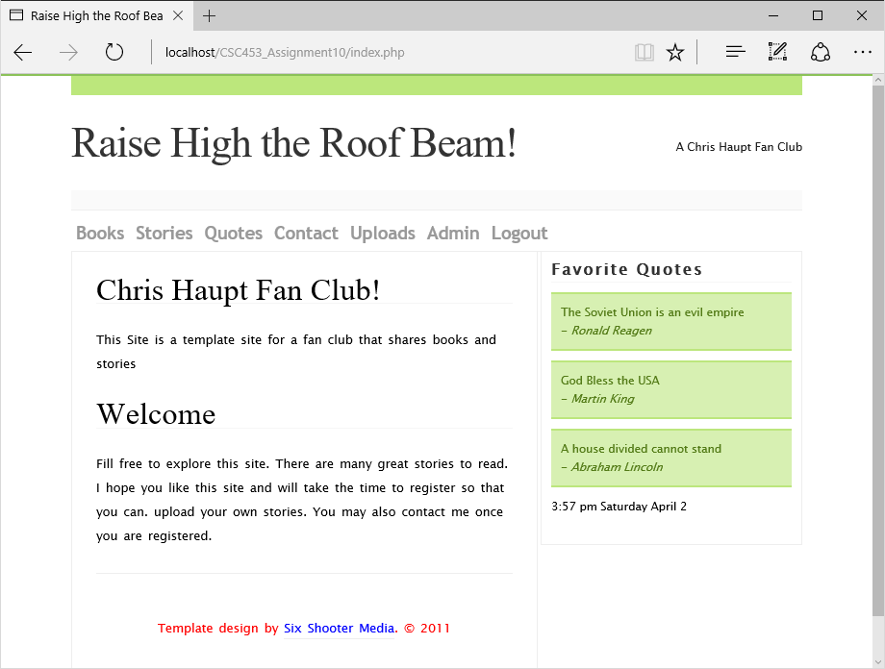

**admin.php, note the drop down menu pulls all users from the users table.**

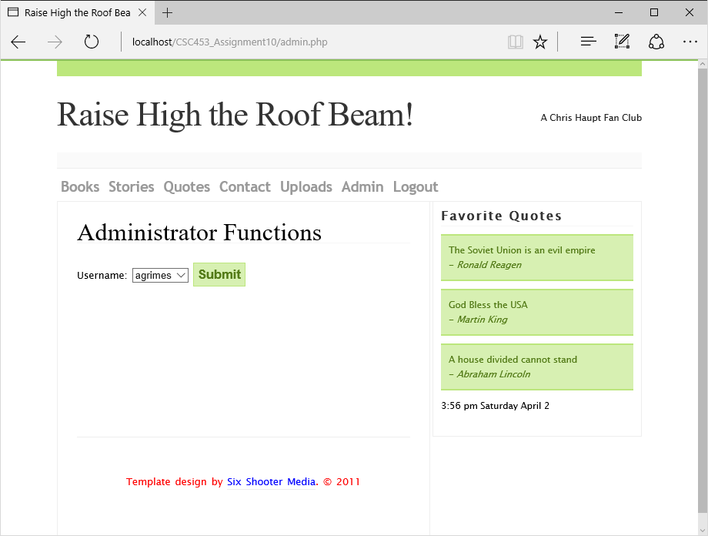

**The account options are now present. Please display appropriate messages when making changes. Notice the option Open is selected. This is because the account agrimes is opened. If I lock the account and come back to this screen Locked should be selected. Notice also that the option Grant Administrator Role is present. If agrimes was already an administrator, it should say Revoke Administrator Role.**

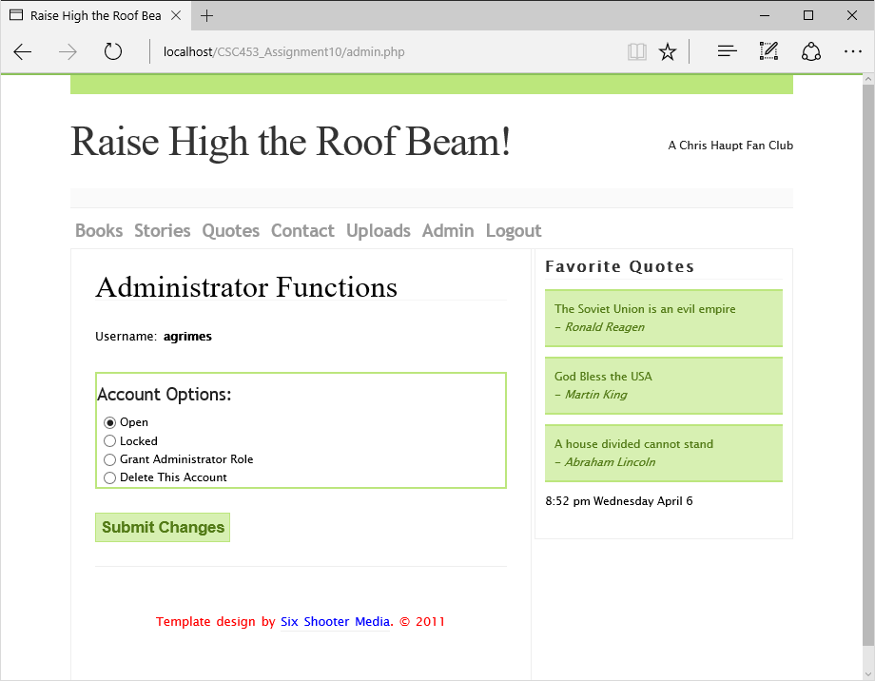

**Example Below: I just locked an account. Please note the drop down list doesn’t update until we refresh the page. Once the changes were submitted, I simply redirected to another page called status.php that displays the message you see below. Creating a status page is optional but probably easiest. Based on the option I choose, an appropriate message is displayed. Please note in order for the status page to pick up your changes, you will need to either use POST/GET to send a variable with the message or you can use a session variable. In my example I used a session variable. I also added a redirect back to the admin page which takes effect after 4 seconds. The syntax for this is header('refresh: 4, admin.php');**

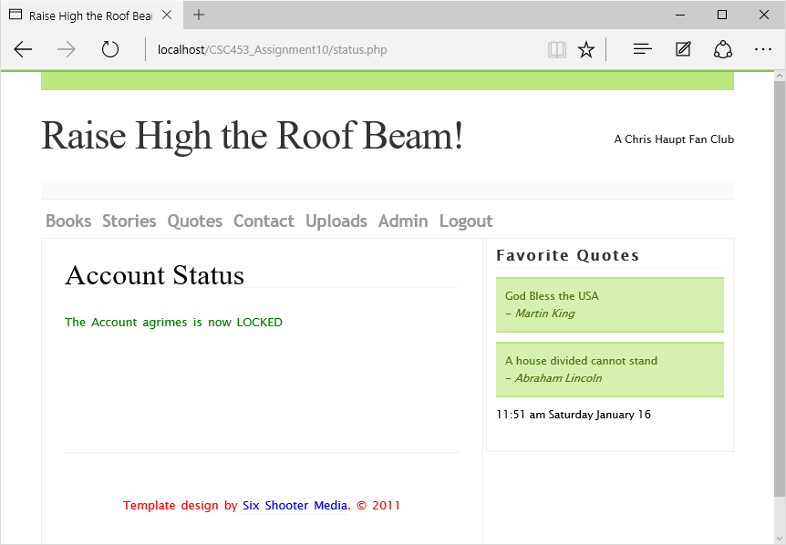

**Submission:**

Use Blackboard to upload your file to me. Please do not email me your assignment if your assignment contains multiple files please pack them in a zip file and name the zipped file your **netid + Assignment9**. For Example my netid is chaup2 so **chaup2Assignment9** would be my filename. On the Assignment link you should see a file upload box.