# Kubernetes Observability Platform
This project demonstrates a production-grade Kubernetes monitoring and alerting system using Grafana and Prometheus on AWS EKS.
---
## 🔧 Tech Stack

- AWS EKS (Kubernetes)
- Prometheus (Monitoring)
- Grafana (Visualization)
- Alertmanager (Alert Routing)
- Kubernetes (Workloads & Metrics)
---

## 📊 Grafana Dashboards

This project includes 4 professional dashboards designed for real-world monitoring:

### 1. System Overview
- Cluster CPU & Memory usage
- Running Pods & Node count
- Resource utilization trends

### 2. Application Performance
- Traffic (Request rate)
- Error trends
- Latency (simulated for demo)
- Pod-level performance

### 3. Infrastructure Metrics
- Node CPU & Memory usage
- Network traffic (Ingress/Egress)
- Node-level performance comparison

### 4. Alerts & Health
- Active / Pending / Resolved alerts
- Alert trends over time
- Alert details table

---

## 📸 Dashboard Screenshots

### System Overview
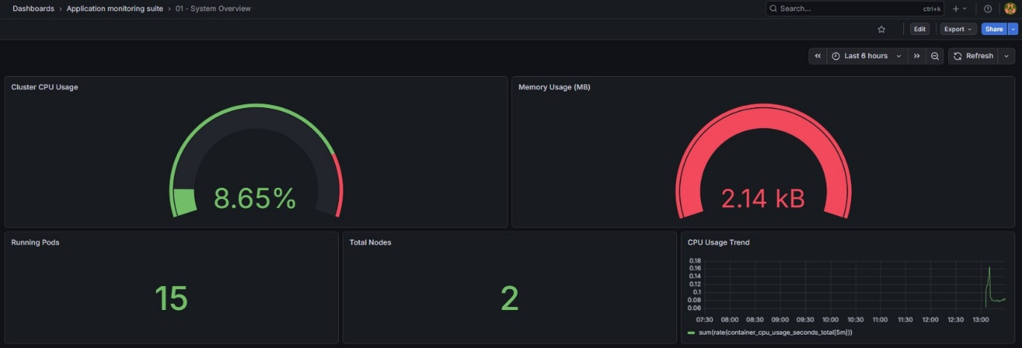

### Application Performance
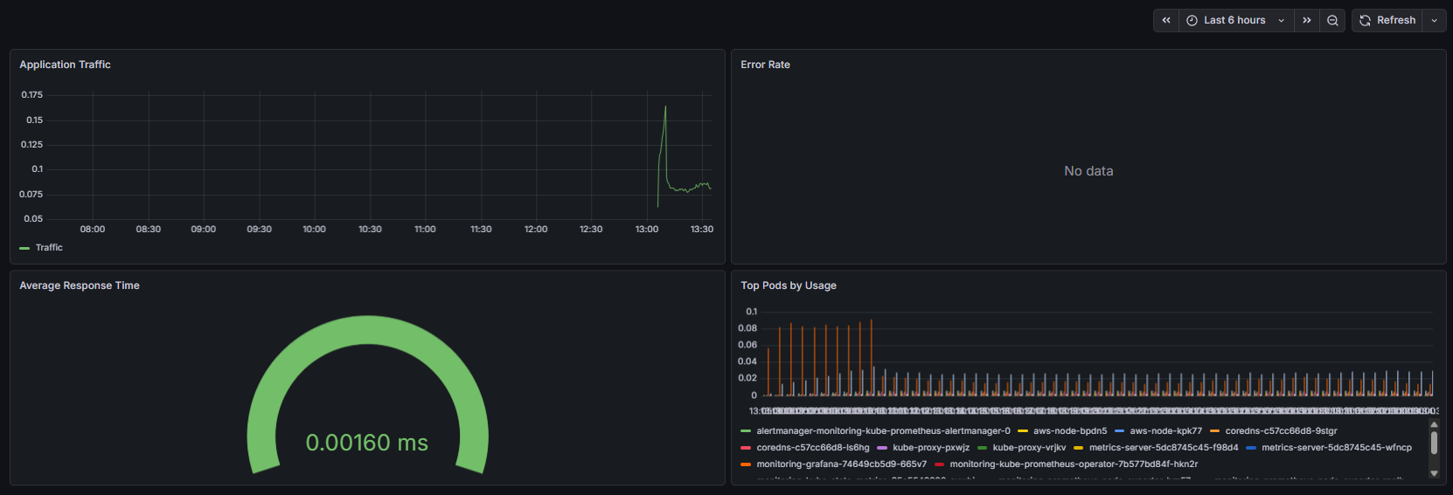

### Infrastructure Metrics
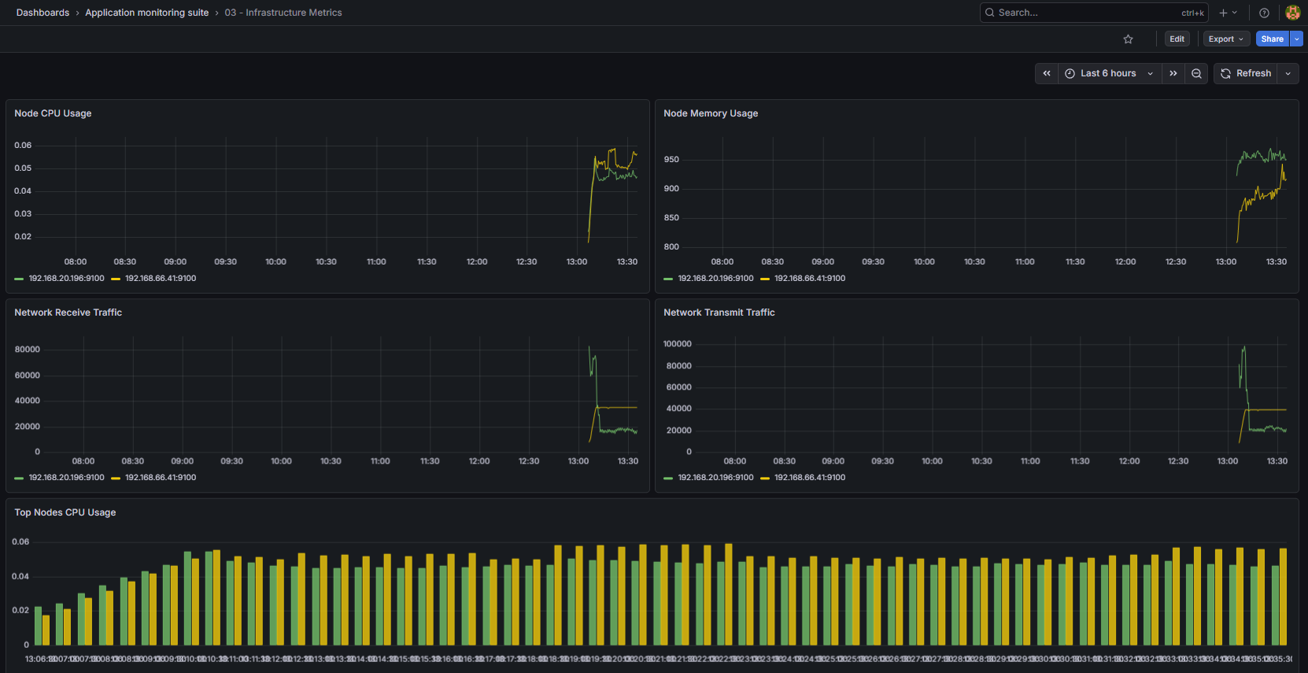

### Alerts & Health
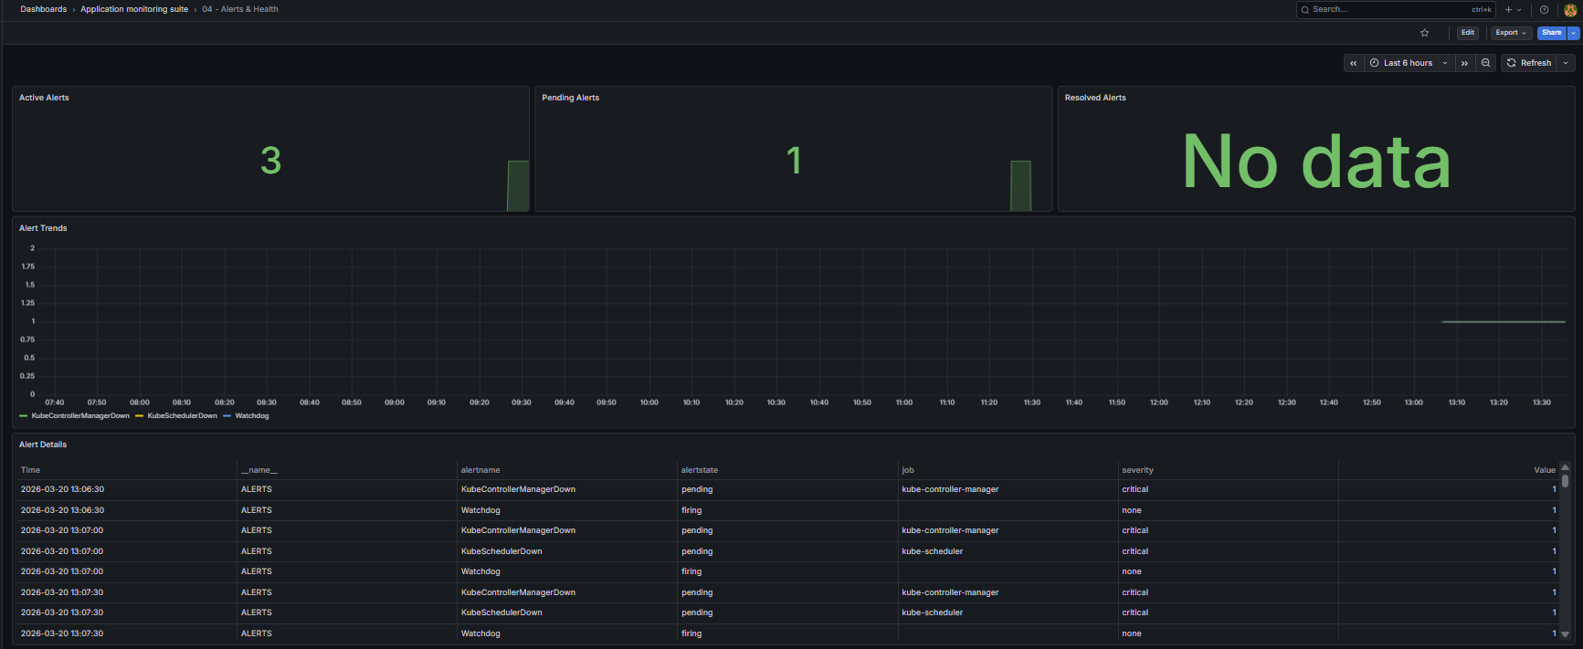

---

## 🚨 Alerting

- High CPU usage alert implemented using PrometheusRule
- Alertmanager webhook integration configured
- Real-time alert triggering tested
- Alerts successfully delivered to webhook service

---

## 📦 Deliverables

- Grafana Dashboard JSON files (import-ready)
- Prometheus alert rules
- Kubernetes manifests
- Alertmanager webhook configuration
- Complete monitoring setup

---

## 📁 Project Structure

alerts/
dashboards/
screenshots/
README.md

---

## 💼 Use Case

This project simulates a real-world DevOps monitoring setup suitable for:

- Production Kubernetes cluster observability
- Performance monitoring & optimization
- Incident detection & alerting
- Freelance and portfolio demonstration

---

## 🚀 How to Use

1. Deploy Kubernetes cluster (EKS)
2. Install Prometheus & Grafana
3. Import dashboard JSON files
4. Apply alert rules
5. Monitor cluster and visualize metrics

---

## 📌 Note

Some application-level metrics are simulated using system metrics for demonstration purposes.

---

## 👨‍💻 Author

DevOps Engineer | Kubernetes | Monitoring | Observability

