|  |  |
| --- | --- |
| C:\Users\abiat\OneDrive\Documents\My Code\quote-invoice\quote_invoice\assets\main_logo.png  user’s Guide  ***Quote & Invoice 0.1.0-Beta*** | Created by Festus Abiatar |

Table of Contents

[Introduction 2](#_Toc132059852)

[Installation 2](#_Toc132059853)

[Installation on Windows 2](#_Toc132059856)

[Interface/How-to 2](#_Toc132059857)

[User registration 2](#_Toc132059859)

[Settings 3](#_Toc132059860)

[General Settings 3](#_Toc132059862)

[Folder Settings 4](#_Toc132059863)

[Customers 4](#_Toc132059864)

[Add/Modify Customer 4](#_Toc132059866)

[Retrieve Customers 5](#_Toc132059867)

[Products 6](#_Toc132059868)

[Add/Modify Products & Service 6](#_Toc132059870)

[Retrieve Products & Services **Error! Bookmark not defined.**](#_Toc132059871)

[Quotations 6](#_Toc132059872)

[Add/Modify Quotations 6](#_Toc132059874)

[Retrieve Quotations 6](#_Toc132059875)

[Print Quotations 6](#_Toc132059876)

[Quotation Templates 6](#_Toc132059877)

[Orders 7](#_Toc132059878)

[Add/Modify Orders 7](#_Toc132059880)

[Retrieve Orders 7](#_Toc132059881)

[Print Invoices 7](#_Toc132059882)

[Invoice Templates 7](#_Toc132059883)

[Contributing 7](#_Toc132059884)

[Feedback 7](#_Toc132059886)

[Contributing to Code/Docs 7](#_Toc132059887)

# Introduction

A desktop application to keep track of your customers and generate quotes and invoices. This project was adapted from a Microsoft Access application I made for my colleague's business. As part of my Python learning journey, I decided to convert the Access application to a desktop application using Python and its Tkinter module. The application has a number of features, which include storing and retrieving customer information, products and services, quotations and orders, as well as generating quotes and invoices based on quotations and orders saved in the database.

# Installation



## Installation on Windows

This application has only been tested on a 64-bit Windows 10 machine so far. To install the application on your Windows computer, download the exe installer and follow on-screen instructions.

# Interface/How-to



## User registration and authentication

When launched, the application checks if there is an Admin user in the database. If it finds one, it displays a login dialog for the user to sign in (the **Register** button will be disabled as only one Admin user is currently allowed in the database, and non-Admin users (not yet implemented) can only be registered by the Admin).

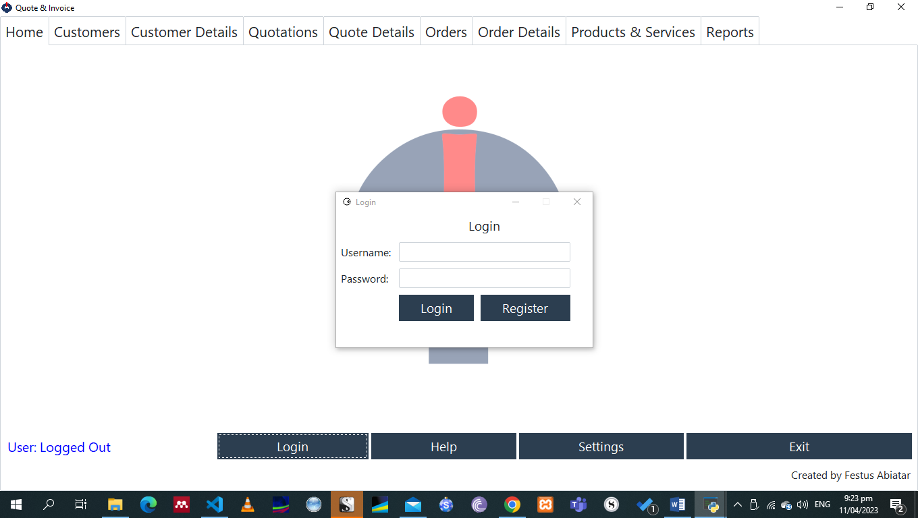

If no Admin user is found in the database, the application displays a login dialog with the **Register** button activate. Clicking this button will open the Admin registration window, where the user can complete the registration process.

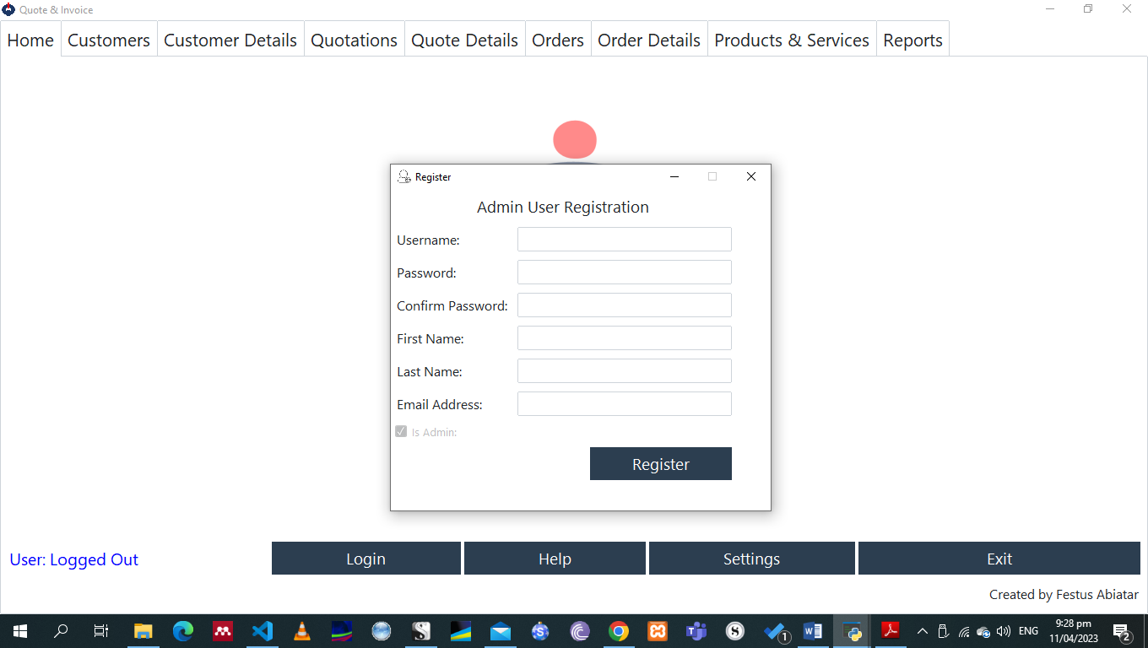

Once registered successfully, the user will be automatically logged in to access the rest of the application functionalities. On every launch of the application, the user will be prompted to login.

The username of the currently logged in user will be displayed at the bottom left corner of the Home tab, and the **Login** button will change to **Logout**.

# Settings

The application comes with some configurable settings. Where settings have not been configured by the user, the application uses default settings. This version provides two types of settings, namely, General Settings and Folder Settings. User Settings is not yet implemented



## General Settings

General Settings provides option to update the VAT rate and quotation validity period. If these options are not configured, the application will use default values of 15% and 30 days, respectively.

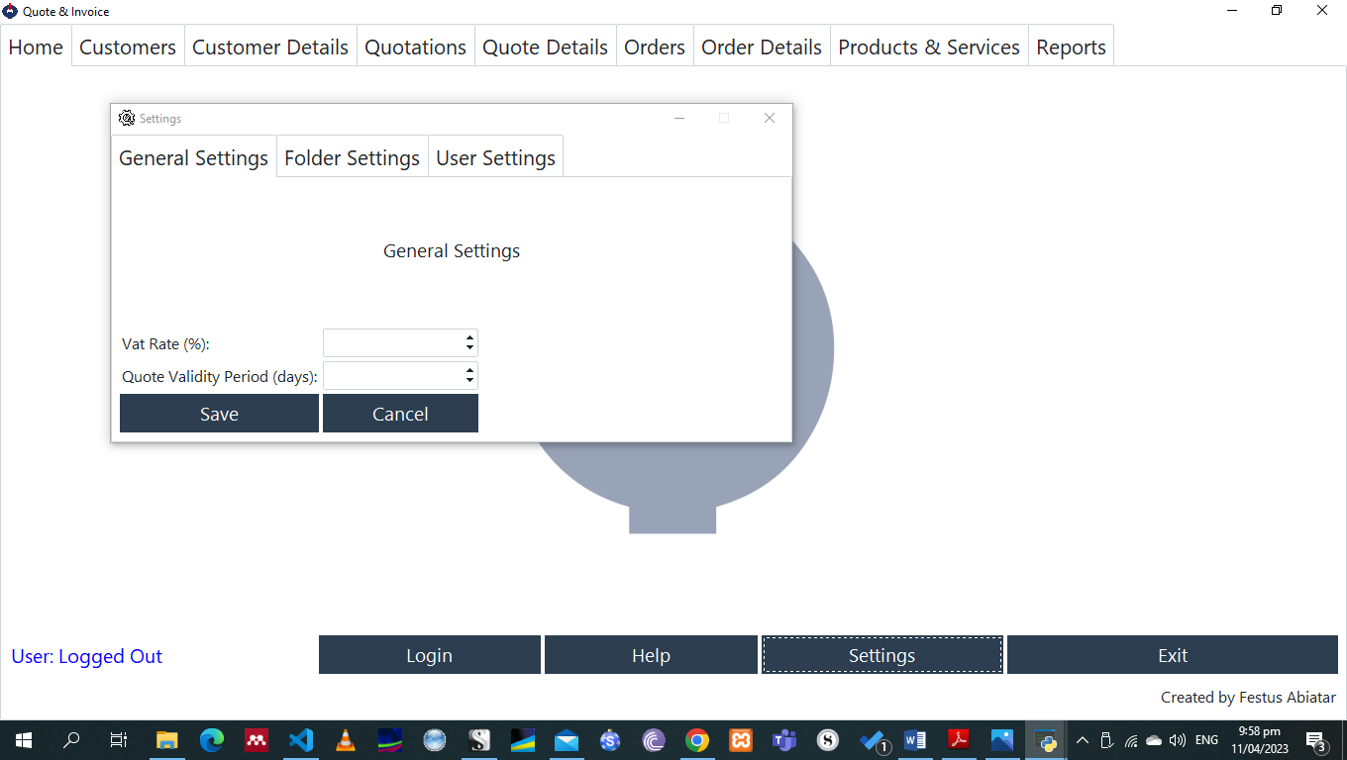

## Folder Settings

Folder Settings provide options to configure locations (folders/directories) where the application should look for quotation and invoice templates as well where it should output the generated quotations and invoices.

If these options are not configured by the user, the application will look for templates in the application’s working directory. The application will also use the same location as the destination for generated quotations/invoices.

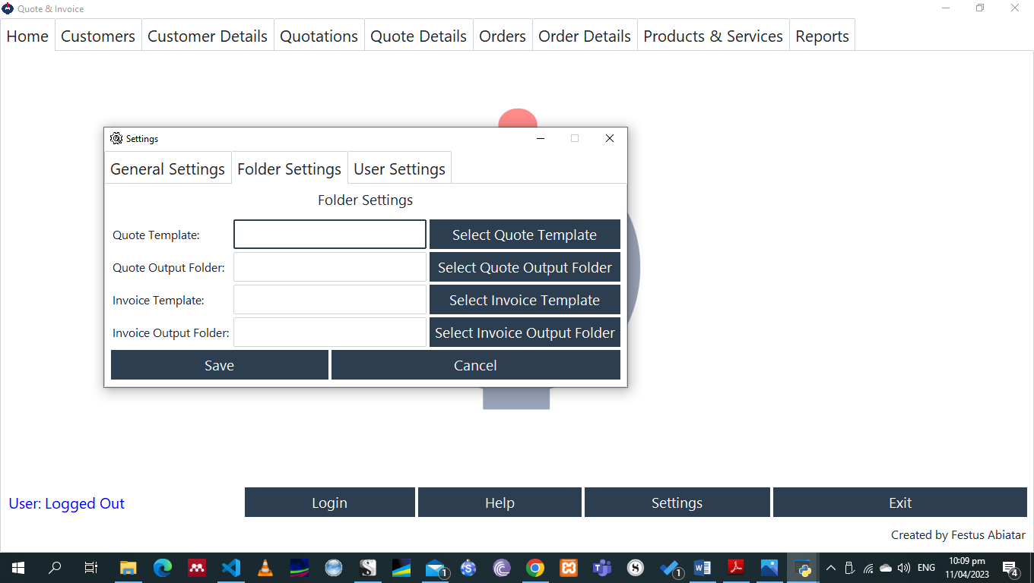

# Customers



## Add/update Customer

Quote & Invoice allows storing and updating of stored customer details. To add a new customer, go to **Customer Details** tab and complete the customer data entry form. To modify or view details of a customer stored in the database, search for the customer from the **Customers** tab, select the customer from the list and click **Open Selected Record**. The selected customer will be opened in the Customer Details tab with an option to update.

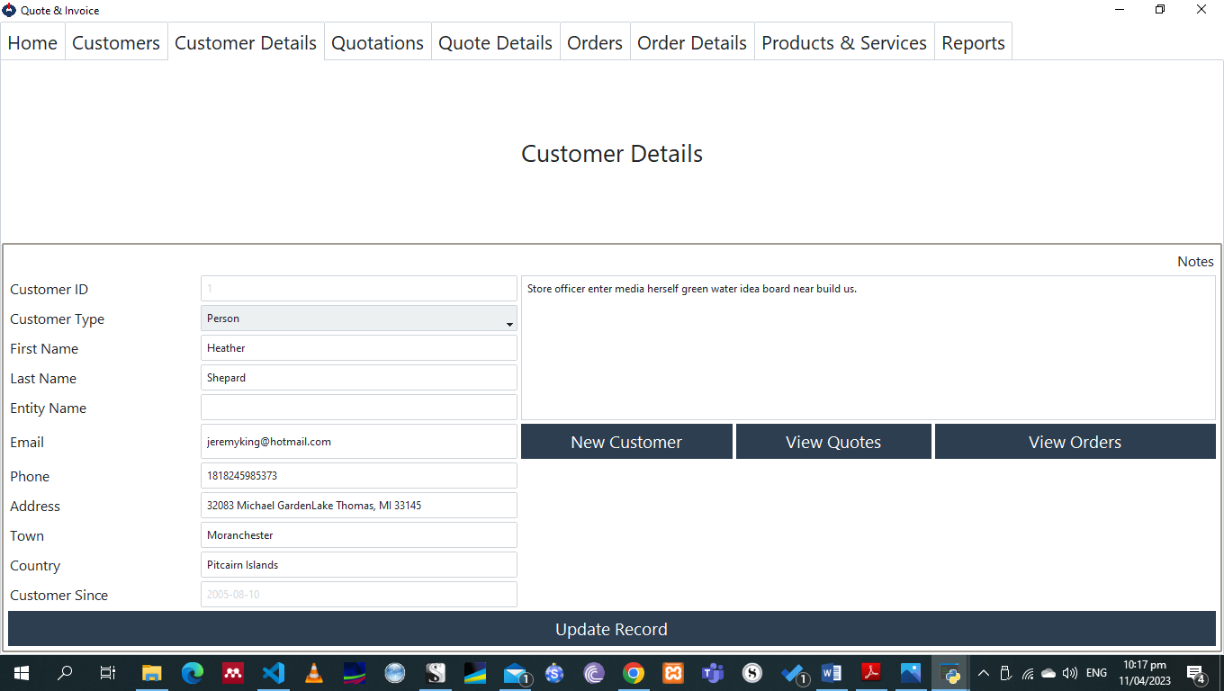

The Customer Details page also provides option to view orders and quotes of the currently active customer.

## Retrieve Customers

A list of all customers stored in the database can be viewed on the **Customers** tab. The page also provides an option to search for customers by **Customer ID** or by Other Variables, which will search for the provided search text within customer names, towns and emails.

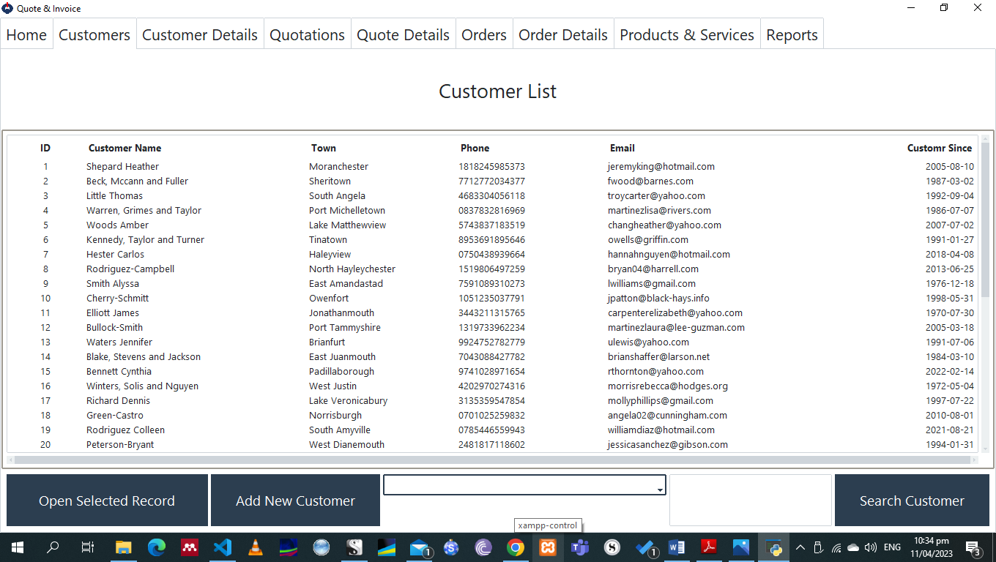

To reset the list, search with an empty search option and empty search text or an empty search text with the option Other Variables

# Products



## Add/Retrieve/Update Products & Service

Quote & Invoice allows storing and updating of stored products and services. To add a new product/service, go to **Products & Services** tab and complete the product/service data entry form.

The page displays a list of all products and services stored in the database. The page also provides an option to search for products/services by **Product ID, SKU, Barcode, or Product Name**.

To update the details of a product stored in the database, select the product from the list and its details will be auto populated into the product entry form below with an option to update.

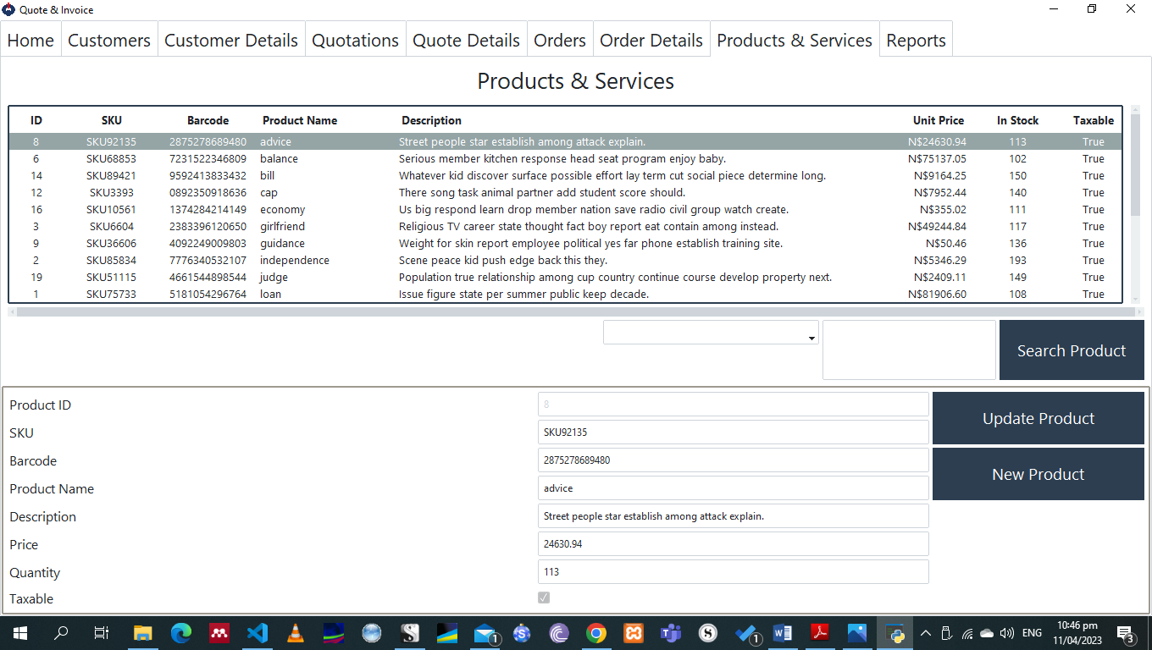

# Quotations



## Add/Modify Quotations

## Retrieve Quotations

## Print Quotations

## Quotation Templates

# Orders



## Add/Modify Orders

## Retrieve Orders

## Print Invoices

## Invoice Templates

# Contributing



## Feedback

## Contributing to Code/Docs

## I welcome any and all contributions! Here are some ways you can get started:

## Report bugs: If you encounter any bugs, please let me know. Open up an issue and let me know the problem.

## Contribute code: If you are a developer and want to contribute, follow the instructions below to get started!

## Suggestions: If you don't want to code but have some awesome ideas, open up an issue explaining some updates or imporvements you would like to see!

## Documentation: If you see the need for some additional documentation, feel free to add some!