AUTHOR BY ONABANJI ABIOLA

Master 1 CCN Project First Semester

Creating a website for ECOLE DU SACRE-COEUR D'ORGERES.

In this website, HTML, PHP, CSS, JavaScript and PDO was utilised in order to design both the front-end and back-end.

In the home page (Accueil) we have two menu bar - : at the top right and the other making a 360° round the moving picture. Also a daily time (with date and day) is found at the bottom left of the home page (fig1). Each menu as to be click on in order to access the sub-menu (fig2).

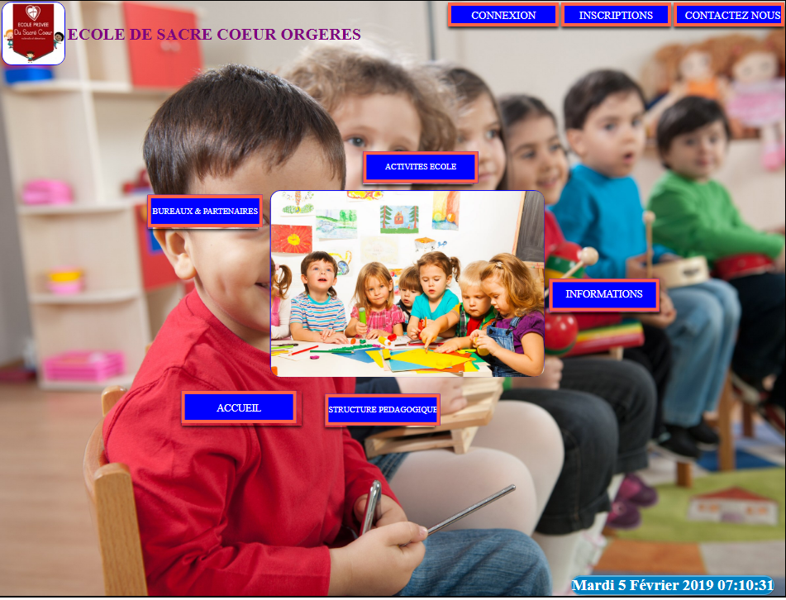

Figure 1: Home Page.

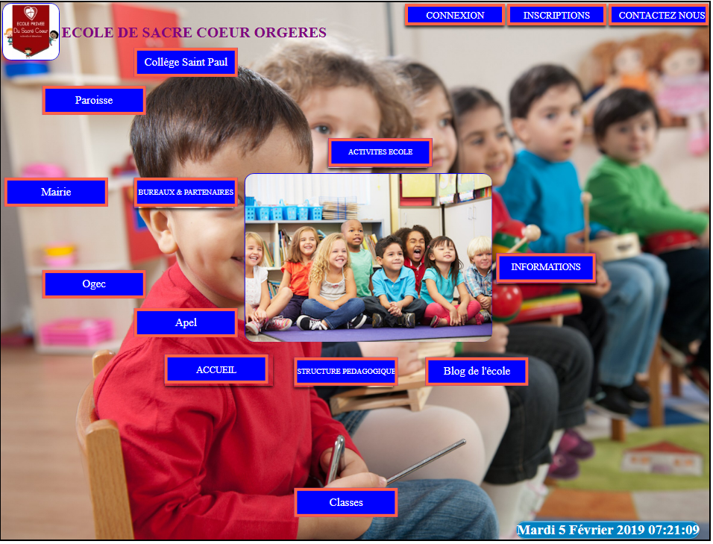

Figure 2: Home Page with Menu Open.

On visiting the site, one may need to contact the school for more information, this is done with the ‘contactez nous’ button seen at the top right of the home page(fig1 or fig2). On clicking, we get fig3, and on sending a massege to the school we get (fig4). Which is confirmed in the email box (fig5). In order to do this, i had to configure my local server (XAMPP).

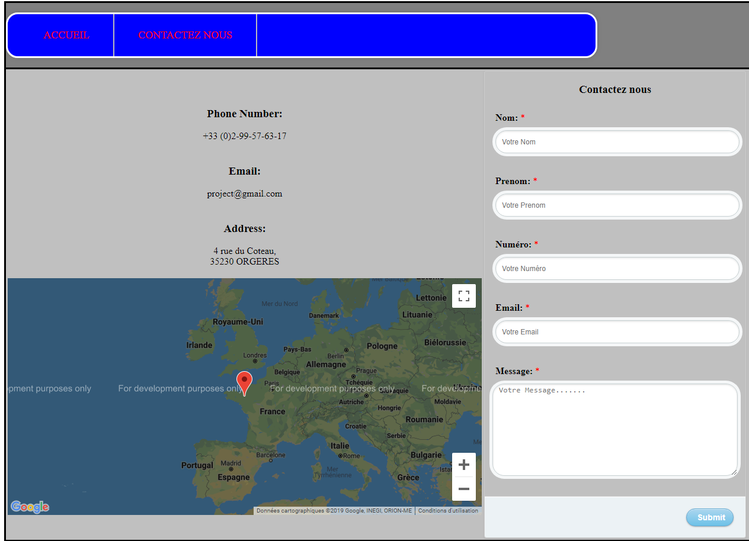

Figure 3: Contact Us Page with Google Map Location.

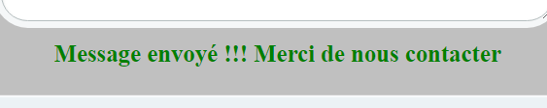

Figure 4: After Sending a Massage to the school.



Figure 5: Contect us email confirmation in email box.

On visiting the site, one wants to register his/her child, this is done with the ‘insciptions’ button also seen at the top right of the home page(fig1). On clicking, we get (fig6). Once you sign in, we obtain (fig7) the continuation of the registartion, and (fig8) which is the confirmation of the link in email box.

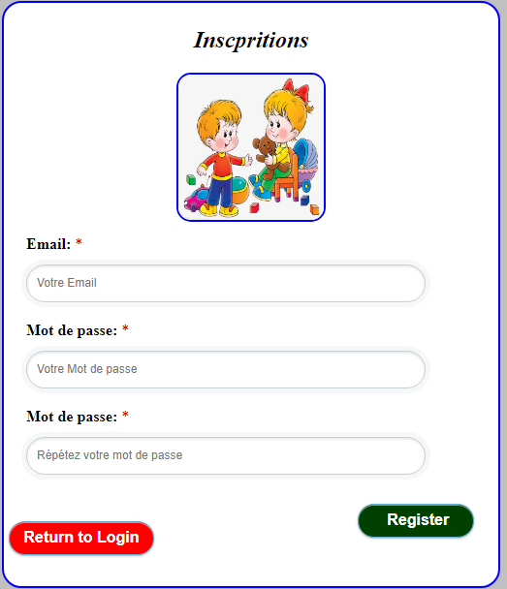

Figure 6: Inscription Page.

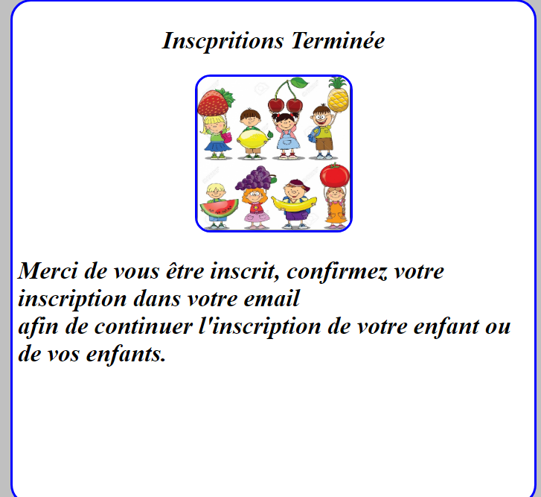

Figure 7: Redirction to Email.

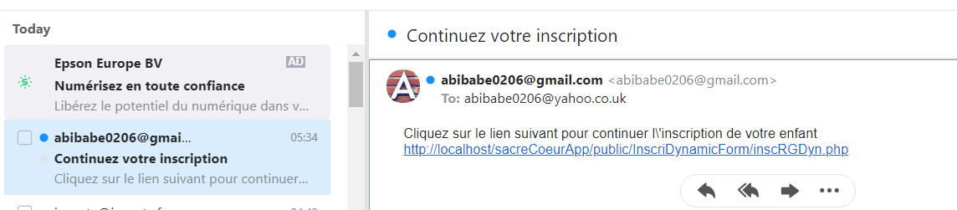

Figure 8: Link in Email box.

Onces the link is clicked on, it takes the user to a new page with a form ‘inscription form’ (fig9a). The form is a DYNAMIC FORM which enables the user to register one or more child at the same time (fig9b). Onces this form is filled and submitted, a congratulation page is shown (fig10a) and a comfirmation email is sent to the

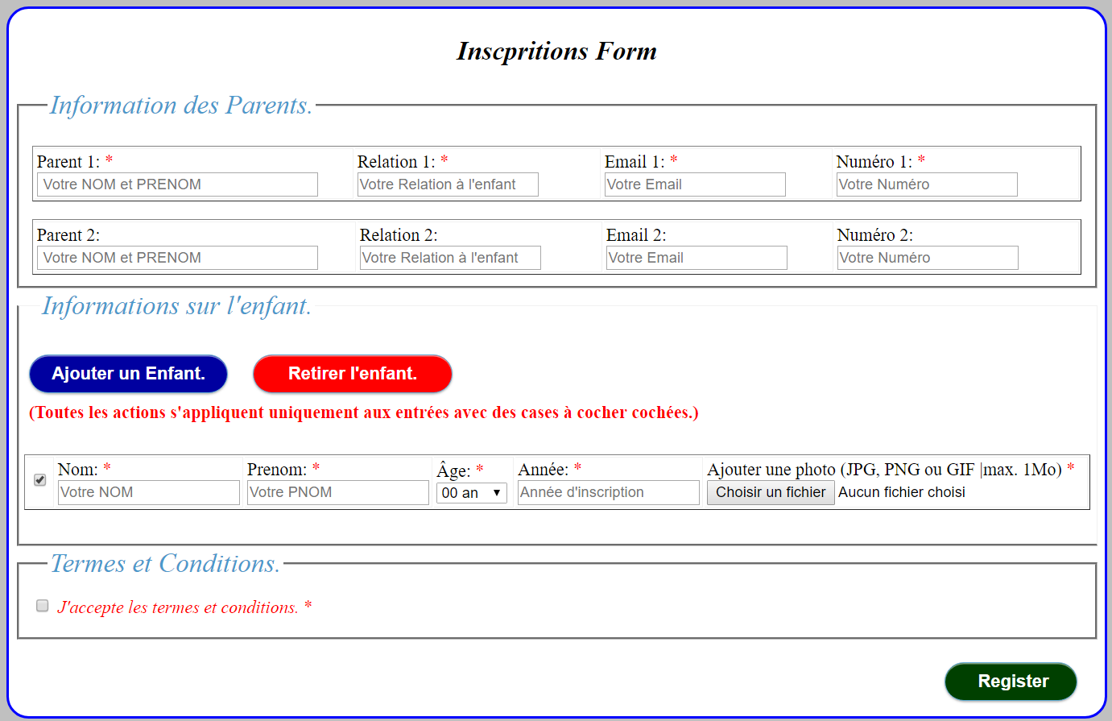

Figure 9a : Inscription Form.

User’s mail box (fig10b). With this, the user can now login (fig11). Onces logged in, the user can see his or her childrens information (fig12). Other images such as my database is shown in fig 13(a,b, and c).

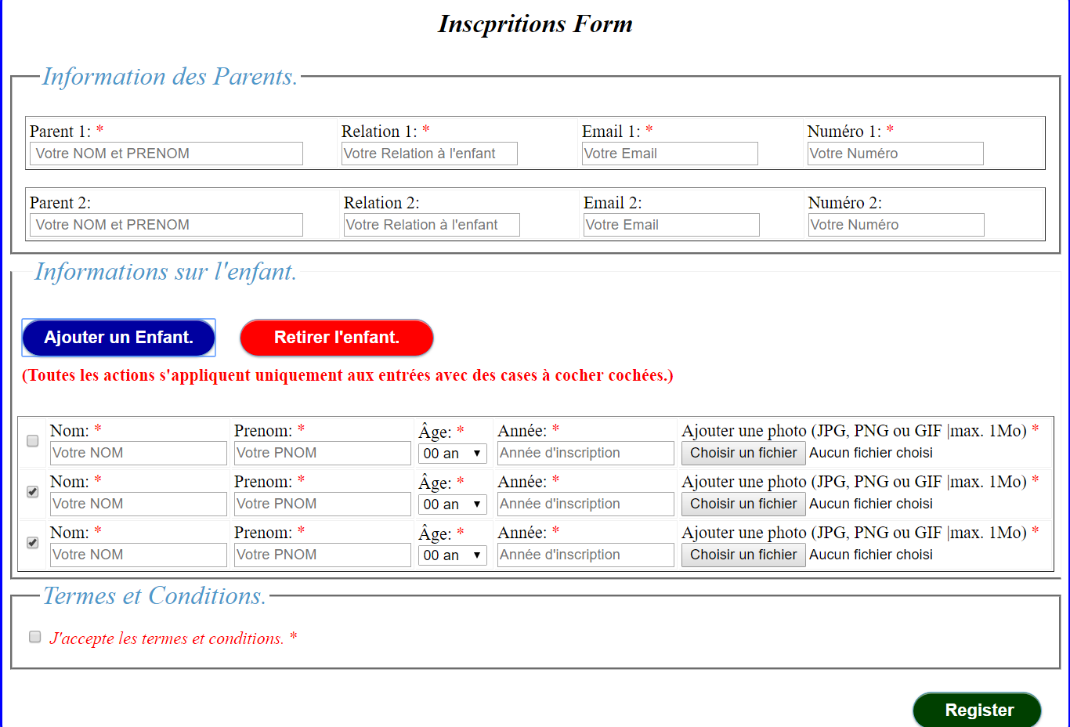

Figure 9b: Dynamic Inscription Form .

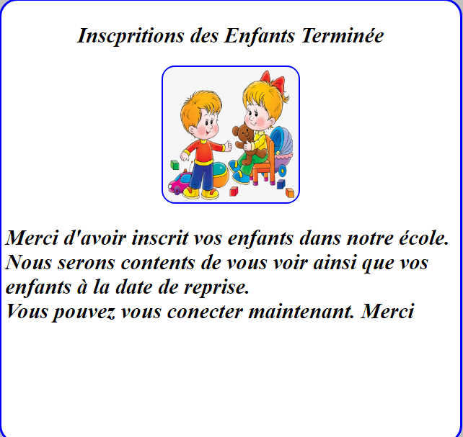

Figure 10a: Inscription Confirmation Page.

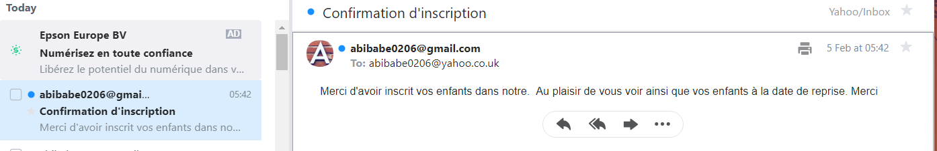

Figure 10b: inscription Confirmation Email.

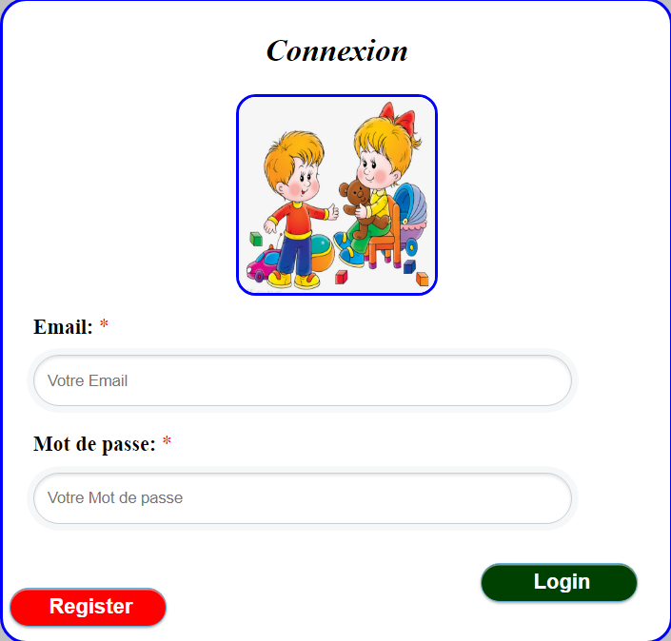

Figure 11: Login page.

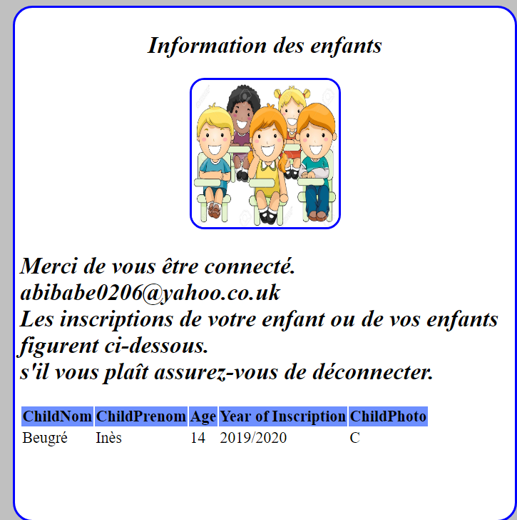

Figure 12: Children's Information after Login.

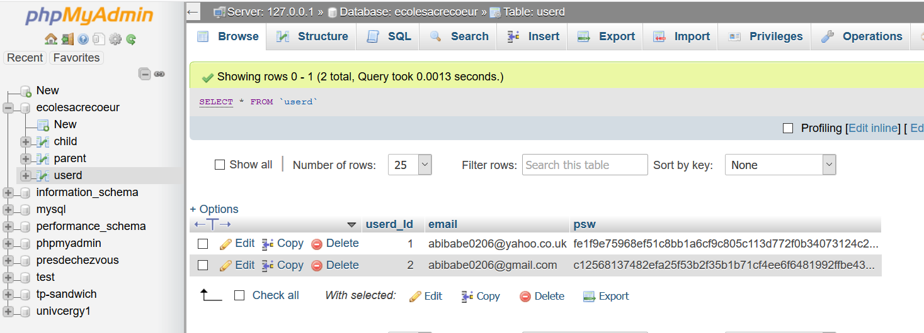

Figure 13a: Two Registered Users in Database.

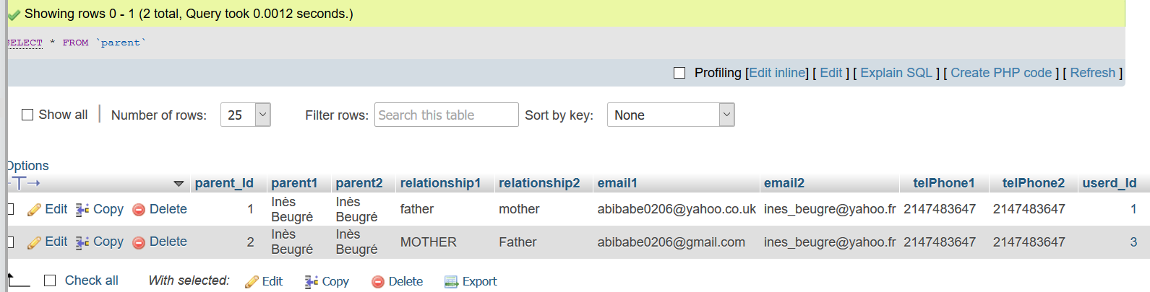

Figure 13b: Two New Registered Parents in Database.

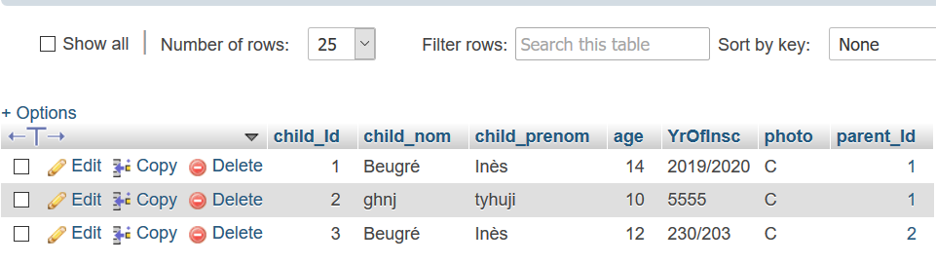

Figure 13c: Three Children Register but to Two different Parents (see parent_id).

To create table in the database, attached to this project a text is an XML file.