A Project Report On

AEGISTRADER: TRADING SIMULATION

AND BACKTESTING PLATFORM

Submitted to the

Department of Computer Applications

In partial fulfillment of the

MASTER OF COMPUTER APPLICATIONS

Under the guidance of
Mr. TIJI THOMAS

Project Done by

ABI BINU

Reg No:253242210169
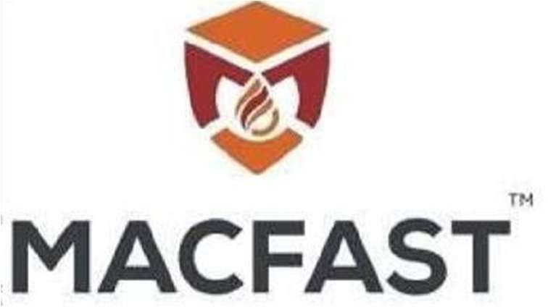

DEPARTMENT OF COMPUTER APPLICATIONS MAR ATHANASIOS COLLEGE FOR ADVANCED STUDIES
TIRUVALLA(MACFAST)

689101, KERALA www.macfast.org

2025-2027

MAR ATHANASIOS COLLEGE FOR ADVANCED STUDIES TIRUVALLA (MACFAST), THIRUVALLA


BONAFIDE CERTIFICATE
Certified that the Project Work entitled

AEGISTRADER: TRADING SIMULATION

AND BACKTESTING PLATFORM

is a Bonafide work done by

ABI BINU
In partial fulfillment of the requirement for the Award of

MASTER OF COMPUTER APPLICATIONS

Degree From
Mahatma Gandhi University, Kottayam 2025-2027

Mr. TIJI THOMAS Mr. TIJI THOMAS

HEAD OF THE DEPARTMENT PROJECT GUIDE

Submitted for the Viva-voce Examination held on ………………

External Examiners1: External Examiners2:

MAR ATHANASIOS COLLEGE FOR ADVANCED STUDIES TIRUVALLA (MACFAST), THIRUVALLA



CERTIFICATE

This is to certify that the project ‘AEGISTRADER: TRADING SIMULATION
AND BACKTESTING PLATFORM’ has been successfully carried out by ABI BINU (Reg No:253242210169) in partial fulfilment of the course Master of Computer Applications.

Mr. TIJI THOMAS Mr. TIJI THOMAS
INTERNAL GUIDE HEAD OF THE DEPARTMENT

Date-:

MAR ATHANASIOS COLLEGE FOR ADVANCED STUDIES TIRUVALLA (MACFAST), THIRUVALLA

CERTIFICATE

This is to certify that the project ‘AEGISTRADER: TRADING SIMULATION AND BACKTESTING PLATFORM’ has been successfully carried out by ABI BINU (Reg No:253242210169) in partial fulfilment of the course Master of Computer Applications under my guidance.

This is to certify that the project ‘AEGISTRADER: TRADING SIMULATION

AND BACKTESTING PLATFORM’ has been successfully carried out by ABI BINU

(Reg No:253242210169) in partial fulfilment of the course Master of Computer Applications

under my guidance.

DATE-:

Mr. TIJI THOMAS
INTERNAL GUIDE

MAR ATHANASIOS COLLEGE FOR ADVANCED STUDIES TIRUVALLA (MACFAST), THIRUVALLA


DECLARATION

I, ABI BINU, hereby declare that the project work entitled “AEGISTRADER: TRADING SIMULATION AND BACKTESTING PLATFORM” is an authenticated work carried out by me under the guidance of Mr. TIJI THOMAS for the partial fulfilment of the course MASTER OF COMPUTER APPLICATIONS. This work had not been submitted for a similar purpose anywhere else except to MAR ATHANASIOS COLLEGE FOR ADVANCED STUDIES TIRUVALLA (MACFAST), THIRUVALLA. I understand that detection of any such copying is liable to be punished in any way the college deems fit.

Date: ABI BINU
Place: Thiruvalla

ACKNOWLEDGEMENT
First and foremost let thank the God Almighty for his immense grace and blessing at each and every stage of Our project. I have taken efforts in this project. However, it would not have been possible without the kind support and help of many individuals and organizations. I would like to extend our sincere to all of them, I owe a debt of gratitude to Prof. Dr. Varghese K Cheriyan, Principal, MACFAST, for liberally extending the valuable facilities of the college for our project completion and for his constant support.
I am highly indebted Mr. Tiji Thomas, HOD, Department of Computer Applications, for his guidance and constant supervision as well as for providing necessary guidance regarding the project & also for his support in completing the project. I would like to express my gratitude towards my parents for their kind cooperation, encouragement, which helped me in completing of this project. The project would not have been completed without the support of my friends. I whole heartedly thank each and every one who supported me through this endeavor

ABI BINU

TABLE OF CONTENTS

SI NO | CONTENTS | PAGE NO
1 | CHAPTER 1 INTRODUCTION  - Introduction  - Problem statement  - Scope and Relevance 1.4Objectives | 2-5
2 | CHAPTER 2 SYSTEM ANALYSIS  - Introduction  - Existing System  - Proposed System  - Feasibility Study  - Software Engineering Paradigm | 6-10
3 | CHAPTER 3 SYSTEM DESIGN  - Introduction  - Database Design  - Entity Relationship  - Data Dictionary  - Data Flow Digram  - UML Digrams  - Modular Design  - Input Design  - Output Design | 11-30
4 | CHAPTER 4 SYSTEM ENVIRONMENT  - Introduction  - Software Reqiurement Specification  - Hardware Reqiurement Specification  - Tools and Platforms | 31-33
5 | CHAPTER 5 SYSTEM IMPLEMENTATION  - Introduction  - Coding  - Debugging  - Unit Testing | 34-37

TABLE OF CONTENTS

SI NO | CONTENTS | PAGE NO
6 | CHAPTER6 SYSTEM PLANNING AND SCHEDULING  - Introduction  - Planning Software Project  - GANNT Chart  - PERT Chart | 38-44
7 | CHAPTER 7 SYSTEM COST ESTIMATION  - Introduction  - Function point based estimation | 45-48
8 | CHAPTER 8 SYSTEM TESTING  - Introduction  - Testing Procedures | 49-52
9 | CHAPTER 9 SYSTEM MAINTENANCE  - Introduction  - Maintenance | 53-56
10 | CHAPTER10 SYSTEM SECURITY MEASURES  - Introduction  - Operating System Level Security  - Database Level Security  - System Level Security | 57-60
11 | CHAPTER 11 FUTURE ENHANCEMENT | 61-63
12 | CHAPTER 12 CONCLUSION | 64-66
13 | CHAPTER 13 ANNEXURE | 67-72

ABSTRACT

AegisTrader is a full-stack, enterprise-grade financial technology platform engineered to facilitate quantitative backtesting, live paper trading, and advanced performance analytics for modern structural trading frameworks such as Inner Circle Trader (ICT) and Smart Money Concepts (SMC). Traditional trading simulators often suffer from lookahead bias and fail to replicate adverse real-world slippage, making strategy validation unreliable. To address these critical flaws, AegisTrader provides quantitative traders with a deterministic, zero-risk sandbox environment to rigorously test execution mechanics and algorithms without capital exposure. At the core of the system is a deterministic historical replay engine that implements a strict anti-lookahead timestamp barrier, mathematically restricting data visibility to prevent future price action from influencing simulated outcomes.

The backend infrastructure, developed using ASP.NET Core 10 Web API, Entity Framework Core 10, and PostgreSQL 16, features a bespoke multi-timeframe aggregation engine. This service performs on-the-fly integer-division epoch grouping on over a million rows of 1-minute historical candlestick data, generating accurate higher-timeframe charts dynamically without redundant database storage. Furthermore, the core execution engine incorporates a proprietary defensive "Overlap Constraint" algorithm; in scenarios of extreme market volatility where a single candlestick breaches both Take Profit and Stop Loss boundaries simultaneously, the system enforces a pessimistic Stop Loss closure to accurately simulate real-world execution slippage.

For real-time market simulation, the platform features a live paper trading module powered by a custom Python bridge that polls a local MetaTrader 5 (MT5) terminal, seamlessly forwarding live Forex tick data to the web client at 500-millisecond intervals. The presentation layer is built utilizing a modern React 19 and Vite 8 architecture, incorporating TradingView Lightweight Charts v5 to deliver a professional financial canvas equipped with interactive order management, visual stop-loss lines, and dynamic floating unrealized profit and loss (P&L) tracking. Designed upon a clean, decoupled Controller-Service-Repository architectural pattern with secure JWT Bearer token state management and BCrypt password hashing, the completed Minimum Viable Product (MVP) successfully delivers an end-to-end simulation environment. Through precise historical data replay, continuous MT5 integration, and a dedicated analytics service calculating quantitative metrics such as Win Rate, Profit Factor, and Maximum Drawdown, AegisTrader effectively demonstrates rigorous enterprise-grade software engineering practices and advanced financial mathematics.

CHAPTER 1

INTRODUCTION

  - INTRODUCTION

The Master of Computer Applications (MCA) project, titled AegisTrader, represents the development of a full-stack, enterprise-grade trading simulation platform. Engineered specifically for quantitative backtesting, live paper trading, and advanced performance analytics, the system is fundamentally tailored to accommodate modern volume and structural trading frameworks, most notably Inner Circle Trader (ICT) and Smart Money Concepts (SMC). To achieve this, AegisTrader leverages a robust, decoupled Controller-Service-Repository architectural pattern. The backend API layer is constructed utilizing ASP.NET Core 10 Web API, which interfaces seamlessly with a PostgreSQL 16 database managed via Entity Framework Core 10. The presentation layer relies on React 19 and Vite 8, integrating TradingView Lightweight Charts v5 to deliver a professional visual canvas complete with candlesticks, volume histograms, and interactive order markers. Through the synergistic implementation of a deterministic historical replay engine and a real-time paper trading sandbox powered by a MetaTrader 5 (MT5) live price bridge, AegisTrader provides a rigorous, zero-risk environment for financial strategy validation.

  - PROBLEM STATEMENT

In the domain of financial technology and algorithmic backtesting, standard retail simulators frequently suffer from architectural deficiencies that compromise the integrity of quantitative strategy validation. A primary vulnerability is lookahead bias, where future price data inadvertently influences historical testing outcomes. AegisTrader resolves this by engineering a deterministic historical replay engine equipped with strict anti-lookahead timestamp protection, ensuring data visibility is mathematically restricted by the replay clock. Furthermore, conventional platforms often miscalculate trade outcomes during periods of extreme market volatility. When a single candlestick's range simultaneously breaches both Take Profit (TP) and Stop Loss (SL) boundaries, basic simulators may erroneously award a profitable win. AegisTrader mitigates this critical flaw by implementing a pessimistic Overlap Constraint resolution, which forces a defensive SL execution under such conditions to accurately mirror adverse real-world slippage. Finally, to accurately test structural frameworks, platforms require high-precision mathematics; AegisTrader addresses this by utilizing 5-decimal Forex pip calculations and dynamic unrealized floating P&L tracking rather than generic, lower-resolution percentage-based models.

  - SCOPE AND RELEVANCE

The scope of the AegisTrader platform is highly focused on delivering a secure, deterministic, and analytically rigorous simulation environment. The functional boundaries encompass secure user state management utilizing BCrypt password hashing and JWT Bearer tokens. The core simulation scope includes a replay clock featuring adjustable step-forward intervals ranging from one minute to four hours, supported by a multi-timeframe aggregation engine that performs server-side integer-division epoch grouping on 1-minute historical data. The live testing scope is defined by a Python bridge that polls a local MT5 terminal (specifically utilizing a Vantage Markets demo) to forward continuous tick data at 500-millisecond intervals. Furthermore, the analytical scope provides real-time computation of vital performance metrics, including Win Rate %, Profit Factor, Max Drawdown %, Net P&L, and Total Trades. As defined by the current system boundaries, live broker integration with real capital routing and automated AI signal generation remain explicitly out of scope. The relevance of this project lies in its rigorous demonstration of enterprise software development patterns, secure API routing, and complex mathematical modeling within a practical FinTech context.

  - OBJECTIVES

The primary engineering and academic objectives of the AegisTrader project are defined as follows:
- Implement a Deterministic Backtesting Sandbox: To develop a historical replay engine that strictly enforces an absolute timestamp barrier ($Timestamp≤CurrentReplayTimestamp$) to guarantee zero-lookahead bias during strategy evaluation.
- Engineer Server-Side Data Aggregation: To construct a dynamic multi-timeframe aggregation algorithm utilizing integer division on Unix Epoch timestamps, thereby generating higher-timeframe charts directly from over a million rows of 1-minute historical Dukascopy Forex data without requiring redundant database storage.
- Simulate Realistic Market Execution: To integrate a defensive Overlap Constraint resolution algorithm that pessimistically defaults to a Stop Loss closure when market volatility causes a single candle to intersect both the TP and SL levels simultaneously.
- Establish a Real-Time Live Price Bridge: To build a real-time paper trading module powered by a Python bridge utilizing the MetaTrader5 SDK to poll local terminal data and forward tick updates to the web client at 500-millisecond intervals.
- Generate Professional Quantitative Analytics: To deploy a dedicated analytical dashboard service that processes closed trade histories to dynamically calculate and visualize key performance indicators, including Win Rate, Profit Factor, and Maximum Drawdown.

CHAPTER 2

SYSTEM ANALYSIS

2.1 INTRODUCTION

The system analysis phase establishes the foundational requirements and evaluates the technological environment necessary for AegisTrader. It involves a rigorous examination of the limitations within current trading simulators and outlines the architectural imperatives for a deterministic, zero-risk sandbox. Because the platform is specifically engineered to accommodate quantitative backtesting and real-time paper trading for modern structural trading frameworks—such as Inner Circle Trader (ICT) and Smart Money Concepts (SMC)—a deep analysis of data flow, execution mechanics, and real-time processing constraints is strictly required.

2.2 EXISTING SYSTEM

Existing retail trading simulators and backtesting platforms present significant architectural and functional limitations that compromise strategy validation.
- Lookahead Bias: Many legacy platforms lack an absolute, mathematically enforced timestamp barrier, inadvertently exposing future price action during historical backtesting sessions and skewing strategy results.
- Flawed Execution Modeling: Conventional execution engines inadequately model market volatility. When a single candlestick's range breaches both Take Profit (TP) and Stop Loss (SL) boundaries simultaneously, existing systems often erroneously register a profitable trade rather than simulating realistic adverse slippage.
- Imprecise Financial Mathematics: Existing systems typically rely on generalized, percentage-based profit models rather than precise 5-decimal fractional Forex pip calculations, which are critical for accurate ICT/SMC structural analysis.
- Database Bloat: Generating multiple timeframes (e.g., 5m, 15m, 1H) in legacy systems often requires maintaining duplicate database tables for each interval, leading to severe storage bloat and slow retrieval times.

2.3 PROPOSED SYSTEM

AegisTrader is proposed as a full-stack, enterprise-grade solution that systematically eliminates the flaws of existing trading platforms.
- Deterministic Replay Engine: The proposed system implements a historical replay clock secured by a strict anti-lookahead timestamp barrier ($Timestamp≤CurrentReplayTimestamp$), mathematically restricting data visibility to prevent future price action from influencing simulated outcomes.
- Dynamic Server-Side Aggregation: To optimize storage and performance, the system features a bespoke multi-timeframe aggregation engine. This service performs on-the-fly integer-division epoch grouping on 1-minute historical data, dynamically generating higher timeframes without requiring redundant, pre-calculated database tables.
- Defensive Overlap Constraint: The execution model introduces a pessimistic Overlap Constraint algorithm; if a single candle violates both SL and TP boundaries simultaneously, the engine defensively forces a Stop Loss closure to accurately simulate real-world execution slippage.
- Real-Time MT5 Bridge: For live simulation, the system proposes a paper trading sandbox driven by a Python bridge that polls a local MetaTrader 5 (MT5) terminal (Vantage Markets demo), forwarding live tick data to the web client at 500-millisecond intervals via Inter-Process Communication.
- Embedded Analytics: A quantitative analytics engine calculates professional-grade metrics over closed trade histories, including Win Rate %, Profit Factor, and Maximum Drawdown %.

2.4 FEASIBILITY STUDY

The feasibility of AegisTrader is evaluated across technical, economic, and operational dimensions to ensure the viability of the MVP.

2.4.1 TECHNICAL FEASIBILITY

The project is technically highly feasible through the implementation of a modern, decoupled Controller-Service-Repository architecture. The backend relies on ASP.NET Core 10 Web API and PostgreSQL 16, utilizing Entity Framework Core 10 for ORM data access with code-first migrations. Sub-millisecond data retrieval over millions of rows is achieved via a targeted composite database index on the Symbol and Timestamp fields within the Candlesticks table. Furthermore, the live data pipeline utilizing the Python MetaTrader5 SDK bridge to push continuous HTTP POST tick updates to the .NET API is a proven, robust method for real-time data ingestion.

2.4.2 ECONOMIC FEASIBILITY

The platform is exceptionally economically feasible as it operates exclusively on open-source, zero-cost dependencies. The frontend ecosystem utilizes React 19, Vite 8, Tailwind CSS v4, and TradingView Lightweight Charts v5, requiring no licensing fees for enterprise development. Additionally, historical backtesting data—consisting of over 1,000,000 rows of tick/candle data for EURUSD—is sourced from free Dukascopy 1-minute OHLCV CSV exports, entirely circumventing the need for expensive premium historical data subscriptions.

2.4.3 OPERATIONAL FEASIBILITY

The system is operationally viable and highly intuitive for the end-user. The presentation layer utilizes a modular component composition and single-page routing provided by React Router v7. The integration of a dark-mode financial layout and an interactive visual canvas ensures seamless multi-timeframe switching and frictionless order management, allowing traders to focus on strategy execution rather than software navigation.

  - SOFTWARE ENGINEERING PARADIGM

The development of AegisTrader adheres to an iterative, Agile software engineering paradigm combined with a clean layered architecture. By enforcing a strict decoupled client-server relationship utilizing RESTful JSON endpoints, the Presentation Layer (React/Vite) and the API Layer (ASP.NET Core) can be developed, tested, and iterated upon independently.

This paradigm supports the continuous integration and isolation of complex Business Logic Layer services—such as the AggregationService, ReplayService, and TradeService. By isolating these services from the Data Access Layer, defensive execution mechanics and multi-timeframe mathematical algorithms can be rigorously unit-tested and refined for edge cases before any frontend UI integration occurs. Security is maintained iteratively by embedding BCrypt password hashing and JWT Bearer tokens directly into the stateless HTTP request pipeline from the project's inception.

CHAPTER 3

SYSTEM DESIGN

3.1 INTRODUCTION

The system design phase translates the analytical requirements established in Chapter 2 into a detailed, technical blueprint that guides the implementation of AegisTrader. This chapter focuses heavily on the structural architecture of the data layer, prioritizing data integrity, relational constraints, and optimization for high-performance financial data retrieval. Given that AegisTrader relies on PostgreSQL and Entity Framework Core 10, the database design must accommodate precise 5-decimal fractional Forex pip calculations and sub-millisecond retrieval of historical candlestick data for the multi-timeframe aggregation engine. The design employs an Entity-Relationship (ER) model to map the logical structure and a Data Dictionary to define the physical database schema.

3.2 DATABASE DESIGN
The database architecture of AegisTrader is engineered using a relational model. It strictly adheres to ACID (Atomicity, Consistency, Isolation, Durability) properties to ensure transaction-safe historical storage and reliable trade execution logging.

3.2.1 ENTITY RELATIONSHIP
The Entity-Relationship (ER) diagram conceptually models the database structure, illustrating the primary entities within the AegisTrader platform and the logical relationships that bind them.

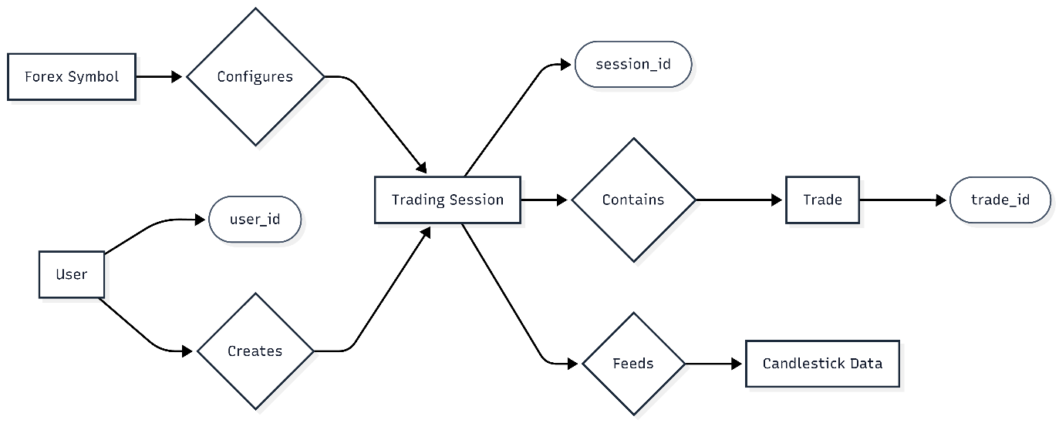
Based on the provided ER diagram and the system architecture, the core relationships are defined as follows:
- User to Trading Session (Creates): A User entity has a one-to-many (1:N) relationship with the Trading Session entity. A single user can create and manage multiple historical replay or live forward-testing sessions, but a session belongs strictly to one user_id.
- Forex Symbol to Trading Session (Configures): The Forex Symbol configures the baseline parameters of the Trading Session.
- Trading Session to Trade (Contains): A Trading Session maintains a one-to-many (1:N) relationship with the Trade entity. A session acts as a ledger that contains multiple individual trades, identified by trade_id.
- Trading Session to Candlestick Data (Feeds): The historical or live Candlestick Data acts as the data feed for the Trading Session, providing the chronological OHLCV (Open, High, Low, Close, Volume) data required for the session's execution engine.

3.2.2 DATA DICTIONARY
The Data Dictionary provides the physical schema implementation of the ER model. It defines the tables, column names, data types, and primary/foreign key constraints implemented via Entity Framework Core. All financial fields utilize a decimal(18,6) data type to guarantee absolute precision for Forex pip calculations.

TABLE 1: USERS
Stores secure user authentication credentials and profile state.
Field Name | Data Type | Key Type | Description
Id | UUID | Primary Key (PK) | Unique cryptographic identifier for the user.
Username | VARCHAR(50) | - | The user's display name.
Email | VARCHAR(100) | Unique | The user's email address (used for login).
PasswordHash | VARCHAR(255) | - | BCrypt hashed string of the user's password.
CreatedAt | TIMESTAMP | - | The UTC timestamp of account creation.

TABLE 2: TRADINGSESSIONS
Manages the state of both historical backtesting and live paper trading sandboxes.
Field Name | Data Type | Key Type | Description
Id | UUID | Primary Key (PK) | Unique identifier for the specific session.
UserId | UUID | Foreign Key (FK) | References Users.Id.
Symbol | VARCHAR(10) | - | The traded instrument (e.g., "EURUSD").
SessionType | VARCHAR(20) | - | Defines the mode: "Replay" or "Forward".
InitialBalance | DECIMAL(18,6) | - | The starting equity of the sandbox.
CurrentBalance | DECIMAL(18,6) | - | The dynamically updated current equity.
CurrentReplayTimestamp | TIMESTAMP | - | The strict anti-lookahead barrier pointer for the replay clock.
CreatedAt | TIMESTAMP | - | The UTC timestamp of session creation.

TABLE 3: TRADES
The financial ledger tracking all executed and closed positions within a session.
Field Name | Data Type | Key Type | Description
Id | UUID | Primary Key (PK) | Unique identifier for the trade execution.
SessionId | UUID | Foreign Key (FK) | References TradingSessions.Id.
Direction | VARCHAR(10) | - | Order type ("Buy" or "Sell").
Status | VARCHAR(20) | - | Current state ("Open" or "Closed").
EntryPrice | DECIMAL(18,6) | - | Execution price at market entry.
StopLoss | DECIMAL(18,6) | - | Defensive liquidation boundary.
TakeProfit | DECIMAL(18,6) | - | Target profit liquidation boundary.
LotSize | DECIMAL(18,6) | - | Volume of the trade (e.g., 1.00 standard lots).
ExitPrice | DECIMAL(18,6) | - | Execution price at market exit/liquidation.
PnL | DECIMAL(18,6) | - | The calculated Net Profit and Loss in USD.
OpenedAt | TIMESTAMP | - | Timestamp of trade initiation.
ClosedAt | TIMESTAMP | - | Timestamp of trade closure.

TABLE 4: CANDLESTICKS
Stores historical OHLCV data. This table utilizes a composite index on (Symbol, Timestamp) to ensure sub-millisecond data retrieval during multi-timeframe aggregation.
Field Name | Data Type | Key Type | Description
Id | BIGINT | Primary Key (PK) | Sequential identifier for the data row.
Symbol | VARCHAR(10) | - | The specific Forex pair (e.g., "EURUSD").
Timestamp | TIMESTAMP | Index | The UTC time of the candlestick close.
Open | DECIMAL(18,6) | - | Opening price.
High | DECIMAL(18,6) | - | Highest price achieved in the interval.
Low | DECIMAL(18,6) | - | Lowest price achieved in the interval.
Close | DECIMAL(18,6) | - | Closing price of the interval.
Volume | DECIMAL(18,6) | - | Traded volume during the interval.

3.3 PROCESS DESIGN-DATA FLOW DIAGRAM
A data flow diagram is a graphical technique that depicts information flow and transforms that are applied as data move from input to output. The DFD is used to represent increasing information flow and functional details. A level 0 DFD also called a fundamental system model represents the entire software elements as a single bible with input and output indicated by incoming and outgoing arrows respectively.
Data flow diagrams are the pictorial way of showing the flow of data into, around and out of the system. The users can understand them easily and there is no way to misinterpretation than textual description. With a dataflow diagram, users are able to visualize how the system will operate, what the system will accomplish and how the system will be implemented.
A data flow diagram illustrates the processes, data stores, and external entities in a business or other system and the connecting data flows. The four components of a data flow diagram (DFD) are:

• External Entities/Terminators/Sources/Sinks: Represented by a square
• Process: Represented by a circle
• Data Flows: Represented by an arrow.
• Data Source: Represented by two parallel lines, connected by a vertical line

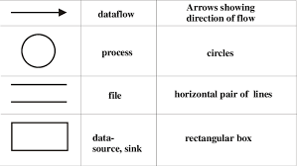

LEVEL 0 DFD

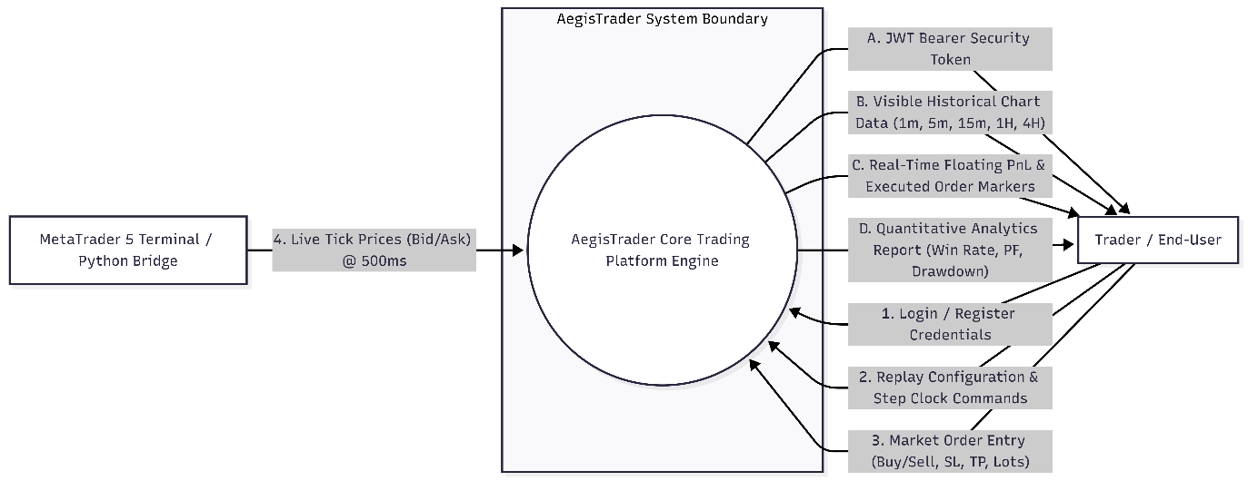

LEVEL 1 DFD

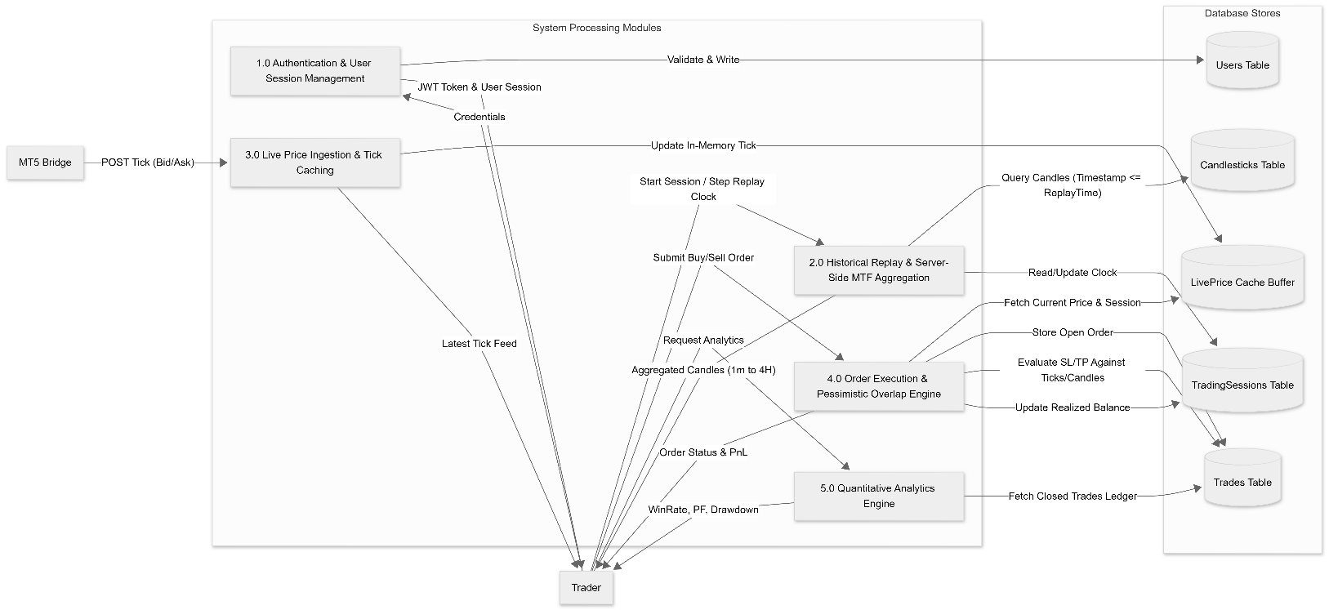

LEVEL 2 DFD (Replay Engine & MTF Aggregation)
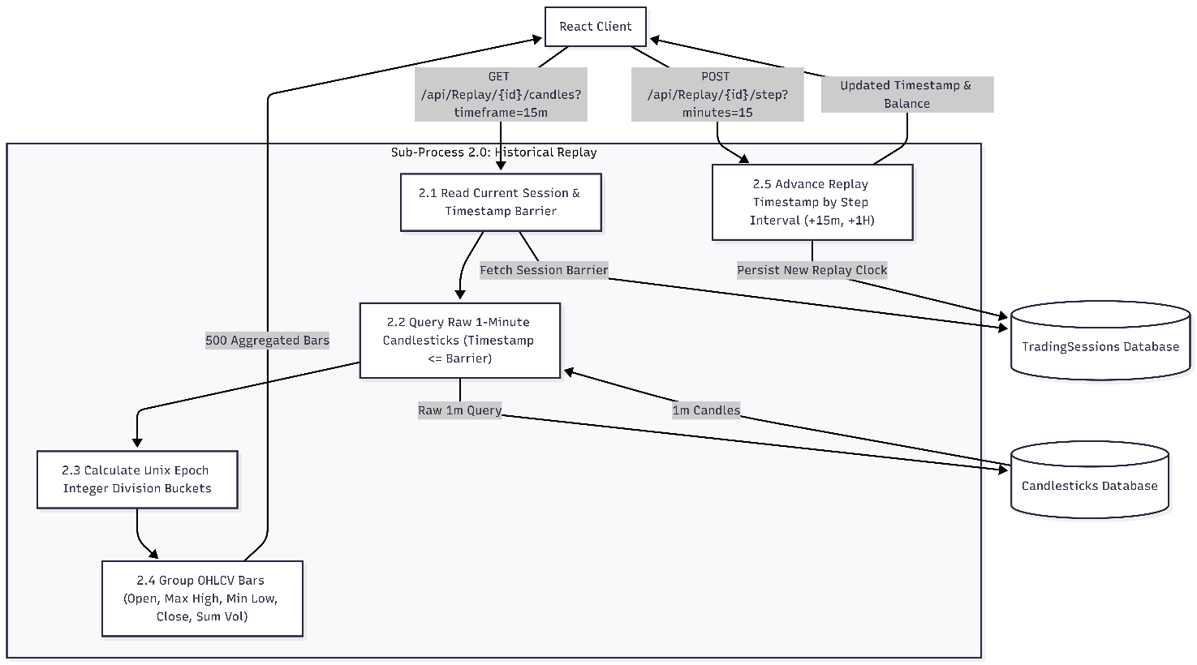

3.4 OBJECT ORIENTED DESIGN -UML DIGRAMS
3.4.1 USE CASE DIGRAM
Use cases help to determine the functionality and features of the software from user’s perspective. A use case describes how a user interacts with the system by defining the steps required to accomplish a specific goal. Variations in the sequence of steps describe various 23 scenarios. In the diagram the stick figure represents an actor that is associated with one category of user. In the use-case diagram the use cases are displayed as ovals. A use case is a set of scenarios that describing an interaction between a user and a system. A use case diagram displays the relationship among actors and use cases. The two main components of a use case diagram are use cases and actors. The actors are connected by lines to the use cases that they carry out. The use cases are placed in a rectangle but the actors are not .This rectangle is a visual remainder of the system boundaries and that the actors are outside the system.

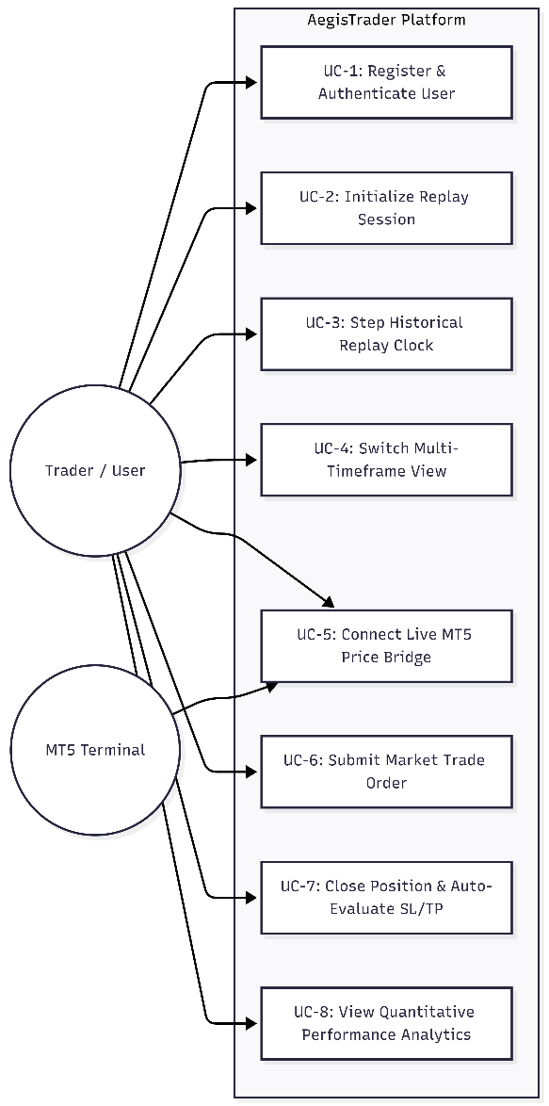

3.4.2 ACTIVITY DIAGRAM
An Activity Diagram is a crucial behavioral diagram in UML (Unified Modeling Language) that visualizes the step-by-step workflow of a system. For AegisTrader, it acts as an execution logic map, detailing how a trader traverses through simulation workflows and how the underlying backend services process quantitative execution decisions. While a Use Case Diagram outlines what functionalities the platform offers, the Activity Diagram models how the deterministic replay engine, order execution service, and analytics pipelines perform those functions in a precise chronological sequence.
Key Functional Aspects:
- Logic Visualization: It explicitly visualizes complex branching logic within the execution engine. It maps out processes such as validating order parameters, evaluating the defensive Overlap Constraint (determining whether a single candle triggers a Take Profit, Stop Loss, or simultaneous violation defaulting to a pessimistic stop-out), and verifying JWT Bearer token authorization.
- Workflow Modeling: It captures the end-to-end dynamic behavior across the platform's core modules. This spans from user authentication and historical session configuration to sequential timeline stepping, dynamic multi-timeframe aggregation, and real-time P&L calculation.
- System Refinement: It aids in identifying edge cases, temporal race conditions, and computational bottlenecks in data retrieval or chart rendering before production deployment. This process ensures that the anti-lookahead timestamp barrier is consistently preserved.
Standard Components Used
To maintain professional UML standards in your system modeling (e.g., via Draw.io), the following standard elements are utilized:
- Initial Node (Start): A solid black circle representing the beginning of a workflow, such as initiating a replay session or submitting an order via the React client.
- Action States: Rounded rectangles representing the atomic tasks or processes performed by the client or backend API. Examples include "Fetch 1m Candlesticks", "Calculate Forex Pip P&L", and "Aggregate Timeframe".
- Decision Diamonds: Used for branching logic where the system must choose a path based on a condition. In AegisTrader, this represents conditional system checks like "Is Timestamp <= CurrentReplayTimestamp?", "Has SL or TP Been Breached?", or "Did Overlap Occur?".
- Control Flow: Directed arrows that show the sequential direction of the process and the transfer of control between actions.
- Final Node (End): A bullseye symbol (a solid black circle inside an outlined circle) marking the successful termination of an activity workflow. This denotes the completion of actions such as session closure or a liquidated trade.

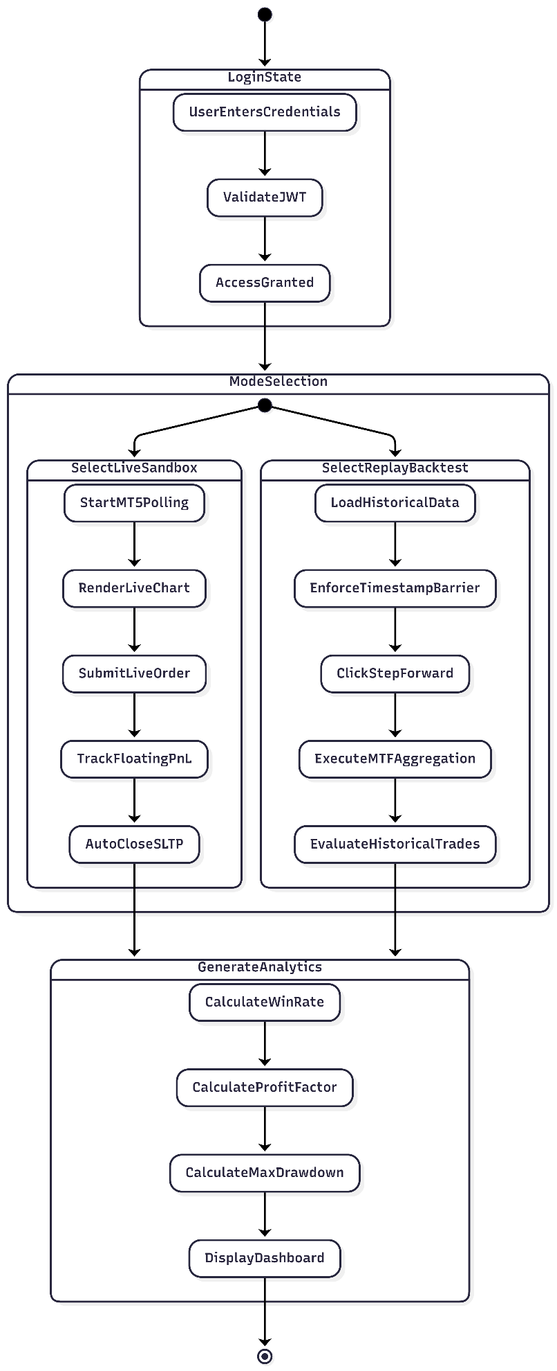

3.4.3 CLASS DIGRAM

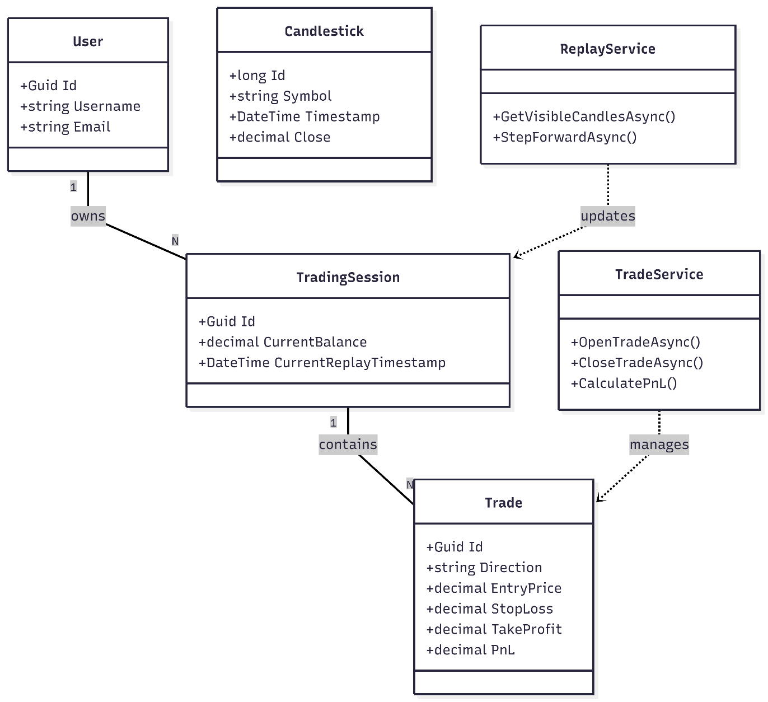

3.4.4 SEQUENCE DIAGRAM
A Sequence Diagram is a behavioral diagram within the Unified Modeling Language (UML) framework that illustrates how objects or components communicate with one another over time. It is particularly valuable for visualizing the chronological flow of messages exchanged during a specific use case or software process. For the AegisTrader platform, the Sequence Diagram maps the complex, time-sensitive execution pathways between the React client, the .NET Web API, background processing services, and the PostgreSQL database.
AegisTrader Execution Sequences
Based on the provided system architecture, the sequence diagram models four primary execution workflows within AegisTrader:
- User Authentication: The sequence initiates with the trader submitting login credentials via the React Client. The API queries the PostgreSQL Database via the authentication service to verify the BCrypt hash. Upon successful validation, the system returns a JWT Bearer token to authorize subsequent requests.
- Real-Time Live Tick Ingestion: During live simulation, the MT5 Python Bridge continuously forwards tick data at 500ms intervals via a POST request to the API. This data updates the in-memory cache, which the React client subsequently queries to dynamically render the live chart and floating Profit & Loss (P&L).
- Historical Replay & MTF Aggregation: When a user advances the historical replay clock, the React Client issues a step-forward request to the API. The backend engine advances the strict anti-lookahead timestamp barrier and queries the database for newly visible 1-minute candlesticks. These raw candles are then dynamically processed by the aggregation service and returned to the client as aggregated higher-timeframe bars.
- Order Execution & Overlap Resolution: Upon submitting a market order with predefined Stop Loss (SL) and Take Profit (TP) parameters, the API records the open position in the database. As new price data arrives, the trade engine evaluates the position. If a single price spike simultaneously breaches both the SL and TP boundaries, a defensive logic executes, forcing a pessimistic Stop Loss closure before updating the session's equity balance.

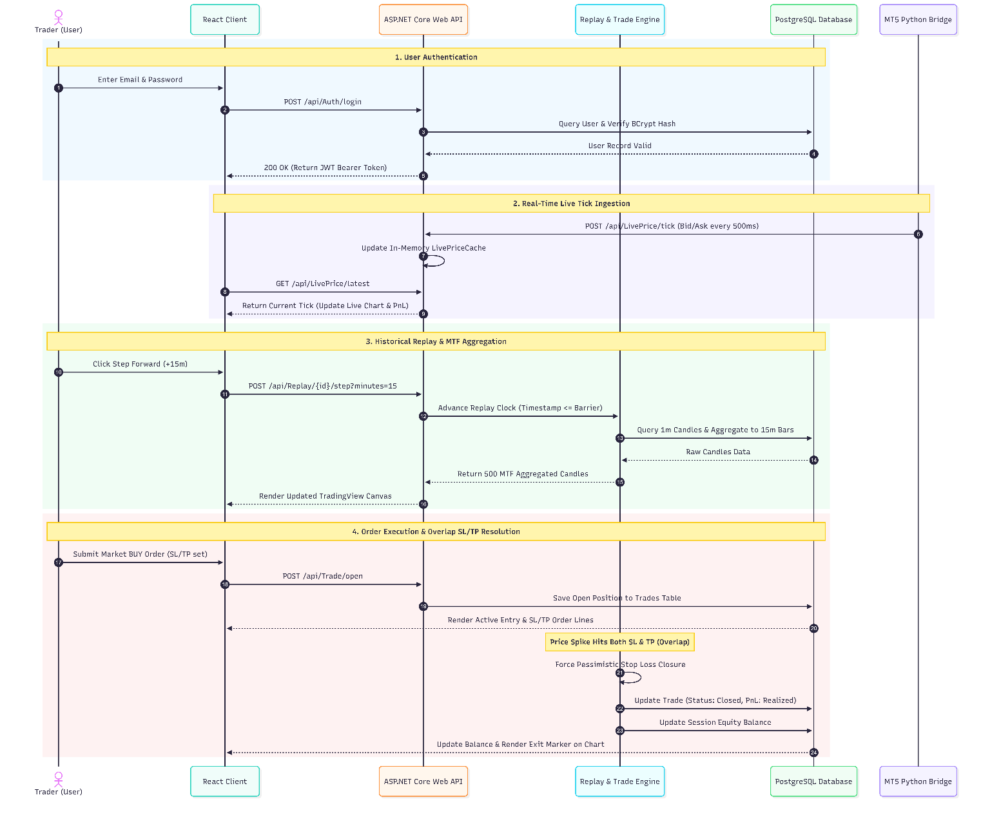

3.5 MODULAR DESIGN

Modular design is a foundational software engineering paradigm that subdivides a complex system into smaller, distinct, and highly independent components or modules. Each module encapsulates a specific subset of system functionality, exposing well-defined interfaces while hiding its internal implementation details. For the AegisTrader platform, adopting a modular architecture ensures high maintainability, facilitates isolated unit testing for complex financial algorithms, and enforces a strict separation of concerns across the Controller-Service-Repository pattern.
The AegisTrader platform is architected into five primary, highly cohesive modules:
3.5.1 Presentation and Client Module
This module constitutes the frontend architecture, engineered using React 19 and the Vite 8 build tool. It is responsible for all client-side rendering, user interaction, and single-page application routing via React Router v7.
- Visual Canvas Sub-module: Integrates TradingView Lightweight Charts v5 to render professional financial charts, including candlesticks, volume histograms, and interactive order markers.
- State Management Sub-module: Manages global application state, explicitly handling JWT Bearer tokens within an AuthContext layer to securely authorize subsequent HTTP requests.
3.5.2 API Routing and Controller Module
Developed within the ASP.NET Core 10 Web API framework, this module acts as the secure gateway for all incoming client communications. It intercepts RESTful JSON requests and routes them to the appropriate underlying business services.
- Endpoint Controllers: It isolates traffic into specific, purpose-built controllers, including the AuthController for authentication, the ReplayController for historical timeline management, the LivePriceController for real-time market simulation, and the TradeController for order execution.
3.5.3 Core Business Logic and Services Module
This module represents the analytical core of the platform, completely decoupled from both the database and the HTTP presentation layers. It contains autonomous services that execute AegisTrader’s proprietary mathematical and execution algorithms:
- ReplayService: Enforces the strict anti-lookahead timestamp barrier ($Timestamp≤CurrentReplayTimestamp$) to mathematically restrict data visibility during backtesting.
- AggregationService: Dynamically groups raw 1-minute historical candlestick data into higher timeframes (e.g., 5m, 15m, 1H) using server-side integer-division epoch algorithms.
- TradeService: Manages financial evaluations, executing 5-decimal Forex pip calculations and applying the defensive Overlap Constraint to realistically simulate adverse slippage.
- AnalyticsService: Iterates over closed trade ledgers to compute quantitative performance metrics, such as Win Rate %, Profit Factor, and continuous Maximum Drawdown %.
3.5.4 External Bridge and Ingestion Module
This standalone ingestion module bridges the gap between the internal web architecture and external live market data.
- MT5 Python Bridge: Utilizes Python 3.10+ and the MetaTrader5 SDK to continuously poll a local MT5 terminal (Vantage Markets demo) for real-time market data.
- Tick Forwarding: Asynchronously pushes live tick data via HTTP POST requests to the backend's in-memory LivePriceCache at rapid 500-millisecond intervals.
3.5.5 Data Persistence and ORM Module This module handles all long-term data storage, structural integrity, and historical data retrieval optimizations.
- Relational Storage: Powered by PostgreSQL 16, ensuring ACID-compliant, transaction-safe storage for user credentials, trading session states, and trade ledgers.
- ORM Translation: Utilizes Entity Framework Core 10 to translate object-oriented C# models and LINQ queries into optimized SQL commands, managing code-first migrations and enforcing composite indexing for sub-millisecond queries over millions of historical candlestick records.

3.6 INPUT DESIGN
Input design is a critical phase of system engineering that focuses on ensuring data is captured accurately, securely, and efficiently before it enters the processing layers. For the AegisTrader platform, input mechanisms are heavily standardized using RESTful JSON payloads sent from the React client to the ASP.NET Core API. The system is uniquely designed to handle both user-driven form inputs and automated, high-frequency data ingestion.
- User Authentication Inputs: The presentation layer captures user credentials (username, email, and password) via secure UI forms, securely transmitting the payload for BCrypt hashing and validation.
- Replay Session Configuration: To initialize the deterministic sandbox, users input their desired backtesting parameters, including the specific Forex symbol, initial account balance, historical start time, and desired timeframe resolution (such as 1m, 5m, 15m, 1H, or 4H).
- Order Execution Parameters: The trade entry interface captures critical financial inputs from the trader: the session ID, trade direction (Buy or Sell), Stop Loss (SL) price, Take Profit (TP) price, and the precise Lot Size for the position.
- Automated Tick Ingestion: During live simulation, the custom Python bridge continuously inputs live market bid and ask tick data directly into the API via HTTP POST requests at rapid 500-millisecond intervals.
- Historical Data Seeding: The backend administrative system accepts file path inputs pointing to Dukascopy 1-minute OHLCV CSV files to seed the PostgreSQL database with over a million rows of raw candlestick data.

3.7 OUTPUT DESIGN
Output design is centered on presenting processed data in a format that is immediately actionable, mathematically accurate, and highly readable for the end-user. In AegisTrader, outputs are rigorously tailored to provide quantitative traders with precise visual feedback and professional financial analytics.
- Visual Charting Rendering: The platform outputs processed timeframe data directly to a TradingView Lightweight Charts v5 canvas, displaying interactive candlesticks, volume histograms, Simple Moving Averages (SMA), and visual order markers for active trades.
- Trade Execution Feedback: Upon the closure of a trade (either manually or defensively via the Overlap Constraint), the system outputs a detailed ledger entity containing the exact entry price, exit price, and the realized Net P&L calculated down to 5-decimal Forex pip precision.
- Quantitative Analytics Dashboard: The backend analytics service outputs a comprehensive performance audit, returning real-time programmatic calculations for Win Rate %, Profit Factor, Max Drawdown %, and Total Closed Trades.
- Real-Time Simulation Telemetry: During live paper trading, the React UI continuously outputs the dynamically updating floating unrealized P&L alongside the current live tick price derived from the MT5 bridge.

CHAPTER 4

SYSTEM ENVIRONMENT

4.1 INTRODUCTION
The system environment chapter outlines the exact technical prerequisites required to develop, deploy, and operate the AegisTrader platform. Because the system features a decoupled architecture spanning a React client, an ASP.NET Core API, a PostgreSQL database, and an external Python bridge, the environment must be configured to support seamless Inter-Process Communication (IPC). This chapter defines the specific hardware parameters and software dependencies necessary to ensure high-performance data ingestion and sub-millisecond execution.
4.2 SOFTWARE REQUIREMENT SPECIFICATION
The software environment consists of the frameworks, runtimes, and background services required to execute the platform's core modules.
- Operating System: Windows 10/11 or a comparable Linux distribution (Windows is highly recommended to natively support the MetaTrader 5 terminal).
- Backend Framework: .NET 10 SDK (Version 10.0+) is strictly required to run the ASP.NET Core Web API.
- Frontend Environment: Node.js (Version 20+) and npm are required to serve the React 19 and Vite 8 client.
- Database Engine: PostgreSQL 16 is necessary for relational data storage and historical backtesting data persistence.
- Live Bridge Runtime: Python 3.10+ is required to execute the MT5 live price ingestion bridge.
- Terminal Software: MetaTrader 5 (MT5) terminal, specifically configured with a Vantage Markets demo account, to supply real-time tick data.
4.3 HARDWARE REQUIREMENT SPECIFICATION
To process over a million rows of historical Dukascopy Forex data and handle 500-millisecond live tick ingestion without computational bottlenecks, the host machine must meet the following hardware criteria.
- Processor (CPU): Minimum of a Quad-Core processor (e.g., Intel Core i5 or AMD Ryzen 5) to efficiently handle server-side multi-timeframe integer-division epoch grouping.
- Memory (RAM): 8 GB minimum; 16 GB is highly recommended to concurrently run PostgreSQL, the .NET Web API, the Vite development server, and the MT5 terminal.
- Storage Space: A Solid State Drive (SSD) with a minimum of 50 GB of free space is required to ensure rapid read/write speeds for bulk database ingestion of massive historical CSV files.
- Network Adapter: A stable broadband internet connection is mandatory to facilitate the real-time polling of live Forex market data from external broker servers.
4.4 TOOLS AND PLATFORMS
The development and integration of the AegisTrader MVP rely on a specific stack of open-source tools and enterprise platforms.
- API Architecture Platform: ASP.NET Core 10 Web API utilizing Entity Framework Core 10 for ORM code-first migrations.
- Frontend Architecture Platform: React 19 with React Router v7 for single-page routing, styled using Tailwind CSS v4 and Lucide React icons.
- Financial Charting Tool: TradingView Lightweight Charts v5 to render the high-performance visual canvas, interactive SL/TP lines, and candlestick data.
- Inter-Process Communication Tool: The MetaTrader5 Python SDK alongside the Requests library to bridge the MT5 terminal to the backend API.
- Authentication & Security Tool: BCrypt.NET-Next for cryptographic password hashing and standardized JWT for stateless Bearer token generation.

CHAPTER 5

SYSTEM IMPLEMENTATION

5.1 INTRODUCTION
The system implementation phase marks the transition from theoretical architectural design to executable, production-ready software. For the AegisTrader platform, this involves the physical construction of the full-stack infrastructure utilizing ASP.NET Core 10, React 19, PostgreSQL 16, and the external Python live bridge. The implementation rigorously adheres to the decoupled Controller-Service-Repository design pattern, ensuring that the presentation layer, API routing, and core business logic remain completely autonomous. By isolating these modules, the implementation guarantees that the deterministic historical replay engine and the real-time paper trading sandbox operate efficiently without computational interference.
5.2 CODING
The coding phase applies modern, enterprise-grade software engineering conventions across three distinct programming environments.
- Backend Services (C#): The API layer is coded in C# utilizing the .NET 10 framework. Entity Framework Core 10 is employed to write code-first migrations and LINQ queries, mapping object-oriented data directly to PostgreSQL tables. Complex proprietary algorithms, such as the server-side multi-timeframe aggregation engine and the 5-decimal Forex pip P&L mathematical models, are strictly coded within isolated business services like AggregationService.cs and TradeService.cs.
- Frontend Client (JavaScript/React): The presentation layer is engineered using the React 19 Hooks API. The code utilizes Tailwind CSS v4 for financial UI layouts and dynamically manages JWT Bearer token state across the application. The charting implementation involves complex canvas manipulations to render TradingView Lightweight Charts v5.
- Live Ingestion Bridge (Python): The external live market bridge is coded in Python 3.10+. It utilizes the MetaTrader5 SDK to establish a connection with a local Vantage Markets MT5 terminal, employing the Requests library to push continuous tick updates to the .NET API via HTTP POST payloads at 500-millisecond intervals.
5.3 DEBUGGING
Debugging a highly decoupled, asynchronous FinTech platform requires specialized techniques to trace data flow across disparate network layers.
- State & Authorization Debugging: Chrome DevTools were extensively utilized to monitor the RESTful JSON payloads traveling between the Vite development server and the API, ensuring that the JWT Bearer token request interceptors consistently appended authorization headers.
- Temporal Logic Debugging: A significant portion of backend debugging focused on the historical replay clock. It was imperative to trace the LINQ queries to guarantee the strict anti-lookahead timestamp barrier ($Timestamp≤CurrentReplayTimestamp$) functioned without exposing future candlesticks to the client.
- Concurrency & IPC Debugging: Tracking the Inter-Process Communication (IPC) between the Python bridge and the API involved console logging the tick ingestion timestamps to ensure the in-memory LivePriceCache updated correctly every 500 milliseconds without dropping packets or causing memory leaks.
5.4 UNIT TESTING
Unit testing within AegisTrader prioritizes the validation of the autonomous business logic services to ensure absolute mathematical precision and deterministic execution.
- Defensive Overlap Constraint Validation: A critical testing vector involved simulating extreme market volatility against the TradeService.cs module. Test cases were explicitly written to feed the engine a single historical candlestick whose high and low violated both the Take Profit (TP) and Stop Loss (SL) boundaries simultaneously; the tests were configured to pass only when the engine pessimistically forced a Stop Loss closure to mirror real-world slippage.
- Aggregation Algorithm Verification: The server-side multi-timeframe aggregation algorithm was rigorously tested by injecting raw 1-minute historical data and verifying that the integer-division epoch grouping mathematically output perfectly structured higher-timeframe bars (e.g., 5m, 15m, 1H).
- Quantitative Formulas: Dedicated test suites validated the mathematical accuracy of the AnalyticsService.cs outputs. The tests confirmed that the dynamic calculations for Win Rate %, Profit Factor, and Maximum Drawdown % evaluated correctly against historical trade ledgers utilizing the precise 5-decimal Forex pricing model.

CHAPTER 6

SYSTEM PLANNING AND SCHEDULING

6.1 INTRODUCTION
System planning and project scheduling are vital engineering management disciplines that govern the systematic lifecycle of software development. In complex, full-stack systems like AegisTrader, proper planning ensures that architectural dependencies, mathematical modeling, and multi-service integrations are staged logically without bottlenecks. Scheduling transforms high-level architectural milestones into concrete, time-bound deliverables, ensuring that backend services, database migrations, live market bridges, and presentation layers converge harmoniously toward a production-ready Minimum Viable Product (MVP). This chapter details the operational planning methodology, structured milestone breakdown, and timeline visualizations using standard project management tools—specifically the Gantt Chart and the Program Evaluation and Review Technique (PERT) Chart.
6.2 PLANNING SOFTWARE PROJECT
Software project planning establishes the procedural roadmap for resource allocation, technical risk management, and task sequence optimization. The engineering lifecycle of AegisTrader spanned approximately three months—commencing on June 08 and culminating in the final MVP Release and Academic Evaluation on September 06.
To ensure efficiency for a single-engineer development model, the project adopted an iterative, phased planning approach divided into six discrete engineering phases:
- Phase 1: Requirements & Analysis (Weeks 1–2): Conducting domain literature surveys across ICT/SMC algorithmic models, formalizing the Problem Statement, executing feasibility assessments, and drafting the Software Requirements Specification (SRS).
- Phase 2: System Architecture & Database Design (Weeks 3–4): Formulating the decoupled Controller-Service-Repository architecture pattern and configuring PostgreSQL relational schemas with Entity Framework Core 10 mappings.
- Phase 3: Core Backend & Replay Engine (Weeks 5–7): Establishing the ASP.NET Core 10 Web API scaffolding, implementing BCrypt password hashing and JWT token authentication, and constructing the core Replay Engine with the anti-lookahead timestamp barrier and server-side multi-timeframe aggregation logic.
- Phase 4: Live Bridge & Execution Mechanics (Weeks 8–10): Building the Python-to-MetaTrader 5 (MT5) live tick bridge, engineering the trade execution engine with defensive Overlap Constraint resolution, and deploying the quantitative analytics engine.
- Phase 5: Frontend UI & Interactive Charts (Weeks 11–12): Constructing the React 19 single-page interface with Tailwind CSS v4 and embedding TradingView Lightweight Charts v5 with dynamic indicators and visual order lines.
- Phase 6: Testing, Hardening & Final MVP (Weeks 13): Executing end-to-end integration testing, database composite index performance tuning, compiling formal academic documentation, and preparing the evaluation demo script.
6.3 GANTT CHART
A Gantt Chart provides a visual timeline representing the sequential progression, duration, and overlap of distinct tasks across the project schedule. It serves as an operational tracking mechanism to monitor progress against predefined milestones.
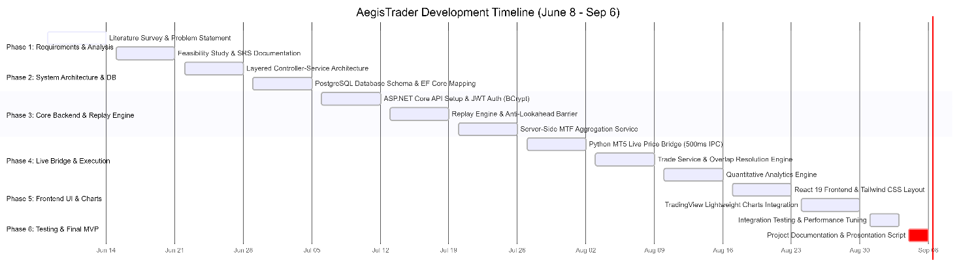Comprehensive Task Breakdown Schedule
The table below outlines the work breakdown structure (WBS) corresponding to the AegisTrader development timeline:
Phase | Task Description | Start Date | End Date | Duration
Phase 1: Requirements & Analysis | Literature Survey & Problem Statement | June 08 | June 14 | 7 Days
 | Feasibility Study & SRS Documentation | June 15 | June 21 | 7 Days
Phase 2: Architecture & Database | Layered Controller-Service Architecture Design | June 22 | June 28 | 7 Days
 | PostgreSQL Database Schema & EF Core Mapping | June 29 | July 05 | 7 Days
Phase 3: Core Backend & Replay Engine | ASP.NET Core API Setup & JWT Auth (BCrypt) | July 06 | July 12 | 7 Days
 | Replay Engine & Anti-Lookahead Barrier | July 13 | July 19 | 7 Days
 | Server-Side MTF Aggregation Service | July 20 | July 26 | 7 Days
Phase 4: Live Bridge & Execution | Python MT5 Live Price Bridge (500ms IPC) | July 27 | August 02 | 7 Days
 | Trade Service & Overlap Resolution Engine | August 03 | August 09 | 7 Days
 | Quantitative Analytics Engine | August 10 | August 16 | 7 Days
Phase 5: Frontend UI & Charts | React 19 Frontend & Tailwind CSS Layout | August 17 | August 23 | 7 Days
 | TradingView Lightweight Charts Integration | August 24 | August 30 | 7 Days
Phase 6: Testing & Final MVP | Integration Testing & Performance Tuning | August 31 | September 03 | 4 Days
 | Project Documentation & Presentation Script | September 04 | September 06 | 3 Days
Final Milestone | MVP Release & Evaluator Assessment | September 06 | September 06 | Milestone

The linear cascading nature of the Gantt chart emphasizes backend stability before frontend consumption, directly adhering to the decoupled development mandate of the project.
6.4 PERT CHART
The Program Evaluation and Review Technique (PERT) Chart models the task interdependencies, event networks, and concurrent development streams within the AegisTrader engineering lifecycle. Unlike a standard Gantt chart, a PERT network highlights parallel workflows and critical path sequencing required to reach the terminal milestone.
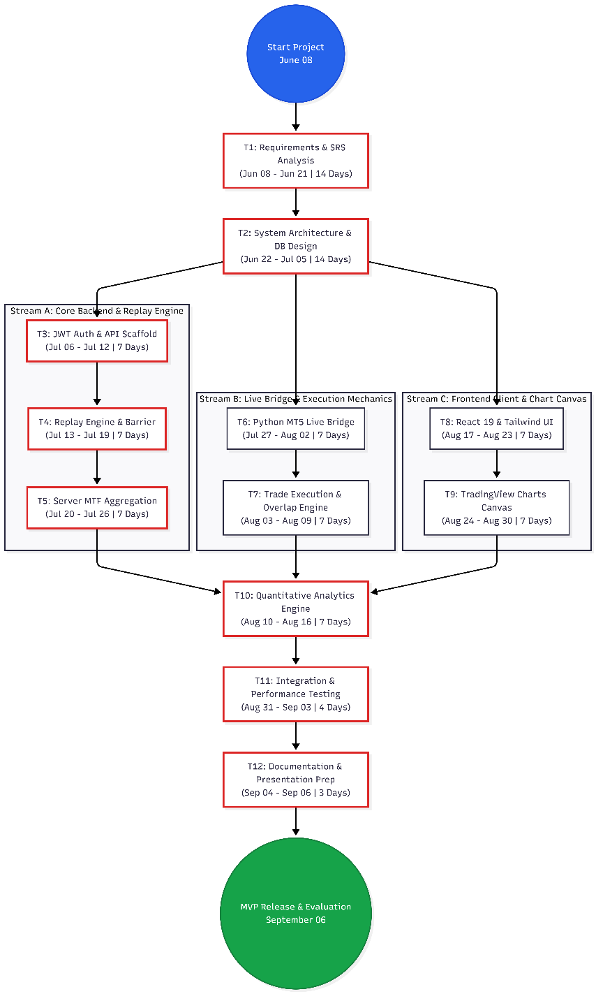
Structural Network & Stream Decomposition
Following the preliminary foundational phases (T1: Requirements Analysis and T2: Architecture & DB Design), the project branches into three distinct, specialized execution streams:
- Stream A (Core Backend & Replay Engine): Comprises task nodes T3 (JWT Auth & API Scaffold), T4 (Replay Engine & Barrier), and T5 (Server MTF Aggregation). This stream establishes the foundational data access layers and deterministic historical replay pipeline.
- Stream B (Live Bridge & Execution Mechanics): Encompasses task nodes T6 (Python MT5 Live Bridge) and T7 (Trade Execution & Overlap Engine). This stream handles external real-time data ingestion and pessimistic liquidation trade rules.
- Stream C (Frontend Client & Chart Canvas): Encompasses task nodes T8 (React 19 & Tailwind UI) and T9 (TradingView Charts Canvas). This stream encapsulates client-side visual engineering and high-performance charting canvas integration.
Stream Convergence and Critical Path
- Analytics Convergence: Streams A and B converge directly into T10 (Quantitative Analytics Engine) from August 10 to August 16, ensuring that closed trade metrics, drawdown algorithms, and P&L calculations operate over stable replay and trade data.
- Systemic Convergence: All parallel streams ultimately integrate into T11 (Integration & Performance Testing) from August 31 to September 03, validating that client requests, live tick streams, and database queries operate harmoniously under full load.
- Terminal Milestone: Following T12 (Documentation & Presentation Prep), the project achieves MVP Release & Evaluation on September 06, fulfilling the full three-month academic software development plan.

CHAPTER 7

SYSTEM COST ESTIMATION

7.1 INTRODUCTION
System cost estimation is a critical project management activity used to quantify the theoretical financial investment and human effort required to develop a software application. For the AegisTrader platform, the architectural constraints explicitly mandated a free, open-source cost profile, entirely eliminating ongoing cloud infrastructure bills by hosting the PostgreSQL database and application execution layers locally on-premise. Consequently, there are zero licensing costs associated with the technology stack, which relies entirely on free enterprise tools such as ASP.NET Core 10, React 19, Vite 8, and the Python MetaTrader5 SDK. Furthermore, historical market data is procured freely via Dukascopy 1-minute OHLCV CSV exports rather than expensive premium data subscriptions.
Given the zero-cost infrastructure model, the primary cost associated with AegisTrader is the theoretical human development effort. To scientifically estimate this labor cost and quantify the system's size, the project utilizes Function Point Based Estimation, translating the platform's logical capabilities into a standardized metric of engineering effort.
7.2 FUNCTION POINT BASED ESTIMATION
Function Point Analysis (FPA) is a standard software engineering methodology used to estimate the size of a software project based on the functionality it provides to the user, independent of the programming languages used. The estimation process calculates Unadjusted Function Points (UFP) by categorizing system functions into five distinct information domain components.
For the AegisTrader MVP, the components are meticulously mapped to the system's decoupled Controller-Service-Repository architecture:
1. External Inputs (EI): External inputs represent data crossing the boundary from the outside into the system to update internal files or alter execution states.
- Authentication Payloads: Secure user registration and login data submitted for BCrypt hashing and JWT token generation.
- Trade Execution Parameters: Market order payloads containing the Session ID, Buy/Sell direction, precise Lot Size, Take Profit (TP), and Stop Loss (SL) boundaries.
- Live Tick Ingestion: High-frequency bid/ask price data pushed continuously from the MT5 Python bridge into the backend's in-memory LivePriceCache at 500-millisecond intervals.
- Replay Session Configuration: Parameters dictating the historical start time, initial account balance, and the specific Forex symbol.
2. External Outputs (EO): External outputs are data crossing the boundary from the system to the outside, representing processed, calculated, or aggregated information.
- TradingView Chart Canvas: The dynamic rendering of aggregated candlestick bars, volume histograms, and visual order lines transmitted to the React client.
- Quantitative Analytics Dashboard: The programmatic computation and display of complex financial metrics, specifically the Win Rate %, Profit Factor, Maximum Drawdown %, and Net P&L.
- Trade Ledger Feedback: The output of closed trade entities detailing execution entry/exit prices and 5-decimal Forex pip calculations following a manual close or a defensive Overlap Constraint liquidation.
3. External Inquiries (EQ): External inquiries are input/output combinations that result in data retrieval without fundamentally altering the system's internal state.
- Historical Candle Retrieval: API GET requests querying the strict anti-lookahead timestamp barrier (/api/Replay/{id}/candles) to fetch dynamically grouped multi-timeframe bars.
- Live Price Polling: The React UI fetching the latest tick from the in-memory cache to update the floating unrealized P&L.
- Trade History Audits: Client-side retrieval of open and closed trade ledgers for a specific session (/api/Trade/history/{sessionId}).
4. Internal Logical Files (ILF): ILFs are user-identifiable groups of logically related data maintained entirely within the AegisTrader database boundary.
- Users Table: Stores cryptographic user identifiers and profile states.
- TradingSessions Table: Maintains the financial state, equity balances, and current replay clock timestamp pointers for backtesting and forward-testing sandboxes.
- Trades Table: The financial ledger persisting all order parameters and execution outcomes.
- Candlesticks Table: The massive repository storing over a million rows of historical OHLCV data utilizing a composite index for rapid retrieval.
5. External Interface Files (EIF): EIFs are logically related data referenced by AegisTrader but maintained by external systems.
- MetaTrader 5 (MT5) Terminal Data: The live market data feed maintained by Vantage Markets and accessed externally via the Python bridge.
- Dukascopy Historical Repositories: The external CSV data structures imported into the system via the backend seed controller.
Effort and Schedule Correlation By applying standard industry weighting (Simple, Average, Complex) to these five domains, the total Function Points for AegisTrader reflect a highly complex, mathematically rigorous enterprise platform. Given the strict three-month development lifecycle for a single engineer, achieving this MVP required maintaining a highly accelerated productivity rate (Function Points processed per person-month), successfully validating the intensive scheduling and decoupled development methodologies outlined in Chapter 6.

CHAPTER 8

SYSTEM TESTING

8.1 INTRODUCTION
System testing is a systematic, rigorous phase of the software engineering lifecycle aimed at evaluating a complete and integrated system to verify that it meets its specified functional and non-functional requirements. For the AegisTrader platform, this phase is exceptionally critical given the financial nature of the application and the stringent necessity for absolute mathematical precision. The primary objective of testing AegisTrader is to guarantee the integrity of the deterministic historical replay engine and the real-time paper trading interface. Because the platform is built upon a decoupled Controller-Service-Repository architecture, testing must validate not only the isolated business logic—such as 5-decimal Forex pip calculations and anti-lookahead barriers—but also the asynchronous Inter-Process Communication (IPC) across the React client, the .NET Web API, and the Python MT5 bridge.
8.2 TESTING PROCEDURES
To ensure a robust, enterprise-grade Minimum Viable Product (MVP), the AegisTrader platform was subjected to a multi-tiered testing strategy. This approach systematically isolated individual algorithms before verifying full end-to-end data pipelines.
8.2.1 UNIT TESTING
Unit testing focuses on verifying the smallest testable parts of the application independently. In AegisTrader, this primarily targeted the autonomous service classes within the Business Logic Layer.
- Execution Engine Validation: The TradeService.cs module was rigorously tested to ensure the defensive Overlap Constraint functioned flawlessly. Test cases explicitly simulated extreme volatility by passing a single candlestick that breached both Take Profit (TP) and Stop Loss (SL) boundaries simultaneously; the test asserted that the engine successfully forced a pessimistic Stop Loss closure to simulate real-world slippage.
- Aggregation Algorithm Testing: The AggregationService.cs was tested by injecting raw 1-minute historical data arrays to verify that the integer-division epoch grouping mathematically produced perfectly accurate 5m, 15m, 1H, and 4H aggregated bars.
- Financial Mathematics: Unit tests validated that the pip conversion formulas correctly calculated the Net P&L utilizing 5-decimal precision based on standard $10 per pip lot sizing for EURUSD.
8.2.2 INTEGRATION TESTING
Integration testing evaluates how gracefully independent modules communicate when combined.
- Client-API Authorization: Test suites verified the data flow between the React 19 Presentation Layer and the ASP.NET Core 10 API Layer. This ensured that the AuthContext correctly stored the JWT Bearer tokens and that HTTP request interceptors successfully authorized secure endpoints.
- Live Bridge IPC Verification: The integration between the external Python bridge and the backend API was tested to confirm that live tick data fetched from the local MT5 terminal was accurately processed via HTTP POST requests at continuous 500-millisecond intervals without causing packet loss or memory cache overflow.
8.2.3 SYSTEM AND END-TO-END TESTING
System testing evaluates the fully integrated application against the original software requirements to ensure flawless execution of user workflows.
- Deterministic Replay Workflow: Testers executed the full backtesting loop by initializing a session, placing market orders, and triggering the "Step Forward" API endpoint. This verified that the strict timestamp barrier (Timestamp <= CurrentReplayTimestamp) successfully advanced the clock and revealed data chronologically without lookahead bias.
- Analytics Pipeline Verification: Following the closure of simulated trades, the end-to-end test confirmed that the AnalyticsService.cs successfully queried the database and dynamically calculated accurate professional metrics, including Win Rate %, Profit Factor, and Maximum Drawdown %.
8.2.4 PERFORMANCE AND DATABASE TESTING
Because quantitative backtesting requires massive data throughput, performance testing was conducted directly against the PostgreSQL 16 database.
- Composite Index Verification: The database testing procedure ensured that querying the Candlesticks table—which contains over 1,000,000 rows of Dukascopy historical OHLCV data—achieved sub-millisecond retrieval times. This was confirmed by profiling the Entity Framework Core queries utilizing the specific composite index placed on the Symbol and Timestamp fields.

CHAPTER 9

SYSTEM MAINTENANCE

9.1 INTRODUCTION
System maintenance is the final and ongoing phase of the software development lifecycle (SDLC), dedicated to ensuring that a deployed application remains functional, secure, and optimized over time. For financial technology platforms like AegisTrader, rigorous maintenance is paramount, as the system must continuously process high-frequency live market data and execute complex quantitative algorithms without degradation. Because AegisTrader was engineered utilizing a decoupled Controller-Service-Repository architectural pattern, system maintenance is inherently streamlined. Engineers can independently service the ASP.NET Core 10 Web API backend, the PostgreSQL 16 database, or the React 19 presentation layer without disrupting the entire operational ecosystem. Maintenance in this context ensures that the deterministic historical replay engine retains its strict anti-lookahead timestamp barrier and that the real-time MT5 bridge continues to ingest data smoothly at rapid 500-millisecond intervals.
9.2 MAINTENANCE
Software maintenance for the AegisTrader platform is categorized into four standard engineering disciplines: corrective, adaptive, perfective, and preventive maintenance. Each category addresses specific technological requirements to sustain the enterprise-grade simulation environment.
9.2.1 CORRECTIVE MAINTENANCE
Corrective maintenance involves diagnosing and rectifying latent bugs or logical errors discovered post-deployment.
- Execution Logic Audits: Continuous monitoring of the TradeService.cs module to ensure the defensive Overlap Constraint accurately forces pessimistic Stop Loss closures during unprecedented periods of market volatility.
- Live Bridge Diagnostics: Tracing and repairing asynchronous packet drops or desynchronization within the Inter-Process Communication (IPC) pipeline, ensuring the Python bridge consistently updates the in-memory LivePriceCache from the MetaTrader 5 terminal without failure.
- UI Synchronization: Resolving any React state anomalies where the TradingView Lightweight Charts v5 canvas might fail to render the dynamic floating unrealized P&L or visual order lines accurately.
9.2.2 ADAPTIVE MAINTENANCE
Adaptive maintenance modifies the system to accommodate changes in its external operating environment, such as operating system upgrades, third-party API deprecations, or shifting framework standards.
- Framework Upgrades: Transitioning security patches and standard runtime updates for the .NET 10 LTS ecosystem and the Node.js 20+ environment.
- External Integration Compliance: Adjusting the Python bridge logic to remain compliant with updates to the MetaTrader5 SDK or changes in the Vantage Markets demo server protocols.
- Database Migrations: Adapting the Entity Framework Core 10 models to accommodate new physical server environments or upgraded PostgreSQL relational standards.
9.2.3 PERFECTIVE MAINTENANCE
Perfective maintenance focuses on performance tuning and implementing new functional requirements to satisfy the evolving needs of quantitative traders.
- Algorithmic Optimization: Refining the server-side multi-timeframe aggregation engine to optimize the integer-division epoch grouping mathematics, further reducing the computational overhead of generating 15m or 1H bars from 1-minute data.
- Database Query Tuning: Enhancing the composite index on the Candlesticks table to guarantee sub-millisecond retrieval times even as the historical database scales beyond the initial 1,000,000+ rows of Dukascopy Forex data.
- Roadmap Expansion: Executing the proposed future system roadmap, which includes building an automated strategy scripting engine, deploying AI-assisted pattern recognition for Fair Value Gaps, and expanding data pipelines for multi-asset trading, specifically including XAUUSD (Gold), BTCUSD (Crypto), and Index Futures.
9.2.4 PREVENTIVE MAINTENANCE
Preventive maintenance encompasses proactive engineering practices designed to prevent future system degradation and technical debt.
- Security Hardening: Periodically rotating the cryptographic secrets used for generating JWT Bearer tokens and updating the BCrypt.NET-Next hashing libraries to defend against emerging cybersecurity vulnerabilities.
- Data Integrity Checks: Regularly auditing the Trades and TradingSessions relational tables to ensure that the 5-decimal Forex pip P&L calculations maintain absolute mathematical integrity without floating-point drift.
- Memory Management: Profiling the React client and the backend ASP.NET Core API to proactively identify and resolve memory leaks, particularly those associated with rendering thousands of candlestick bars on the visual canvas over prolonged backtesting sessions.

CHAPTER 10

SYSTEM SECURITY MEASURES

10.1 INTRODUCTION
System security is a paramount engineering requirement, particularly for financial technology platforms that process sensitive user credentials and simulate market executions. The security architecture of AegisTrader is purposefully engineered not merely to defend technical perimeters, but to align with the foundational principles of cyber jurisprudence—guaranteeing data confidentiality, non-repudiation of trade executions, and the rigorous safeguarding of user identities within this financial cyberspace. Because AegisTrader operates on a decoupled Controller-Service-Repository architecture, security measures are implemented in a defense-in-depth strategy across multiple operational layers. This multi-tiered approach ensures that vulnerabilities in the React presentation layer, the ASP.NET Core 10 API, the PostgreSQL database, or the external Python MT5 bridge are systematically isolated and mitigated.
10.2 OPERATING SYSTEM LEVEL SECURITY
Operating System (OS) level security forms the foundational boundary that protects the host environment executing the AegisTrader application services.
- Process Isolation: The architecture strictly isolates the Python 3.10+ live market bridge from the main ASP.NET Core Web API. By decoupling the MetaTrader 5 (MT5) SDK polling script into an autonomous OS process, any terminal-level crashes or external memory overflows are contained, preventing them from halting the core API infrastructure.
- Port Restriction and Firewall Configuration: For local, on-premise execution, the OS firewall is configured to restrict access to critical ports. The PostgreSQL database (default port 5432) and the ASP.NET Core API server are bound exclusively to localhost, preventing unauthorized external network interfaces from attempting direct connections.
- File System Access Controls: The backend seeding mechanism requires reading massive Dukascopy 1-minute OHLCV CSV files. OS-level read-only permissions are enforced on these historical data directories to prevent malicious scripts from modifying or corrupting the backtesting data prior to database ingestion.
10.3 DATABASE LEVEL SECURITY
Database security ensures the structural integrity and confidentiality of the financial ledgers, user states, and historical candlestick repositories managed by PostgreSQL 16.
- Cryptographic Password Hashing: The system never stores plaintext user passwords. Instead, the AuthService utilizes the BCrypt.NET-Next cryptographic hashing algorithm. This ensures that even in the event of a catastrophic database exfiltration, the cryptographic hashes residing in the Users table cannot be reverse-engineered.
- SQL Injection Prevention: By utilizing Entity Framework (EF) Core 10 as the Object-Relational Mapper (ORM), AegisTrader inherently neutralizes SQL injection vulnerabilities. EF Core translates all C# LINQ queries into strictly parameterized SQL commands, ensuring that malicious user inputs cannot alter the structure of database queries.
- Identity and Access Management: The PostgreSQL connection string defined in the API's appsettings.json is configured to utilize a dedicated database user profile with least-privilege access. This profile is granted permission to read and write to the TradingSessions and Trades tables but is restricted from dropping or structurally altering the schema.
10.4 SYSTEM LEVEL SECURITY
System-level security encompasses the application layer, dictating how the React 19 client and the ASP.NET Core 10 API securely communicate and authorize interactions.
- Stateless JWT Authentication: AegisTrader employs JSON Web Tokens (JWT) for secure, stateless session management. Upon a successful login via the /api/Auth/login endpoint, the API issues a signed Bearer token. This token mathematically validates the user's cryptographic identity without requiring the backend to maintain a stateful, memory-intensive session cache.
- API Endpoint Authorization: Sensitive HTTP endpoints—including the ReplayController, LivePriceController, and TradeController—are strictly guarded by authorization middleware. The React frontend utilizes Axios request interceptors to automatically attach the JWT Bearer token to the header of every outgoing request, ensuring that only authenticated users can place trades or step the historical replay clock forward.
- Cross-Origin Resource Sharing (CORS): The ASP.NET Core HTTP request pipeline is configured with strict CORS policies. This ensures that the backend API will only accept RESTful JSON payloads originating from the trusted Vite development server (e.g., http://localhost:5173), immediately rejecting unauthorized cross-site requests.
- Algorithmic Input Validation: To protect the integrity of the execution engine, the backend strictly validates all inbound order parameters. Before the TradeService evaluates the defensive Overlap Constraint, it programmatically verifies that the submitted Lot Size, Stop Loss, and Take Profit values are structurally valid and mathematically coherent for 5-decimal Forex pricing.

CHAPTER 11

FUTURE ENHANCEMENT

11.1 INTRODUCTION
While the current Minimum Viable Product (MVP) of AegisTrader successfully delivers a rigorous, deterministic historical replay engine and a real-time paper trading sandbox, the decoupled enterprise architecture is intentionally designed for long-term extensibility. The future enhancement roadmap focuses on scaling the platform's analytical capabilities, broadening its financial asset coverage, and introducing advanced custom scripting engines. These planned phases will elevate the system from a specialized Forex simulator into a comprehensive, multi-asset quantitative research terminal, fully preparing the codebase for enterprise deployment in major software development hubs like Technopark or Infopark.
11.2 MULTI-ASSET EXPANSION AND DEDICATED GOLD (XAU/USD) OPTIMIZATION
Currently, the system's financial mathematics and data ingestion pipelines are optimized for 5-decimal Forex pairs like EURUSD. The Phase 5 roadmap entails a strategic expansion into additional asset classes, specifically targeting Crypto (BTCUSD) and Index Futures (NQ/ES). Most importantly, the execution engine and Pip/Point calculation models will be significantly upgraded to support and focus heavily on XAU/USD (Gold). Adapting the defensive Overlap Constraint and historical database seeders for Gold's unique intraday volatility profile will allow traders to concentrate their manual technical analysis exclusively on this high-yield commodity.
11.3 ADVANCED STRATEGY SCRIPTING AND CUSTOM INDICATORS
To support bespoke technical analysis, Phase 3 introduces a dynamic scripting engine capable of executing C# algorithms and custom Pine Script logic directly within the platform. This enhancement will allow the frontend visual canvas to render complex, user-defined Pine Script v6 indicators. Specifically, the engine will be programmed to dynamically map global trading session boxes (Asian, London, and New York) and convert them accurately into Indian Standard Time (IST). This capability will empower traders to visually track session-specific liquidity sweeps and Fair Value Gaps (FVGs) directly on the AegisTrader charts without relying on external platforms.
11.4 ANALYTICAL TRADE JOURNAL AND PATTERN RECOGNITION
Phase 4 of the development roadmap involves the integration of an AI-assisted Trade Journal and Pattern Recognition module. Because the platform's core philosophy strictly prioritizes manual trade execution and technical analysis over automated AI trading bots, this enhancement will function purely as an analytical support tool. The system will automatically scan historical and live candlesticks to detect and visually highlight Smart Money Concepts (SMC), such as Fair Value Gaps (FVGs) and Order Blocks. Furthermore, it will log Market Structure Shifts (MSS), providing traders with a mathematically precise journal to review their manual execution accuracy against verified structural patterns.
11.5 ENTERPRISE CONTAINERIZATION
Beyond financial features, the software architecture itself will undergo operational hardening. The current local on-premise deployment model will be upgraded into a fully containerized microservices architecture utilizing tools like Docker and Kubernetes. Migrating the decoupled ASP.NET Core API, React client, and PostgreSQL database into scalable cloud containers will ensure the platform meets modern DevOps industry standards, guaranteeing high availability and fault tolerance as the platform scales to support concurrent users.

CHAPTER 12

CONCLUSION

12.1 PROJECT SUMMARY
The AegisTrader project represents the successful engineering and deployment of a full-stack, enterprise-grade trading simulation platform. Designed to bridge the gap between institutional backtesting software and retail execution, the platform provides a deterministic sandbox tailored specifically for Smart Money Concepts (SMC) and Inner Circle Trader (ICT) methodologies. By architecting a robust backend with ASP.NET Core 10 Web API and PostgreSQL 16, paired with a dynamic React 19 presentation layer, the system effectively manages massive historical data pipelines alongside high-frequency live market ingestion.
12.2 FULFILLMENT OF CORE OBJECTIVES
The Minimum Viable Product (MVP) rigorously satisfied all predefined engineering objectives. The historical replay engine successfully implemented an absolute anti-lookahead timestamp barrier, mathematically guaranteeing that future price action remains hidden during backtesting sessions. The bespoke multi-timeframe aggregation service achieved sub-millisecond, on-the-fly integer-division epoch grouping on 1-minute data, effectively eliminating database bloat. Crucially, the execution engine integrated the defensive Overlap Constraint, which realistically simulates adverse market slippage by forcing a pessimistic Stop Loss closure when price spikes violate both liquidation boundaries simultaneously. Finally, the real-time Python bridge seamlessly connected with a local MetaTrader 5 (MT5) terminal to forward continuous tick data at 500-millisecond intervals, finalizing the live paper trading environment.
12.3 ACADEMIC AND PROFESSIONAL IMPACT
The successful architectural design and deployment of this platform satisfy the rigorous technical mandates of the Master of Computer Applications (MCA) curriculum at Mar Athanasios College for Advanced Studies, Tiruvalla (MACFAST), under Mahatma Gandhi University. Developing a decoupled Controller-Service-Repository architecture capable of handling Inter-Process Communication (IPC), asynchronous API routing, and complex 5-decimal Forex pip calculations demonstrates profound full-stack software development proficiency. This comprehensive level of system design and academic documentation establishes a formidable portfolio asset. It directly aligns with the advanced technical competencies demanded by premier software development and IT hubs, such as Technopark in Trivandrum and Infopark in Kochi.
12.4 FINAL VERDICT
Ultimately, AegisTrader succeeds in its primary FinTech mandate: delivering a mathematically precise, zero-risk sandbox that empowers users to move away from opaque, automated AI trading bots in favor of rigorous, manual technical analysis. By optimizing for granular execution mechanics, precise data ingestion, and deterministic replay capabilities, the platform is perfectly positioned to support focused, manual trading strategies on highly volatile assets such as XAU/USD (Gold). The system stands as a definitive testament to the capability of modern open-source technologies in constructing scalable, enterprise-level financial software.

CHAPTER 13

ANNEXTURE

13.1 REFERENCES
The following references acknowledge the official documentation, open-source libraries, and financial data repositories utilized in the architecture and development of the AegisTrader platform. The citations are formatted according to IEEE standards for software and web references.
[1] Microsoft Corporation, "ASP.NET Core Web API Documentation," Microsoft Learn. [Online]. Available: https://learn.microsoft.com/en-us/aspnet/core/
[2] MetaQuotes Ltd., "MetaTrader 5 Integration for Python," MQL5 Documentation. [Online]. Available: https://www.mql5.com/en/docs/integration/python_metatrader5
[3] TradingView, "Lightweight Charts," GitHub. (2025) [Source code]. Available: https://github.com/tradingview/lightweight-charts
[4] Dukascopy Bank SA, "Historical Data Export," Dukascopy Swiss Financial Group. [Online]. Available: https://www.dukascopy.com/swiss/english/marketwatch/historical/
[5] Meta Platforms, Inc., "React: The library for web and native user interfaces," React Docs. [Online]. Available: https://react.dev/
[6] Npgsql, "Npgsql Entity Framework Core Provider," GitHub. (2025) [Source code]. Available: https://github.com/npgsql/efcore.pg
[7] T. Hougaard, The Best Loser Wins, Petersfield, Hampshire: Harriman House, 2022. (Referenced for risk management and adverse slippage modeling).
[8] M. Douglas, Trading in the Zone, New York, NY: New York Institute of Finance, 2000. (Referenced for quantitative consistency frameworks).

13.2 SYSTEM SCREENSHOTS
Figure 13.2.1: USER AUTHENTICATION
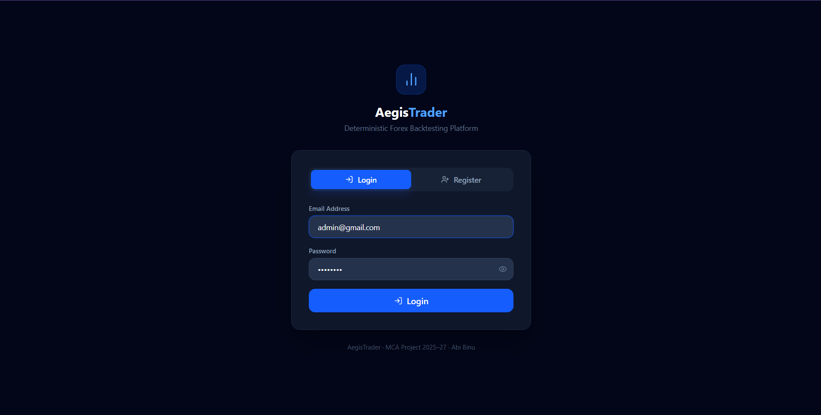
Figure 13.2.2: HISTORICAL REPLAY ENGINE & MULTI-TIMEFRAME CANVAS
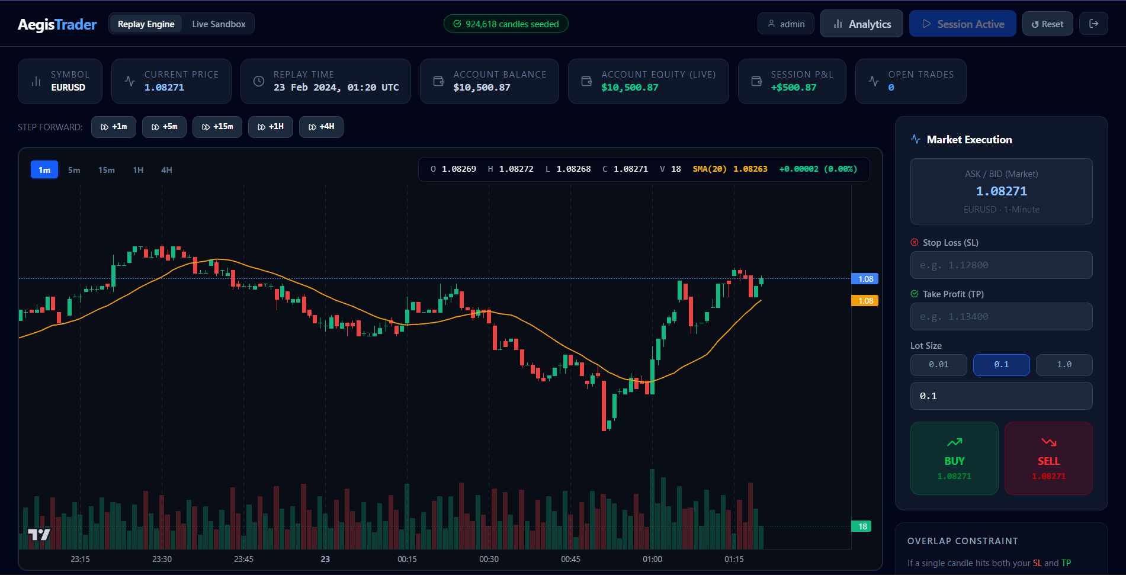

Figure 13.2.3: ORDER EXECUTION & VISUAL SL/TP LINES
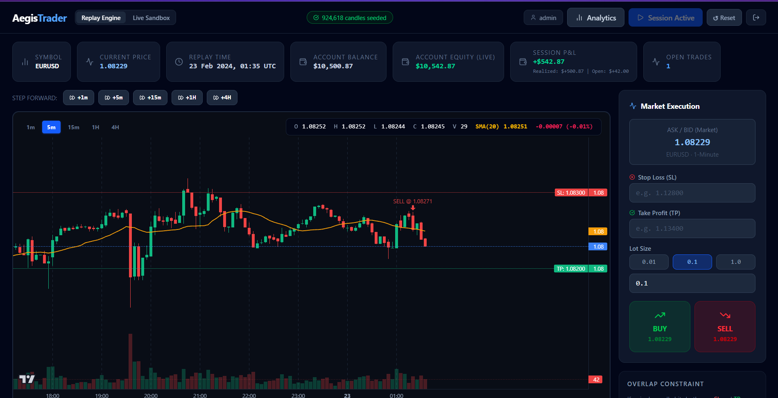
Figure 13.2.4: REAL-TIME MT5 LIVE PRICE BRIDGE
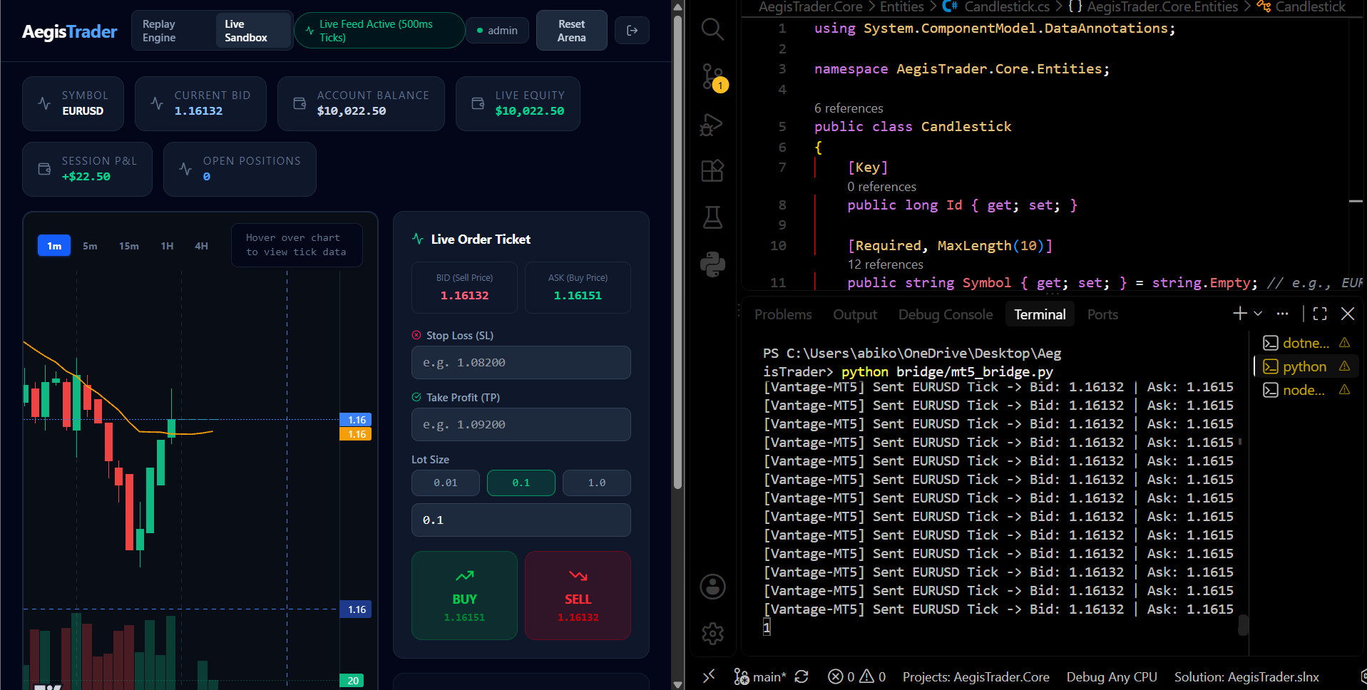

Figure 13.2.5: QUANTITATIVE ANALYTICS DASHBOARD
