

# WOLLO UNIVERSITY

## Kombolcha Institute of Technology (KIOT) College of Informatics

**Department of Software Engineering**

**A project Submitted to the Department of Software Engineering for Partial Fulfillment of the three month internship in Software Engineering.**

**Title: Employee Management System**

**Name ID**

#### Abebe Minale wour/3970/13

##### Advisor: Mr.Bihoneg SubmissionDate:11/19/2024

##### **Kombolcha , Wollo ,Amahara,Ethiopia**

1

## Declaration

Where by declare that project entitled“ **Employee Management System**” Is original work and has not been presented by any individual/organization ,and all sources of material usedfor this project have been duly acknowledged.

### Name ID

#### Abebe Minale wour/3970/13

This project has been submitted for examination with my approval as a Project Advisor: Name: **Bihoneg(MSc)**

Signature: Date of submission: / /2024

# APPROVAL OF THE BOARD OF EXAMINERS

We, the undersigned, member of the Board of Examiners of the final open defense by List of student listed above, have read and evaluated their project entitled “**Employee management system**” and examined the candidates. This is, therefore, to certify that the project has been accepted in partial fulfillment three-month internship in Software Engineering.

(Advisor) Signature Date

(Chairperson) Signature Date

(Examiner1) Signature Date

(Examiner2) Signature Date

(Examiner3) Signature Date

### ACKNOWLEGMENT

First of all, I would like to say thank you to almighty God for giving strength to complete this project. I have taken effort in this project. However, it would not have been possible without the kind support and help of many individuals and organizations. I would like to extend our sincere thanks to all of them.

I have highly indebted to Bihoneg (advisor) for his guidance and constant supervision as well as for providing necessary information regarding to the project and also for his support in completing the project.

I would like to express our gratitude towards Dr. leul (Supervisor, ASTCC) for his kind co- operation and encouragement which help us in completion of this project

**ይዘት**

የሰራተኞች አስተዳደር ስርዓት በድርጅቱ ውስጥ ሰራተኞችን የማስተዳደር ሂደትን ለማመቻቸት እና በራስ-ሰር ለማቀናበር የተነደፈ የሶፍትዌር መፍትሄ ነው። በተለምዶ እንደ የሰራተኛ መረጃ አስተዳደር፣ የመገኘት ክትትል፣ የአፈጻጸም ግምገማ፣ የደመወዝ ክፍያ ሂደት እና የስልጠና አስተዳደር ያሉ ባህሪያትን ያካትታል።

የሰራተኛ መረጃን እና ሂደቶችን ማእከላዊ በማድረግ, ይህ ስርዓት ድርጅቶች ቅልጥፍናን እንዲያሻሽሉ, ስህተቶችን እንዲቀንሱ እና አጠቃላይ ምርታማነትን እንዲያሳድጉ ይረዳል. እንዲሁም የሰው ሃይል መምሪያዎች የሰራተኛውን አፈጻጸም በተሻለ ሁኔታ እንዲቆጣጠሩ፣ የስራ እድገትን እንዲከታተሉ እና የኩባንያውን ፖሊሲዎች እና ደንቦችን መከበራቸውን ለማረጋገጥ ያስችላል።

በአጠቃላይ የሰራተኛ አስተዳደር ስርዓት የሰው ሃይል አስተዳደር ሂደቶችን ለማመቻቸት፣የሰራተኞችን ተሳትፎ ለማሳደግ እና ለድርጅት ስኬት አስተዋፅዖ ለማድረግ ወሳኝ ሚና ይጫወታል።

.

## Table of Contents

[Declaration ii](#_bookmark0)

[APPROVAL OF THE BOARD OF EXAMINERS iii](#_bookmark1)

[ACKNOWLEGMENT iv](#_bookmark2)

[Abstract v](#_bookmark3)

[CHAPTERONE 4](#_bookmark4)

[INTRODUCTION 4](#_bookmark5)

* 1. [Back ground of organization 4](#_bookmark6)
  2. [Existing System of the project 4](#_bookmark7)
  3. Objective ………………………………………………………………………………………………..14

1.3.1 General Objective………………………………………………………………………………...……14

1.3.2 Specific Objective …………………………………………………………………………………….14

* 1. [Proposed System 5](#_bookmark8)
  2. [Scope and Limitation of the project 6](#_bookmark9)
     1. [Scope 6](#_bookmark10)
     2. [Limitation 17](#_bookmark11)
  3. [Target Beneficiary of the System 8](#_bookmark11)
  4. [Feasibility Study 10](#_bookmark12)
     1. Technical Feasibility 10
     2. Operational Feasibility 10
     3. Economic Feasibility 11
     4. Legal and Regulatory Feasibility 11
     5. Political Feasibility 11
     6. Schedule Feasibility 12
  5. [Project Budget break-down and cost analysis 12](#_bookmark13)

[CHAPTERTWO 13](#_bookmark15)

[SYSTEM REQUIREMNT SPECIFICATION 13](#_bookmark16)

* 1. [Background (Overview) 13](#_bookmark17)
  2. [Scope 13](#_bookmark18)
  3. [Purpose 14](#_bookmark19)
  4. [Reading Suggestions 16](#_bookmark21)
  5. [Definitions, Acronyms, & Abbreviations 17](#_bookmark22)
     1. [Definitions 17](#_bookmark23)
  6. [Acronym and abbreviations 19](#_bookmark24)
  7. [Overall Description 20](#_bookmark26)
     1. [Product Perspective 20](#_bookmark27)
     2. [Product Features/Functions 21](#_bookmark28)
  8. [User Classes and Characteristics 21](#_bookmark29)
  9. [General Constraints 23](#_bookmark30)
     1. [Design and Implementation Constraints 23](#_bookmark31)
     2. [Technology and Communication Constraint 24](#_bookmark32)
     3. [Time constraint 24](#_bookmark33)
     4. [Assumptions and Dependencies 24](#_bookmark34)
  10. [Specific Requirement 24](#_bookmark35)
      1. [User Requirements 24](#_bookmark36)
  11. [External Interface Requirements 33](#_bookmark53)
      1. [User Interfaces 33](#_bookmark54)
  12. [Software Interfaces 34](#_bookmark55)
      1. [Database 34](#_bookmark56)
      2. [php 34](#_bookmark57)
      3. [Bootstrap Framework 34](#_bookmark57)
  13. [Communications Interfaces 35](#_bookmark58)
  14. [Essential Use Cases 36](#_bookmark59)

[CHAPTER THREE 37](#_bookmark60)

[REQUIREMENT ANALYSIS MODELING 37](#_bookmark61)

* 1. [Overview of Analysis Model 37](#_bookmark62)
  2. [System Use Case Model 38](#_bookmark63)
     1. [Use case description 39](#_bookmark65)
  3. [Sequence Diagrams 42](#_bookmark69)
  4. [Activity Diagrams 43](#_bookmark70)

[CHAPTER FOUR 45](#_bookmark71)

[SYSTEM DESIGN 45](#_bookmark72)

* 1. [Overview 45](#_bookmark73)
     1. [Purpose of the System 45](#_bookmark74)
     2. [Design Goals 45](#_bookmark75)
     3. [Performance 45](#_bookmark76)
     4. [Dependability 45](#_bookmark77)

[4.16 Maintenance 46](#_bookmark78)

* 1. [Hardware/software mapping 46](#_bookmark79)
  2. [Low Level Design Model 46](#_bookmark80)
  3. [Class Diagram 47](#_bookmark81)

[Chapter Five 48](#_bookmark82)

[IMPLEMENTATION AND TESTING 48](#_bookmark83)

* 1. [Overview 48](#_bookmark84)
  2. [Implementation 48](#_bookmark85)
  3. [Testing 50](#_bookmark88)
     1. [Unit Testing 50](#_bookmark89)
     2. [Integration Testing 51](#_bookmark90)
     3. [System Testing 51](#_bookmark91)

[CHAPTER SIX 52](#_bookmark92)

[CONCLUSION AND RECOMMENDATION 52](#_bookmark93)

* 1. [conculusion 49](#_bookmark90)
  2. [recommndation 52](#_bookmark90)
  3. [refernces 54](#_bookmark90)

**List of table**

[Table 1.1 cost analysis 12](#_bookmark14)

[Table2.1 Acronym and abbreviations 19](#_bookmark25)

[Table2.2TableFR-01Registration 25](#_bookmark37)

[Table2.3FR-02Login 26](#_bookmark38)

[Table2.4FR-03upload new employee 26](#_bookmark39)

[Table2.9NFRusability 27](#_bookmark42)

[Table2.10 NFR security requirements 28](#_bookmark43)

[Table2.11NFR efficiency requirement 28](#_bookmark44)

[Table2.12 NF Reliability requirement 29](#_bookmark45)

[Table2.13NFR correctness requirements 29](#_bookmark46)

[Table2.14 NFR maintain ability requirement 30](#_bookmark47)

[Table2.15 NFR test ability requirement 30](#_bookmark48)

[Table2.16NFR flexibility requirement 31](#_bookmark49)

[Table2.17 NFR reusability requirement 32](#_bookmark50)

[Table2.18NFR probability requirements 32](#_bookmark51)

[Table2.19 NFR interoperability requirement 33](#_bookmark52)

[Table3.1UC1 Login 40](#_bookmark66)

[Table3.2add employee 41](#_bookmark67)

[Table3.2response request 41](#_bookmark68)

**List of figure**

[Figure3.1 essential usecase diagam 4](#_bookmark64)9

[Figure3.1 Usecase diagam](#_bookmark64) 51

[Figure3.1Squence diagam 5](#_bookmark64)2

[Figure3.2 Activity diagam 5](#_bookmark64)5

[Figure3.1 Class diagam 5](#_bookmark64)7

[Figure3.1Component diagam 6](#_bookmark64)3

[Figure3.1Deployment diagam 6](#_bookmark64)3

[Figure3.1 Arcticteral diagam 6](#_bookmark64)4

[Figure5.login page 6](#_bookmark86)9

[Figure5.2 status update page 69](#_bookmark87)

[Figure5.3 maneger home page 7](#_bookmark88)2

# CHAPTERONE INTRODUCTION

### Back ground of organization

For the first time in 1995, the task of coordinating and leading the sector, which started in our region by an expert and the relevant regional offices as a committee, has been carried out since the end of 2001 through the implementation of a basic work process change study under the capacity building office, when a study and trial implementation was carried out to organize a work process and three versions. During the preparations for full implementation, the regional government allowed the sector to be established as an agency, and in December 2002, it was established independently under Rule No. 72/2002 as the ABKME Information and Communication Technology Development Agency.For the first time in 1995, the task of coordinating and leading the sector, which started in our region by an expert and the relevant regional offices as a committee, has been carried out since the end of 2001 through the implementation of a basic work process change study under the capacity building office, when a study and trial implementation was carried out to organize a work process and three versions.

During the preparations for full implementation, the regional government allowed the sector to be established as an agency, and in December 2002, it was established independently under Rule No. 72/2002 as the ABKME Information and Communication Technology Development Agency. The commission was established as part

of Ethiopia’s broader efforts to improve science and technology dissemination and education at a regional level. The Science and Technology Communication commission (STCC) is an organization typically focused on enhancing the public's understanding of science and technology. Its mission often includes improving communication between scientists, engineers, The background of such commissions usually involves: Purpose: Established to bridge the gap between scientific communities and the general public, aiming to make science and technology more accessible and engaging. Functions: They may organize science outreach programs, develop educational materials, host public lectures or discussions, and support media efforts that accurately convey scientific information. Formation: These commissions can be set up by governments, professional societies, or educational institutions, reflecting a growing recognition of the importance of effective science communication. Impact: They contribute to informed decision-making, foster public interest in science, and address misinformation by promoting clear and accurate communication about scientific advancements and technological developments.

### Existing System of the project

The employee management system is a software solution designed to streamline and automate the process of managing employees within an organization. It typically includes features such as employee data management, attendance tracking, performance evaluation, payroll processing, and training management.

By centralizing employee information and processes, this system helps organizations improve efficiency, reduce errors, and enhance overall productivity. It also enables HR departments to better monitor employee performance, track career development, and ensure compliance with company policies and regulations.

Overall, an employee management system plays a crucial role in optimizing human resource management processes, fostering employee engagement, and contributing to the success of an organization.The existing system of an employee management system project typically involves manual processes for managing

employee data, attendance tracking, performance evaluation, payroll processing, and training management. In a traditional setup:

**Employee Data Management**: Employee information is often stored in physical files or spreadsheets, making it challenging to maintain data accuracy and accessibility.

**Attendance Tracking**: Attendance may be recorded manually through timesheets or punch cards, leading to errors and inefficiencies in tracking employee hours.

**Performance Evaluation**: Performance reviews are conducted periodically through manual assessments, which can be subjective and time-consuming.

**Payroll Processing**: Payroll calculations may be done manually, increasing the likelihood of errors in salary calculations and tax deductions.

**Training Management**: Training schedules and progress tracking are managed through spreadsheets or documents, making it difficult to monitor employee development effectively.

Challenges in the existing system may include data redundancy, lack of real-time information, human errors, and inefficiencies in managing HR processes. These limitations can result in decreased productivity, compliance issues, and difficulties in tracking employee performance and growth.The transition to an automated employee management system can address these challenges by centralizing data, automating processes, providing real-time insights, improving accuracy, and enhancing overall efficiency in managing human resources within an organization.

### Proposed System

In the proposed system for an employee management system, several key enhancements and features can be introduced to overcome the limitations of the existing manual processes. Here are some aspects of the proposed system:

##### Centralized Employee Database:

1. Implement a centralized database to store all employee information securely.
2. Ensure data integrity, accessibility, and ease of updating employee records.

##### Automated Attendance Tracking:

1. Introduce biometric systems, RFID cards, or mobile applications for automated attendance tracking.
2. Real-time monitoring of employee attendance to improve accuracy and reduce time theft.

##### Performance Evaluation Tools:

1. Incorporate performance management software for continuous feedback, goal setting, and performance reviews.
2. Implement key performance indicators (KPIs) to track employee performance effectively.

##### Integrated Payroll Processing:

1. Integrate payroll software to automate salary calculations, tax deductions, and payment processing.
2. Ensure compliance with tax regulations and streamline payroll management.

##### Training and Development Module:

1. Develop a training management system to schedule, track, and evaluate employee training programs.
2. Provide online learning resources and tools for continuous employee development.

##### Self-Service Portals:

1. Create employee self-service portals for accessing personal information, applying for leave, and updating details.
2. Empower employees to manage their HR-related tasks independently.

**Analytics and Reporting**:

#### Incorporate analytics tools to generate reports on key HR metrics, such as employee turnover, performance trends, and training effectiveness.

1. Use data insights to make informed decisions and improve HR strategies.

##### Mobile Compatibility:

1. Ensure the system is mobile-responsive to enable access from smartphones and tablets.
2. Facilitate remote work and on-the-go HR management for both employees and HR professionals.

By implementing these enhancements in the proposed employee management system, organizations can streamline HR processes, enhance employee engagement, improve decision-making with data-driven insights, and ultimately optimize the management of human resources within the organization.

3.3: **Objective**

Objective of the project The objective of this project is to develop online employee management system (OEMS) for ASTCCand the project has the following general and specific objectives.

3.3.1: **General objective**

The general objective of the project is to develop online project employee management system for ASTCC.

3.3.2: **Specific objectives**

The following are the specific objective of online project employee management system: To identify problem of the current existing system. To gather different information that will help us in building our system. To develop user friendly interface. To build database that will record different employee.

### 1.4 Scope and Limitation of the project

* + 1. Scope of the Employee Management System Project:

##### Comprehensive Employee Data Management:

The system will store and manage employee information such as personal details, contact information, employment history, and performance records.

##### Attendance Tracking and Management:

Automated attendance tracking to monitor employee presence, absence, and leave management efficiently.

##### Performance Evaluation and Feedback:

Implement tools for setting goals, conducting performance reviews, and providing feedback to employees.

##### Payroll Processing and Management:

Automation of salary calculations, tax deductions, and payment processing to streamline payroll management.

##### Training and Development:

System features for scheduling, tracking, and evaluating employee training programs to enhance skill development.

##### Self-Service Portals:

Employee self-service portals for accessing HR information, applying for leave, updating personal details, and other HR-related tasks.

##### Analytics and Reporting:

Generation of reports and analytics on key HR metrics to facilitate data-driven decision-making.

##### Mobile Compatibility:

Responsive design to enable access from mobile devices, supporting remote work and on-the-go HR management.

Limitations of the Employee Management System Project:

##### Initial Implementation Challenges:

Potential challenges during the initial implementation phase, such as data migration and user training.

##### Integration Issues:

Difficulties in integrating the system with existing HR processes, software, or legacy systems within the organization.

##### Data Security Concerns:

Ensuring data security and privacy to protect sensitive employee information from unauthorized access or breaches.

##### Technical Limitations:

System performance issues, software bugs, or technical constraints that may impact the system's functionality and user experience.

##### User Adoption:

Resistance to change or challenges in user adoption of the new system due to unfamiliarity or lack of training.

##### Scalability:

Potential limitations in scalability as the organization grows or as the system needs to accommodate a larger number of employees.

##### Regulatory Compliance:

Ensuring that the system complies with relevant labor laws, data protection regulations, and industry- specific requirements.

By addressing these limitations and proactively managing the scope of the project, the employee management system can effectively enhance HR processes, improve organizational efficiency, and optimize the management of human resources within the organization.

**1.3.2 limitation**

While Employee Management Systems (EMS) offer numerous benefits, they also come with certain limitations. Here are some of the common limitations:

### 1. ****Implementation Costs****

* **High Initial Investment**: The costs associated with purchasing, customizing, and implementing an EMS can be substantial, especially for small businesses.
* **Ongoing Maintenance Costs**: Regular updates, technical support, and potential additional features can lead to ongoing expenses.

### 2. ****Complexity and Usability****

* **User Training Required**: Employees and HR personnel may require extensive training to use the system effectively, which can be time-consuming.
* **Complex Interfaces**: Some EMS solutions may have complicated user interfaces that are not user-friendly, leading to frustration and decreased productivity.

### 3. ****Data Security Risks****

* **Sensitive Information**: EMS systems store sensitive employee information, which can be vulnerable to data breaches or cyberattacks if not properly secured.
* **Compliance Risks**: Failing to comply with data protection regulations (e.g., GDPR, HIPAA) can lead to legal issues.

### 4. ****Dependence on Technology****

* **Technical Issues**: System outages or technical glitches can disrupt HR operations, impacting access to important employee data.
* **Limited Internet Access**: Cloud-based systems rely on internet connectivity, which can be problematic in areas with unstable connections.

### 5. ****Inflexibility and Customization Challenges****

* **Lack of Customization**: Some EMS solutions may not offer the level of customization needed to fit specific organizational processes or requirements.
* **Rigid Structures**: Predefined workflows may not accommodate unique business practices, leading to inefficiencies.

### 6. ****Resistance to Change****

* **Cultural Resistance**: Employees and management may resist adopting new technologies, preferring traditional methods of HR management.
* **Change Management Issues**: Implementing an EMS requires effective change management strategies to ensure a smooth transition.

### 7. ****Over-Reliance on Automation****

* **Loss of Personal Touch**: Excessive automation can lead to a lack of personal interaction in HR processes, potentially affecting employee relationships.
* **Inaccurate Data**: Automated data entry may lead to errors if not properly monitored, resulting in incorrect information being stored.

### 8. ****Scalability Limitations****

* **Growth Challenges**: Some EMS solutions may not scale well as organizations grow, requiring additional investments or migration to a different system.
* **Performance Issues**: Increased data volume and user activity may cause performance degradation in some systems.

### 9. ****Limited Features****

* **Basic Functionality**: Some EMS solutions may offer limited features that do not fully address the comprehensive needs of an organization.
* **Integration Challenges**: Difficulty in integrating with existing systems (e.g., accounting software, project management tools) can hinder efficiency.

### 10. ****Inaccurate Performance Metrics****

* **Data Interpretation Issues**: Relying solely on quantitative metrics may not provide a complete picture of employee performance or engagement.
* **Bias in Evaluations**: Automated performance evaluations may lack the nuance needed to assess qualitative aspects of employee contributions.

### Target Beneficiary of the System

Target Beneficiaries of the Employee Management System:

##### Human Resources Department:

HR professionals can streamline their workflow, automate administrative tasks, and focus more on strategic HR initiatives.

Access to real-time data for informed decision-making, performance evaluation, and workforce planning.

##### Employees:

Access to self-service portals for managing personal information, leave requests, and training programs.

Enhanced communication with HR, improved transparency in HR processes, and better access to performance feedback.

##### Managers and Supervisors:

Tools for performance evaluation, goal setting, and monitoring employee progress.

Easy access to employee data, attendance records, and performance metrics for effective team management.

##### Organizational Leadership:

Data-driven insights for strategic decision-making related to workforce management, talent development, and resource optimization.

Improved visibility into HR metrics, employee engagement, and overall organizational performance.

##### IT Department:

Support in system implementation, maintenance, and integration with existing IT infrastructure. Collaboration on data security measures, compliance with regulations, and system scalability.

##### Training and Development Teams:

Tools for designing, scheduling, and tracking employee training programs.

Access to performance data for assessing training effectiveness and identifying skill gaps.

##### Finance Department:

Streamlined payroll processing, accurate salary calculations, and compliance with tax regulations. Integration with financial systems for budgeting, cost allocation, and financial reporting.

##### Compliance and Legal Teams:

Ensure adherence to labor laws, data protection regulations, and industry-specific compliance requirements.

Access to employee data for compliance audits, reporting, and legal documentation.

By targeting these key beneficiaries, the employee management system aims to improve operational efficiency, enhance employee engagement, empower decision-makers with data-driven insights, and ultimately contribute to the overall success and growth of the organization.

##### Software requirements

* Visual studio-code editor
* Php:back-end
* Bootstrap: A front-end framework for developing responsive and visually appealing web interfaces.
* SQLite3: Used for designing and managing the database.
* Enterprise architecture and e-draw max: for designing UML diagrams associated with project.
* Microsoft office2019: for documenting the corresponding deliverable association with the project.
* API Testing tool like Post man : A tool for testing APIs and ensuring smooth communication between frontend and backend.

##### Hardware requirements

* Flash disk
* Papers and pens
* Laptops

### Feasibility Study

Feasibility Study of the Employee Management System:

##### Technical Feasibility:

* + **Hardware and Software Requirements**: Assess the hardware and software resources needed for system implementation and ensure compatibility with existing infrastructure.
  + **System Integration**: Evaluate the feasibility of integrating the new system with existing HR software, databases, and IT systems.
  + **Scalability**: Determine if the system can scale as the organization grows and handles increasing data and user loads.

##### Operational Feasibility:

* + **User Acceptance**: Evaluate the willingness of users to adopt the new system through training, demonstrations, and user feedback.
  + **Impact on Operations**: Assess how the system will impact daily HR operations, workflow efficiency, and employee productivity.
  + **Change Management**: Plan for change management strategies to facilitate a smooth transition to the new system.

##### Economic Feasibility:

* + **Cost-Benefit Analysis**: Evaluate the costs associated with system development, implementation, training, and maintenance against the benefits it will bring to the organization.
  + **Return on Investment (ROI)**: Determine the expected ROI from implementing the system in terms of time savings, cost reduction, improved productivity, and better decision-making.

##### Legal and Compliance Feasibility:

* + **Regulatory Compliance**: Ensure that the system complies with data protection regulations, labor laws, and industry-specific compliance requirements.
  + **Data Security**: Assess the measures in place to protect sensitive employee data from unauthorized access, breaches, and data loss.

##### Schedule Feasibility:

* + **Implementation Timeline**: Evaluate the time required for system development, testing, deployment, and user training.
  + **Project Management**: Ensure that the project timeline aligns with organizational goals and deadlines, and that resources are allocated appropriately.

##### Risk Analysis:

* + Identify potential risks such as technical challenges, user resistance, data security breaches, and system downtime.
  + Develop risk mitigation strategies to address and minimize the impact of these risks on the project.

### Project Budget break-down and cost analysis

The budget of project is clearly explained. I have done some preliminary investigation what hardware and software tools used to do the project and metric those all-in cash

|  |  |  |  |  |
| --- | --- | --- | --- | --- |
| Input (hardware or software  used) | cost | Quantity | Total cost | units |
| Pen for writing | 20 | 1 | 20 | ETB |
| Notebook | 120 | 1 | 120 | ETB |
| Internet | 1876 | 1 | 1876 | ETB |
| Transport | 500 | 1 | 500 | ETB |
| Time spent for the project | 2000 | 1 | 2000 | ETB |
| Effort | 20000 | 1 | 20000 | ETB |
| Flash(8 GB) | 350 | 1 | 350 | ETB |
| Sum | 24,866 | 7 | 24,866 | ETB |
| Total Budget | 24,866 Birr | | | |

Table 1.1 cost analysis

Table 1.1 cost analysis

CHAPTERTWO

# SYSTEM REQUIREMNT SPECIFICATION

### Background (Overview)

The Employee Management System is a comprehensive software solution designed to automate and streamline various HR processes related to managing employees within an organization. This system serves as a centralized platform for storing, organizing, and managing employee information, thereby optimizing HR operations and enhancing workforce management efficiency.

#### Key Components of an Employee Management System:

**Employee Data Management**: Centralized storage of employee information, including personal details, contact information, job history, training records, and performance evaluations.

**Attendance Tracking**: Automation of attendance monitoring through methods such as biometric systems, RFID cards, or mobile applications to track employee presence and absences accurately.

**Performance Evaluation**: Tools for setting goals, conducting performance reviews, providing feedback, and tracking employee performance to improve productivity and employee engagement.

**Payroll Processing**: Automation of salary calculations, tax deductions, and payment processing to streamline payroll management and ensure accurate and timely compensation for employees.

**Training and Development**: Features for scheduling, tracking, and evaluating employee training programs to enhance skill development and career growth within the organization.

**Self-Service Portals**: Employee self-service portals for accessing personal information, submitting leave requests, updating details, and managing HR-related tasks independently.

**Analytics and Reporting**: Reporting tools to generate insights on key HR metrics, such as employee turnover rates, performance trends, training effectiveness, and workforce demographics.

**Mobile Compatibility**: Responsive design to enable access from mobile devices, facilitating remote work and on-the-go HR management for both employees and HR professionals.

### Scope

The scope of an Employee Management System encompasses a wide range of functionalities and features aimed at streamlining HR processes, enhancing employee management, and improving organizational efficiency. Here are the key aspects that fall within the scope of an Employee Management System:

##### Employee Information Management:

* Centralized storage and management of employee data, including personal details, contact information, employment history, skills, certifications, and performance records.

##### Attendance Tracking and Leave Management:

* Automation of attendance tracking to monitor employee presence, absences, late arrivals, and leaves.
* Efficient management of leave requests, approvals, accruals, and tracking of attendance trends.

##### Performance Evaluation and Feedback:

* Tools for setting goals, conducting performance appraisals, providing feedback, and tracking employee performance over time.
* Performance metrics and analytics to identify top performers, areas for improvement, and training needs.

##### Payroll Processing and Compensation Management:

* Automation of salary calculations, tax deductions, benefits administration, and payment processing.
* Compliance with tax regulations, accurate payroll management, and generation of payslips.

##### Training and Development:

* Scheduling, tracking, and evaluation of employee training programs, workshops, certifications, and skill development initiatives.
* Identification of training needs, tracking of training completion, and assessing the impact of training on performance.

##### Self-Service Portals:

* Employee self-service features for accessing personal information, updating profiles, submitting leave requests, viewing payslips, and managing benefits.
* Empowering employees to take control of their HR-related tasks and reducing administrative overhead.

##### Analytics and Reporting:

* Generation of reports, dashboards, and analytics on key HR metrics, such as employee turnover rates, attendance trends, performance evaluations, and training effectiveness.
* Data-driven insights to support strategic decision-making, workforce planning, and performance management.

##### Regulatory Compliance:

* Ensuring compliance with labor laws, data protection regulations, industry standards, and internal policies.
* Safeguarding employee data, maintaining confidentiality, and adhering to legal requirements.

##### Mobile Compatibility:

* Responsive design for mobile access, enabling employees and HR professionals to manage HR tasks on-the-go.
* Mobile apps or mobile-friendly interfaces for convenient access to HR information and services.

### Purpose

The primary purpose of an Employee Management System is to streamline HR processes, enhance workforce management, and improve overall organizational efficiency. Here are the key purposes of an Employee Management System:

##### Efficient Data Management:

* Centralized storage and management of employee information, including personal details, job history, performance records, and training certifications for easy access and retrieval.

##### Attendance Monitoring and Leave Management:

* Automating attendance tracking to monitor employee presence, absences, and late arrivals, facilitating accurate payroll processing and leave management.

##### Performance Evaluation and Feedback:

* Facilitating goal setting, performance appraisals, feedback provision, and tracking employee progress to enhance performance and productivity.

##### Payroll Processing and Compensation Management:

* Automating salary calculations, tax deductions, benefits administration, and payment processing to ensure accurate and timely compensation for employees.

##### Training and Development:

* Managing employee training programs, tracking progress, identifying skill gaps, and evaluating training effectiveness to enhance employee skills and career development.

##### Employee Self-Service Portals:

* Empowering employees to access and update personal information, submit leave requests, view payslips, and manage HR-related tasks independently, reducing administrative burden.

##### Analytics and Reporting:

* Generating reports, dashboards, and analytics on key HR metrics to provide insights for strategic decision-making, workforce planning, and performance management.

##### Regulatory Compliance:

* Ensuring compliance with labor laws, data protection regulations, industry standards, and internal policies to mitigate legal risks and maintain organizational integrity.

##### Employee Engagement and Satisfaction:

* Enhancing communication, providing timely feedback, offering training opportunities, and promoting transparency to increase employee engagement and satisfaction.

##### Cost Efficiency and Productivity:

* Automating repetitive tasks, reducing manual errors, optimizing processes, and leveraging data-driven insights to improve efficiency, reduce costs, and boost productivity.

### Reading Suggestions

To effectively navigate the SRS document, readers are encouraged to follow these suggestions:

##### Familiarize with the Table of Contents:

Start by reviewing the table of contents to identify sections of interest and to understand the overall structure of the document.

##### Review the Background and Overview:

Read the background section to gain context about the purpose and goals of the GIMS, providing a foundation for understanding subsequent details.

##### Focus on User Requirements:

Pay special attention to the user requirements section, as it outlines the specific needs and expectations of various user roles.

##### Examine Functional and Non-Functional Requirements:

Review both functional and non-functional requirements to understand the system's capabilities and performance expectations.

##### Check the Diagrams and Illustrations:

Refer to any diagrams, figures, or flowcharts included in the document for visual representation of system architecture and workflows.

##### Note Requirement Priorities:

Be aware of the priority levels assigned to each requirement, as this will guide development focus and resource allocation.

##### Refer to the Glossary:

Utilize the glossary for definitions of technical terms and acronyms, ensuring clarity and understanding of the terminology used throughout the document.

### Definitions

The following are definitions abbreviations and acronyms that are included in this SRS document. Definitions are short explanations about the word or names that are not familiar for readers on our perspective.

### Definitions

The definitions given in this section of the document describes the word that we are assumed to be clear for individuals who reads these software requirements specificationdocument.Thesewordsorphrasesthatwearegoingtodescribeare importantandmustbeclearforspecifiedstakeholder.Amongthemthefollowing are listed and discussed.

Here are the definitions for the terms you've listed, formatted for clarity:

**Database**: A collection of all the information monitored by a system.

**Field**: A cell within a form where data can be entered or displayed.

**Software Requirements Specification (SRS)**: A document that completely describes all the functions of a proposed system and the constraints under which it must operate. This document outlines the requirements for the system's development.

**Stakeholder**: Any person with an interest in the project who is not a developer, including users, clients, and project sponsors.

**Php:**is embedded within HTML documents and processed by a PHP interpreter on the web server to generate dynamic web pages. Here is a brief definition of PHP:

**Bootstrap**: A front-end framework that provides a collection of CSS and JavaScript tools for developing responsive, mobile-first websites quickly and efficiently.

**SQLite3**: A lightweight , server less , self-contained SQL database engine that is easy to set up and use for smaller applications.

**Relational Database**: A database that stores and organizes related data points in tables, allowing the use of relational operators to manipulate and query data in a structured manner.

**Proposed System** : The system that is being developed, as documented in the Software Requirements Specification (SRS).

**Existing System**: The current system that needs to be modified or improved.

**Use Case:** is a list of actions or event steps typically defining the interactions between a role (known in the Unified Modeling Language(UML)as an actor)and a system to achieve a goal.

* **Actor:** An actor might be a person, accompany or organization, a computer program, or a computer system hardware, software, or both.
* **Use case diagram:** In the Unified Modeling Language(UML),a use case diagram can summarize the details of our system's users (also known as actors) and their interactions with the system.**:**
* **Sequence diagram:** A sequence diagram simply depicts interaction between objects in a sequential order i.e., the order in which these interactions take place.
* **Activitydiagram:**Anactivitydiagramisabehavioraldiagrami.e.;itdepictsthe behavior of a system.An activity diagram portrays the control flow from a start point to a finish point showing the various decision paths that exist while the activity is being executed.

**System requirement :** System requirements are the configuration that asystem must have in order for a hardware or software application to run smoothly and efficiently.

**User requirement:** describes the business needs for what users require from the system.

**Functional requirement (FR) :** Is a description of the service that the software must offer

**Non-functional requirement (NFR):**is a specification that describes the system’s operation capabilities and constraints that enhance its functionality.

**User interface:** The IEEE 830-1998 standard defines 'User Interfaces' as: 'the logical characteristics of each interface between the software product and its users'.

### Acronym and abbreviations

|  |  |  |
| --- | --- | --- |
| Word/phrase | Description | Remark |
| SRS | Software requirement specification | This document |
| SQL | Structural query language |  |
| UI | User interface |  |
| FR | Functional requirement | Requirement type |
| NFR | Non Functional requirement | Requirement type |
| HTML | Hypertext markup language | Mark up language |
| CSS | Cascading style sheet |  |
| UML | Unified modeling language |  |
| SDD | System design document |  |
| EGP | Enterprise Resource Planning |  |
| DB | Database | Storage of bidding system |
| API | Application programming interface |  |

Table2.1 Acronym and abbreviations

### Overall Description

This SRS document is organized with six chapter:

The **first chapter** describes the introduction part which contains the background of the organization, existing system of the project, system of the problem, proposed system, objective of the project, scope and limitation of the project and others.

The **second chapter (this chapter,** the system requirement specification), this document is written primarily for the developers and describes in technical terms the details of the functionality of the product. This chapter explores in detail about scope and purpose of the SRS, document convention, general constraints, assumption and dependency specific requirements, external interface requirement and system requirements.

The **third chapter**, Requirement Analysis modeling section, of this document is written primarily for the developers and describes in technical terms the details of the functionality of the product. This chapter explores in detail about:

System use case model, use case description, sequence diagrams, activity diagrams

The **fourth chapter** (System Design) in this Software requirement specification document is organized to elaborate the following topics:

Purpose of the system, design goal, proposed system architecture, low level design

The **fifth chapter** (Implementation and testing)describes detail about the implementation and testing phases.

The last chapter (**chapter six**)of this document organized by describing the conclusion, recommendations and the references of the project.

### Product Perspective

The product perspective of abiding system in employee management system refers to howthe bidding system fits into the larger framework of employee management and the role it plays in facilitating the procurement process. The bidding system should be user-friendly, ‘quick

to learn ’and reliable software. It is intended to be a stand-alone product and should not depend on the availability of other software .

### Product Features/Functions

The main purpose of this proposed system is to reduce the manual work. This software is capable of Bidding information management, Consultancy, agreement follow-up, supervision in construction industry. The system provides so many advantage.

User-Friendly Interface: The bidding system should have an intuitive and user-friendly interface to ensure that researchers can easily navigate the system. This helps in efficient communication and collaboration during the bidding process.

Communication Tools: Features for communication between project researchers. This helps ensure that bidders have a clear understanding of project requirements.

Open the bid: Tools for conducting bid openings in a transparent and organized manner. The system should support the recording and documentation of bid opening events.

Bid Submission : A secure and user-friendly platform for bidders to submit their bids. This may include online bid submission, ensuring a streamlined and standardized process.

* 1. **User Classes and Characteristics** User’scharacteristicswilldeterminethefunctionalityofthesoftwareproduct. Therearevariouskindsofusersforthethesystem.Usually,webproductsare visited by various users for different reasons. These users are:
* HR
* Employee
* Manager

##### User: Employee

**Knowledge Level or Experience**: The employee has a managerial background with experience in project oversight and resource management. This expertise enables them to effectively navigate the system and make informed decisions regarding GPU utilization.

##### Functions:

* View profile.
* View atendance leave
* View adverts

##### User: HR

**Knowledge Level or Experience**: The hr has a strong understanding of system management and operations, with experience in processing requests and overseeing user interactions. This role requires familiarity with project workflows and resource allocation.

##### Functions:

* + Register employee
  + Train register
  + View profile
  + Salary calculate

##### User: Manager

**Knowledge Level or Experience**: The Manager possesses extensive experience in resource management and system oversight, with a deep understanding of project management

##### Functions:

* Create and delete employee accounts.
* Update date of joining
* Post adverts

### General Constraints

#### Operating Environment

The System will be operating in windows environment. The bidding System is a web based and shall operate in all famous browsers, for a model we are taking Microsoft Internet Explorer, Google Chrome, and Mozilla Firefox.Also, it will be compatible with the IE 6.0. Most of the features will be compatible with the Google Chrome & Opera 7.0 or higher version. The only requirement to use this online product would be the internet connection.

### Design and Implementation Constraints

A critical constraint of the system is **security**. All user data and interactions must be secured to protect personal and organizational information. It is essential to implement robust security measures, including encryption for sensitive data and secure authentication protocols, to safeguard against unauthorized access.

Another constraint involves **data integrity**. The system must ensure that all data related to GPU reservations, user profiles, and project management is accurate and consistently updated to prevent conflicts and errors.

**User training** is also a constraint. Adequate training sessions and documentation must be provided to users (HR,employee,manager) to ensure they can effectivelynavigate and utilize the system’s features.

**Maintenance and Support**: The organization will be responsible for the ongoing maintenance of the system, with support provided by the development team. This includes regular updates to improve functionality, security patches, and enhancements based on user feedback.

Lastly, there is a potential for **misunderstandings regarding user requirements**. Effective communication between stakeholders and developers is crucial to ensure that the system meets the actual needs and expectations of its users. Regular feedback loops should be established to align development efforts with user requirements.

These constraints are vital for the successful design and implementation of the GPU Information Management System, ensuring it operates effectively and securely.

### Technology and Communication Constraint

The bidding system does this communication by using modulated API .but it is challenge due to The technology (php)may affect the development cycle. Since it updates from time to time and it needs internet connection.

### Time constraint

I didn't have enough time to complete the project and couldn't work as planned due to the instability in the country.

### Assumptions and Dependencies

It is assumed that users are familiar with internet browsers and comfortable using a keyboard and mouse. Since the GPU Information Management System is web-based, access via a compatible internet browser is necessary. Users are expected to have reliable internet connectivity.

Additionally, it is assumed that the application will primarily be used on mobile devices that meet adequate performance standards.

### Specific Requirement

### User Requirements

This topic provides a brief overview of user requirements, which are categorized into functional and non-functional requirements.

Functional requirements detail the system's functionalities and services by organizing each requirement into specific groups. In contrast, non-functional requirements outline the constraints on these services, addressing aspects such as timing, development processes, and system standards.

User requirements are divided into two sections: one focuses on the system's functionality and the services it offers (Functional Requirements), while the other highlights the operational constraints it must adhere to (Non-Functional Requirements).

##### 1User Functional requirement

|  |  |
| --- | --- |
| Requirement ID | FR-02 |

|  |  |
| --- | --- |
| Requirement | The system must allow the registered users to login to the system. |
| Description | Only authenticated users should login using their id and password into thesystem. |
| Source | Hr,employee,manager |
| Priority | High |
| Related  Requirements | FR-01 |

Table2.2TableFR-01Registration

|  |  |
| --- | --- |
| Requirement ID | FR-01 |
| Requirement | The system must require user name, middle name , last name ,phone, academic status ,collage , department , email, password from users To register to the system. |
| Description | Any one who want to participate in the system that have legal  Person can register. |
| Source | Hr,employee,manager |
| Priority | High |

|  |  |
| --- | --- |
| Related  Requirements | FR-01 |

Table2.3FR-02Login

|  |  |
| --- | --- |
| Requirement ID | FR-03 |
| Requirement | The system shall allow the hr to add employee amount |
| Description | The Super admin add to employee amount every authenticated usersto view it. |
| Source | hr |
| Priority | Medium |
| Related  Requirements | FR-01,FR-02 |

Table2.4FR-03upload new

|  |  |
| --- | --- |
| Requirement ID | FR-05 |
| Requirement | The system must allow the hr add to employee amount |
| Description | The the employee can send request to ful fil the form  requirement. |
| Source | Bidder |
| Priority | High |
| Related  Requirements | FR-03,FR-04 |

Table2.6FR-05 Upload gpu

|  |  |
| --- | --- |
| Requirement ID | FR-7 |
| Requirement | The system must allow the manager to approve or reject employee request |
| Description | The system shall allow hr to approve or reject  Employee request after the hr submit the request based on the requirement. |
| Source | manager |
| Priority | High |

Table2.8 FR-07 response researcher request

##### Non-Functional Requirements

Non-functional requirements are a specification that describes the system’s operation capabilities and constraints that enhance its functionality. Some of non- functional requirements of our system are listed below:

Product operational nonfunctional requirements

##### 1 Usability

|  |  |
| --- | --- |
| Requirement ID | NFR-01 |
| Requirement | The system must be user friendly and easy to train. |
| Description | The system is easy to use, to learn and to operate. |
| Source | All system users |
| Priority | High |
| Related  Requirements | Usability, security, efficiency, correctness, reliability and  Interoperability requirement. |

Table2.9NFRusabilitySecurity or integrity

|  |  |
| --- | --- |
| Requirement ID | NFR-02 |
| Requirement | The system must have high security integrity. |
| Description | Some data in system are private and have big issues which need care of security. So, the system should have access control and shall keep these data to be integrated. |
| Source | All system users |
| Priority | High |
| Related  Requirements | Usability ,efficiency ,correctness, reliability requirement. |

Table2.10 NFR security requirements

##### Efficiency

|  |  |
| --- | --- |
| Requirement ID | NFR-03 |
| Requirement | The system must be efficient in memory usage and processing  performance. |
| Description | The memory it needed to load and the time it requires is main  requirement of efficient system. So, our system shall perform in as much short time and small memory capacity as possible. |
| Source | All system users |
| Priority | High |
| Related  Requirements | Usability,security,correctness,reliabilityrequirement. |

Table2.11NFR efficiency requirement

##### Reliability

|  |  |
| --- | --- |
| Requirement ID | NFR-04 |

|  |  |
| --- | --- |
| Requirement | The system shall be reliable. |
| Description | The reliable system is expected to be concise, simple, error  To lerance and accurate.The information provided by the system should be reliable. |
| Source | All system users |
| Priority | High |
| Related  Requirements | Usability,security,efficiency,correctness,requirement. |

Table2.12 NF Reliability requirement

##### 2. Correctness

|  |  |
| --- | --- |
| Requirement ID | NFR-04 |
| Requirement | The system shall be correct. |
| Description | The correctness of the system is measured the appropriate information for intended users. The system shall be correct for  Any legal users of the system. |
| Source | All system users |
| Priority | High |
| Related Requirements | Usability Security efficiency  reliability requirement. |

Table2.13NFR correctness requirements

##### Product review non-functional requirements Maintainability

|  |  |
| --- | --- |
| Requirement ID | NFR-06 |
| Requirement | The system shall be maintain able when ever needed. |
| Description | Maintainability is the evolution of the system throughout the life time of the software application. In order to the system is maintainable it should be autode scriptive , modularized,  consistent, and simple. |
| Source | All system users |
| Priority | High |
| Related Requirements | Usability Security efficiency  reliability requirement. |

Table2.14 NFR maintain ability requirement

##### Testability

|  |  |
| --- | --- |
| Requirement ID | NFR-07 |
| Requirement | The system shall be highly testability. |
| Description | Maintainability is the power of the system to be crosschecked by sample user, developer, or real users and able to get inputs  For improvements. |
| Source | Developers, customers |
| Priority | Low |
| Related  Requirements | maintainability, flexibility |

Table2.15 NFR test ability requirement

##### Product transition non functional requirements Flexibility

|  |  |
| --- | --- |
| Requirement ID | NFR-08 |
| Requirement | The system shall be highly flexible for any explanations and  extensions. |
| Description | The need for scalability may be one requirement of the system. If there is a need to enlarge the system, the system shall  Support by being flexible. |
| Source | Maintainers ,and related researchers |
| Priority | High |
| Related Requirements | maintainability, testability |

Table2.16NFR flexibility requirement

##### Reusability

|  |  |
| --- | --- |
| Requirement ID | NFR-09 |
| Requirement | The system shall be reusable. |
| Description | In order to be reusable, the system shall independent of any specific software or Hardware platform. So, our system shall reusable by being modularized, machinein dependent,  generality, and auto descriptive. |
| Source | All concerned user |
| Priority | Medium |

|  |  |
| --- | --- |
| Related Requirements | portability, interoperability, usability ,requirements. |

Table2.17 NFR reusability requirement

##### Portability

|  |  |
| --- | --- |
| Requirement ID | NFR-10 |
| Requirement | The system shallbe portable. |
| Description | The ability of software to be transferred from one machine or system to another is referred to as portability. The system shall be portable by being modularized, self-described, machine independent, and software independent. |
| Source | All concerned user |
| Priority | Medium |
| Related  Requirements | Reusability  Interoperability |

Table2.18NFR probability requirements

##### Interoperability

|  |  |
| --- | --- |
| Requirement ID | NFR-11 |
| Requirement | The system shall interporable. |
| Description | interoperability is a characteristic of a product or system, whose interfaces are completely understood, to work with other products or systems, at present or in the future, in either implementation or access, without any restrictions. This system shall be interoperable if anyone wants to develop system which is related to this system. |
| Source | All concerned user |

|  |  |
| --- | --- |
| Priority | Medium |
| Related  Requirements | Reusability  Portability |

Table2.19 NFR interoperability requirement

### External Interface Requirements

### User Interfaces

Since this is a Web based application, it should provide a very User-friendly interface. It should be easy to navigate without any learn curve involved. A decent and pleasant appearance with ease of navigation should help to users. User interface has been specifically designed with their user in mind, allows to user to access their own personal privilege and publicly information. The home screen offers a menu with a list of functions that the device performs. The user can select one of the options on the menu, and is taken to the respective screen. Every screen displays the navigation bar on the top. The user can click on anyone of the options and is taken to the screen of their choice. There will be proper validation on each user interface page providing appropriate messages if any information is incorrectly entered.

##### Employee Home page interface

The Home page will display featured property various links

Such as, view profile, view salary,login, login, Logout. There will be see everyone to want and click themand go into the need page and do the task.

##### HR Home page interface

The Home page will display featured property various links

Such as, register, Logout. There will be see everyone to want and click them and go into theneed page and do the task.

##### Manager Home page interface

The Home page will display featured property various links

Such as, update status,update profile, Logout. There will be see everyone to want and click them and go into theneed page and do the task.

### Software Interfaces

The communication between client and server is asynchronous. This will help to handle a large number of users simultaneously. The system should support all major web browsers that will make it convenient for the user to access our system with ease. The back- end i.e., the database services will be used to a great extent and hence it will be quiet efficiently designed.

#### Database**:**

This relational database will serve as the backbone of the **system**. It will allow the users information to be captured, stored and then displayed in various forms to each user who visits the web site.

### Php

PHP, which stands for "Hypertext Preprocessor," is a widely-used server-side scripting language primarily designed for web development. PHP code is embedded within HTML documents and processed by a PHP interpreter on the web server to generate dynamic web pages. Here is a brief definition of PHP:

PHP Definition:

* + - * **PHP** is a server-side scripting language used for creating dynamic web pages and interactive web applications.
      * It is open-source and widely supported, making it a popular choice for web development.
      * PHP code is executed on the server before the resulting HTML is sent to the client's web browser.
      * PHP can interact with databases, manage sessions, handle form data, generate dynamic content, and perform a wide range of web-related tasks.
      * It is often paired with MySQL or other databases to build robust web applications.
      * PHP syntax is similar to C, Java, and Perl, making it relatively easy to learn and work with for developers.
      * PHP offers flexibility, scalability, and a large community of developers contributing to its ecosystem.

### Bootstrap Framework

Bootstrap is a popular front-end framework for developing responsive and mobile-first websites. It provides a collection of CSS and JavaScript components that facilitate the design of modern web interfaces, ensuring consistency and ease of use. With its grid system, pre-designed components (such as buttons, forms, and navigation bars), and utility classes, Bootstrap allows developers to create visually appealing and functional layouts quickly. Additionally, Bootstrap is customizable, enabling developers to tailor its components to fit their project's specific needs.

### Communications Interfaces

User should be connected by LAN or WAN and MAN for the communication purpose.TheHTTPprotocolwillbeusedtofacilitatecommunicationsbetweenthe client and server.

GoogleChrome:

SpecificationNumber:5.0 Source:https://[www.google.com/chrome](http://www.google.com/chrome)

Google chrome is a free and open-source web browser that will interpret theHTML markup the **php**parser produces and apply the necessary styles as defined in the various **Bootstrap** pagesto create the overall look and feel of the system.

MozillaFirefox:

SpecificationNumber:5.0 Source:<http://www.mozilla.com/firefox>

Mozilla Firefox is a free and open-source web browser that will interpret the HTML markup the **php** parser produces and apply the necessary styles as defined in the various **Bootstrap** pagesto create the overall look and feel of the system.

##### System Requirements

This section will provide a detailed description of all the functional requirements outlined above. These requirements represent the system capabilities necessary for users to utilize the features and execute the use cases effectively. It will also cover how the product should respond to anticipated error conditions and invalid inputs. The main functional requirements to be described are as follows:

TableFR-01Registration FR-02Login

FR-03Add employee

FR-05 update profile FR-07 delet employee FR-08 salary slip

### Essential Use Cases

I have outlined the following essential use cases for the system. These use cases are designed to provide a simplified, generalized, and abstract description of specific tasks or interactions. They are technology-agnostic and implementation-independent, offering a comprehensive overview from the perspective of users in various roles. Each use case captures the purpose and intentions behind the interactions with the system.

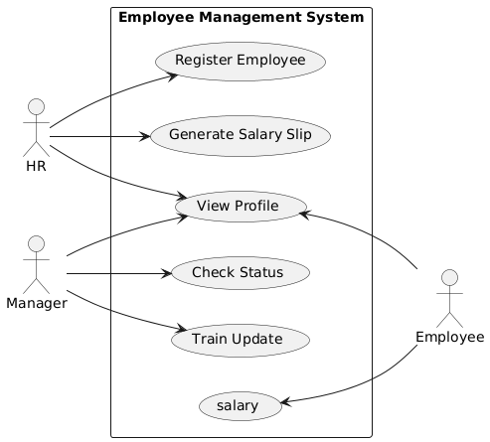

**Figure2.1 essential Usecase**

# CHAPTER THREE REQUIREMENT ANALYSIS MODELING

### Overview of Analysis Model

This chapter presents all the analysis models utilized in developing the specific requirements outlined in this Software Requirements Specification (SRS) document. Each model includes an introduction and a narrative description for clarity.

An analysis model serves as a technical representation of the system, acting as a bridge between the system description and the design model. In analysis modeling, the system's information, behavior, and functions are defined and subsequently translated into architectural, component, and interface-level designs.

The analysis model should:

Establish a framework for software design creation. Clearly describe customer requirements.

Define a set of requirements that can be validated once the software is built. Illustrate the system implementation process.

### System Use Case Model

The use-case model illustrates how various system actors interact with the system to solve specific problems. It outlines user goals, the interactions between users and the system, and the expected behavior of the system in meeting these goals.

Key elements of the use-case model include:

**Use Cases:** Specific functionalities or services provided by the system, detailing the sequences of actions in response to actor requests.

**Actors:** External entities (users, other systems, or devices) that interact with the system, each with distinct goals.

**Relationships:** Connections between use cases and actors, including associations (interactions), generalizations (hierarchies), and include/extend relationships (dependencies).

The use-case model serves several important purposes:

**Specification of Functional Requirements:** It provides a clear, concise specification of functional requirements, ensuring that stakeholders understand the system’s capabilities.

* **Foundation for Analysis and Design:** The model serves as a basis for further analysis and design, facilitating collaboration among developers, stakeholders, and users.
* **Input for Iteration Planning:** It informs iteration planning by identifying critical functionalities that need prioritization in development.
* **Definition of Test Cases:** Use cases guide the creation of test cases, ensuring that the system meets specified requirements.
* **Reference for User Documentation:** The model acts as a resource for user documentation, aiding end-users in understanding how to interact with the system effectively.

By leveraging the use-case model, we can effectively translate user needs into actionable functionalities, ensuring the developed software aligns with user expectations and business objectives.

**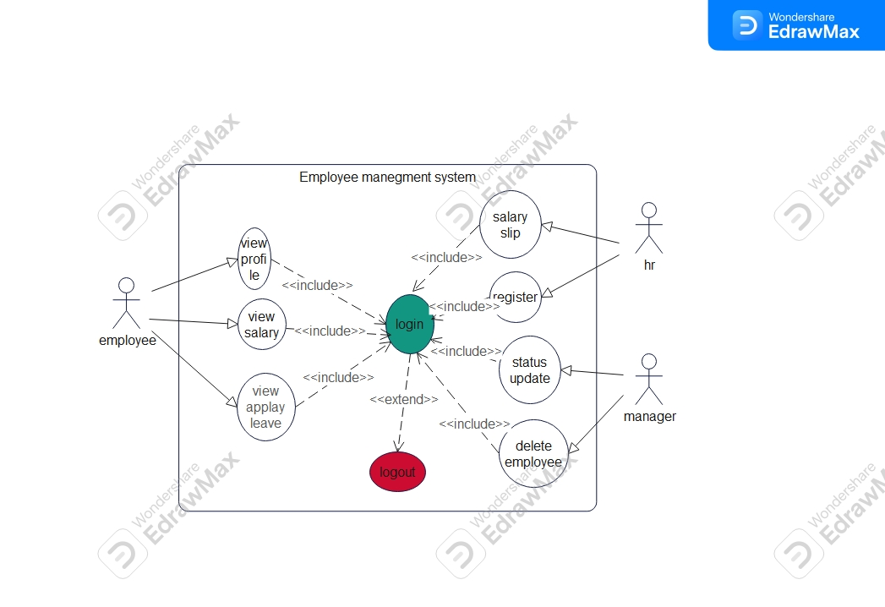**

**Figure3.1 usecase diagam**

### Use case description

|  |  |
| --- | --- |
| Use case name | Login |
| Use case ID | UC1 |
| Actor | Hr,employee,manager |
| Description | Login users that have legal email and password can access the system. |

|  |  |  |
| --- | --- | --- |
| Precondition | The user must register. | |
| Post condition | User must login and do his or her own activity | |
| Basic course of action | User action System response | |
| User open the system | 1.1Thes system display login page. |
|  | The user fills his email and password.  Click **login** button. | 2.1 The system check email password of the user in the database.  3.1The system direct to user page with that account based on the |
|  | Use case ends. | User account. |

Table3.1UC1 Login

|  |  |
| --- | --- |
| Use case name | Add new employee |
| Use case ID | UC1 |
| Actor | hr |
| Description | The hr adds new employee to send reservation requests. |
| Precondition | The hr must login to get admin page. |
| Post condition | The system should display new employee amount for researcher who can log in |
| Basic course of | User action System response |

|  |  |  |
| --- | --- | --- |
| action | User open the system  Super admin **login** to system click login  click add employee button | The system display login page.  The system checks email and password of the user in the database.  The system direct to admin page with that account based on the admin account.  The system display form to add new employee |

Table3.2add employee

|  |  |  |
| --- | --- | --- |
| Use case name | Response request | |
| Use case ID | UC5 | |
| Actor | staff admin | |
| Description | Staff admin view request and accept or reject request | |
| Precondition | The staff admin must login to view researcher request | |
| Basic course of action | User action System response | |
| staff admin open the system  Click **login** button  Click the open box item in sidebar  Staff admin view all requests and response requests based on criteria | The system display login page.  The system checks email and password of the staff admin in the database.  The system direct to staff admin page System should notify send request |

Table3.2response request

### Sequence Diagrams

I used sequence diagrams to model the flow of messages, events, and actions between the objects or components of my system. In these diagrams, time is represented vertically, illustrating the sequence of interactions among the header elements displayed horizontally at the top.

Sequence diagrams primarily serve to design, document, and validate the architecture, interfaces, and logic of the system by detailing the actions required to complete a task or scenario. They are valuable design tools because they offer a dynamic view of system behavior, which can be challenging to capture with static diagrams or specifications.

### IMG_256

**Figure3.2 sequence diagram payroll**

### Activity Diagrams

I primarily used activity diagrams as flowcharts to represent the activities performed by the system. While similar to flowcharts, activity diagrams offer additional capabilities that enhance their functionality.

Before creating the activity diagram, I familiarized myself with the key elements involved. The main components of the activity diagrams include activities (functions performed by the system), associations, conditions, and constraints. Once I identified these elements, I developed a mentlayout of the entire flow, which was then translated into the activity diagram. Below is the activity diagram for WUPS.

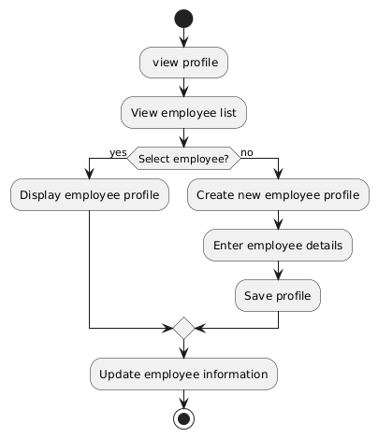

**Figure3.3 Activity diagram to login**

# CHAPTER FOUR SYSTEM DESIGN

### Overview

This document outlines the system design for a gpu information management system in the researcher center. It includes design goals, the proposed system architecture, and object design details.

### Purpose of the System

The purpose of this document is to address the design considerations for the overall system. It provides a comprehensive architectural overview of the proposed system and captures significant architectural decisions made during its development.

### Design Goals

The design goals specify the qualities that the system should achieve and address during its development. These goals are categorized into four key areas:

### Performance

The system must meet the following performance criteria:

Response Time: Depending on the network connection available to the user, the system should interact with and respond to user requests within a maximum of one second.

### Dependability

To ensure the system is resilient and reliable, the following dependability characteristics must be achieved:

* + - * **Robustness:** As a web-based system utilizing a menu-driven interface, user input issues are minimized. However, errors may occur on the server side during data entry. In such cases, the system will display an error page while continuing to operate without failure or crash.
      * **Security:** Access to the system will be restricted to authenticated users. The system employs php Passport, ensuring each authenticated user has their own scope.
      * **Reliability:** The information presented by the system will be trustworthy, maintained by a persistent database, and accurately reflected on the webpage interface.

### 4.16 Maintenance

In time of failure or need modification the system needs to be maintained. To be maintainable the system should meet the following maintenance criteria

* **Extensibility: -**if it is needed to add new functionality to the system, this must be achieved by only making a separate page and integrate this page with the existing system.
* **Modifiability**:-if in the system, some functionality requires to be modified, this modification must be done specifically to that function or page without affecting the overall system organization.
* Portability: -the system is developed to be viewed and retrieved from any web browser regardless of their version and platform it resides in it.

### Hardware/software mapping

The employee management system will have three main components: the user, the web server and the database server. The web server of EMS will run and contain all subsystem. The database server will use SQL server database and will handle all persistent data storage. The client will access the EMS web app through the internet browser (i.e., Mozilla fir fox, google chrome and internet explorer). And also, the client will access the server through the mobile application installed on a smart phone. The web server and the database server will be hosted on the same physical machine. However, it is possible to place on separate machine as needed.

### Low Level Design Model

The LLD phase is the stage where the actual software components are designed. The LLD phase is the stage where the actual software components are designed .Its goal is to give the internal logical design of the actual program code. Low-level design is created based on the high-level design. LLD describes the class diagrams with the methods and relationships between classes and program specifications. It describes the modules so that the programmer can directly code the program from the document. A good low-level design document makes the program easy to develop when proper analysis is utilized to create a low-level design document .The code can

then be developed directly from the low-level design document with minimal debugging and testing. Other advantages include lower cost and easier maintenance.

### Class Diagram

The Class diagram captures the logical structure of the system; the classes and things that make up the model. It is a static model, describing what exists and what and behavior it has, rather than how something is done. Class diagrams are attributes most useful to illustrate relation- ships between classes and interfaces.

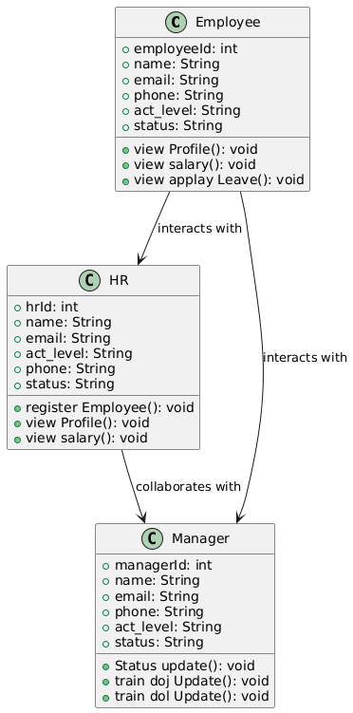

**Figure4.1 class diagram**

### Component Diagram

### Show analysis classes represent conceptual things, which can perform behavior. In design, analysis classes evolve into a number of different kinds of design elements: including  Classes, to represent a set of rather fine-grained responsibilities; Note: Keep In mind that, you have to state everything inline to your project asides to the definitions mentioned underneath  Subsystems, to represent a set of coarse-grained responsibilities, perhaps composed of a further set of subsystems, but ultimately a set of classes;  Active classes, to represent threads of control in the system;  Interfaces, to represent abstract declarations of responsibilities provided by a class or subsystem.

### comp

**Figure4.2 component diagram**

### Deployment Diagram

### Deployment diagrams showing the nodes and allocation of processes and components. Commentary on the networking.

### deplo

### **Figure4.3 Deployment diagram**

### Architectural Design

### Architectural design in an Employee Management System (EMS) refers to the structured framework that outlines the system's components, their relationships, and how they interact to support the functionalities required for managing employee-related processesarcti

Figure4.4 Architectural diagram

## Chapter Five IMPLEMENTATION AND TESTING

### Overview

In this portion of chapter, we used to describe about implementation and testing phase of the system.

### Implementation

Implementation refers to the Coding of all documents gathered starting from requirement analysis to Design phase. In the implementation phase all the programs are written, database is created, user operational document is written, users are trained, and the system tested with operational data. As mentioned earlier I have used to php and bootstrap frameworks to develop our system. In the following we will show the sample codes of our system functionalities to apply for tender/bidding project



**Figure5.1login page**

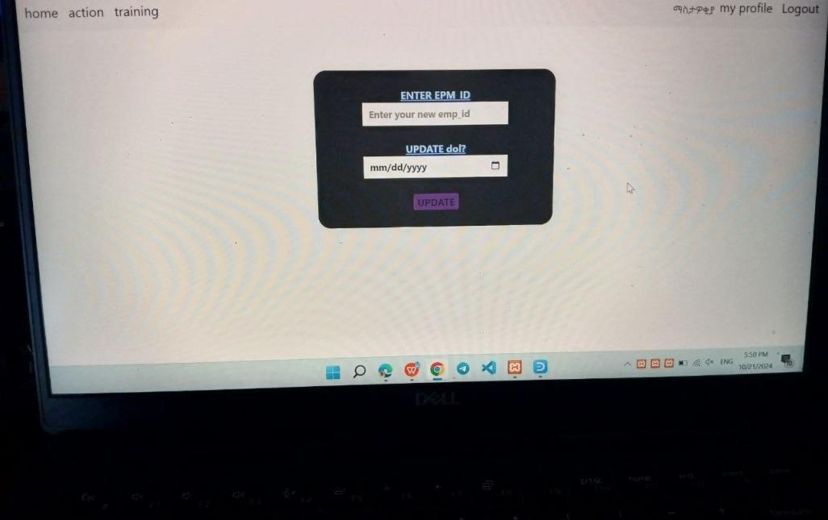

**Figure5.2 status update page**

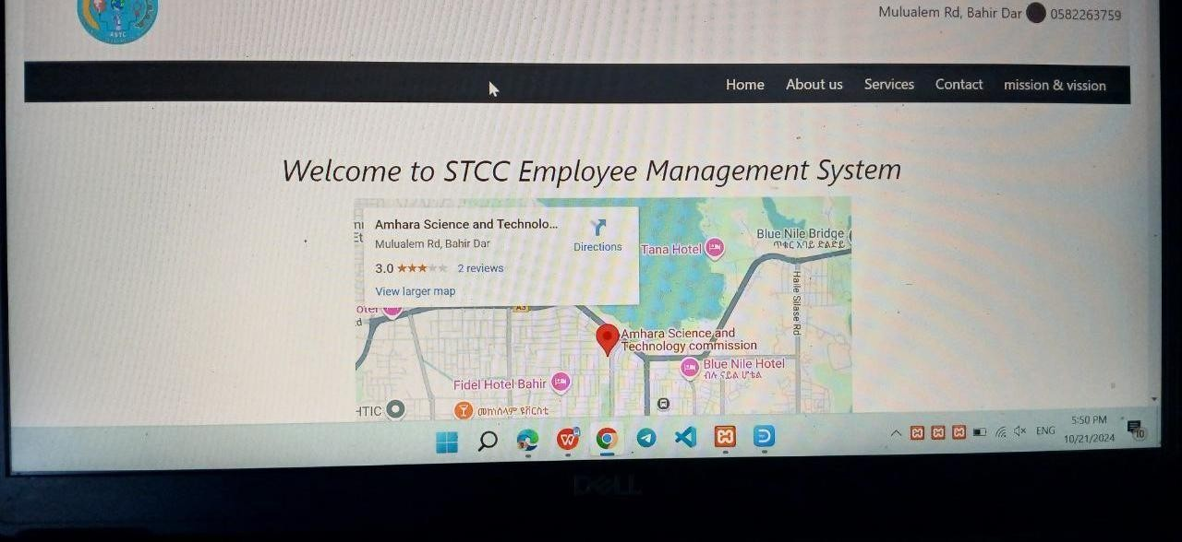

### Testing

##### Figure5.3 manager home page

Testing is the process of evaluating a system or its component with the intent to find that whether it satisfies the specified requirements or not. This activity results in the actual, expected and difference between their results. Testing is executing a system in order to identify any gaps, errors or missing requirements in contrary to the actual desire or requirements.

### Unit Testing

Every module of the System is separately tested. I.e., the team tests every module by applying some selection mechanism. Through this mechanism every module gets tested. If an error occurs correction will be taken without affecting another module. Unit testing gives stress on modules independently of one another, to find errors. This helps the tester in detecting errors in coding and logic that are contained within that module alone. The errors resulting from the Interaction between modules are initially avoided.

### Integration Testing

In this testing part, all the modules will be combined to get there and tested it for its fitness with each other and with the systems functionality. If error occurs in combining them, the module with problem will be identified and re combined.

### System Testing

System test ensures that the entire integrated software system meets requirements. It tests a configuration to insure known and predictable results. System testing is based on process description and flows, emphasizing pre- driven process links and integration points. In essence system testing is not about checking the individual parts of design, but about checking the system as a whole. In effect it is one giant component. System testing ensures the following have been met correctly. These are**:**

Functional requirements

Non-Functional requirements

# CHAPTER SIX CONCLUSION AND RECOMMENDATION

### Conclusion

Employee Management Systems play a pivotal role in modern organizations by centralizing HR processes, streamlining workforce management, and enhancing overall efficiency. Through this brief exploration, we can draw several conclusions regarding the significance and impact of these systems:

**Efficiency and Productivity**: Employee Management Systems streamline HR tasks, automate processes, and reduce manual interventions, leading to improved operational efficiency and increased productivity within the organization.

**Data Centralization and Accessibility**: By consolidating employee data in a centralized system, organizations can access, update, and utilize information more effectively, leading to informed decision-making and better HR strategies.

**Compliance and Risk Mitigation**: These systems help ensure regulatory compliance with labor laws, data protection regulations, and industry standards, reducing legal risks and safeguarding sensitive employee information.

**Employee Engagement and Development**: Through features like performance evaluations, training management, and self-service portals, Employee Management Systems foster employee engagement, skill development, and career growth, contributing to a positive workplace culture.

**Strategic Decision-Making**: Analytics and reporting tools provided by these systems offer valuable insights into key HR metrics, enabling organizations to make data-driven decisions, plan effectively, and optimize their workforce.

**Cost Efficiency and Resource Optimization**: By automating processes, reducing errors, and enhancing resource allocation, Employee Management Systems help organizations cut costs, allocate resources efficiently, and achieve operational excellence.

In conclusion, Employee Management Systems are indispensable tools for modern organizations seeking to effectively manage their human capital, drive employee engagement, and achieve strategic HR objectives. By leveraging these systems, organizations can navigate the complex landscape of HR management with greater ease, efficiency, and effectiveness, ultimately leading to enhanced organizational performance and success.

### Recommendations

Implementing an Employee Management System can bring numerous benefits to an organization, but successful deployment requires careful planning and execution. Here are some key recommendations for organizations considering the implementation of an Employee Management System:

##### Assess Organizational Needs:

Conduct a thorough assessment of your organization's HR processes, pain points, and requirements to identify the features and functionalities needed in an Employee Management System.

##### Involve Stakeholders:

Engage HR professionals, managers, and employees in the selection and implementation process to ensure that the chosen system meets the needs of all stakeholders.

##### Choose the Right System:

Select an Employee Management System that aligns with your organization's size, industry, and specific requirements. Consider factors such as scalability, user-friendliness, customization options, and integration capabilities.

##### Provide Adequate Training:

Offer comprehensive training to HR staff, managers, and employees on how to use the Employee Management System effectively. Training sessions can help maximize system adoption and utilization.

##### Ensure Data Security:

Implement robust data security measures to protect sensitive employee information stored within the system. Utilize encryption, access controls, and regular security audits to safeguard data.

##### Promote Employee Engagement:

Leverage the self-service features of the system to empower employees to manage their information, request leaves, and access relevant HR resources. Encourage employee engagement with the system through training opportunities, feedback mechanisms, and communication tools.

##### Regularly Update and Maintain the System:

Keep the Employee Management System up-to-date with software updates, patches, and enhancements to ensure optimal performance, security, and compatibility with evolving HR needs.

##### Monitor System Usage and Performance:

Track key metrics related to system usage, user satisfaction, and performance to identify areas for improvement and ensure that the system is delivering the expected benefits.

##### Integrate with Other Systems:

Integrate the Employee Management System with other organizational systems such as payroll software, time tracking tools, and performance management systems to ensure seamless data flow and process automation.

##### Seek Feedback and Continuous Improvement:

Encourage feedback from users and stakeholders to identify areas for improvement and innovation. Continuously evaluate the system's effectiveness and make adjustments as needed to optimize its impact on HR processes.

By following these recommendations, organizations can effectively implement an Employee Management System that enhances HR operations, improves workforce management, and contributes.

##### REFERENCES

Internet source, detail design [https://www.tutorialspoint.com](https://www.tutorialspoint.com/uml/uml_class_diagram.htm) Internet source, detail design https://[www.php documentation.com](http://www.djangodocumentation.com/) internet source,youtube

Wollo university kombolcha institute of technology engineering department handout and lecture note