

IT Department

**Geographic Information System (GIS)**

**Ref#:** IT-Service

**Version:** 1.0

**Date:** 04-December-2019

**RCJ Internal Use**

**Mobile App Deployment**

Contents

1. Introduction 3

2. Business/Functional Requirements 3

1. Oracle SQL Developer 3

2. WMS/WFS GeoMedia server 3

3. Mobile Map works configuration 3

4. External services configuration Active directory & Picture upload 3

3. Configuration 3

4. Data base Structure 4

5. Solution Physical and Logical Design 5

6. Mobile App expected Growth and Expansion 6

# Introduction

ESDIM mobile app is developed for android and IOS platform. It is native application developed in java and swift technologies

Its main purpose is view LAR tabular and graphics data in mobile and performs necessary tasks like actions and upload pictures etc. Its provide GPS functionality user can trace LAR on map and check LAR boundary etc. User can see multiple layers on map through map viewer. It also support multiple language and QR scan feature

# Business/Functional Requirements

## Oracle SQL Developer

Install SQL developer and enable rest services for technical details contact with DBA

## WMS/WFS GeoMedia server

Configure WMS and WFS etc. on geo media, for technical details contact with DBA

## Mobile Map works configuration

It is Hexagon component, which is used in mobile app for displaying local data on OSM map

## External services configuration Active directory & Picture upload

Make sure active directory and picture upload services are up, these services are provided by RCJ. These are also on RCJ resource service machine.

# Configuration

* 1. Open source code for java in android studio and for IOS in XCode
  2. Simple attach device and install application, already configured everything services IP etc.,

For switching app production to test server change IP in Global Parm file, which is the part of application

# Data base Structure

The following sections cover the architectural and implementation details to fulfill the requirements and deliver a top-notch mobile application!

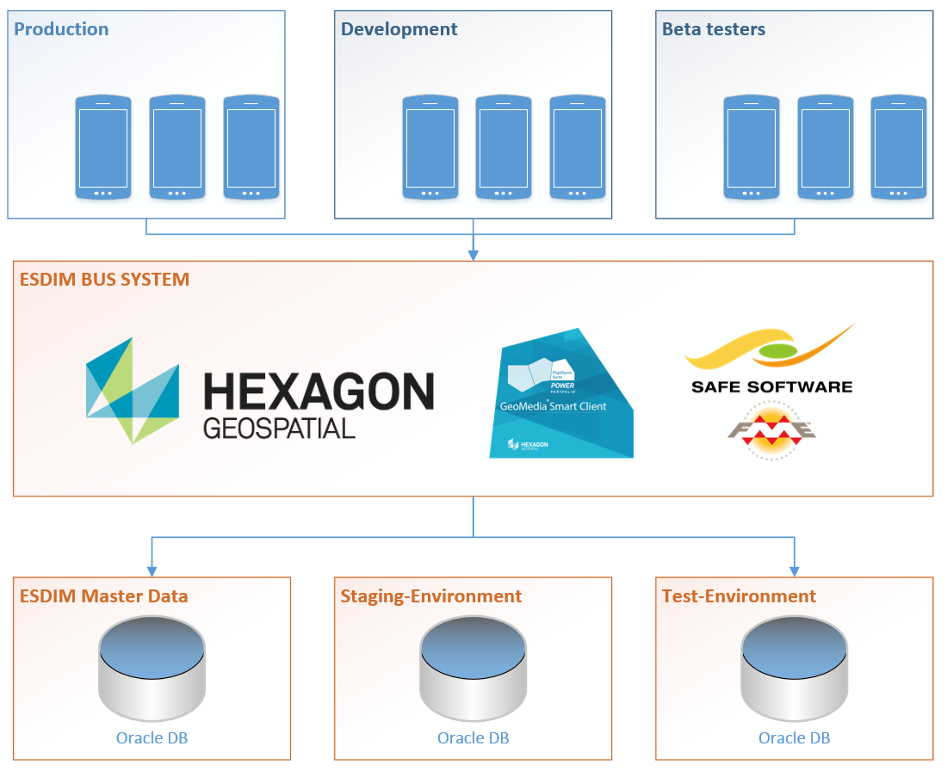

To apply the “separation of concerns” pattern on a high level, the overall architecture is setup as shown in the previous image:

There is the given ESDIM master data system and we will most likely add additional databases the physical storage for testing and audit purpose.

On the upper end, we will end up with at least two different applications because android and iOS are based on different technologies. Those two apps are then again split into different logical groups according to the actual needs. Currently we think of a production group that is using the stable releases, a beta group that is testing new functionalities and a development group that is always working with the latest features for testing purposes.

# Deployment of mobile app

* Create respective packages through xcode and android studio
* Configure mobile map works
  + Install xampp framework on required machine
  + Configure mmw folder in production server for public access (https)
  + Configure mmw folder in Any local machine which has internet connection for local run (http)
* Configure oracle ORDS

# Solution Physical and Logical Design

Mobile application connects with ESDIM database through Restful services in a secured manner.

Below diagram is the better presentation of mobile app implementation. Mobile app connected with ESDIM database through Restful API

Mobile application connects with ESDIM database through Restful services in a secured manner.

Below diagram is the better presentation of mobile app implementation. Mobile app connected with ESDIM database through Restful API

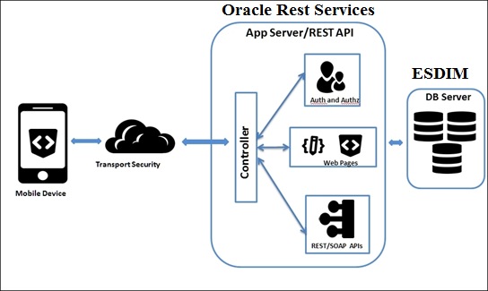

# Mobile App expected Growth and Expansion

* Mobile app server can be expand two different servers for better performance
* Mobile app mobile map works new features can be added in next phase
* Load balancing feature can be added in next phase
* Java micro service based REST API architecture can be introduced in next phase
* Map caching can be implement in future
* Offline mode can be added in future
* Oauth2 JWT based security can be added in next phase
* Mobile Alert
* Mobile Alert Configurator
* Offline authentication and authorization
* Update GIS data through mobile