WEEK 6
INTEGRATIVE
CAPSTONE
Wine Classification &
Unsupervised Segmentation
A complete Data Science with Python pipeline
DATA | EDA | MODELING | INSIGHTS

PROJECT SNAPSHOT
Public Wine Recognition dataset • 178 observations • 13 numeric predictors • 3 classes • Supervised learning + K-Means clustering • Reproducible Python workflow
Prepared as the technical report accompanying the executed Jupyter notebook

1. Executive Summary
This capstone demonstrates an end-to-end Data Science workflow using Python. The project uses the publicly available Wine Recognition dataset to solve two complementary problems: supervised three-class wine classification and unsupervised segmentation. The workflow covers reproducible data acquisition, quality inspection, cleaning, exploratory analysis, preprocessing, model comparison, evaluation, clustering and critical interpretation.
RESULT AT A GLANCE
Random Forest reached 1.0000 test accuracy and weighted F1 on the held-out test set. Logistic Regression and SVM each reached 0.9722 test accuracy. Five-fold cross-validation produced 0.9665, 0.9832 and 0.9833 mean accuracy respectively. K-Means selected k=3 because it gave the highest tested silhouette score of 0.2849.

What the capstone demonstrates
- A reproducible data acquisition and quality-check stage.
- Explicit cleaning, stratified train/test splitting and scale-aware preprocessing.
- EDA used to understand class balance and feature characteristics before modeling.
- Comparison of three supervised algorithms with consistent metrics and cross-validation.
- Unsupervised K-Means analysis with silhouette-based cluster selection.
- Critical interpretation: strong test performance is not the same as production readiness.

1.1 Alignment with the Internship Task
Requirement | Implemented in this project
Problem statement | Three-class wine classification + descriptive clustering
Data collection | Wine Recognition dataset loaded reproducibly with scikit-learn
Data cleaning | Missing-value and duplicate checks; duplicate removal retained in pipeline
EDA | Class distribution, descriptive statistics and visualizations
Modeling | Logistic Regression, Random Forest, SVM and K-Means
Evaluation | Accuracy, precision, recall, F1, 5-fold CV, confusion matrix, silhouette score
Insights / recommendations | Feature importance, limitations, next steps and critical analysis
Reflection | Challenges, design decisions, leakage control and lessons learned

2. Problem Statement, Objectives & Scope

2.1 Problem Statement
Given numerical measurements of wine samples, the supervised task is to predict which of three known wine classes a sample belongs to. The complementary unsupervised task is to investigate whether standardized measurements naturally form compact groups without using the class label during clustering.

2.2 Objectives
- Build a reproducible end-to-end Data Science pipeline in Python.
- Inspect and clean the dataset before modeling.
- Use EDA to understand class distribution and feature characteristics.
- Compare multiple supervised algorithms using consistent evaluation criteria.
- Add K-Means clustering to discover structure in the feature space.
- Use cross-validation and multiple metrics rather than relying on accuracy alone.
- Document design decisions, challenges, limitations and future improvements.

2.3 Scope
This is an educational capstone, not a production system. The analysis demonstrates technical workflow and analytical reasoning. Practical deployment would require independent validation, additional data and domain expertise.

3. Data Collection & Dataset Study
The Wine Recognition dataset is accessed through scikit-learn's built-in loader. This makes the acquisition step reproducible because the dataset does not depend on a manually maintained local CSV file.
Property | Value
Observations | 178
Predictor features | 13 continuous / numeric features
Target classes | 3
Missing values before cleaning | 0
Duplicate rows before cleaning | 0
Final cleaned observations | 178

Core acquisition code:
from sklearn.datasets import load_wine
import pandas as pd
wine = load_wine(as_frame=True)
df = wine.frame.copy()
df["target_name"] = df["target"].map(
dict(enumerate(wine.target_names))
)
print("Shape:", df.shape)
print("Classes:", list(wine.target_names))
print("Missing values:", int(df.isna().sum().sum()))
print("Duplicate rows:", int(df.duplicated().sum()))

4. Data Cleaning & Preprocessing

4.1 Data Quality Checks
The executed notebook reports zero missing values and zero duplicate rows. Although no substantial correction was required, duplicate removal is retained in the workflow so that the pipeline explicitly verifies data quality rather than assuming that a dataset is clean.

4.2 Train/Test Split
The dataset is divided into 80% training data (142 samples) and 20% test data (36 samples). random_state=42 makes the split reproducible, while stratification preserves the relative class distribution.
Partition | Shape
Training set | 142 × 13
Test set | 36 × 13

4.3 Feature Scaling
StandardScaler is used for Logistic Regression, SVM and K-Means. These methods are sensitive to feature scale: large-valued variables can otherwise dominate optimization or distance calculations.

4.4 Leakage Control
For the supervised pipelines, scaling is placed inside scikit-learn Pipeline objects. This ties preprocessing to the training portion during validation and reduces the risk of accidentally allowing test-set information to influence model fitting.
from sklearn.model_selection import train_test_split
df = df.drop_duplicates()
X = df[wine.feature_names]
y = df["target"]
X_train, X_test, y_train, y_test = train_test_split(
X, y, test_size=0.20,
random_state=42, stratify=y
)

5. Exploratory Data Analysis
EDA is treated as a decision-making stage rather than only a visualization step. Class counts help assess whether severe imbalance could distort evaluation, while descriptive statistics reveal the very different numeric ranges across the 13 predictors.
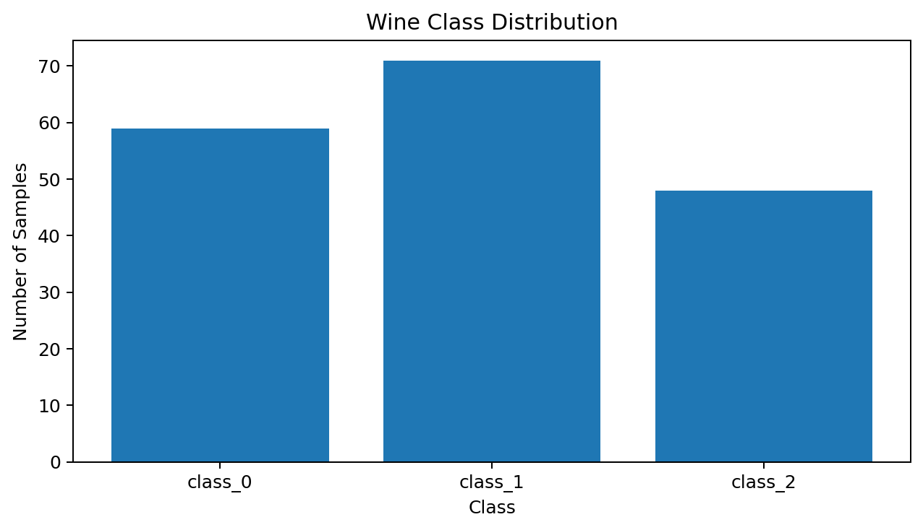
Figure 1. Distribution of the three wine classes.
Class | Samples
class_0 | 59
class_1 | 71
class_2 | 48

Selected descriptive statistics:
Feature | Mean | Std | Min | Max
alcohol | 13.00 | 0.81 | 11.03 | 14.83
malic_acid | 2.34 | 1.12 | 0.74 | 5.80
magnesium | 99.74 | 14.28 | 70.00 | 162.00
color_intensity | 5.06 | 2.32 | 1.28 | 13.00
proline | 746.89 | 314.91 | 278.00 | 1680.00

6. Methodological Approach & Model Design
The supervised comparison deliberately uses algorithms with different inductive biases. This reduces the risk of selecting a model only because it was chosen in advance and provides a more informative comparison of the dataset's separability.
Model | Role | Key settings
Logistic Regression | Interpretable baseline | StandardScaler; max_iter=3000
Random Forest | Nonlinear ensemble; feature importance | 300 trees; random_state=42
SVM (RBF) | Flexible nonlinear decision boundary | RBF; C=1.0; gamma='scale'; StandardScaler
K-Means | Unsupervised structure discovery | Standardized features; k selected by silhouette

6.1 Supervised Model Training
from sklearn.pipeline import Pipeline
from sklearn.preprocessing import StandardScaler
from sklearn.linear_model import LogisticRegression
from sklearn.ensemble import RandomForestClassifier
from sklearn.svm import SVC
models = {
"Logistic Regression": Pipeline([
("scaler", StandardScaler()),
("model", LogisticRegression(
max_iter=3000, random_state=42))
]),
"Random Forest": RandomForestClassifier(
n_estimators=300, random_state=42),
"SVM": Pipeline([
("scaler", StandardScaler()),
("model", SVC(
kernel="rbf", C=1.0, gamma="scale"))
])
}

6.2 Unsupervised K-Means
K-Means groups observations by minimizing within-cluster squared distance to cluster centroids. Because the algorithm is distance-based, standardized features are used. Candidate values of k are compared using silhouette score, which balances cluster cohesion and separation.

7. Model Evaluation & Results
Each classifier is fitted on the training partition and evaluated on the held-out test partition. Five-fold cross-validation provides an additional estimate of stability and reduces dependence on one train/test split.
Model | Accuracy | Precision | Recall | F1 | 5-Fold CV
Random Forest | 1.0000 | 1.0000 | 1.0000 | 1.0000 | 0.9665
Logistic Regression | 0.9722 | 0.9741 | 0.9722 | 0.9720 | 0.9832
SVM | 0.9722 | 0.9741 | 0.9722 | 0.9720 | 0.9833

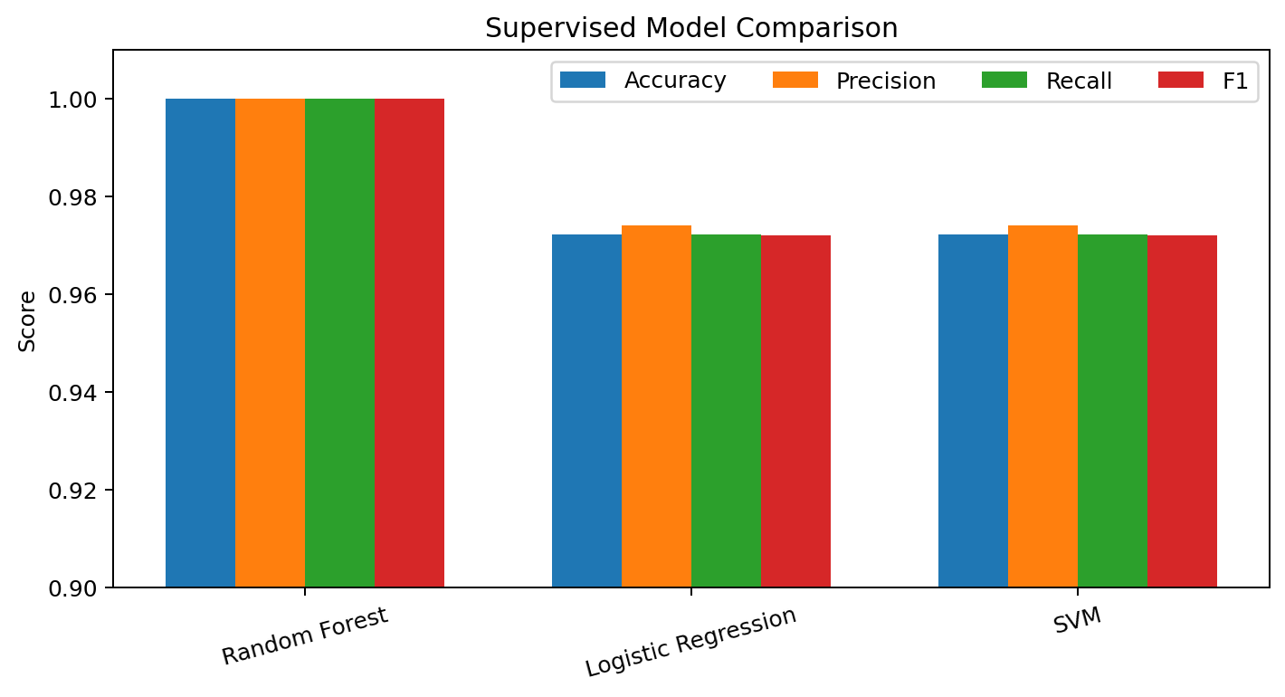
Figure 2. Comparison of supervised model metrics.
INTERPRETATION
Random Forest is the selected model under the report's primary ranking by held-out weighted F1. However, Logistic Regression and SVM show higher five-fold CV means (0.9832 and 0.9833) than Random Forest (0.9665). This is an important reason not to interpret a perfect test score as universal superiority.

7.1 Detailed Evaluation of the Selected Model
Class | Precision | Recall | F1 | Support
class_0 | 1.00 | 1.00 | 1.00 | 12
class_1 | 1.00 | 1.00 | 1.00 | 14
class_2 | 1.00 | 1.00 | 1.00 | 10
Macro avg | 1.00 | 1.00 | 1.00 | 36
Weighted avg | 1.00 | 1.00 | 1.00 | 36

Confusion matrix for Random Forest:
[[12 0 0]
[ 0 14 0]
[ 0 0 10]]

8. Hyperparameter Sensitivity
The executed notebook includes actual sensitivity experiments rather than only describing tuning conceptually. These experiments show how model settings can influence cross-validation performance even when the held-out test metrics remain similar.

8.1 Random Forest: Number of Trees
n_estimators | Test Accuracy | Test F1 | CV Mean
50 | 1.0000 | 1.0000 | 0.9610
100 | 1.0000 | 1.0000 | 0.9721
200 | 1.0000 | 1.0000 | 0.9665
300 | 1.0000 | 1.0000 | 0.9665
500 | 1.0000 | 1.0000 | 0.9663

All tested tree counts produced 1.0000 test accuracy and 1.0000 test F1 on this split. The best reported CV mean among these settings was 0.9721 at 100 trees, while 200–300 trees produced 0.9665.
rf_rows = []
for n in [50, 100, 200, 300, 500]:
model = RandomForestClassifier(
n_estimators=n, random_state=42)
model.fit(X_train, y_train)
pred = model.predict(X_test)
# accuracy, F1 and 5-fold CV are recorded here

8.2 SVM: C Parameter
C | Test Accuracy | Test F1 | CV Mean
0.1 | 0.9722 | 0.9720 | 0.9663
0.5 | 0.9722 | 0.9720 | 0.9833
1 | 0.9722 | 0.9720 | 0.9833
2 | 0.9722 | 0.9720 | 0.9889
10 | 0.9444 | 0.9432 | 0.9889

The SVM test accuracy remained 0.9722 through C=2, while C=10 reduced test accuracy to 0.9444. The reported CV mean reached 0.9889 at C=2 and C=10, illustrating why validation should be considered alongside a single held-out score.

9. Unsupervised Analysis — K-Means
The clustering stage does not use the target labels to fit K-Means. The standardized feature matrix is clustered first; the known labels can only be used later for descriptive comparison. This keeps the analysis genuinely unsupervised during cluster formation.
k | Silhouette | Inertia | Decision
2 | 0.2593 | 1658.7589
3 | 0.2849 | 1277.9285 | Selected
4 | 0.2586 | 1175.3519
5 | 0.2315 | 1107.0073
6 | 0.2372 | 1046.0023

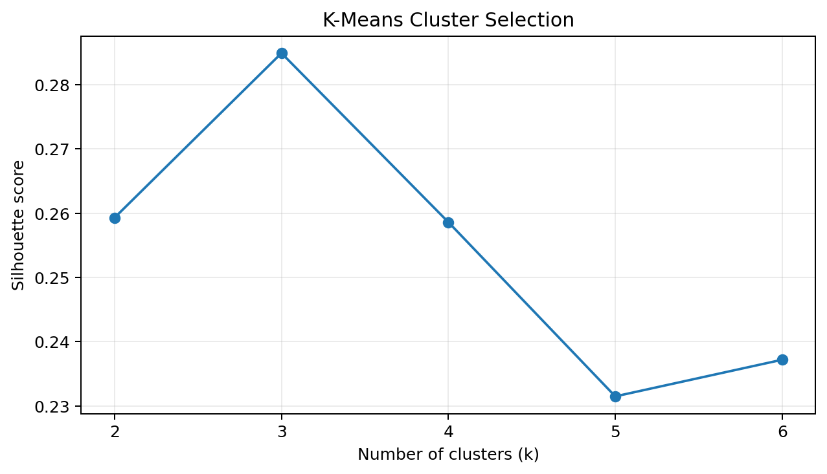
Figure 3. Silhouette scores for tested K-Means cluster counts.
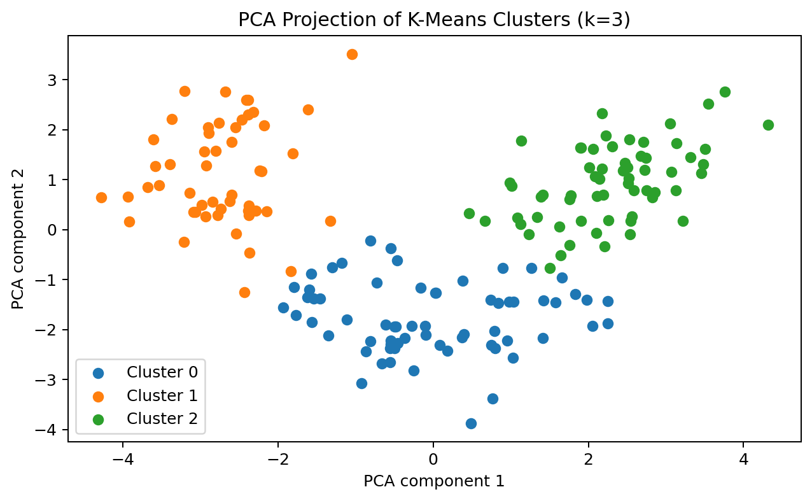
Figure 4. PCA projection of the K-Means clusters for k=3.
CLUSTERING CONCLUSION
k=3 produced the highest tested silhouette score (0.2849). This indicates the strongest cohesion/separation among the tested values, but it does not prove that the clusters exactly reproduce the known wine classes.
from sklearn.preprocessing import StandardScaler
from sklearn.cluster import KMeans
from sklearn.metrics import silhouette_score
X_scaled = StandardScaler().fit_transform(X)
for k in range(2, 7):
model = KMeans(
n_clusters=k, random_state=42, n_init=20)
labels = model.fit_predict(X_scaled)
score = silhouette_score(X_scaled, labels)

10. Feature Importance & Analytical Insights
The Random Forest feature-importance output identifies which variables contributed most strongly to prediction within this fitted model. It should not be interpreted as causal evidence. Correlated predictors can share or redistribute importance.
Feature | Random Forest Importance
color_intensity | 0.1808
flavanoids | 0.1729
proline | 0.1511
alcohol | 0.1124
hue | 0.0996
od280/od315_of_diluted_wines | 0.0904
total_phenols | 0.0516
malic_acid | 0.0331

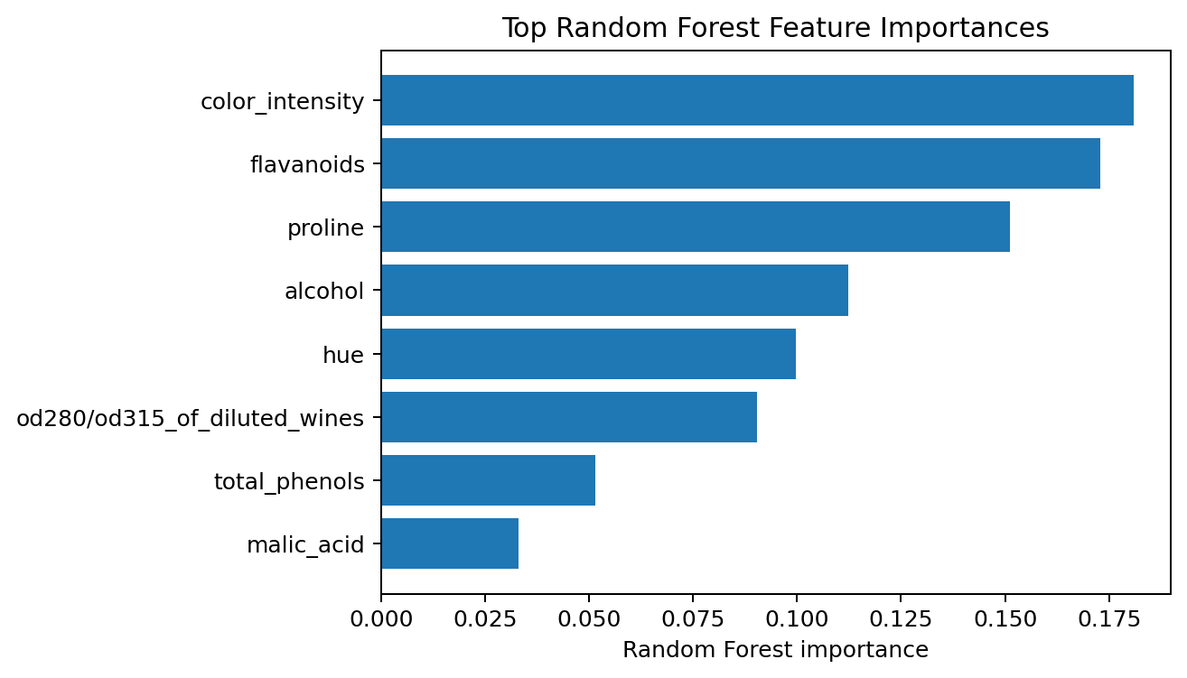
Figure 5. Most important features reported by the Random Forest model.

Key insights
1. The dataset is clean at ingestion. The notebook reports zero missing values and zero duplicate rows, and the final cleaned dataset remains at 178 observations.
2. Feature scales differ substantially. For example, proline has a mean of 746.89 while hue has a mean of 0.96, supporting scale-aware preprocessing for distance/optimization-based methods.
3. The held-out test set is perfectly separated by Random Forest. All 36 test samples were classified correctly, producing a diagonal confusion matrix.
4. Cross-validation gives a more nuanced picture. Logistic Regression and SVM have higher mean five-fold accuracy than Random Forest in the reported experiment.
5. Unsupervised structure is weaker than supervised separability. The best silhouette score is 0.2849, so the cluster structure should be treated as moderate exploratory evidence rather than definitive class recovery.

11. Challenges, Design Decisions & Reflection
Challenge | Why it matters | Response
Different feature scales | Large-valued features can dominate distance calculations and optimization. | StandardScaler used where appropriate.
Small dataset | A single split can give unstable estimates. | Five-fold cross-validation added.
Model selection bias | Accuracy alone can hide class-specific weaknesses. | Precision, recall, F1 and confusion matrix included.
Over-reliance on labels | Supervised metrics do not reveal hidden structure. | K-Means and silhouette analysis added.
Interpretability | High performance does not automatically explain why predictions occur. | Feature importance and model comparison included.
Reproducibility | Different random splits can change results. | Fixed random_state values and reproducible loader used.

11.1 What Could Go Wrong?
- Data leakage can make evaluation unrealistically optimistic.
- An unlucky train/test split can produce misleading estimates.
- Excessive hyperparameter tuning on the test set can invalidate the final score.
- Clusters may look meaningful visually without having a useful real-world interpretation.
- A perfect test score on a small controlled dataset may not transfer to future or externally collected samples.

11.2 Reflection on Successes
The main success of the project is the integration of multiple Data Science stages into one reproducible workflow. EDA, preprocessing, model development and evaluation are connected rather than treated as isolated exercises. The project also demonstrates that a strong metric is only one component of a trustworthy solution: data quality, leakage prevention, cross-validation, multiple metrics, interpretability and limitations all matter.

12. Insights, Recommendations & Future Work
Use model comparison: Do not select an algorithm before seeing how different inductive biases perform.
Retain cross-validation: Use it to assess stability rather than relying on one held-out split.
Perform systematic tuning: Use cross-validated search when higher robustness is required.
Validate externally: Test on an independent dataset before considering practical deployment.
Expand error analysis: Investigate class-specific errors in future model revisions.
Strengthen clustering analysis: Compare K-Means with hierarchical clustering or DBSCAN and evaluate stability.
Separate importance from causality: Treat feature importance as model-specific evidence, not causal explanation.
Monitor future data: If the pipeline is ever deployed, track data quality and distribution drift.
FINAL TAKEAWAY
The capstone successfully covers the requested internship pipeline: acquisition → cleaning → EDA → supervised modeling → evaluation → unsupervised analysis → insights → reflection. The strongest result is Random Forest's 1.0000 held-out test performance, while the most important analytical caution is that the small, controlled dataset and the CV comparison mean this result should not be generalized without external validation.

Appendix A. Core Python Workflow
The following compact excerpts represent the main technical stages from the executed notebook. The complete executed notebook should be submitted alongside this report when the internship bundle allows multiple files.
# Model evaluation
from sklearn.metrics import (
accuracy_score, precision_score,
recall_score, f1_score
)
from sklearn.model_selection import cross_val_score
for name, model in models.items():
model.fit(X_train, y_train)
pred = model.predict(X_test)
accuracy = accuracy_score(y_test, pred)
precision = precision_score(
y_test, pred, average="weighted")
recall = recall_score(
y_test, pred, average="weighted")
f1 = f1_score(
y_test, pred, average="weighted")
cv_mean = cross_val_score(
model, X, y, cv=5,
scoring="accuracy").mean()
# Final evaluation
from sklearn.metrics import classification_report, confusion_matrix
best_model.fit(X_train, y_train)
best_pred = best_model.predict(X_test)
print(classification_report(
y_test, best_pred,
target_names=wine.target_names))
print(confusion_matrix(y_test, best_pred))
# K-Means selection
cluster_rows = []
for k in range(2, 7):
model = KMeans(
n_clusters=k,
random_state=42,
n_init=20
)
labels = model.fit_predict(X_scaled)
cluster_rows.append({
"k": k,
"Silhouette": silhouette_score(
X_scaled, labels),
"Inertia": model.inertia_
})

Appendix B. Submission Checklist
- ✓ Detailed DOCX project report
- ✓ Problem statement and objectives
- ✓ Data acquisition and cleaning
- ✓ EDA and visualizations
- ✓ Supervised modeling
- ✓ Unsupervised modeling
- ✓ Evaluation metrics and implications
- ✓ Challenges and critical analysis
- ✓ Recommendations and reflection
- ✓ Python code examples
- ✓ Executed notebook as technical companion

