Software Development Specifications
For
ActiveHour

An application to suggest activities based on users interest by detecting the idleness of user’s smartphone.
Version 1.0 approved
Prepared by: Abid Hassan, Afnan Bin Mustafij, Fatin Fuad Karim ,Rahma Akter Bithi.
Organisation: Fall2019.CSE327.3.T1
Date created: 30/10/2019

Index

1.1 Purpose of the Document

1.2 Document Conventions

1.3 Intended Audience and Reading Suggestions

2. Design Components

3. Database Design

4. UML diagram

5. Details of class

1. Introduction

1.1 Purpose of the Document
This design document describes all the data, architectural, interface and component level designs for the Software. The design specification provides explicit information about the requirements for the product and how the product will be put together.
1.2 Document Conventions
Typical document conventions are maintained where main topics are bold, have a font size of about 18pt. Sub topics are bold, have a smaller font size of about 14pt and are numbered with the main topic number as a prefix, eg 1.1 to 1.5.
1.3 Intended Audience and Reading Suggestions
The intended audience for this document are project managers and developers. This document is meant to be used as a guideline for all the development needs of its creators. The document contains several technical terminologies and diagrams; hence readers are advised to have predetermined knowledge about the topics covered.
2. Design Components
Our application is a web and android based app which will suggest the user to different stuff depending on his activity level. For the web view of the project backend of the project Django will be used as it's comparatively easy. The front end will be designed using- JavaScript, HTML, CSS and BOOTSTRAP. We will use MySql database for the project. The android app will be developed on android studio and the language will be kotlin or Java.

To reduce complexity, we are using MTV. The MVT (Model View Template) is a software design pattern. It has three important components Model View and Template. The Model helps to handle database. It is a data access layer which handles the data. The Template is a presentation layer which handles User Interface part completely. The View is used to execute the business logic and interact with a model to carry data and renders a template.
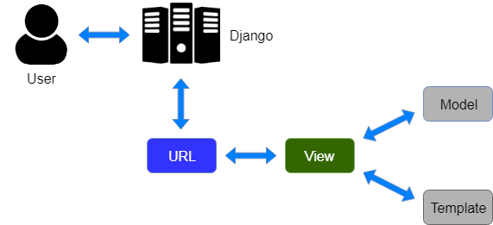

3. Database Design
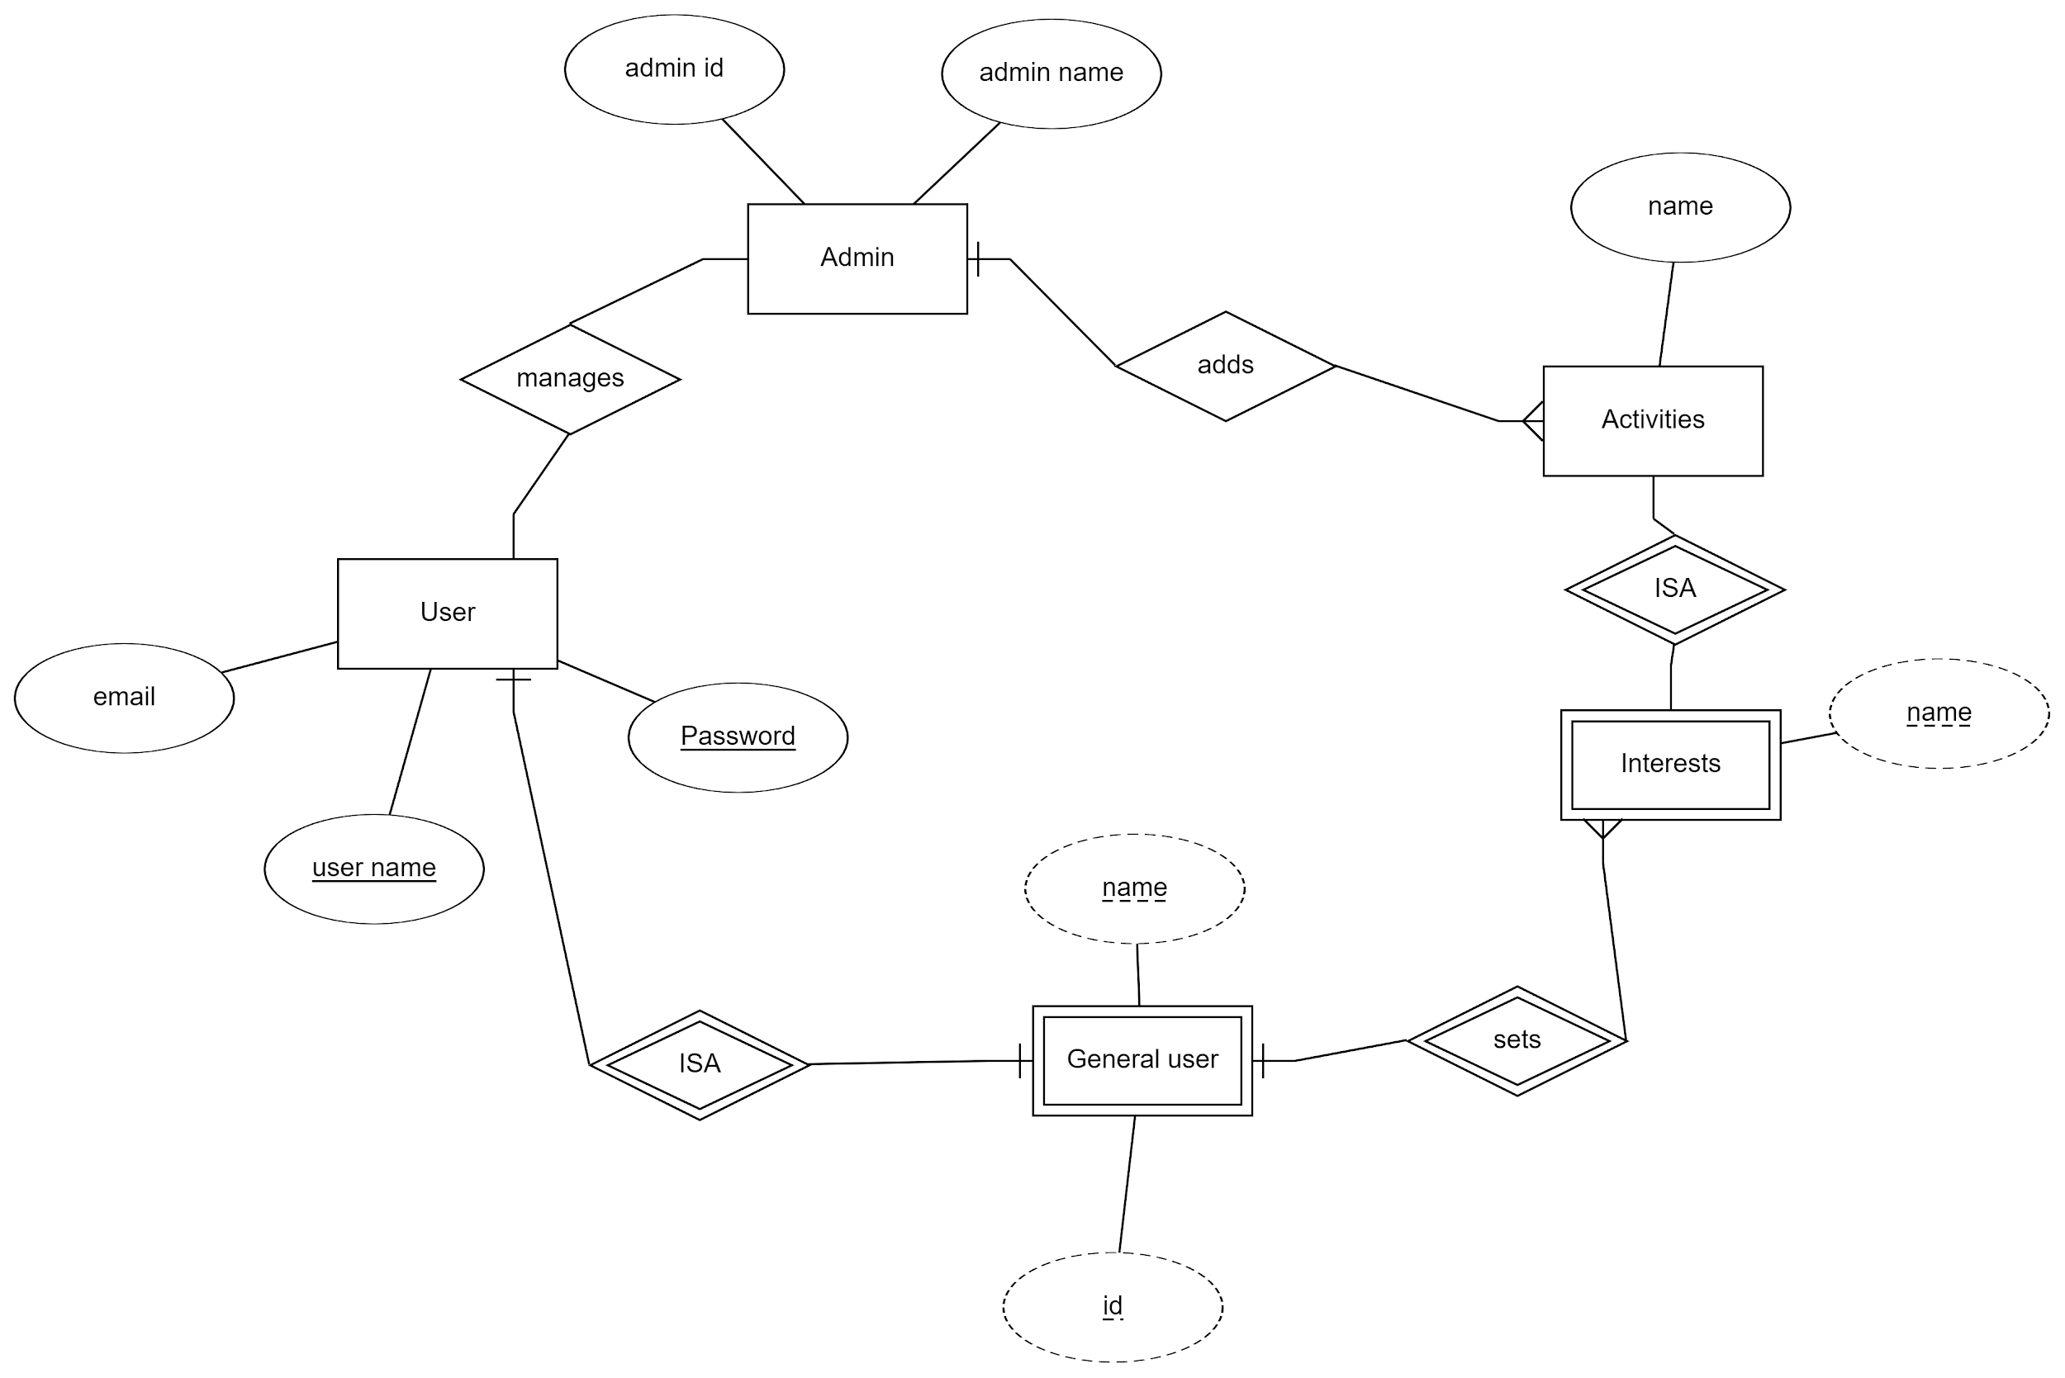

4. UML diagram
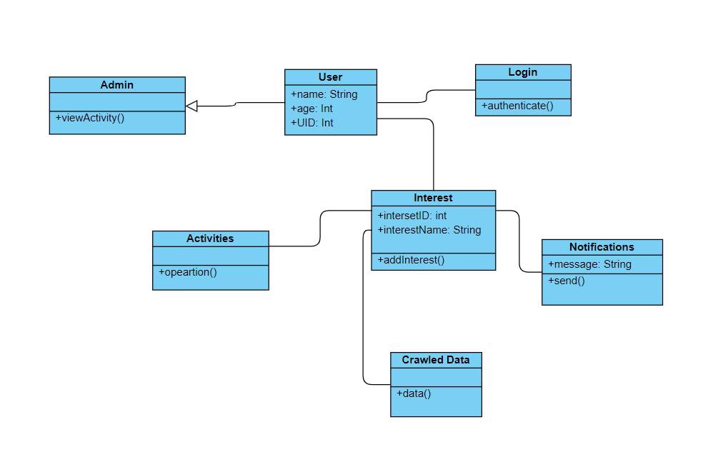
5. Details of the class:

