Software Requirements Specifications

For

**ActiveHour**

An application to suggest activities based on users interest by detecting the idleness of user’s smartphone.

**Version 1.0 approved**

**Prepared by: Abid Hassan, Afnan Bin Mustafij, Fatin Fuad Karim ,Rahma Akter Bithi.**

**Organisation: Fall2019.CSE323.11.T1**

**Date created: 01/11/2019**

**Table of Contents**

**Table of Contents ii**

**Revision History ii**

**1. Introduction 1**

1.1 Purpose 1

1.2 Document Conventions 1

1.3 Intended Audience and Reading Suggestions 1

1.4 Product Scope 1

1.5 References 1

**2. Overall Description 2**

2.1 Product Perspective 2

2.2 Product Functions 2

2.3 User Classes and Characteristics 2

2.4 Operating Environment 2

2.5 Design and Implementation Constraints 2

2.6 User Documentation 2

2.7 Assumptions and Dependencies 3

**3. External Interface Requirements 3**

3.1 User Interfaces 3

3.2 Hardware Interfaces 3

3.3 Software Interfaces 3

3.4 Communications Interfaces 3

**4. System Features 4**

4.1 System Feature 1 4

4.2 System Feature 2 (and so on) 4

**5. Other Nonfunctional Requirements 4**

5.1 Performance Requirements 4

5.2 Safety Requirements 5

5.3 Security Requirements 5

5.4 Software Quality Attributes 5

5.5 Business Rules 5

**6. Other Requirements 5**

**Appendix A: Glossary 5**

**Appendix B: Analysis Models 5**

**Appendix C: To Be Determined List 6**

**Revision History**

|  |  |  |  |
| --- | --- | --- | --- |
| **Name** | **Date** | **Reason For Changes** | **Version** |
|  |  |  |  |

# Introduction

## Purpose

In this document software requirement specifications for “an application to suggest activities based on user’s interest by detecting the idleness of user’s smartphone” is documented and the version number here is 1.0.

Our application will be a smart companion of the user to suggest him various activities, detecting the idleness of the phone. This application will suggest user to do something based on his interest. For example, the app may suggest to read a new article on user’s interest, or suggest a walk to a nearby park etc.

## Document Conventions

Front page:

Title of the project:

Font: Arial

Face: Bold

Size: 32

Others titles and descriptions:

Font: Arial

Face: Bold

Size: 14

Main section titles:

Font: Times

Face: Bold

Size: 18

Subsection titles:

Font: Times

Face: Bold

Size: 14

Description:

Font: Arial

Face: Normal

Size: 1

## Intended Audience and Reading Suggestions

As this is an academic project under Operating system course,the main audience of this document are developers for this project, our course instructor Rashed Mazumder sir and designated personnel by our course instructor. The index page gives a proper summary of the placement of the titles. The best way to read this document is to go step by step. But the part “2. Overall Description” can give a fast overview in short.

## Product Scope

This product can work as a smart companion of the user. This can help the user to get a more refined user experience. Our present goal for this 1.0 version is to make an application to deliver activity suggestion based on the users’ idleness on smartphone. But with further release and versions we try to get new improvements.

**2. Overall Description**

## Product Perspective

Our application will be a system to suggest the user various activities on his interest, depending on the idleness of his phone. The system will have both android app and web service. The web service will only be used to set the interest topics and monitor user’s activity which was done through this app. The mobile app and the website both will have same database access.

## Product Functions

The smartphone app is the main trigger of this project. Smartphones has sensors to count movements. Again, smartphone takes count of its screen standby time. With the help of this functionality, we can track if the phone is in idle mode or not. If the phone is idle the app will send notifications suggesting user to do something of his taste. The user has to set up his or her preferred tasks or activities what he likes. According to the taste of the user the application will send him links or tasks he would love to do.

## User Classes and Characteristics

The user is the all in all of this application. He is the sole administrator or user of this application.

The user will have access to the administrative panel of both Android app and web interface to manage the app and collect or edit data according to his choice.

## Operating Environment

The system will have functionality in both Android and Web environment.

## Design and Implementation Constraints

As the app will have a shared database between Android and web environment, internet connection is a constraint. Again, the smartphone will depend on his accelerometer sensor to detect the user’s idleness by its phone movement. Accelerometer is not fully accurate.

## 1.10 User Documentation

User documentation will be provided in future versions of SRS. It will be available soon after our first prototype.

## Assumptions and Dependencies

For this project we are depending on strong internet connect connection and different sensors and the functionalities of the sensors of a smartphone. The internet and the sensor need to perform well in order to run the project smoothly. The smartphone application needs to have permission to run in the background all the time in order to work properly.

# External Interface Requirements

## User Interfaces

For application end the user will be asked to sign up with necessary details for a single time. The user will be kept logged in as long as the user doesn’t intentionally get logged himself out. For web interface the user will find log in or create an account option. After logging in both of interfaces the user will see an admin panel where he can set all his interest and all other settings such as notification. Selected interested topic will be on the home screen of the android application and web view.

## Hardware Interfaces

The hardware devices for this project will be PC and smartphone. The PC must be able to connect to the internet and have a decent internet connection. The smartphone is also needed to be connected to the internet. Android devices at version Android 7.0 and above will be good to go with the application.

## Software Interfaces

We have agreed on that the android app will be developed using Kotlin and and the web interface will have HTM5, CSS, JavaScript at the frontend. For the backend we will use Node.js. If there needs to be any change, it will be declared later.

## Communications Interfaces

The communication between the interfaces will be done using the same database for web and smartphone app version of the project.

# System Features:

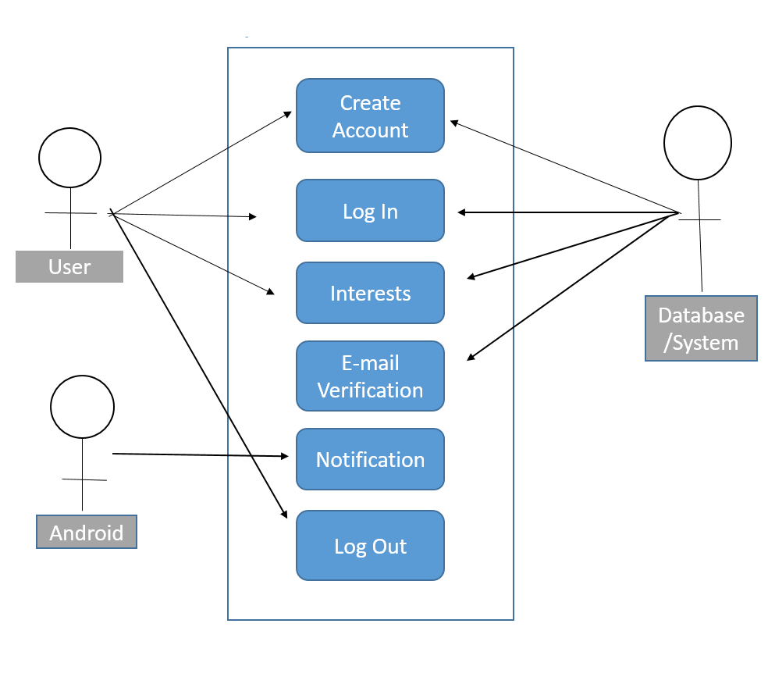

**Expanded use cases:**

**USE Case Name: Create Account**

Type: Primary

Actor: User, System

Brief Overview:

The user will create an account using First and Last name, password, confirmation of password and an email address. E-mail is to verify all the information given by the user. The features need have database association in order to register user’s information.

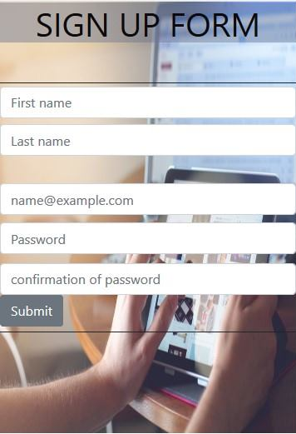

**USE CASE Name: Log In**

Type: Primary

Actor: User, System

Brief Overview:

User can log in to his account using the Email address and password, he provided during account creation. After this step, the user will be allowed to view the home screen. The application needs to be matched with the data stored in the database in order to let the user Log in.

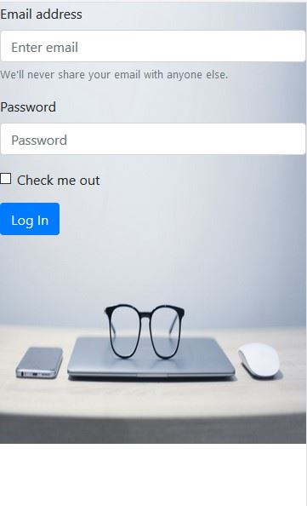

**USE Case Name: Interests**

Type: Primary

Actor: User, System

Brief Overview:

User will save his interest to notifications based on his interests or priority. User will get notifications based on the interest he will save. Android push notifications will be required to send notifications to the user.

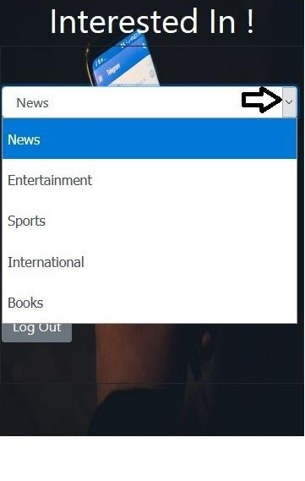

**USE Case Name: Email Verification**

Type: Primary

Actor: System

Brief Overview:

E-mail address will be given the user while account creation. Email needs to be verified to check if the user is authentic and not registered before. If the email id is present in the database from before then it there will be a warning displayed with message.

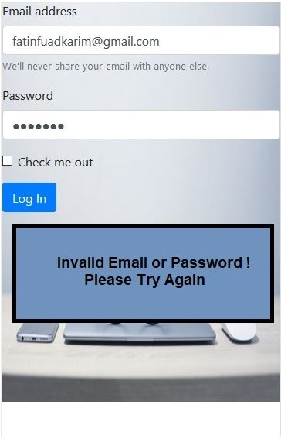

**USE Case Name: Notification**

Type: Primary

Actor: Android App

Brief Overview:

User will get a notification based on the interests he saved before. That will be saved in the database. And the notification will be sent to user by Android push notification.

**USE Case Name: Log Out**

Type: Primary

Actor: User

Brief Overview:

The user can log out from the mobile application using this feature. He will stop getting notification after that.

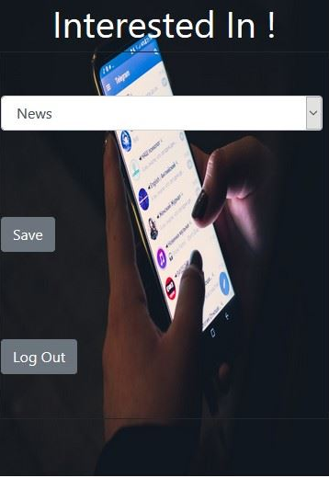

# Other Nonfunctional Requirements

## Performance Requirements

Android Push notifications: Android push notifications is a must for this project. It will let the user to get involved into something that he will like.

## Safety Requirements

As the user will put on his interest on this application it is very crucial to main the confidentiality. The database has to be well protected in order to maintain the security.

## Security Requirements

Login security: The login process should be secure enough to protect unauthorized login.

Database security: The database should be secured enough to block any types of data stealing.

## Software Quality Attributes

Reliability**:** The application should be reliable enough to give valid suggestions

Maintainability: This application should be written in such a way that will allow any further development.

Availability: This app should operable from both Web and Android platform.

## Business Rules

A good user experience must be provided in order to use the app more efficiently. The suggestions should be well accurate enough and should not bother the user at any circumstances.

# Other Requirements

As we will search the web for finding suggestions based on users interest, so there will be no suggestions for any type block within the region the user is staying. So the user has to be aware during adding interests.

**Appendix A: Glossary**

There was no use of appendix.

**Appendix B: Analysis Models**

We will use class diagrams in future versions.

**Appendix C: To Be Determined List**

The API level for android usage is to be determined. We will clear that in future versions of SRS.