

**Department of CSE**

**Software Engineering and System Analysis Lab (CSE 356)**

**Assignment**

Schema Diagram of Blood Donation Management System (RedRescue)

**Submitted By :**

**Fahima Abida Chowdhury**

ID: 0432220005101135

Semester: Spring-2025

Batch: 52(6B1)

**Submitted To :**

**Khandoker Nosiba Arifin**

Lecturer

Department of CSE

University of Information Technology and Sciences

**Date of Submission:** 11.03.2025

**Title** : **Schema Diagram of Blood Donation Management System**

**Objectives**

* To design a relational database schema for managing blood donation processes efficiently.
* To understand the relationship between different entities in the database.
* To ensure data integrity and consistency in blood donation records.

**Schema Diagram Description**

The schema diagram represents the structure of the database tables, their attributes, and relationships in the Blood Donation Management System. The following entities are included:

1. **Donor**: Stores donor information such as name, age, blood group, contact details, and donation history.
2. **Receptionist**: Manages donor registration and blood requests.
3. **Blood Bank Manager**: Oversees blood bank operations.
4. **Blood Bank**: Stores blood units and tracks issuance.
5. **Hospital**: Requests and receives blood for patients.
6. **Patient**: Represents individuals receiving blood donations.
7. **Blood**: Stores blood type and cost information.
8. **DonationReq**: Handles blood donation requests and their statuses.
9. **BloodTransaction**: Records blood donation transactions, linking donors to their respective blood units.

**Schema Components and Relationships**

* **Primary Keys (PK):** Each table has a unique identifier.
* **Foreign Keys (FK):** Establish relationships between tables.
* **One-to-Many Relationships:**
  + A donor can have multiple donation requests.
  + A hospital can request multiple blood units.
  + A blood bank manages multiple blood donations.

**Diagram**

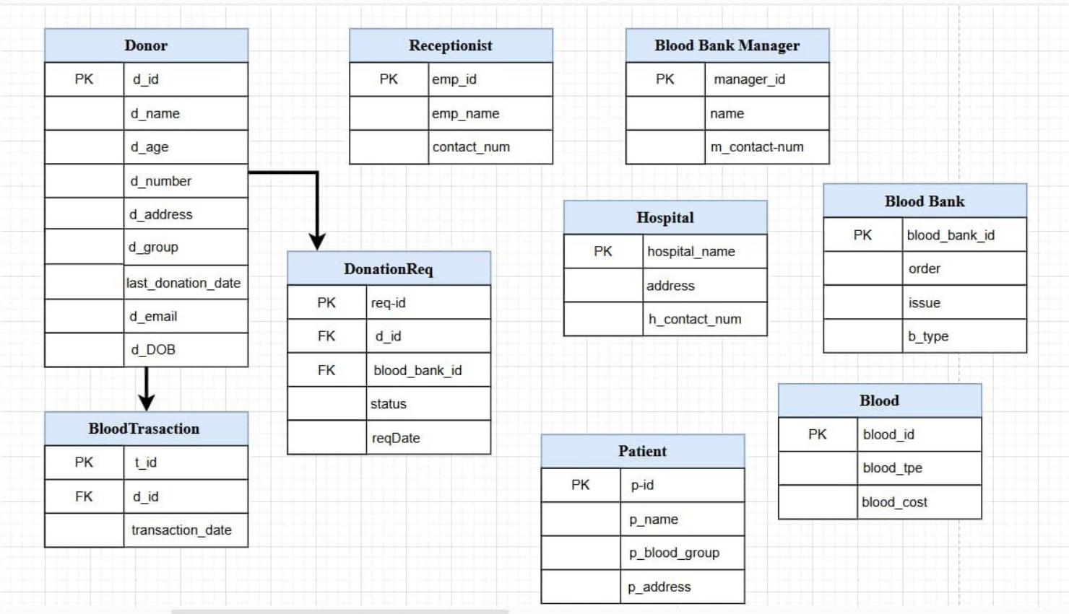

**Discussion**

* The schema ensures efficient data retrieval and management of blood donations.
* Relationships between tables are properly defined to prevent redundancy and maintain consistency.
* Normalization is applied to avoid data anomalies and improve database performance.
* The design allows for easy tracking of blood requests, donations, and transactions.

**Conclusion**

The schema diagram provides a well-structured relational database model for a Blood Donation Management System. By implementing this schema, data can be managed systematically, ensuring accurate tracking of donors, blood storage, hospital requests, and patient records. This model facilitates efficient blood donation processes while maintaining data integrity and security.