

**Department of CSE**

**Software Engineering and System Analysis Lab (CSE 356)**

**LAB REPORT 2**

Class Diagram of Blood Donation Management System (RedRescue)

**Submitted By :**

**Fahima Abida Chowdhury**

ID: 0432220005101135

Semester: Spring-2025

Batch: 52(6B1)

**Submitted To :**

**Khandoker Nosiba Arifin**

Lecturer

Department of CSE

University of Information Technology and Sciences

**Date of Submission:** 11.03.2025

**Experiment No: 02**

**Experiment Name:** Class Diagram of Blood Donation Management System (RedRescue)

**Objectives:**

* To understand the object-oriented design of the Blood Donation Management System.
* To create a class diagram that represents the key entities and their relationships.
* To analyze the interaction between different components in the system.

**Apparatus Required:**

* Computer with UML modeling software (Lucidchart, Draw.io)
* Reference materials on UML class diagrams
* Blood Donation System use case description

**Theory:**  
 A **Class Diagram** is a fundamental part of UML (Unified Modeling Language) used to represent the structure of a system by showing its classes, attributes, operations, and relationships among objects.

**Blood Donation Management System (RedRescue)** is designed to manage the process of blood donation efficiently. The system includes various entities such as donors, blood banks, hospitals, patients, and transaction records. The key functionalities include donor registration, blood storage, blood issuing, donation requests, and hospital orders.

**Main classes in the diagram:**

1. **BloodBankManager:** Manages blood banks.
2. **Receptionist:** Registers donors and handles blood orders.
3. **Donor:** Provides blood donation details.
4. **Blood:** Represents donated blood and its properties.
5. **BloodBank:** Stores and issues blood as per hospital requests.
6. **Hospital:** Orders and receives blood for patients.
7. **Patient:** Checks available donors and receives blood.
8. **DonationRequestTable:** Handles blood donation requests from donors to blood banks.
9. **BloodTransactionTable:** Records transaction details, including donor, recipient, unit of blood, transaction date, and method type.

**Diagram:**

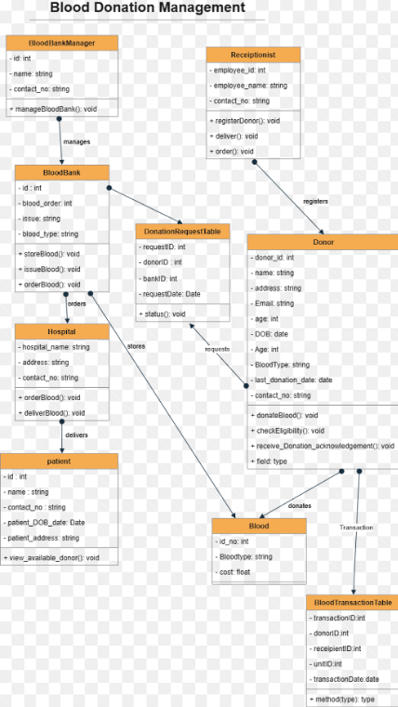

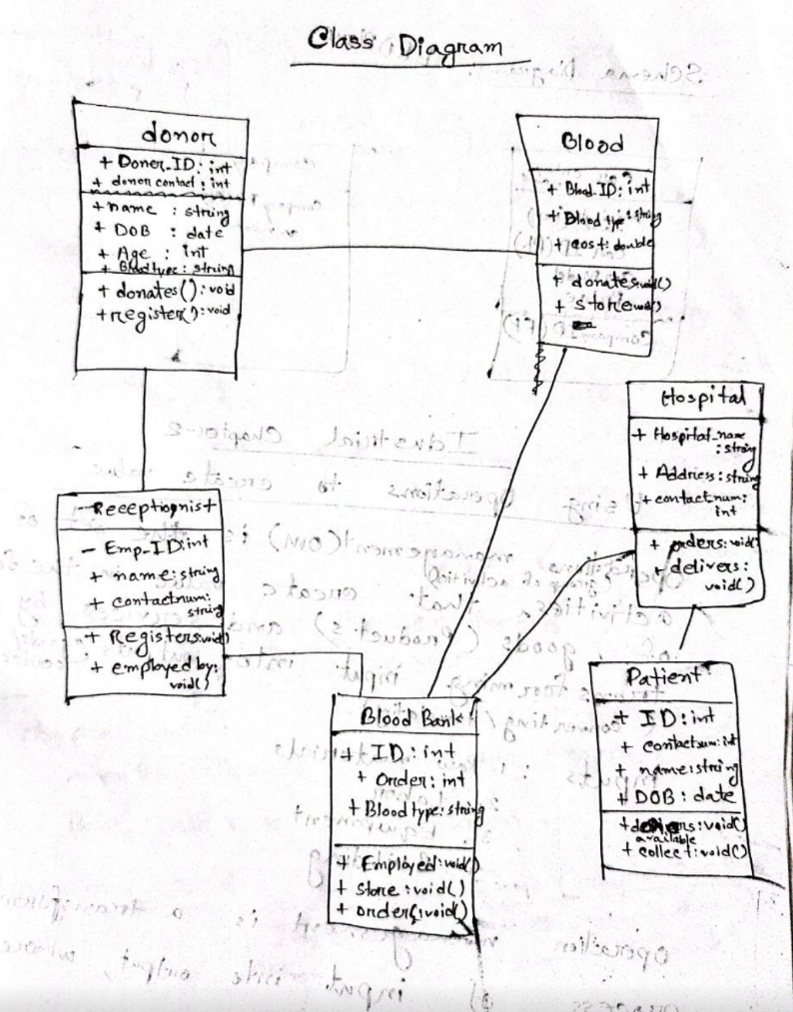

**Result and Discussion:**

* The relationships such as **"manages," "registers," "orders," "stores," "delivers," "requests,"** and **"donates"** ensure smooth workflow representation.
* Encapsulation is maintained by defining attributes as **private (-)** and methods as **public (+)** for controlled access.
* The system ensures efficient blood management, from donor registration to hospital delivery and transaction tracking.

**Conclusion:**  
 The **Blood Donation Management System** class diagram provides a structured approach to understanding how different components interact. It helps in designing an efficient system that simplifies donor registration, blood storage, ordering, donation request tracking, and delivery processes. The addition of **DonationRequestTable** and **BloodTransactionTable** further enhances transparency and efficiency. The use of UML class diagrams ensures clarity in software development, making system implementation more manageable.