**Department of CSE**

**Compiler Lab (CSE 352)**

**Lab Report 02**

Recognizing Strings Matching Patterns: 'a', 'a*b+', and 'aab'

**Submitted By :**

**Fahima Abida Chowdhury**

ID: 0432220005101135

Semester: Spring-2025

Batch: 52(6B1)

**Submitted To :**

[**Md. Ismail**](https://uits.edu.bd/md-ismail/)

Lecturer

Department of CSE

University of Information Technology and Sciences

**Experiment No.: 02**  
**Experiment Name:** Recognizing Strings Matching Patterns: 'a', 'a*b+', and 'aab'

**Problem Statement**

The aim of this lab is to develop a C program that recognizes whether a given input string matches any of the following regular expression patterns:

1. 'a' – A single character string consisting of the letter a.
2. 'a*b+' – Zero or more occurrences of a followed by one or more occurrences of b.
3. 'aab' – The exact string "aab".

By matching input strings against these patterns, the program simulates a basic lexical analyzer using pattern recognition logic.

**Implementation**

#include <stdio.h>

#include <string.h>

#include <stdbool.h>

bool is_a(const char *str) {

return strcmp(str, "a") == 0;

}

bool is_a_star_b_plus(const char *str) {

int i = 0;

while (str[i] == 'a') {

i++;

}

int b_count = 0;

while (str[i] == 'b') {

i++;

b_count++;

}

return (b_count > 0 && str[i] == '\0');

}

bool is_aab(const char *str) {

return strcmp(str, "aab") == 0;

}

int main() {

char input[100];

printf("Enter a string: ");

scanf("%s", input);

if (is_a(input)) {

printf("String matches pattern 'a'\n");

} else if (is_a_star_b_plus(input)) {

printf("String matches pattern 'a*b+'\n");

} else if (is_aab(input)) {

printf("String matches pattern 'aab'\n");

} else {

printf("String does not match any pattern.\n");

}

return 0;

}

**Input**

The program reads a string from standard input.

**Example Input 1:**

a

**Example Input 2:**

aaabbb

**Example Input 3:**

aab

**Output**

The output is a message indicating which pattern the string matches.

**Example Output for Input 1:**

String matches pattern 'a'

**Example Output for Input 2:**

String matches pattern 'a*b+'

**Example Output for Input 3:**

String matches pattern 'aab'

If the input string does not match any of the three patterns, the output will be:

String does not match any pattern.

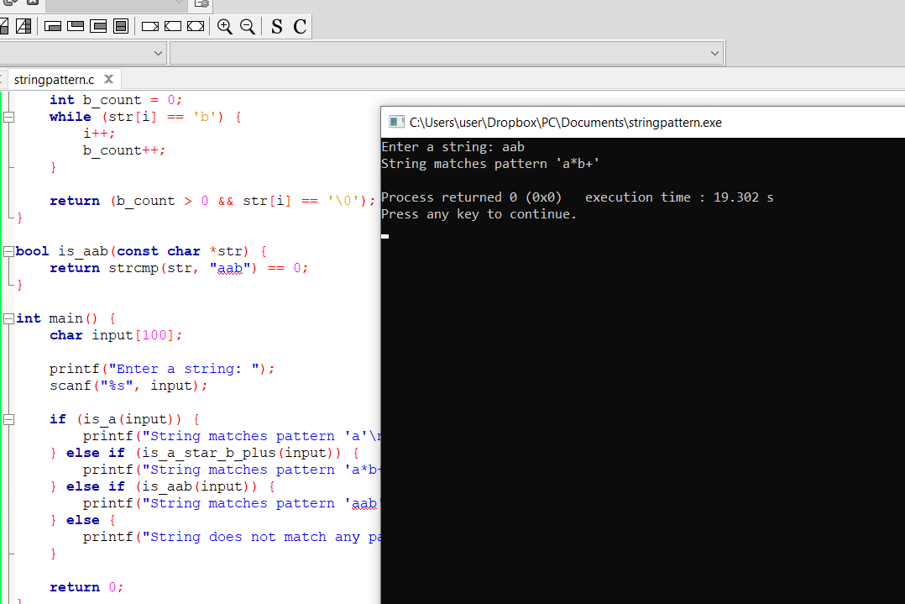

**Conclusion**

This experiment demonstrates how to implement basic pattern recognition using C. The program accurately identifies strings that match the patterns 'a', 'a*b+', and 'aab' through the use of string comparison and character-by-character analysis.

This is a practical introduction to concepts used in lexical analysis and regular expressions, providing foundational knowledge for more advanced topics in compiler design and string pattern matching.