Lab Plan – 10 & 11: Text Fields, Navigation and Weather App using weather api
Task 1: Create a Flutter Project
- Open VS Code or Android Studio.
- Use shortcut:
Ctrl + Shift + P → Flutter: New Project (for VS Code).
- Name your project lab_10 and set up the folder location.

Task 2: Add Home Screen (Main.dart)
- Add an AppBar with Centered Text (Notepad) and background color and Foreground Colors using themes
- Add two buttons at the center of the screen.
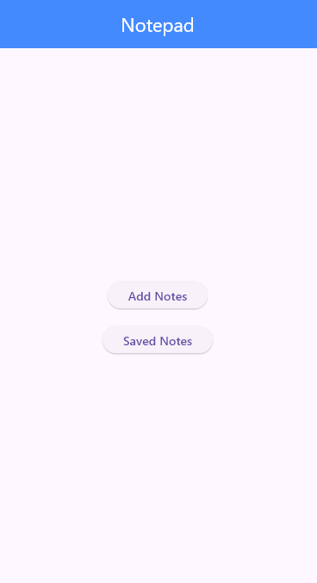

Task 3: Add Notes Screen
- By Clicking on Add notes on Home screen the user navigates to the Add Notes screen.
- Add an AppBar with Centered Text (Add Notes) and background color and Foreground Colors using themes
- Add text field on which user can add notes
- Add two buttons Add (Adds the notes) and Home (Going Back to home page)
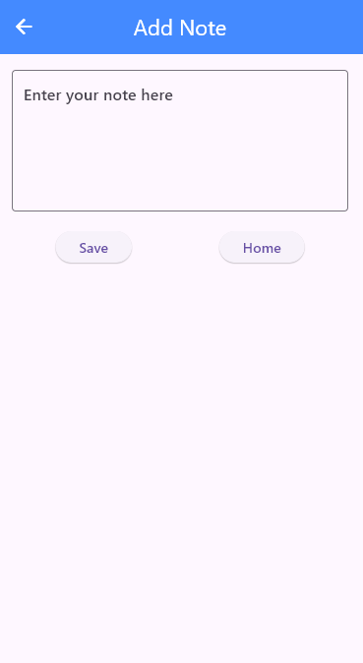

Task 4: Saved Notes Screen
- By Clicking on Saved notes on Home screen the user navigates to the Saved Notes screen.
- Add an AppBar with Centered Text (Saved Notes) and background color and Foreground Colors using themes
- The user should View the Notes Added by the user
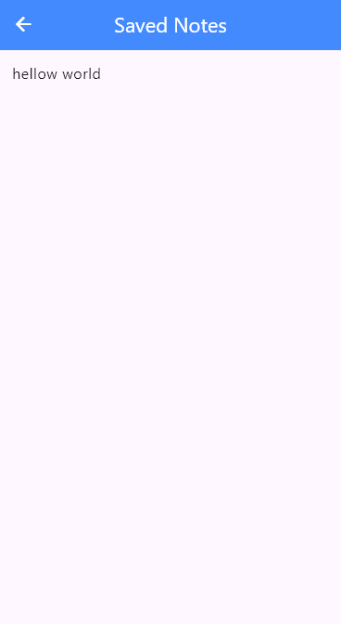

Task 5: Weather App
- Create an application the shows the Current Location in the form of longitude and latitude by using a geolocator class and also use Spin kit while the user is not allowed to access the location and Get the location and show it on the screen

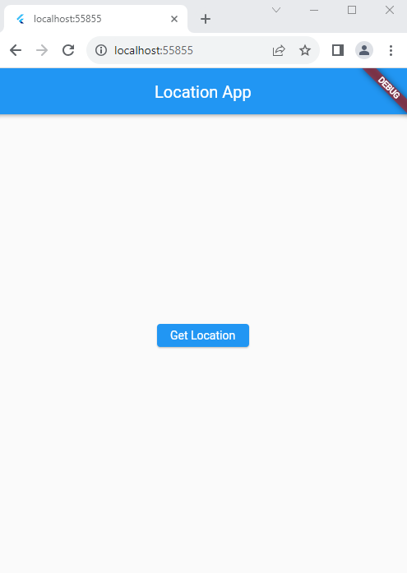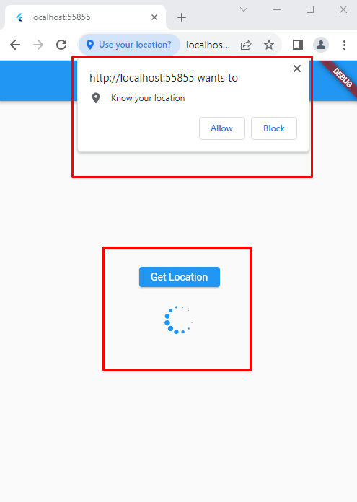

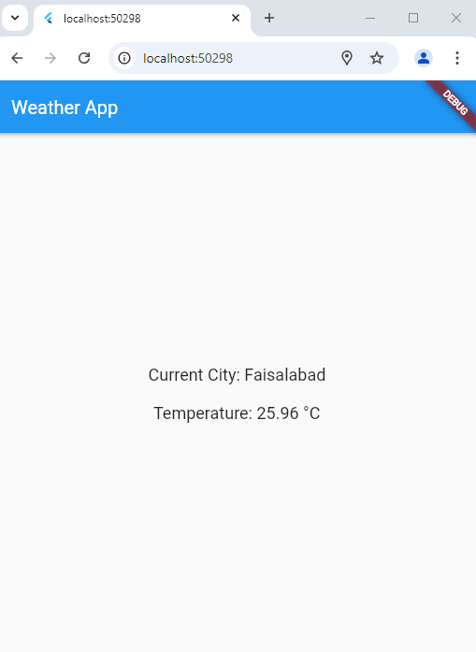

Lab 11
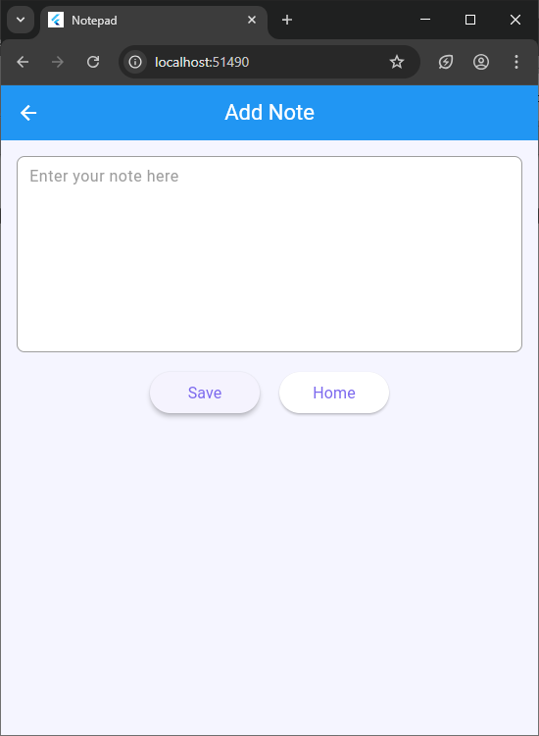
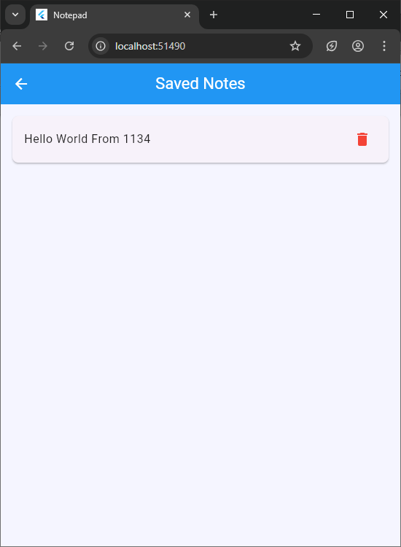
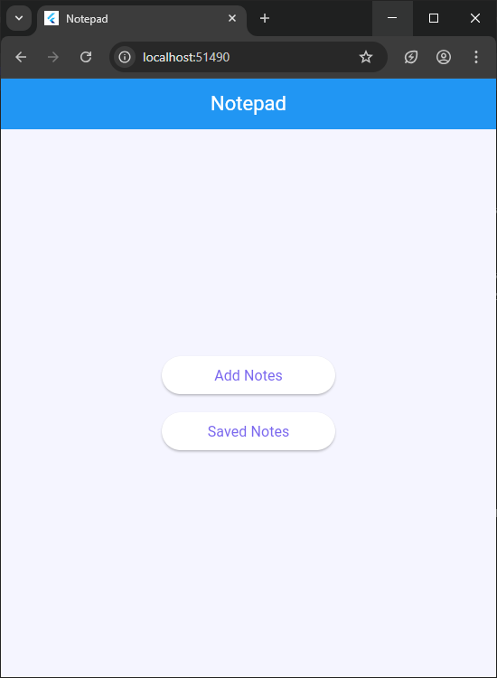
Screenshots

Code:
main.dart
import 'package:flutter/material.dart';
import 'add_note_page.dart';
import 'saved_notes_page.dart';

void main() {
runApp(const MyApp());
}

class MyApp extends StatelessWidget {
const MyApp({super.key});

@override
Widget build(BuildContext context) {
return MaterialApp(
debugShowCheckedModeBanner: false,
title: 'Notepad',
theme: ThemeData(primarySwatch: Colors.blue),
home: const NotepadHome(),
);
}
}

class NotepadHome extends StatelessWidget {
const NotepadHome({super.key});

@override
Widget build(BuildContext context) {
return Scaffold(
appBar: AppBar(
title: const Text('Notepad', style: TextStyle(color: Colors.white)),
backgroundColor: Colors.blue,
centerTitle: true,
),
body: Container(
color: const Color(0xFFF5F5FF),
child: Center(
child: Column(
mainAxisAlignment: MainAxisAlignment.center,
children: [
ElevatedButton(
onPressed: () {
Navigator.push(
context,
MaterialPageRoute(
builder: (context) => const AddNotePage(),
),
);
},
style: ElevatedButton.styleFrom(
backgroundColor: Colors.white,
foregroundColor: const Color(0xFF7B68EE),
minimumSize: const Size(200, 50),
shape: RoundedRectangleBorder(
borderRadius: BorderRadius.circular(25),
),
elevation: 2,
),
child: const Text('Add Notes', style: TextStyle(fontSize: 16)),
),
const SizedBox(height: 20),
ElevatedButton(
onPressed: () {
Navigator.push(
context,
MaterialPageRoute(
builder: (context) => const SavedNotesPage(),
),
);
},
style: ElevatedButton.styleFrom(
backgroundColor: Colors.white,
foregroundColor: const Color(0xFF7B68EE),
minimumSize: const Size(200, 50),
shape: RoundedRectangleBorder(
borderRadius: BorderRadius.circular(25),
),
elevation: 2,
),
child: const Text(
'Saved Notes',
style: TextStyle(fontSize: 16),
),
),
], ),
), ),
); }}
notes_service.dart
class NotesService {
static final NotesService _instance = NotesService._internal();
factory NotesService() => _instance;
NotesService._internal();

final List<String> _notes = [];

List<String> get notes => List.unmodifiable(_notes);

void addNote(String note) {
if (note.isNotEmpty) {
_notes.add(note);
}
}

void deleteNote(int index) {
if (index >= 0 && index < _notes.length) {
_notes.removeAt(index);
}
}

void updateNote(int index, String note) {
if (index >= 0 && index < _notes.length && note.isNotEmpty) {
_notes[index] = note;
}
}
}

saved_notes_page.dart
import 'package:flutter/material.dart';
import 'notes_service.dart';

class SavedNotesPage extends StatefulWidget {
const SavedNotesPage({super.key});

@override
State<SavedNotesPage> createState() => _SavedNotesPageState();
}

class _SavedNotesPageState extends State<SavedNotesPage> {
final NotesService _notesService = NotesService();

@override
Widget build(BuildContext context) {
return Scaffold(
appBar: AppBar(
leading: IconButton(
icon: const Icon(Icons.arrow_back, color: Colors.white),
onPressed: () => Navigator.pop(context),
),
title: const Text('Saved Notes', style: TextStyle(color: Colors.white)),
backgroundColor: Colors.blue,
centerTitle: true,
),
body: Container(
color: const Color(0xFFF5F5FF),
child: _notesService.notes.isEmpty
? const Center(
child: Text(
'No notes saved yet',
style: TextStyle(fontSize: 16, color: Colors.grey),
),
)
: ListView.builder(
padding: const EdgeInsets.all(16.0),
itemCount: _notesService.notes.length,
itemBuilder: (context, index) {
return Card(
margin: const EdgeInsets.only(bottom: 12.0),
elevation: 2,
shape: RoundedRectangleBorder(
borderRadius: BorderRadius.circular(8),
),
child: ListTile(
contentPadding: const EdgeInsets.symmetric(
horizontal: 16.0,
vertical: 8.0,
),
title: Text(
_notesService.notes[index],
style: const TextStyle(
fontSize: 16,
color: Colors.black87,
),
),
trailing: IconButton(
icon: const Icon(Icons.delete, color: Colors.red),
onPressed: () {
setState(() {
_notesService.deleteNote(index);
});
ScaffoldMessenger.of(context).showSnackBar(
const SnackBar(
content: Text('Note deleted'),
duration: Duration(seconds: 1),
),
);
},
),
),
);
},
),
),
);
}
}

add_note_page.dart
import 'package:flutter/material.dart';
import 'notes_service.dart';

class AddNotePage extends StatefulWidget {
const AddNotePage({super.key});

@override
State<AddNotePage> createState() => _AddNotePageState();
}

class _AddNotePageState extends State<AddNotePage> {
final TextEditingController _noteController = TextEditingController();
final NotesService _notesService = NotesService();

@override
void dispose() {
_noteController.dispose();
super.dispose();
}

@override
Widget build(BuildContext context) {
return Scaffold(
appBar: AppBar(
leading: IconButton(
icon: const Icon(Icons.arrow_back, color: Colors.white),
onPressed: () => Navigator.pop(context),
),
title: const Text('Add Note', style: TextStyle(color: Colors.white)),
backgroundColor: Colors.blue,
centerTitle: true,
),
body: Container(
color: const Color(0xFFF5F5FF),
padding: const EdgeInsets.all(16.0),
child: Column(
children: [
Container(
height: 200,
decoration: BoxDecoration(
color: Colors.white,
border: Border.all(color: Colors.grey),
borderRadius: BorderRadius.circular(8),
),
child: TextField(
controller: _noteController,
maxLines: null,
expands: true,
textAlignVertical: TextAlignVertical.top,
decoration: const InputDecoration(
hintText: 'Enter your note here',
hintMaxLines: 5,
hintStyle: TextStyle(color: Colors.grey),
border: InputBorder.none,
contentPadding: EdgeInsets.all(12),
),
),
),
const SizedBox(height: 20),
Row(
mainAxisAlignment: MainAxisAlignment.center,
children: [
ElevatedButton(
onPressed: () {
if (_noteController.text.isNotEmpty) {
_notesService.addNote(_noteController.text);
ScaffoldMessenger.of(context).showSnackBar(
const SnackBar(content: Text('Note saved!')),
);
_noteController.clear();
Navigator.pop(context);
}
},
style: ElevatedButton.styleFrom(
backgroundColor: Colors.white,
foregroundColor: const Color(0xFF7B68EE),
minimumSize: const Size(120, 50),
shape: RoundedRectangleBorder(
borderRadius: BorderRadius.circular(25),
),
elevation: 2,
),
child: const Text('Save', style: TextStyle(fontSize: 16)),
),
const SizedBox(width: 20),
ElevatedButton(
onPressed: () {
Navigator.pop(context);
},
style: ElevatedButton.styleFrom(
backgroundColor: Colors.white,
foregroundColor: const Color(0xFF7B68EE),
minimumSize: const Size(120, 50),
shape: RoundedRectangleBorder(
borderRadius: BorderRadius.circular(25),
),
elevation: 2,
),
child: const Text('Home', style: TextStyle(fontSize: 16)),
),
],
),
],
),
),
); }}
Lab 12
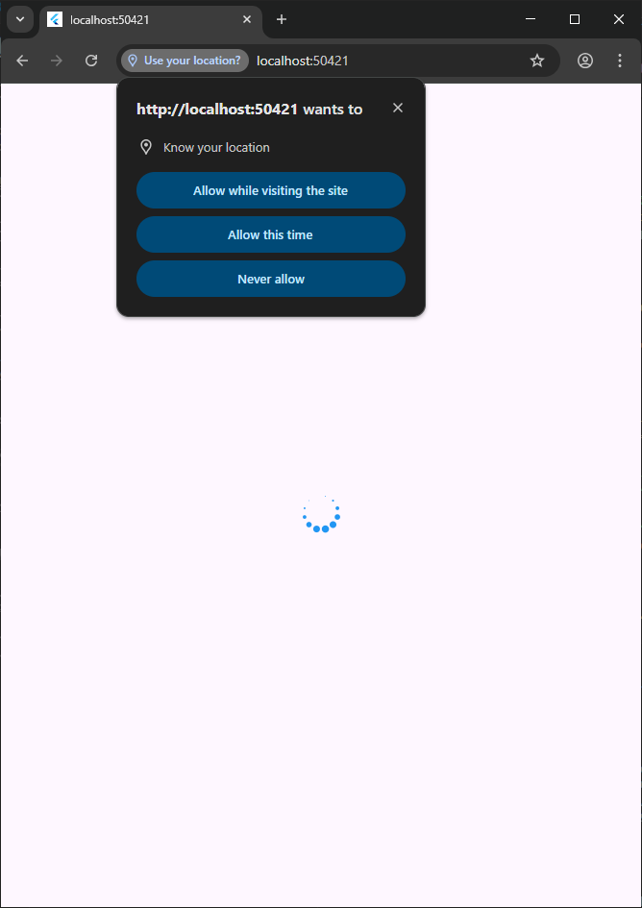
Screenshots:
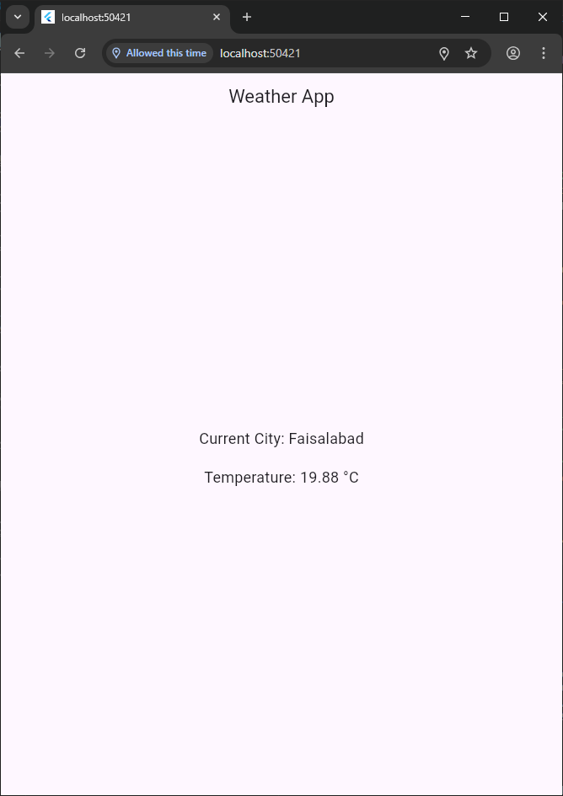

Code:
Main.dart
import 'package:flutter/material.dart';
import 'WeatherPage.dart';

void main(){
runApp(MyApp());
}

class MyApp extends StatelessWidget {
const MyApp({super.key});

@override
Widget build(BuildContext context) {
return MaterialApp(
theme: ThemeData(
appBarTheme: AppBarTheme(
centerTitle: true,
) ),
debugShowCheckedModeBanner: false,
home: WeatherPage(),
); }}

WeatherModel.dart
class Weather{
final String CityName;
final double temprature;
final String weatherCondition;

Weather({
required this.CityName,
required this.temprature,
required this.weatherCondition
});

factory Weather.fromJson(Map<String, dynamic>json){
return Weather(
CityName: json['name'],
temprature: json['main']['temp'].toDouble(),
weatherCondition:json['weather'][0]['main'],);
}}
WeatherPage.dart
import 'package:flutter/material.dart';
import 'package:flutter_spinkit/flutter_spinkit.dart';
import 'WeatherModel.dart';
import 'WeatherService.dart';

class WeatherPage extends StatefulWidget {
const WeatherPage({Key? key}) : super(key: key);

@override
State<WeatherPage> createState() => _WeatherPageState();
}

class _WeatherPageState extends State<WeatherPage> {
final WeatherService weatherService = WeatherService(
"88dbd50246b959ab737a87f4084be451",
);
late Weather _currentWeather;
late String _currentCity;
bool isLoading = true;

@override
void initState() {
super.initState();
_getCurrentWeather();
}

Future<void> _getCurrentWeather() async {
try {
// Fetch current location weather
Weather weather = await weatherService.getWeatherByLocation();

// Update state with current weather and city
setState(() {
_currentWeather = weather;
_currentCity = weather.CityName;
isLoading =
false; // Set loading to false when weather data is available
});
} catch (e) {
// Handle errors
print("Error fetching weather: $e");
setState(() {
isLoading = false; // Set loading to false in case of error
});
}
}

@override
Widget build(BuildContext context) {
return Scaffold(
appBar: AppBar(title: Text('Weather App')),
body: Center(
child: Column(
mainAxisAlignment: MainAxisAlignment.center,
children: [
if (isLoading) SpinKitCircle(color: Colors.blue, size: 50.0),
if (!isLoading)
Text(
'Current City: $_currentCity',
style: TextStyle(fontSize: 18),
),
SizedBox(height: 20),
if (!isLoading)
Text(
'Temperature: ${_currentWeather.temprature} °C',
style: TextStyle(fontSize: 18),
),
], ),
), );
}}

WeatherService.dart
import 'dart:convert';
import 'WeatherModel.dart';
import 'package:http/http.dart' as http;
import 'package:geolocator/geolocator.dart';

class WeatherService {
static const BASE_URL = "https://api.openweathermap.org/data/2.5/weather";

final String apiKey;

WeatherService(this.apiKey);

Future<Weather> getWeather(String cityName) async {
final response = await http.get(
Uri.parse('$BASE_URL?q=$cityName&appid=$apiKey&units=metric'),
);

if (response.statusCode == 200) {
return Weather.fromJson(jsonDecode(response.body));
} else {
throw Exception('Failed to load weather data');
}
}

Future<Position> getCurrentLocation() async {
LocationPermission permission = await Geolocator.checkPermission();

if (permission == LocationPermission.denied) {
permission = await Geolocator.requestPermission();

if (permission == LocationPermission.denied) {
throw Exception('Location permission denied');
}
}

return await Geolocator.getCurrentPosition();
}

Future<Weather> getWeatherByLocation() async {
try {
Position position = await getCurrentLocation();
final response = await http.get(
Uri.parse(
'$BASE_URL?lat=${position.latitude}&lon=${position.longitude}&appid=$apiKey&units=metric',
),
);

if (response.statusCode == 200) {
return Weather.fromJson(jsonDecode(response.body));
} else {
throw Exception('Failed to load weather data');
}
} catch (e) {
throw Exception('Error getting current location: $e');
}
}}

