Lab Plan – 4: Flutter Layout Alignments and Widgets
Objective:
The objective of this lab is to understand and implement Flutter layout widgets i.e. Row alignments, Column alignments, Container usage, Center widget, and applying Padding to design responsive and well-structured UIs.

Task 1: Create a Flutter Project
- Open VS Code or Android Studio.
- Use shortcut:
Ctrl + Shift + P → Flutter: New Project (for VS Code).
- Name your project lab_plan_4 and set up the folder location.

Task 2: Add an AppBar with Centered Text
- Create a Stateless Widget using shortcut stle.
- Inside Scaffold, add an AppBar.
- Use centerTitle: true to align the text in the center.
- Add font size, font weight, and style to the AppBar title.
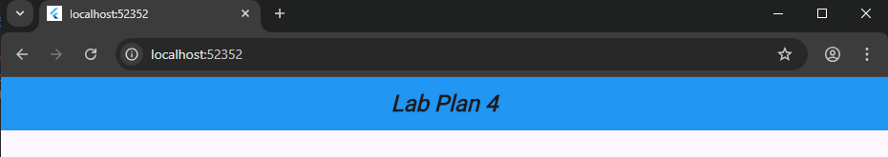
import 'package:flutter/material.dart';

void main() {
runApp(const MyApp());
}

class MyApp extends StatelessWidget {
const MyApp({super.key});

@override
Widget build(BuildContext context) {
return MaterialApp(
home: HomePage(),
debugShowCheckedModeBanner: false,
);
}
}

// stle → Stateless Widget Shortcut
class HomePage extends StatelessWidget {
const HomePage({super.key});

@override
Widget build(BuildContext context) {
return Scaffold(
appBar: AppBar(
title: const Text(
'Lab Plan 4',
style: TextStyle(
fontSize: 24,
fontWeight: FontWeight.bold,
fontStyle: FontStyle.italic,
),
),
centerTitle: true,
backgroundColor: Colors.blue,
),
body: Container(), // Temporary empty body
);
}
}

Task 3: Container Usage
- Add a Container widget at the body
- Apply properties:
  - color
  - height and width
  - margin
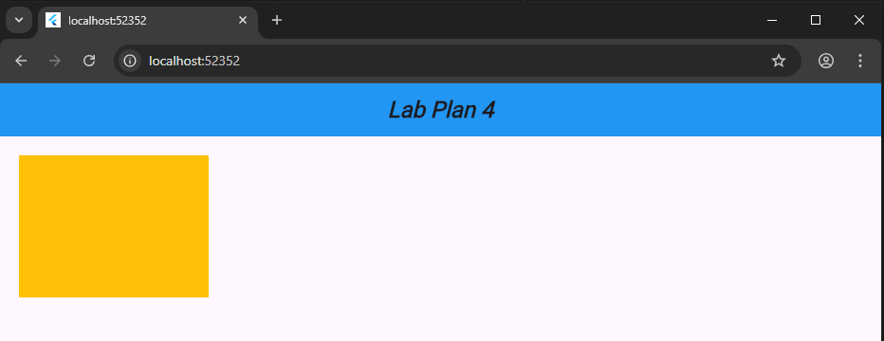
body: Container(
color: Colors.amber,
height: 150,
width: 200,
margin: const EdgeInsets.all(20),
),

Task 4: Row Alignments
- Create a Row widget inside Scaffold’s body.
- Use mainAxisAlignment and crossAxisAlignment properties to align children.
- Example alignments to try:
  - MainAxisAlignment.start
  - MainAxisAlignment.center
  - MainAxisAlignment.spaceEvenly
  - CrossAxisAlignment.start / CrossAxisAlignment.end
- body: Row(
- mainAxisAlignment: MainAxisAlignment.spaceEvenly,
- crossAxisAlignment: CrossAxisAlignment.end,
- children: const [
- Icon(Icons.star, size: 40),
- Icon(Icons.favorite, size: 40),
- Icon(Icons.access_alarm, size: 40),
- ],
- ),

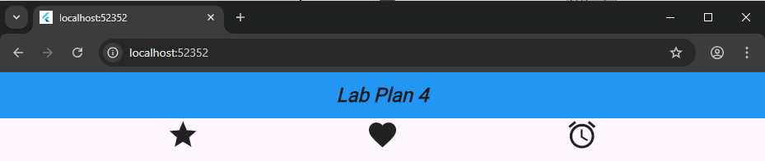

Task 5: Column Alignments
- Create a Column widget inside Scaffold’s body.
- Experiment with vertical alignment:
  - MainAxisAlignment.spaceAround
  - MainAxisAlignment.center
  - MainAxisAlignment.end
- Experiment with horizontal alignment using crossAxisAlignment.
- body: Column(
- mainAxisAlignment: MainAxisAlignment.spaceAround,
- crossAxisAlignment: CrossAxisAlignment.center,
- children: const [Text('Top'), Text('Middle'), Text('Bottom')],
- ),
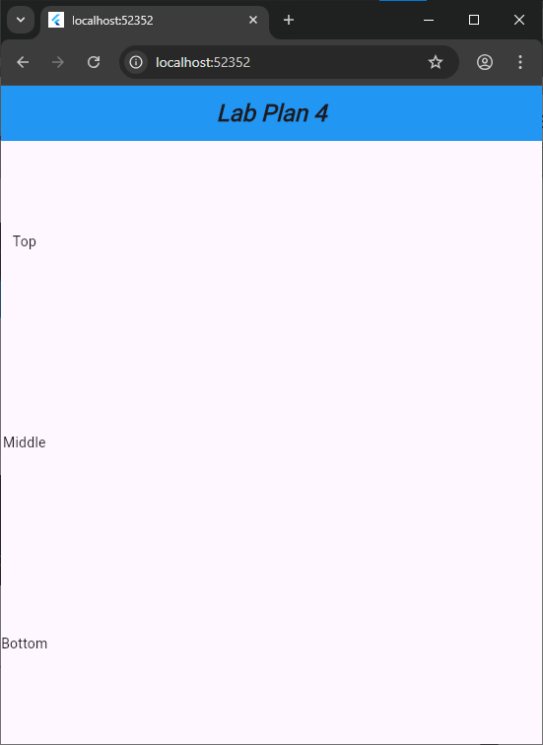

Task 6: Center Widget
- Wrap a widget (like Text or Container) with Center widget.
- Observe how it automatically positions the widget in the middle of available space.
- body: Center(
- child: Container(
- height: 100,
- width: 100,
- color: Colors.green,
- child: const Center(
- child: Text('Centered', style: TextStyle(color: Colors.white)),
- ),
- ),
- ),
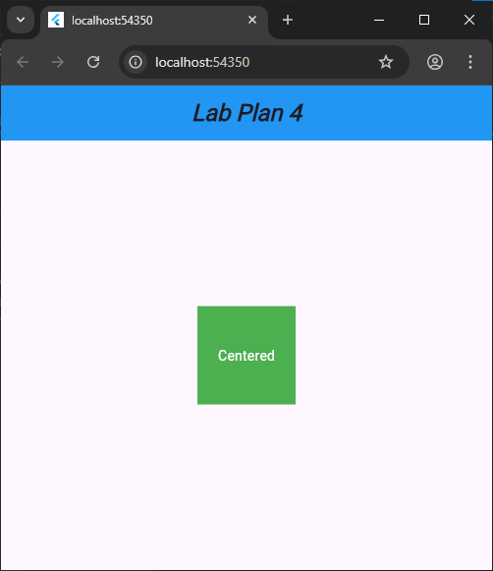

Task 7: Padding on Screen
- Use the Padding widget to add space inside the layout.
- Apply different padding styles:
  - EdgeInsets.all(20)
  - EdgeInsets.symmetric(horizontal: 30, vertical: 10)
  - EdgeInsets.only(left: 15, top: 40)
- body: Padding(
- padding: const EdgeInsets.symmetric(horizontal: 30, vertical: 10),
- child: Container(height: 100, width: 100, color: Colors.purple),
- ),

