EXHIBIT RFE-21
Preliminary Research Artifacts, Version 0.1
Zero Trust Governance Framework for Under-Resourced U.S. Institutions
Abidemi Adeleye Alabi
October 2026
Receipt IOE0937870789

1. Contents
This exhibit contains the first working artifacts of the proposed endeavor, released as version 0.1 in October 2026. Each artifact is the starting version of an output named in the 36-month schedule of the response, and each will be revised and re-released as the research proceeds. Table 1 lists them. The artifacts are maintained in a version-controlled repository at [repository URL], where the commit history records the date of each change.
Table 1. Artifacts in this exhibit
No. | Artifact | Project | Section
A1 | Control catalogue, draft v0.1, with crosswalks to the CISA Zero Trust Maturity Model, the HHS Cybersecurity Performance Goals and the HHS Health Industry Cybersecurity Practices | Project 1 | Section 2; Table 2
A2 | Accountability record template for non-human identities, v0.1 | Project 1 | Section 3; Table 3
A3 | Departure-review workflow specification and interface design, v0.1 | Project 3 | Section 4; Figure 1
A4 | Pre-stated attack-emulation protocol for the critical access hospital reference environment, v0.1 | Project 2 | Section 5; Table 4
A5 | Departure audit script, v0.1, with a demonstration run on a synthetic hospital estate | Project 3 | Section 6; Tables 5 to 8

2. Control catalogue, draft v0.1 (A1)
The catalogue lists the controls the framework tests, grouped by its six pillars: the five pillars of the CISA Zero Trust Maturity Model and the sixth pillar, cloud financial governance. For each control it records the maturity stage the control supports, the HHS Healthcare and Public Health Sector Cybersecurity Performance Goal it serves, the HHS Health Industry Cybersecurity Practices (HICP) practice it falls under, and what the research will measure. Table 2 is the draft. The measured values are added as each experiment is completed.
Table 2. Control catalogue, draft v0.1
ID | Pillar | Control | CISA stage | HHS goal | HICP practice | Measured by the research
ID-1 | Identity | Phishing-resistant multifactor authentication for remote access, administrator and cloud accounts | Advanced | Multifactor Authentication | 3. Identity and Access Management | Attack paths blocked; deployment hours; annual cost
ID-2 | Identity | Separate administrator accounts from everyday user accounts | Initial | Separate User and Privileged Accounts | 3 | Escalation paths remaining; hours
ID-3 | Identity | Unique credentials; remove shared accounts | Initial | Unique Credentials | 3 | Shared accounts removed; disruption caused
ID-4 | Identity | Departure review of every human and non-human identity anchored to a leaver | Advanced | Revoke Credentials for Departing Workforce Members | 3 | Items found against a disable-only baseline; cost recovered
ID-5 | Identity | Accountability record for every non-human identity (A2) | Advanced | Asset Inventory | 5. IT Asset Management | Share of non-human identities with a validated owner
ID-6 | Identity | Conditional access by location and device state | Advanced | Multifactor Authentication (supporting) | 3 | Sign-in attack paths blocked; false blocks
DV-1 | Devices | Device inventory and compliance check before access is granted | Initial | Asset Inventory | 2. Endpoint Protection Systems | Unmanaged devices denied; hours
DV-2 | Devices | Certificate-based device identity with automated enrolment | Advanced | Strong Encryption | 2 | Spoofed-device paths blocked; hours
NW-1 | Networks | Segment clinical, business and cloud zones | Initial | Network Segmentation | 6. Network Management | Lateral-movement paths remaining
NW-2 | Networks | Remove plain-text protocols (FTP, Telnet, unencrypted remote access) | Initial | Strong Encryption | 6 | Credential-capture paths closed
AP-1 | Applications and workloads | Patch and harden internet-facing services | Initial | Mitigate Known Vulnerabilities | 7. Vulnerability Management | Initial-access paths closed
AP-2 | Applications and workloads | Least-privilege consent for application registrations and API keys | Advanced | Separate User and Privileged Accounts | 3 | Token-theft paths remaining
DA-1 | Data | Block public access to cloud storage by default | Initial | Configuration Management | 4. Data Protection and Loss Prevention | Exposed objects remaining
DA-2 | Data | Encrypt data at rest and in transit | Initial | Strong Encryption | 4 | Readable data on capture; hours
VA-1 | Cross-cutting: visibility | Centralized log collection for identity, cloud and endpoint events | Initial | Centralized Log Collection | 8. Security Operations Center and Incident Response | Emulated techniques detected
FG-1 | Cloud financial governance | Licence-to-activity reconciliation | Sixth pillar | Asset Inventory (supporting) | 10. Cybersecurity Oversight and Governance | Unused licences found; annual cost recovered
FG-2 | Cloud financial governance | Idle-resource detection with owner sign-off before removal | Sixth pillar | Configuration Management | 5 | Idle resources found that are also security findings
FG-3 | Cloud financial governance | Cost attribution to an accountable owner | Sixth pillar | Asset Inventory | 10 | Share of spend with a validated owner

3. Accountability record for non-human identities, v0.1 (A2)
Service accounts, application registrations, API keys, certificates and AI agents act in an institution's systems without a person signing in. The framework requires each to carry an accountability record before it is approved for use, and applies a remediation procedure to those already in use without one. Table 3 is the template.
Table 3. Accountability record template, v0.1
Field | Content | Why it is required
Identifier and kind | System identifier; service account, application registration, API key, certificate or AI agent | Discovery and inventory
Accountable owner | A named person and a named team, both current | A departure of one person does not leave the identity unowned
Sponsor | The person who requested it, where different from the owner | Found by the departure review
Purpose | One sentence stating what it does and for which service | Separates a needed identity from a forgotten one
Permissions | Scopes and roles granted, with the reason for any high privilege | Least-privilege review
Dependencies | Systems and jobs that fail if it is disabled | Prevents outages from removal
Secrets and rotation | Where its credential is stored and when it is rotated | Stolen or unrotated credentials
Cost | Licence or consumption cost attributed to it | Sixth-pillar cost attribution
Review and retirement | Next review date and the condition for retirement | Lifecycle closure

A missing owner is a finding to investigate, not an instruction to disable or delete. Technical discovery cannot establish every business purpose or dependency, so each finding is resolved by a person with the authority to decide.

4. Departure-review workflow, v0.1 (A3)
When a person leaves or changes role, the workflow runs the following steps.
- The departure is recorded with the person's last working day and manager.
- Every identity and resource anchored to the person is listed: items the person owns, sponsors, or is tagged on as technical contact, together with assigned paid licences.
- Each item is classified as active, needing review, or no longer used, from its last use, its privileges and whether anything depends on it.
- A recommended action is proposed for each item: transfer and confirm a new owner, investigate, check dependency, request removal after sign-off, or reclaim the licence.
- The manager confirms or changes each action. No item is removed without sign-off.
- The outcome is recorded against each item, and the annual cost recovered is totalled.
Figure 1 shows the design of the review screen for a departing engineer, listing each anchored asset with its type, link to the person, annual cost, status and recommended action. Section 6 runs the same logic on a synthetic estate with the script that implements steps 2 to 4.
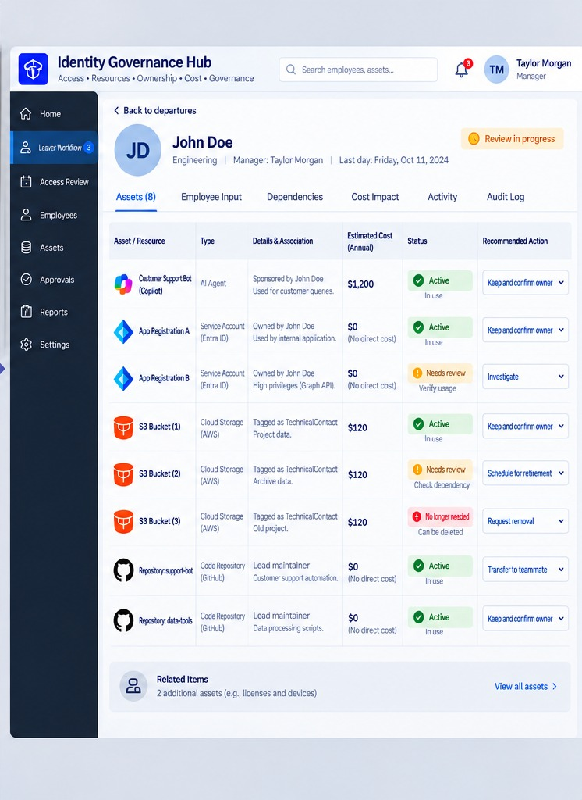
Figure 1. Interface design for the departure-review workflow, v0.1

5. Pre-stated attack-emulation protocol, v0.1 (A4)
The protocol is stated before any experiment is run, so that the results cannot be tuned to the test. It applies to the critical access hospital reference environment, modelled as a 25-bed hospital with a two-person IT team, a cloud identity tenant, cloud storage, an electronic health record integration and a claims clearinghouse connection. All accounts and records in the environment are synthetic, and all testing runs only in cloud accounts registered to me, within the providers' published testing policies.
Procedure. (1) Build the environment from code in its baseline state. (2) Run every technique in Table 4 and record, for each, whether the attack path is open, blocked or detected. (3) Apply one control from Table 2. (4) Re-run every technique and record the change, the hours spent deploying the control, its direct annual cost and any service disruption it causes. (5) Repeat steps 3 and 4 for each control in turn. (6) Rank the controls by attack paths closed per hour and per dollar, and compare that ranked order with an unranked order.
Table 4. Techniques emulated in the hospital environment (MITRE ATT&CK)
Technique ID | Technique | How it is emulated in the hospital model | Controls expected to affect it
T1110.003 | Password Spraying | Common passwords tried against all cloud accounts | ID-1, ID-6
T1078.004 | Valid Accounts: Cloud Accounts | Sign-in with the unrotated credential of a former employee | ID-1, ID-4
T1133 | External Remote Services | Remote access portal reached with a password alone | ID-1, NW-1
T1566 | Phishing | Credential-harvest message to a staff mailbox | ID-1
T1621 | Multi-Factor Authentication Request Generation | Repeated push requests to a staff account | ID-1
T1098 | Account Manipulation | Role added to a compromised everyday account | ID-2
T1528 | Steal Application Access Token | Token taken from an over-privileged application registration | AP-2, ID-5
T1552.001 | Unsecured Credentials: Credentials In Files | API key found in a script in a code repository | ID-5, ID-4
T1190 | Exploit Public-Facing Application | Known flaw in an unpatched internet-facing service | AP-1
T1530 | Data from Cloud Storage | Read of a publicly readable storage bucket | DA-1
T1040 | Network Sniffing | Capture of credentials sent over a plain-text protocol | NW-2, DA-2
T1021 | Remote Services | Lateral movement from a business workstation to a clinical system | NW-1
T1486 | Data Encrypted for Impact | Simulated encryption of reachable file shares, measured by systems reached | NW-1, ID-2

Measures stated in advance. For each control: attack paths open, blocked and detected before and after; deployment hours; direct annual cost; service disruptions and rollbacks caused. For the ranked order: cumulative attack paths closed against cumulative hours and against cumulative cost, compared with the unranked order.

6. Departure audit script, v0.1, and demonstration run (A5)
The script implements steps 2 to 4 of the departure-review workflow. It reads three exports that any small institution can produce from its identity, cloud and licence systems, lists everything anchored to the departing person, classifies each item, recommends an action and totals the annual cost attached. It also reports the disable-only baseline, in which only the person's own account is disabled and every anchored item stays in place. The script changes nothing; it only reports.
To show that it runs, it was applied on October 9, 2026 to a synthetic estate modelled on the hospital reference environment. Tables 5 to 7 list the synthetic inputs and Table 8 the output. The figures demonstrate the script's operation on invented data; they are not research results, which come from the experiments in the 36-month schedule.
Table 5. Synthetic input: identities
ID | Kind | Display name | Owner | Sponsor | Privilege | Last used | Monthly $
jdoe | user | J. Doe (IT engineer) |  |  | admin | 2026-10-01 | 0
mlee | user | M. Lee (IT lead) |  |  | admin | 2026-10-02 | 0
agent-support | AI agent | Patient-portal support agent |  | jdoe | standard | 2026-09-30 | 100
app-ehr-sync | service account | EHR sync app registration | jdoe |  | standard | 2026-10-01 | 0
app-reporting | service account | Reporting app registration | jdoe |  | graph-app-write | 2026-09-12 | 0
svc-backup | service account | Backup job account | mlee |  | standard | 2026-10-01 | 0
key-billing-api | API key | Clearinghouse API key | jdoe |  | standard | 2026-04-20 | 0

Table 6. Synthetic input: resources
ID | Kind | Display name | Owner | Technical contact | Monthly $ | Last access | Depended on by job
bucket-images | cloud storage | Imaging export bucket |  | jdoe | 10 | 2026-09-29
bucket-archive | cloud storage | Archive bucket |  | jdoe | 10 | 2026-03-11
bucket-oldproj | cloud storage | Old project bucket |  | jdoe | 10 | 2025-11-02
repo-portal-bot | code repository | Support agent code | jdoe |  | 0 | 2026-09-30
repo-data-tools | code repository | Data processing scripts | jdoe |  | 0 | 2026-08-15
vm-test | virtual machine | Test VM | jdoe |  | 62 | 2026-02-14
job-archive-sync | scheduled job | Archive sync job | mlee |  | 0 | 2026-10-01 | bucket-archive

Table 7. Synthetic input: paid licences
User | Licence | Monthly $ | Last sign-in
jdoe | Office suite E3 | 36 | 2026-10-01
jdoe | Diagramming tool | 15 | 2026-05-02
mlee | Office suite E3 | 36 | 2026-10-02

The run was made with the command shown below, for the departing engineer jdoe, as of October 9, 2026, with a 90-day idle threshold.
python3 departure_audit.py hospital jdoe 2026-10-09

Table 8. Output of the demonstration run
Item | Type | Link to person | Annual $ | Status | Recommended action
agent-support | AI agent | sponsor | 1,200 | Active | Keep; transfer and confirm new owner
app-ehr-sync | service account | owner | 0 | Active | Keep; transfer and confirm new owner
app-reporting | service account | owner | 0 | Needs review | Investigate privileges; assign new owner
key-billing-api | API key | owner | 0 | No longer used | Request removal after owner sign-off
bucket-images | cloud storage | technical contact | 120 | Active | Keep; transfer and confirm new owner
bucket-archive | cloud storage | technical contact | 120 | Needs review | Check dependency before any change
bucket-oldproj | cloud storage | technical contact | 120 | No longer used | Request removal after owner sign-off
repo-portal-bot | code repository | owner | 0 | Active | Keep; transfer and confirm new owner
repo-data-tools | code repository | owner | 0 | Active | Keep; transfer and confirm new owner
vm-test | virtual machine | owner | 744 | No longer used | Request removal after owner sign-off
licence:Office suite E3 | paid licence | assigned | 432 | No longer used | Reclaim licence at departure
licence:Diagramming tool | paid licence | assigned | 180 | No longer used | Reclaim licence at departure
Totals |  |  | 2,916 |  | 12 items; 2 for review; $1,476 recoverable

The script's summary lines read as follows.
Items anchored to the person: 12
Items needing human review: 2
Annual cost attached to anchored items: $2,916
Annual cost recoverable (unused items): $1,476
Disable-only baseline: items left anchored to a disabled account: 12; annual cost left running: $2,916

On this estate the script found twelve items anchored to the departing engineer, including an AI agent he sponsored, two application registrations, an unused API key, three storage buckets tagged to him, two code repositories, a test virtual machine and two paid licences. Two items were sent for human review: an application registration with high privileges, and a storage bucket on which a scheduled job depends. Under the disable-only baseline all twelve items would remain attached to a disabled account, with $2,916 a year in cost still running; the review identifies $1,476 of that as recoverable from items no longer used.
The full source code of the script follows.
#!/usr/bin/env python3
"""departure_audit.py, version 0.1 (October 2026)

Departure review for human and non-human identities.

Given a person who is leaving, the script lists every identity and resource
anchored to that person (owned, sponsored, or tagged as technical contact),
classifies each one, recommends an action, and totals the annual cost
attached. It then compares the result with a disable-only baseline, in which
only the person's own user account is disabled and every anchored item is
left in place.

Rule: a missing owner is a finding to investigate, not an instruction to
disable or delete. Nothing is changed by this script; it only reports.

Inputs (CSV):
identities.csv id,kind,display,owner,sponsor,privilege,last_used,monthly_cost
resources.csv id,kind,display,owner,technical_contact,monthly_cost,last_access,depends_on
licences.csv user,sku,monthly_cost,last_sign_in

Usage:
python3 departure_audit.py DATA_DIR PERSON AS_OF_DATE [IDLE_DAYS]
"""
import csv
import sys
from datetime import date

HIGH_PRIV = {"high", "admin", "global-admin", "graph-app-write"}

def load(path):
with open(path, newline="") as f:
return list(csv.DictReader(f))

def days_since(iso, as_of):
if not iso:
return None
return (as_of - date.fromisoformat(iso)).days

def classify(item, as_of, idle_days, dependents):
"""Return (status, recommended action)."""
idle = days_since(item.get("last_used") or item.get("last_access"), as_of)
high = item.get("privilege", "") in HIGH_PRIV
if item["id"] in dependents:
return "Needs review", "Check dependency before any change"
if idle is None:
return "Needs review", "Verify usage"
if idle > idle_days:
return "No longer used", "Request removal after owner sign-off"
if high:
return "Needs review", "Investigate privileges; assign new owner"
return "Active", "Keep; transfer and confirm new owner"

def audit(data_dir, person, as_of, idle_days=90):
ids = load(f"{data_dir}/identities.csv")
res = load(f"{data_dir}/resources.csv")
lic = load(f"{data_dir}/licences.csv")

dependents = {r["depends_on"] for r in res if r.get("depends_on")}
rows = []

for i in ids:
if i["id"] == person:
continue
link = []
if i.get("owner") == person:
link.append("owner")
if i.get("sponsor") == person:
link.append("sponsor")
if link:
status, action = classify(i, as_of, idle_days, dependents)
rows.append([i["id"], i["kind"], i["display"], "/".join(link),
12 * float(i.get("monthly_cost") or 0), status, action])

for r in res:
link = []
if r.get("owner") == person:
link.append("owner")
if r.get("technical_contact") == person:
link.append("technical contact")
if link:
status, action = classify(r, as_of, idle_days, dependents)
rows.append([r["id"], r["kind"], r["display"], "/".join(link),
12 * float(r["monthly_cost"] or 0), status, action])

for l in lic:
if l["user"] == person:
rows.append([f"licence:{l['sku']}", "paid licence", l["sku"], "assigned",
12 * float(l["monthly_cost"]), "No longer used",
"Reclaim licence at departure"])

return rows

def main():
data_dir, person, as_of = sys.argv[1], sys.argv[2], date.fromisoformat(sys.argv[3])
idle_days = int(sys.argv[4]) if len(sys.argv) > 4 else 90
rows = audit(data_dir, person, as_of, idle_days)

print(f"Departure review for {person} as of {as_of} (idle threshold {idle_days} days)")
print(f"{'Item':<26}{'Type':<20}{'Link':<20}{'Annual $':>10} {'Status':<15}Action")
for r in rows:
print(f"{r[0]:<26}{r[1]:<20}{r[3]:<20}{r[4]:>10,.0f} {r[5]:<15}{r[6]}")

total = sum(r[4] for r in rows)
recover = sum(r[4] for r in rows if r[5] == "No longer used")
review = sum(1 for r in rows if r[5] == "Needs review")
print()
print(f"Items anchored to the person: {len(rows)}")
print(f"Items needing human review: {review}")
print(f"Annual cost attached to anchored items: ${total:,.0f}")
print(f"Annual cost recoverable (unused items): ${recover:,.0f}")
print(f"Disable-only baseline: items left anchored to a disabled account: {len(rows)}; "
f"annual cost left running: ${total:,.0f}")

if __name__ == "__main__":
main()

Prepared by Abidemi Adeleye Alabi, October 2026.

