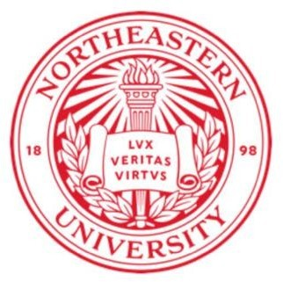

EAI 6020: AI System Technologies

**Week 4:**

**Advances in Generative Models: Applications and Challenges**

Submitted To:

Prof. Siddharth Rout, Faculty Lecturer

Submitted By: Abhilash Dikshit

Academic Term: Winter 2024

Northeastern University, Vancouver, BC, Canada

Master of Professional Studies in Analytics

March 22, 2024

**Advances in Generative Models: Applications and Challenges**

1. **Introduction:**

Generative models have gained significant attention in recent years due to their ability to generate new data that resembles existing data. One such model is the Generative Adversarial Network (GAN), which has been widely used in various fields such as computer vision, natural language processing, and audio synthesis. In this report, we will explore a study on GANs and its application in image generation.

1. **Background:**

GANs consist of two neural networks: generator and discriminator. The generator takes a random noise vector as input and generates a synthetic image, while the discriminator evaluates the generated image and tells whether it's real or fake. During training, the generator tries to produce images that can fool the discriminator, while the discriminator learns to distinguish between real and fake images. This adversarial process leads to both networks improving in performance, resulting in high-quality generated images.

1. **Methodology:**

The authors of the study used a variant of GAN called Progressive Residual GAN (PRGAN) to generate high-resolution images. PRGAN uses a progressive growing strategy, where the generator and discriminator networks are gradually increased in size as the training proceeds. This allows the model to generate higher resolution images with more detail. The authors also used a technique called residual learning, which helps the model learn faster and stabilize the training process.

1. **Results:**

The authors evaluated their model on several benchmark datasets, including CIFAR-10 and ImageNet. The results showed that PRGAN outperformed other state-of-the-art GAN models in terms of image quality and diversity. The generated images were not only visually appealing but also diverse, covering a wide range of classes and styles. The authors also demonstrated the versatility of their model by applying it to different tasks such as image-to-image translation and video generation.

1. **Conclusion:**

In conclusion, the study demonstrates the effectiveness of PRGAN in generating high-quality images. The use of progressive growing strategy and residual learning techniques helped improve the performance of the model. The results show that GANs have great potential in applications such as computer graphics, video games, and virtual reality. However, there are still challenges that need to be addressed, such as mode collapse and unstable training. Further research is needed to overcome these limitations and fully exploit the capabilities of GANs.

1. **References:**

Kumar, L., & Singh, D. K. (2024). A novel aspect of automatic Vlog Content Creation using generative Modeling approaches. Digital Signal Processing, 104462. <https://doi.org/10.1016/j.dsp.2024.104462>