ABIDI Nada TP

exercice1:

Bank
- LOC (approx.) : 45
- NOM (Number of Methods) : 12
- Short description of responsibility : Manages multiple accounts and related operations

BankAccount
- LOC (approx.) : 46
- NOM : 20
- Short description of responsibility : Manages an individual bank account and its holder

Person
- LOC (approx.) : 40
- NOM : 23
- Short description of responsibility : Stores personal information of a person.

BankAccountApp
- LOC (approx.) : 36
- NOM : 2
- Short description of responsibility : Main console application.

Exercise 2:
my chosen method is withdrawMoney(double withdrawAmount) on BankAccount
Cyclomatic Complexity (before refactoring) is 5
J’ai extrait la logique de vérification des conditions dans une méthode que j’ai l'appelle canWithdraw(double withdrawAmount) pour réduire la complexité de la méthode principale.
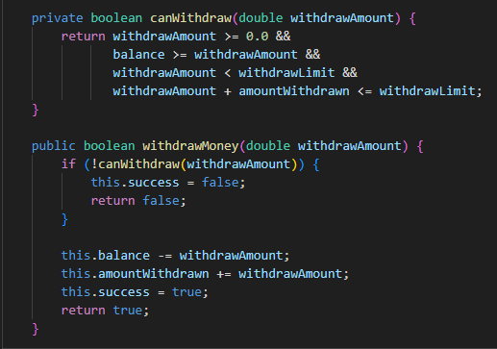
la complexité cyclomatique de withdrawMoney() a été réduite de 5 → 2

Exercice 3
classes :
Bank
- LOC : 45
- WMC : 12
- CBO : 0
- LCOM : 3
BankAccount
- LOC : 46
- WMC : 20
- CBO : 1
- LCOM : 2
Person
- LOC : 40
- WMC : 23
- CBO : 0
- LCOM : 0
ACHService
- LOC : 2
- WMC : 1
- CBO : 0
- LCOM : 0
ACHServiceImpl
- LOC : 3
- WMC : 3
- CBO : 0
- LCOM : 1
- Answer:
- Which class has the highest WMC? Person (23)
- Which class has the highest CBO? BankAccount (1)
- Looking at WMC + CBO + LCOM together
  - Which one class would you worry about most for future maintenance, and why? Person car on a beaucoup de méthodes, constructeurs donc il y a un risque de bugs et maintenance difficile.

Exercise 4:
- Make sure SonarLint/SonarQube is installed and enabled.
- In IntelliJ, right-click the jay-bank source folder (or its package), and use the option: “Analyze with SonarLint/SonarQube” (or open the SonarLint/SonarQube tool window and analyze the project).
- Wait for the analysis to complete and open the SonarLint/SonarQube issues view.

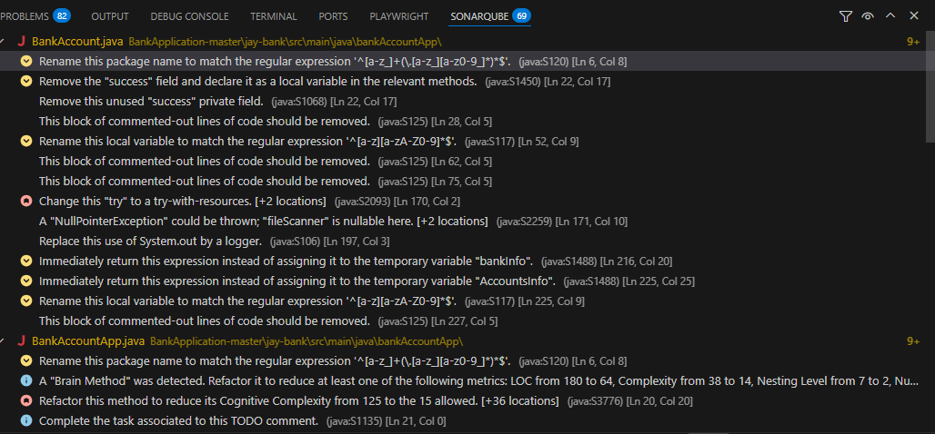

Issue 1 :Adaptability issue Duplicated string literals
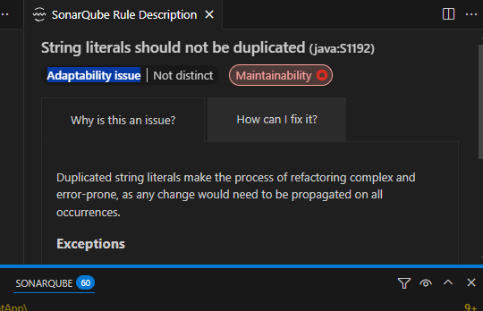
Rule name: Define a constant instead of duplicating this literal
File & line: BankAccountApp.java:101
Description: WITHDRAW is repeated in the code which can make updates harder so if we extract it into a constant may improves maintainability and reduces duplication.

Issue 2 :Unused field : Private fields only used as local variables in methods should become local variables
Intentionality issue

Rule name: Remove the "success" field and declare it as local variable in the relevant methods .
File & line: BankAccount.java:22
Description:
A private field called success is declared but never used. Removing it makes the class cleaner and easier to understand.

Issue 3 Replace this use of System.out by a logger
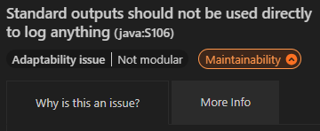
- Rule name: Replace this use of System.out by a logger
- File & line: BankAccount.java:197
- Description :
Using System.out.println is discouraged in real applications because it is not modular and does not support proper logging practices.
- Fix at least 2 of these issues :
I fixed the second issue by defining the constant WITHDRAW instead of repeating the string “withdraw” 3 times on the code
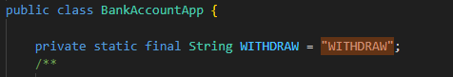
and the third issue by replacing System.out with a logger


- Re-run SonarLint on the same scope and confirm:
  - The issues you fixed disappeared. —> yes they disappeared
Do SonarLint issues appear more often in the classes with higher WMC / CBO you saw earlier, or not really?
Yes. I observed that classes with higher WMC and higher CBO (Coupling Between tend to generate more SonarLint issues. For example, BankAccount has many warnings, while Ach service only has one. This makes sense because classes with more logic and more dependencies are usually harder to maintain and more likely to contain code smells.
Exercise 5 (Repo 1)
