The v7.1b Detector
A walkthrough of final_model_v7_1_reject_stages.ipynb CIC-UNSW-NB15-2024, full CICFlowMeter release (3,540,241 flows)

1. The problem
A network flow is a summary of one conversation between two machines — how long it lasted, how many packets went each way, how big they were, how they were spaced in time. A tool called CICFlowMeter turns raw network traffic into a table of 76 such numbers per flow.
The job: given those numbers, decide whether the flow is normal traffic or one of nine attack families (Analysis, Backdoor, DoS, Exploits, Fuzzers, Generic, Reconnaissance, Shellcode, Worms). Ten possible answers in total.
(a) The classes are wildly unequal. After cleaning, 96.87% of flows are benign. Worms has 243 flows in the entire 2.6-million-row dataset — a ratio of 10,392 : 1. A model that answers "benign" every single time scores 96.87% accuracy and is completely useless. This is why the primary metric here is macro-F1, which averages performance over the ten classes equally, so Worms counts as much as Benign. Accuracy is reported alongside it, but never on its own.
(b) There are a lot of duplicate rows. 26.37% of the raw file consists of flows that are byte-for-byte identical to another flow. If duplicates are left in, the same flow can appear in both the training data and the test data — so the model is tested on rows it has already memorised, and scores near 100%. That is not a good model, it is a broken experiment. The notebook removes duplicates first, before anything is split or trained.

2. The architecture
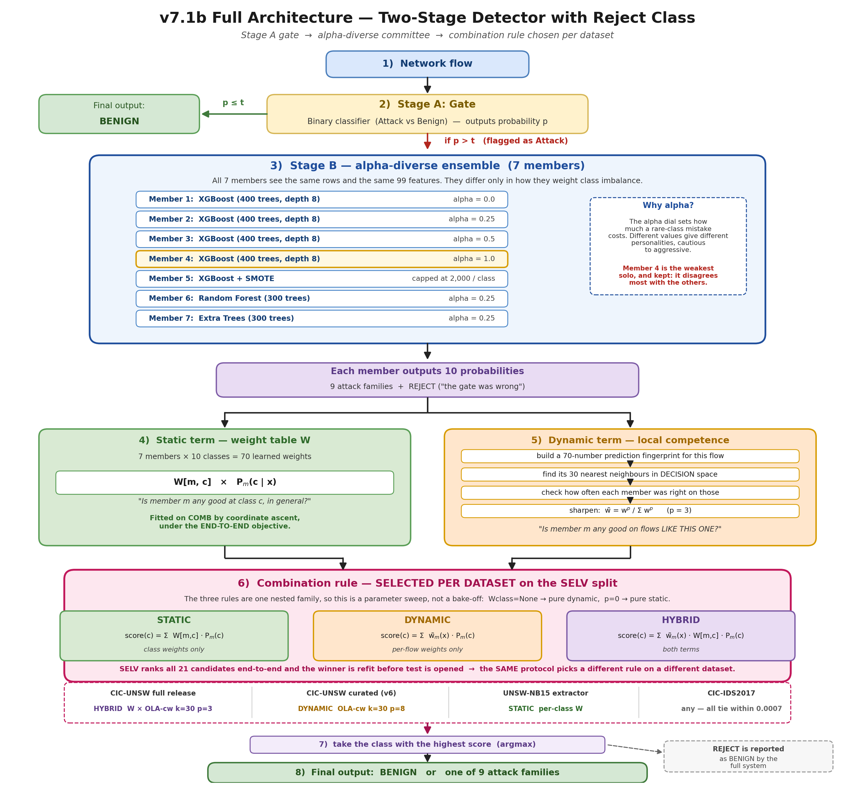
Figure 1 — the full architecture. A flow enters at the top; the gate either clears it as Benign or passes it to the seven-member committee; the committee's ten probability vectors are merged by a combination rule, and the winning class is the answer. The one part of the picture that is not fixed in advance is box 6: Static, Dynamic and Hybrid are three candidate rules, and which one the system uses is chosen per dataset on the SELV split.

3. Preparing the data (Stages 1–2 of the notebook)

3.1 Loading — and what is deliberately thrown away
The full release ships one file with seven metadata columns in front (Flow ID, Src IP, Src Port, Dst IP, Dst Port, Protocol, Timestamp), then the 76 measurements, then the label.
Two of those metadata columns are kept as features: Dst Port and Protocol. Five are deliberately excluded: Flow ID, Src IP, Dst IP, Src Port, Timestamp.
The reason is worth stating clearly, because it is a correctness issue and not a preference. Source IP identifies which machine sent the traffic. In a lab testbed the attack machines and the benign machines are different machines, so "which machine" predicts the label almost perfectly — and predicts nothing at all on a real network, where the attacker's address is not known in advance. A model using source IP would score brilliantly and be worthless. Destination port is different: it says what service was targeted, and attacks genuinely target specific services. That is behaviour, not identity, so it is allowed in.
(The same test was later applied to TTL values recovered from the original UNSW files. TTL failed it — it turned out to encode which machine generated the traffic — and was rejected despite raising the score.

3.2 Removing duplicates
933,438 rows (26.37%) are exact duplicates. They are dropped, leaving 2,606,803 rows.
A useful by-product: comparing "duplicates counted on features only" with "duplicates counted on features and label" reveals rows whose measurements are identical but whose labels disagree — flows the data itself cannot tell apart. There are only 523 of them (0.015%), which is good news: the difficulty in this dataset is not mislabelled data, it is genuine overlap between classes.

3.3 Choosing features — three blocks, 99 columns
Block 1 — the kept originals (43 columns). Two label-free checks are run on the 76 raw measurements:
- Constant columns. Nine columns have the same value in every row (e.g. Bwd PSH Flags is always 0). A column that never changes cannot help distinguish anything. Dropped. 76 → 67.
- Redundant columns. Some pairs of columns are near-perfect copies of each other — for instance Bwd Packet Length Mean and Bwd Segment Size Avg correlate at 1.000, and Flow Duration with Fwd IAT Total at 0.999. For each such pair the second column is dropped. 67 → 43.
Block 2 — engineered ratios (31 columns). The raw measurements are all absolute: a flow that ran for ten minutes has big numbers simply because it ran for ten minutes. Ratios remove that. Examples: forward-to-backward packet ratio, bytes per packet, how variable the packet gaps are, and — importantly — flags expressed as a fraction of packets rather than a raw count.
These are built from the base 67 columns, not the kept 43 — a column dropped for being a linear copy of another can still contribute something new inside a ratio.
Block 3 — service identity (25 columns). Dst Port and Protocol turned into readable features: one-hot flags for 20 well-known services (svc_http, svc_dns, svc_smb, svc_rpc, …), three port-range bins, two protocol flags, and the raw port number.
Total: 43 + 31 + 25 = 99 features.

4. The four architectural decisions
Each one was adopted because a measured alternative failed. That is the honest framing, and it is worth more in a thesis than a story about why each was obviously right.

Decision 1 — Two stages instead of one ten-class model
The obvious design is one model with ten outputs. The notebook instead splits the job in two.
The reason is that the two halves of the problem have wildly different difficulty. Telling attack from benign is nearly solved: the gate achieves 98.8% attack recall. Telling one attack family from another is where everything goes wrong. Putting them in one model means the easy half dominates training — the model spends its capacity on a question it has already answered.

Decision 2 — The reject class (the contribution this notebook tests)
This is the idea the notebook exists to evaluate, and it is best explained through the problem it solves.
The gate is excellent at recall but its precision is only 0.654. In a dataset that is 96.9% benign, 1.7% of benign flows getting through is a large absolute number — 34,101 flows in the training half alone. Every one of them lands in front of Stage B.
And in the previous version (v7), Stage B had only nine outputs: nine attack families. It was structurally incapable of saying "this isn't an attack". Handed an innocent flow, it was forced to pick an attack family for it. The result was 8,370 benign flows labelled as attacks on the test set — a false-alarm flood, most of it landing in the Fuzzers class.
The fix is to add a tenth class. Its training data is defined without leakage: the 34,101 benign flows that fooled a version of the gate that had never seen them. Stage B now learns "what does a gate mistake look like?" as a class in its own right. At inference, anything Stage B assigns to the reject class is reported as Benign.
Result: benign-flagged-as-attack drops from 8,370 to 3,270 — roughly 4× fewer false alarms — and the paired improvement is +0.0265 macro-F1, established at p < 0.001.

Decision 3 — A committee of seven, diversified by class weighting
Stage B is not one model but seven.
The standard way to build a committee is to use different algorithms — a decision tree, a neural network, a nearest-neighbour model — on the theory that different algorithms make different mistakes. That was tried in this project and it failed: the models agreed with each other almost all the time, so averaging them added nothing.
What worked instead was diversifying along the class-weighting axis. During training you can tell a model how much a mistake on a rare class hurts relative to a mistake on a common one. That dial is called alpha:
Member | What alpha does | Worms is worth this much more than Exploits | Solo macro-F1 | Disagreement
XGB alpha=0.0 | ignore imbalance entirely | 1.0× | 0.6234 | 0.078
XGB alpha=0.25 | mild correction | 3.4× | 0.6316 | 0.075
XGB alpha=0.5 | moderate correction | 11.3× | 0.6326 | 0.081
XGB alpha=1.0 | full correction (sklearn's balanced) | 127.5× | 0.6258 | 0.120
XGB SMOTE-2000 | invent synthetic rare-class examples, capped at 2,000 | — | 0.6287 | 0.079
RF alpha=0.25 | same dial, bagged trees | 3.4× | 0.6269 | 0.093
ET alpha=0.25 | same dial, randomised splits | 3.4× | 0.6153 | 0.113

An alpha=0 model is conservative: it rarely calls something Worms, and is usually right when it does. An alpha=1.0 model is aggressive: it calls Worms often, catching more of them and raising more false alarms. These are genuinely different personalities, and the combiner can play them off each other.
The counter-intuitive detail worth putting in the write-up: member 4 (alpha=1.0) is one of the weakest models individually — 0.6258 against 0.6326 for the best — and it is kept anyway, because it disagrees with the rest far more than they disagree with each other (0.120 vs ~0.075–0.093). A committee where everyone thinks alike is just one member with extra cost. Pool members are chosen for complementarity, not individual quality.

Decision 4 — A constrained combiner, not a meta-classifier
Seven members hand over ten probabilities each. Something has to merge them into one answer. The notebook uses:
score(flow, class c) = SUM over members m of Wd[flow, m]^p × W[m, c] × P_m(c | flow)
then picks the highest-scoring class. Two weights:
- W — a fixed 7×10 table of 70 numbers answering "is member m any good at class c, in general?" Fitted by coordinate ascent: try each weight against a small grid of candidate values, keep whatever improves the score, sweep three times.
- Wd — a per-flow weight answering "is member m any good on flows like this one?" Computed by finding the 30 most similar flows in a reference set and checking who got those right.
The similarity lookup deserves a note, because it is not the obvious one. Two flows count as neighbours when the seven members produce a similar pattern of probabilities about them — not when their raw measurements are similar. This is called decision space. It works better because it asks the relevant question directly: "have we seen a case that confused the committee in this particular way before?" rather than "have we seen a flow with roughly these byte counts?"
Why not a proper meta-classifier? Stacking — training a second model to combine the first seven — was tested earlier in the project. A meta-XGBoost scored 0.9178 on the data it was fitted on and 0.5930 on test, at exactly the same parameter count as the weight matrix that beat it. The difference is not capacity, it is inductive bias: the constrained weighted-vote form cannot express the wild functions that let stacking memorise its fitting set. When the data available for fitting the combiner is small relative to what a flexible model can absorb, a constrained combiner is the better choice.

4.5 The one change that makes it v7.1b
W is fitted twice, under two different objectives, with zero change to the architecture and zero extra parameters:
- The Stage-B objective — maximise macro-F1 over Stage B's own ten classes, where "reject" counts as one tenth of the score.
- The end-to-end objective — maximise the macro-F1 the deployed system actually produces, with reject folded back into Benign and gate-negative flows entering as fixed background.
These are not the same target. Getting a reject correct barely moves Benign's F1 (Benign has ~505k test rows; a few thousand either way is noise). But swallowing a real attack costs that family's recall directly, and rare families have very few rows to lose.
Optimising the first objective quietly over-values the reject class. Optimising the second gets it right. On the fitting half the score goes 0.6875 → 0.6906; on test, +0.0036 [+0.0020, +0.0056], p < 0.001.
A detail worth quoting because it is instructive: re-fitting under the end-to-end objective left the reject column of W unchanged. The optimiser rebalanced the nine family columns instead. The operating point lives in the whole matrix, not in the one column you would have guessed.
The general lesson, which costs nothing to apply anywhere else: fit the combiner on the objective you will be judged on, not on the sub-problem's objective.

5. How the numbers are kept honest
This is the part that separates a result from a claim, and it deserves as much space in the thesis as the architecture.

5.1 Nothing that uses the labels runs before the split
The fixed ordering is:
label-free prune → remove duplicates → stratified train/test split → everything else
The variance and correlation checks (§3.3) look only at the measurements, so they may run on the full dataset. Anything that consults the labels — selecting features by relevance, training, resampling — runs strictly on the training side. Violating this is the most common way published NIDS numbers get inflated, and it is invisible in the final figure.
The split is stratified, meaning each class keeps its proportion on both sides. With 243 Worms flows in total, an unstratified random split could easily leave almost none in the test set.
Result: train+val 2,085,442 rows (65,191 attacks, 3.13%), test 521,361 rows (16,298 attacks, 3.13%).

5.2 Cross-fitting — how the reject class avoids cheating
The reject class is defined as "benign flows the gate got wrong". The naive way to find them is to train the gate, run it on its own training data, and collect the mistakes. That does not work: a model is unrealistically good on data it has memorised, so you would find far too few mistakes, and the wrong ones.
Instead the gate is trained five times, each time holding out a fifth of the data, and each flow gets its probability from the version that never saw it. These are out-of-fold (OOF) predictions. They give an honest picture of which benign flows a fresh gate would get wrong.
Reject set: 34,101 flows, 1.688% of benign train+val. Stage B is therefore trained on 65,191 attacks + 34,101 reject = 99,292 rows.
The same cross-fitting is applied to the seven pool members, so the combiner learns from predictions that are honest about each member's weaknesses. Fitted on in-sample predictions, every member looks flawless and there is nothing left to tell them apart.

5.3 Three splits, because three different things get chosen
Split | Size | What it is used for
COMB | 1,042,721 | fit the combiner weights W; serve as the k-NN reference set
SELV | 1,042,721 | rank 21 candidate combination rules, and the gate threshold
test | 521,361 | the reported number — touched once, at the very end

Why the extra split? Because even when all 21 candidate rules are scored fairly on SELV, the winner of 21 comparisons is optimistically biased — some of its lead is luck. Choosing on SELV and reporting on test removes that bias.
Crucially this costs no training data. All seven base models still train on the full 2,085,442 rows. COMB/SELV only decides where the combining step is fitted.
The selection ran, chose HYBRID W × OLA-cw k=30 p=3 (SELV 0.6717), then swept the gate threshold on that winner alone and picked t = 0.7. Everything was then refit on all of train+val before the test set was opened.
Two things the selection table itself shows, worth reading off it:
- The five hybrid rules and the plain static W occupy the top six places (0.6689–0.6717) while every purely dynamic rule sits below them (0.6506–0.6594). The per-class weight table is doing the work; the per-flow term adds a little on top.
- The gate threshold barely matters — all five values span 0.0034. Once the reject class exists, the threshold is a near-null lever, because the reject class does the same job better.
Why Figure 1 draws the combiner as a choice rather than a fixed box. Static, Dynamic and Hybrid are not three rival designs — they are one nested family of rules. Setting the per-class term aside gives pure Dynamic; setting the sharpening exponent p = 0 recovers pure Static exactly (verified on 100.0000% of rows). So the selection step is a parameter sweep, and the honest way to describe the architecture is: the protocol chooses the rule, and it chooses differently on different data.
Dataset | What SELV picked | Why
CIC-UNSW full release (this notebook) | HYBRID W × OLA-cw k=30 p=3 | ten-class problem is hard enough that both terms pay
CIC-UNSW curated subset (v6) | DYNAMIC OLA-cw k=30 p=8 | purer engineered features made neighbourhoods informative
UNSW-NB15 extractor | STATIC per-class W | different representation; the per-flow term stopped helping
CIC-IDS2017 | any — all 17 variants tie within 0.0007 | the problem is near-separable, so combination is irrelevant

That last row is a finding in its own right, not a footnote: the architecture's value is conditional on the problem being hard. On an easy dataset a plain ExtraTrees matches the full stack. Reporting the elaborate architecture without that caveat would overstate what it buys.

6. Results
Metric | Value
macro-F1 (primary) | 0.6887 → quote as 0.689 [0.672, 0.704]
Accuracy | 0.9866
ROC-AUC (macro, one-vs-rest) | 0.9644
Weighted precision / recall / F1 | 0.9880 / 0.9866 / 0.9872

The gap between macro (0.689) and weighted (0.987) is the whole story of this dataset in two numbers: the system is excellent on the traffic you see most and mediocre on the traffic you see rarely. Reporting only the weighted figure would be dishonest.
(A note on the ROC-AUC: this is a pipeline, not a single probabilistic classifier, so a ten-class probability has to be constructed for the metric to mean anything. It is built by soft routing — P(family k) = p_attack × q_k, P(Benign) = (1 − p_attack) + p_attack × q_reject — with gate-negative rows emitting a hard Benign, exactly as the deployed system behaves. The number therefore reflects the gate's hard rejection rather than papering over it.)

6.1 The improvement ladder
All configurations scored on the same test rows, each with its own combiner fitted by the same procedure, so the comparison is fair:
Configuration | macro-F1 | accuracy
v7 — nine-class Stage B (no reject) | 0.6584 | 0.9798
v7.1 — + reject class | 0.6848 | 0.9873
v7.1b — + end-to-end combiner objective | 0.6884 | 0.9865
FINAL (SELV-selected rule and threshold) | 0.6887 | 0.9866

Paired bootstrap, 2,000 resamples:
Comparison | macro-F1 | 95% CI | verdict
reject class vs 9-class baseline | +0.0265 | [+0.0172, +0.0359] | established (p ≈ 0.000)
e2e objective vs Stage-B objective | +0.0036 | [+0.0020, +0.0056] | established (p ≈ 0.000)
FINAL vs 9-class baseline | +0.0304 | [+0.0211, +0.0404] | established (p ≈ 0.000)

6.2 Per-class, and where the gain actually comes from
Class | Test rows | F1 (v7) | F1 (final) | Δ
Benign | 505,063 | 0.9915 | 0.9949 | +0.0034
Analysis | 77 | 0.1571 | 0.1605 | +0.0034
Backdoor | 90 | 0.6582 | 0.6579 | −0.0003
DoS | 884 | 0.5642 | 0.6082 | +0.0440
Exploits | 6,185 | 0.8002 | 0.8234 | +0.0232
Fuzzers | 5,287 | 0.5982 | 0.6396 | +0.0414
Generic | 899 | 0.8764 | 0.8788 | +0.0023
Reconnaissance | 2,407 | 0.8201 | 0.8240 | +0.0039
Shellcode | 420 | 0.5042 | 0.7253 | +0.2211
Worms | 49 | 0.6136 | 0.5743 | −0.0394

Shellcode is the big winner (+0.221), and the mechanism is clean: Shellcode arrives on high ephemeral ports, which is exactly where the gate's benign false positives also live. Before the reject class, that flood of innocent flows was dumped into Shellcode and destroyed its precision. With somewhere else to put them, precision recovers.
Two honest counterweights:
- Analysis remains very weak (F1 0.161). Only 77 test rows, and its flows genuinely look like benign leakage — 47 of them are sent back to Benign. Report it as an interval, not a point.
- Worms went down (−0.039) on 49 test rows. At that support the confidence interval is roughly ±0.13, so this movement means nothing on its own. It should not be presented as a cost of the reject class — and equally, the project's earlier gains on Worms should not be presented as wins.

6.3 What this means in an operations room
Quantity | Value
Alerts raised on the test set | 17,667
Genuine attacks among them | 14,397
False alarm rate among alerts | 19% — about 1 in 5
Benign flows wrongly alerted | 3,270 (v7: 8,370)
Real attacks sent back to Benign | 1,530
Gate attack recall @ t=0.7 | 0.9772
Gate precision @ t=0.7 | 0.6833

For context: on the curated 447k subset the equivalent figure was about 1 false alarm in 16. At the real 96.9% benign base rate it is 1 in 5. This is why the full release matters — it is the realism stress test, and 1-in-5 is the number an analyst would actually live with.

7. Notebook map
Section | Cells | What happens
1. Data Collection | 2–3 | Load 3.54M flows; keep Dst Port/Protocol, drop IP/timestamp
2.1–2.2 Duplicates | 4–7 | 26.37% dropped → 2,606,803 rows
2.3 Class distribution | 8–9 | Benign 96.87%; imbalance 10,392:1
2.4–2.6 Feature prune | 10–16 | 76 → 67 → 43, label-free
2.7 Engineered ratios | 17–18 | +31 scale-free columns
2.8 Service identity | 19–20 | +25 columns → 99 total
2.9 Train/test split | 21–22 | Stratified 80/20
2.10 COMB/SELV split | 23–24 | Fitting vs selection halves
3. Model Selection | 25–26 | The 7-member pool and the alpha dial
4.1 Gate cross-fit | 27–28 | OOF probabilities; recall 0.988 / precision 0.654
4.2 Reject class | 29–30 | 34,101 gate false positives become class 10
4.3 Pool cross-fit | 31–32 | OOF probabilities for all 7 members
4.4 Combiner | 33–35 | W fitted under both objectives
4.5 Rule selection | 36–38 | 21 rules on SELV; gate threshold sweep
4.6 Refit | 39–40 | Everything refit on all train+val
5. Evaluation | 41–46 | Test metrics, confusion matrix, reject accounting
6. Improvement | 47–51 | Ladder, paired bootstrap, closed levers
7. Prediction | 52–53 | classify_flows() inference path

