LAB NO 3:
Introduction To Concurrency
Lab Task :
- Implement the following program on eclipse IDE and answer the following questions . How many threads are running? . How many tasks are running? . If more tasks are added than what will be the impact on number of threads? . Explain the flow of program:
CODE:
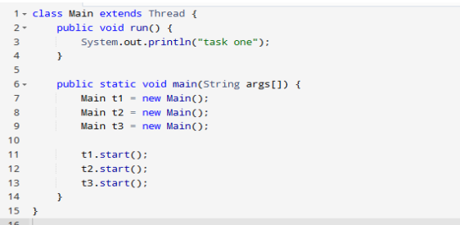
OUTPUT:
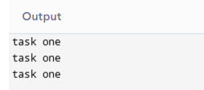

Q1: How many threads are running?
There are 3 threads running in this program — t1, t2, and t3. Each thread executes the run() method separately.

Q2: How many tasks are running?
There are 3 tasks running because each thread performs the same task — printing "task one".
Q3: If more tasks are added, what will be the impact on number of threads?
If more tasks are added by creating more objects (like t4, t5, etc.), then more threads will also be created. Each new thread will run its own copy of the run() method independently. So, the total number of threads will increase as you add more tasks.
Q4: Explain the flow of program:
1. The class Main extends Thread, which allows it to run as a separate thread.
2. The run() method defines the code that each thread will execute — printing "task one". 3. Inside the main() method, three thread objects (t1, t2, and t3) are created.
4. Each thread is started using the start() method, which internally calls the run() method. 5. All three threads run concurrently, and each prints "task one" on the console. 6. The order of execution is not fixed, because the CPU handles threads according to scheduling.

2-With the help of threading print two tables concurrently, print one table number of student roll number e.g. 2019-SE-092 and second number should be date of birth e.g. 05-April.
CODE:
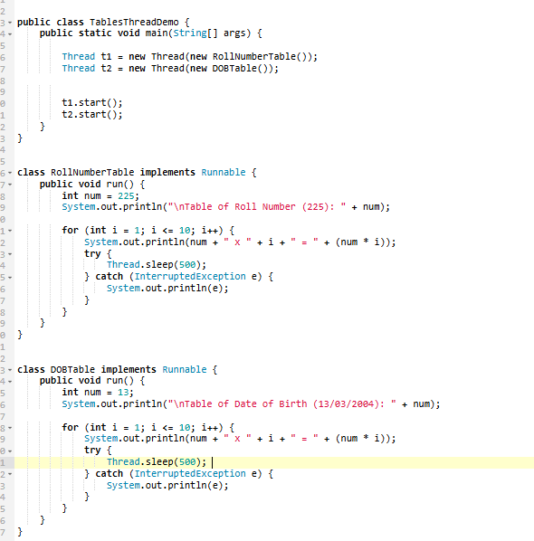
OUTPUT:
