LAB#4
Start sleep and stops methods for multithreading

Objective:
Understanding concurrency by implementing start, sleep and stop thread functions
Lab task:
By using start, stop and sleep methods of threading, print alphabets of English from A–Z. (Hint: use math.random method for getting random numbers and then convert them into characters, print 26 characters under run method loop with fluctuating visualization through sleep method).
Code:
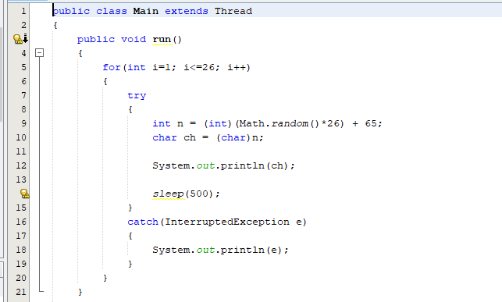
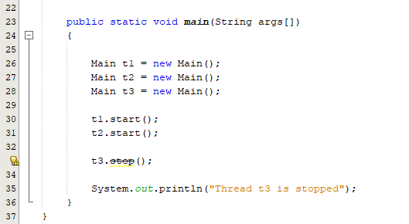
Output:
