FYP Proposal Document

**Short FYP Title:** Pakalo

**Complete FYP Title:** Pakalo - AI Cooking Assistant

**Type of Project:** Development

**FYP Group Information**

|  |  |  |  |  |  |  |
| --- | --- | --- | --- | --- | --- | --- |
| **Name** | **Roll. No.** | **CGPA** | **Credits** | **Email** | **Phone No.** | **Home No.** |
| Mashood Ur Rehman | i16-0063 | 3.56 | 100 | i160063@nu.edu.pk | 0323-8534722 | 051-2256640 |
| Abid Waqar | i16-0229 | 3.53 | 100 | i160229@nu.edu.pk | 0336-8768462 | 0335-0434798 |
| Muhammad Nauraiz Mushtaq | i16-0106 | 3.36 | 100 | i160106@nu.edu.pk | 0343-5799923 | 0345-5708201 |

**FYP Supervisor:** Dr. Omer Beg **Signature:**

**Project Overview**

Pakalo is an app that contains recipes and has a chatbot. The chatbot uses speech and text input from its users and understands it to be able to find recipes, go step by step throughout the recipe alongside the user, suggest recipes according to the user’s interests and the limited ingredients a user has, mention ingredients that are required to make a particular recipe, suggest halal substitute ingredients for recipes with their opposite counterparts and more.

Apart from the chatbot, users will have his or her own account through which users can upload their own recipes. Users can also comment, rate, and share recipes of other users that they liked.

As the user will communicate with the chatbot through either speech or text, the chatbot will use Natural Language Processing to deduce what the user is trying to say. The chatbot will then check the database for helping material and then take action accordingly.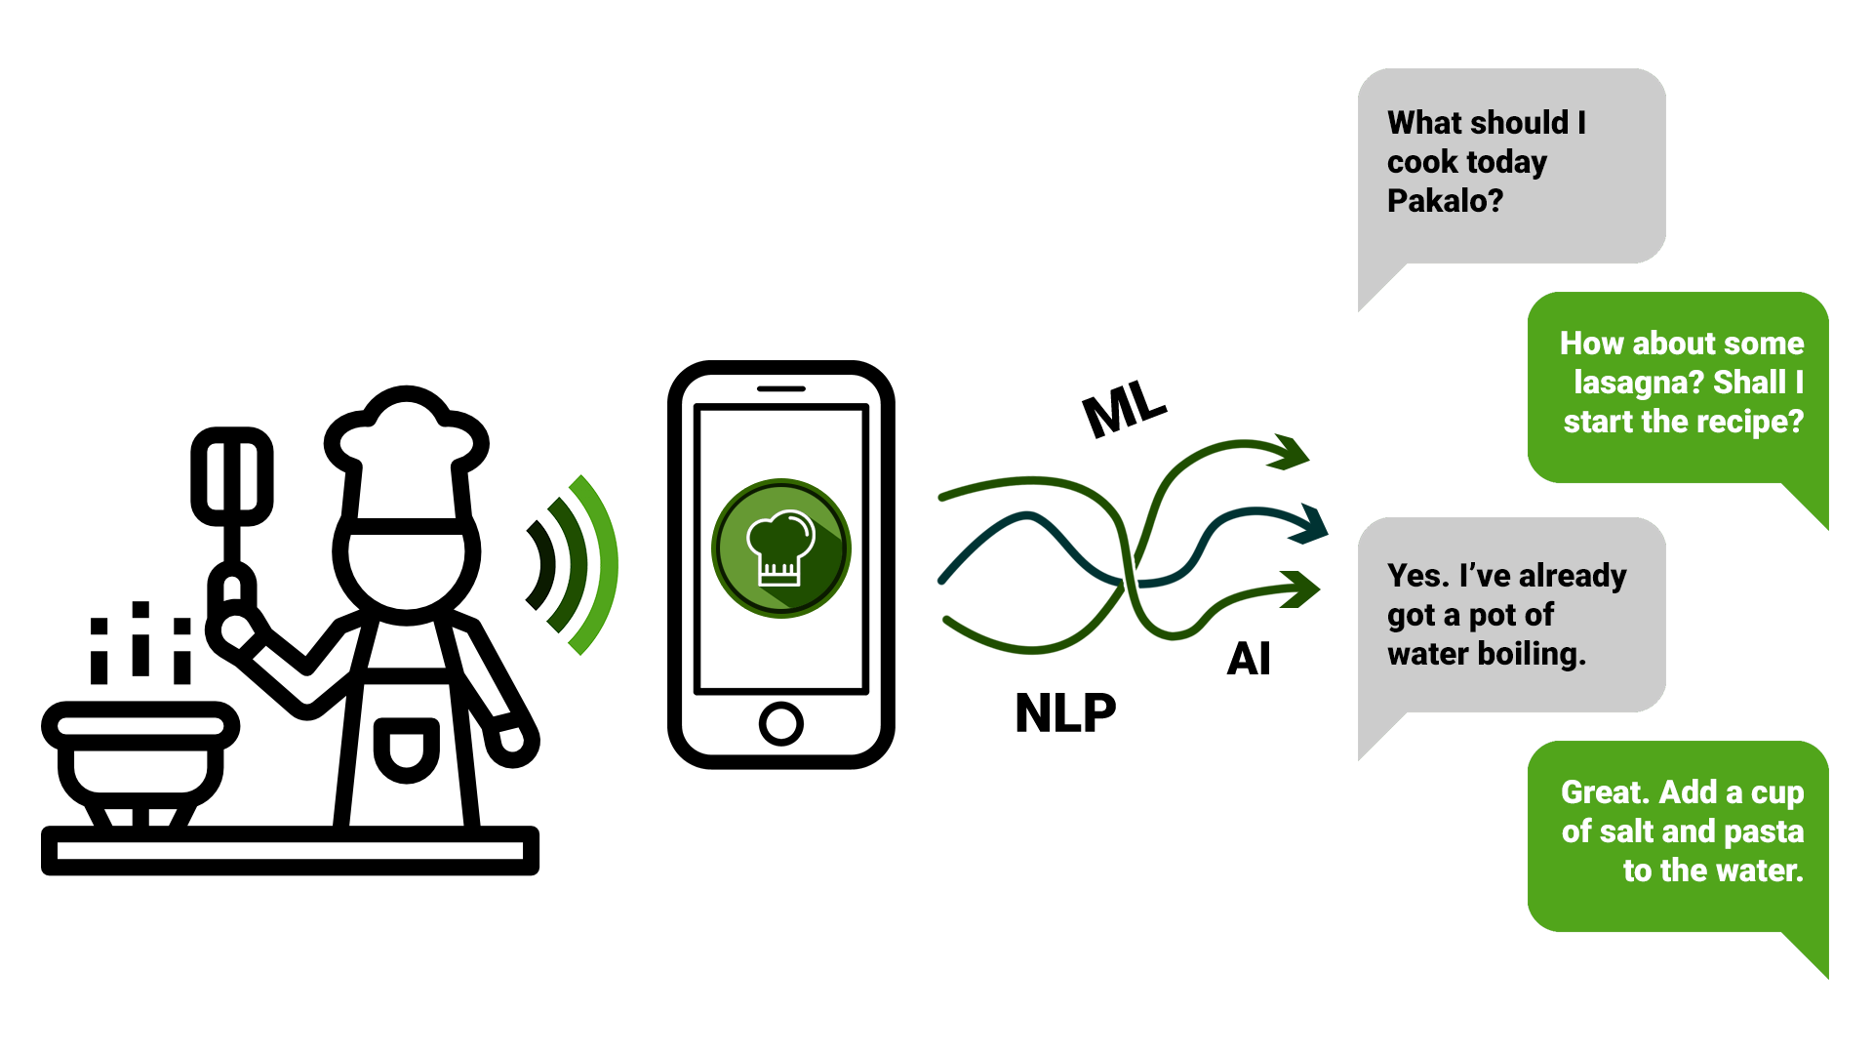

**Motivation**

The app has the target demographic of housewives and husbands, home-cooks, and students. For the students in particular, the app will include recipes that can be made with easily available and/or cheap ingredients. Cooking is already a pretty strenuous task. More multitasking with the hands as someone manages the cooking process along with flipping through cookbooks or pausing and rewinding a video makes the pleasure of cooking all the more difficult.

Much of the target demographic is not able to cook good dishes as they have little to no idea on how and what to cook, and are unable to follow written and video recipes as they are intimidating to a new cook. This app aims to aid their path towards becoming a skillful chef.

**Goals and Objectives**

1. To provide a step by step experience at the user’s own pace when cooking recipes they would love.
2. To recommend recipes based on a limited set of ingredients, and similar interests and user’s history.
3. To have a smart easy to talk to chatbot that the user will be comfortable talking to, and that will aid the user in cooking.
4. To make a rich user friendly social experience for cooks, with user generated recipes and ratings.
5. To suggest substitution of ingredients in cases where they are not available or undesirable.

**Expected Outcomes**

A smart chatbot that will act as an assistant cook and will guide the user throughout their cooking session, and answer any questions that they may have related to cooking. For a rich user experience in an application that the user will love to use, and cook with. And to kickstart a blossoming community of similarly passionate homecooks who will share and rate each other’s recipes.

**Project Scope**

This application, with our bot as a core feature, will aim to revolutionize cooking. More and more smart home solutions are coming into fruition and this bot will be a significant addition to the smart kitchen. The application will be user friendly, similar to the Google Assistant, only it will be focused primarily on cooking.

**High Level Features**

1. Chatbot will go step by step at the user’s pace when cooking recipe.
2. Chatbot will suggest recipe based on available ingredients and user’s interests, and will consider allergies they have.
3. Chatbot will list ingredients needed to make the recipe.
4. Chatbot suggests substitution of ingredients in cases where they are not available or undesirable.
5. Knowledge graph of recipe that can be used to link recipes with sub-recipes. An example would be tomato sauce in pizza. Tomato sauce is a recipe on its own that can be prepared in order to then prepare pizza.
6. User can upload recipe by taking pictures of recipe and app will automatically recognize ingredients and steps from the picture.
7. User will be able to comment on recipes, upload, share and rate recipes.

**Technical Challenges**

1. Identifying which step the user currently stands on by considering what the user is talking about to estimate the standing and then using questions to confirm this standing. Making this estimation accurate is integral.
2. Accurately recommending recipes based on the user’s previous interests, preferences, and allergies. For this to work, categorization of ingredients is necessary.
3. Preparation of a knowledge graph which identifies which ingredient inside a recipe is a recipe on its own and forming a link between them.

**Timeline**

|  |  |  |  |
| --- | --- | --- | --- |
| **Sprint** | **Start Date** | **End Date** | **Workflows and Tasks** |
| One | 27/08/19 | 4/10/19 | Data Scraping, Preprocessing and Categorization |
| Two | 5/10/19 | 25/11/19 | Model Formation, Model Training and Result Ranking |
| Three | 26/11/19 | 17/02/20 | Dynamic Learning and Building Mobile Application |
| Four | 18/02/20 | 26/04/20 | Efficient Responsiveness, Feedback |

**Tools and Technology**

|  |  |
| --- | --- |
| * Python | Image result for python logo |
| * Android | Related image |
| * Keras | Image result for keras logo |
| * NLTK |  |
| * Firebase | Image result for firebase logo |
| * Google Cloud Speech to Text | Related image |

**Expertise Level**

|  |  |  |  |
| --- | --- | --- | --- |
| **Expertise** | **Mashood Ur Rehman** | **Abid Waqar** | **Nauraiz Mushtaq** |
| Python | 8 | 8 | 8 |
| Android | 1 | 2 | 3 |
| NLTK | 0 | 0 | 1 |
| Firebase | 1 | 0 | 0 |
| Keras | 5 | 5 | 5 |
| Data Mining | 8 | 9 | 8 |

**References**

1. S. Bird, E. Klein, and E. Loper, *Natural Language Processing with Python: Analyzing Text with the Natural Language Toolkit.* O’Reilly Media, Inc. 2009.
2. Daniel Jurafsky and James H. Martin, *Speech and Language Processing,* Pearson Education India, 2000.
3. Shawar, Bayan Abu, and Eric Atwell. *Chatbots: are they really useful?*. Ldv forum. Vol. 22. No. 1. 2007.
4. Swayam Mittal, *Deep Learning Techniques for Text Classification,* medium.com, August 17, 2019, [Online]. Available: <https://medium.com/datadriveninvestor/deep-learning-techniques-for-text-classification-9392ca9492c7>