Hoopla Digital Downloader will let you download audiobooks (maybe even videos) from Hoopla Digital.

1. download and install the latest python (i used 3.13.1)

2. Open a command prompt/powershell in the directory hoopladownloaderng\Scripts and enter commands 'pip install requests', 'pip install xmltodict', 'pip install pycryptodome', 'pip install pyperclip', and 'pip install --upgrade protobuf==3.20.3'

or

Install the requirements by running `pip install -r requirements.txt`

3. Run RUNME.bat [Figure 4]

3.1 You will be asked to enter 'dt-custom-data'.

3.1.1 Go to hoopla with google chrome and borrow an audiobook.

3.1.2 Click the Play or Resume button to start playing the content [see Figure 1]. Then Immediately right-click inside Hoopla webpage and click Inspect. (then pause the audio because all we needed (to capture with Chrome's Inspect tool) were those first few moment of network activity after you started playing your hoopla content). Next go to Network tab. [see Figure 2]

3.1.3 Copy and paste the value of the dt-custom-data request header on the POST request to https://lic.drmtoday.com/license-proxy-widevine/cenc/. [see Figure 3 and Figure 4]

3.2 You will be asked to enter URL of the Audiobook https://www.hoopladigital.com/audiobook/the-man-who-disappeared-america-franz-kafka/16233840

4. if every runs smoothly you should find the audiobook in ..\hoopladownloaderng\FINISHED

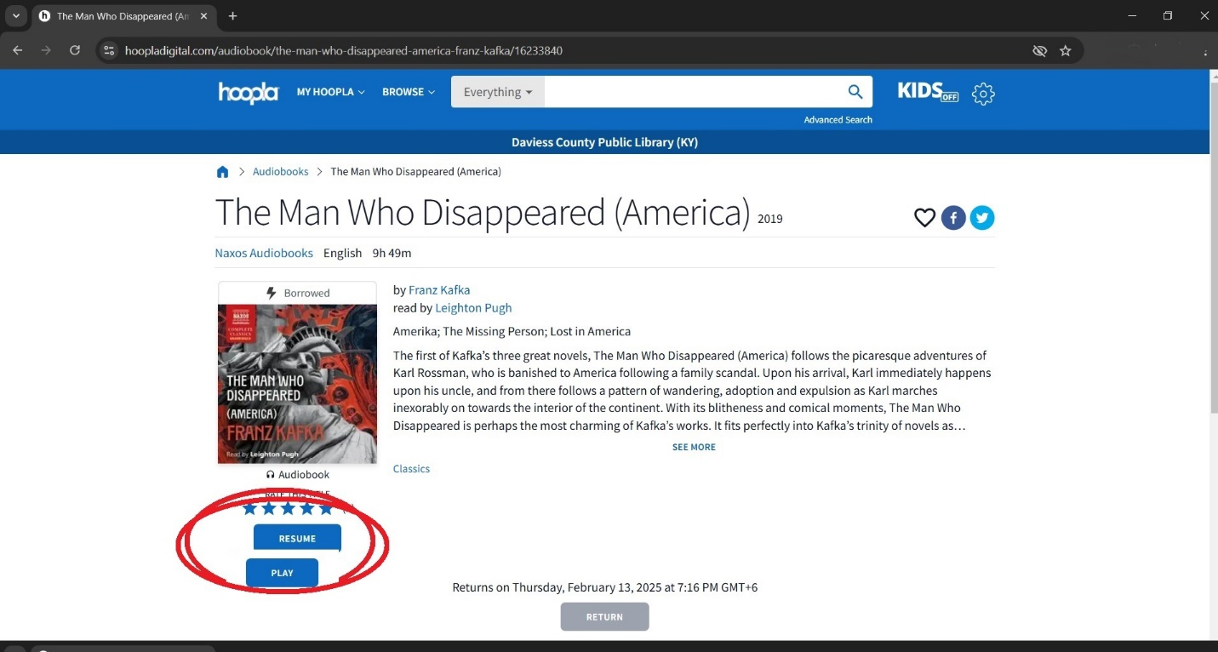

Figure 1

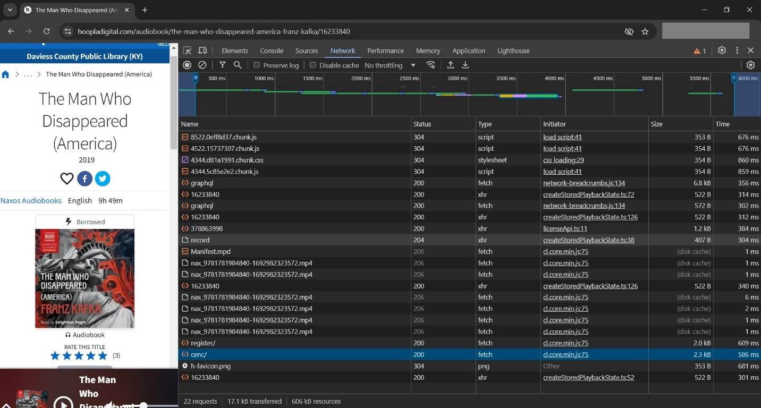

Figure 2

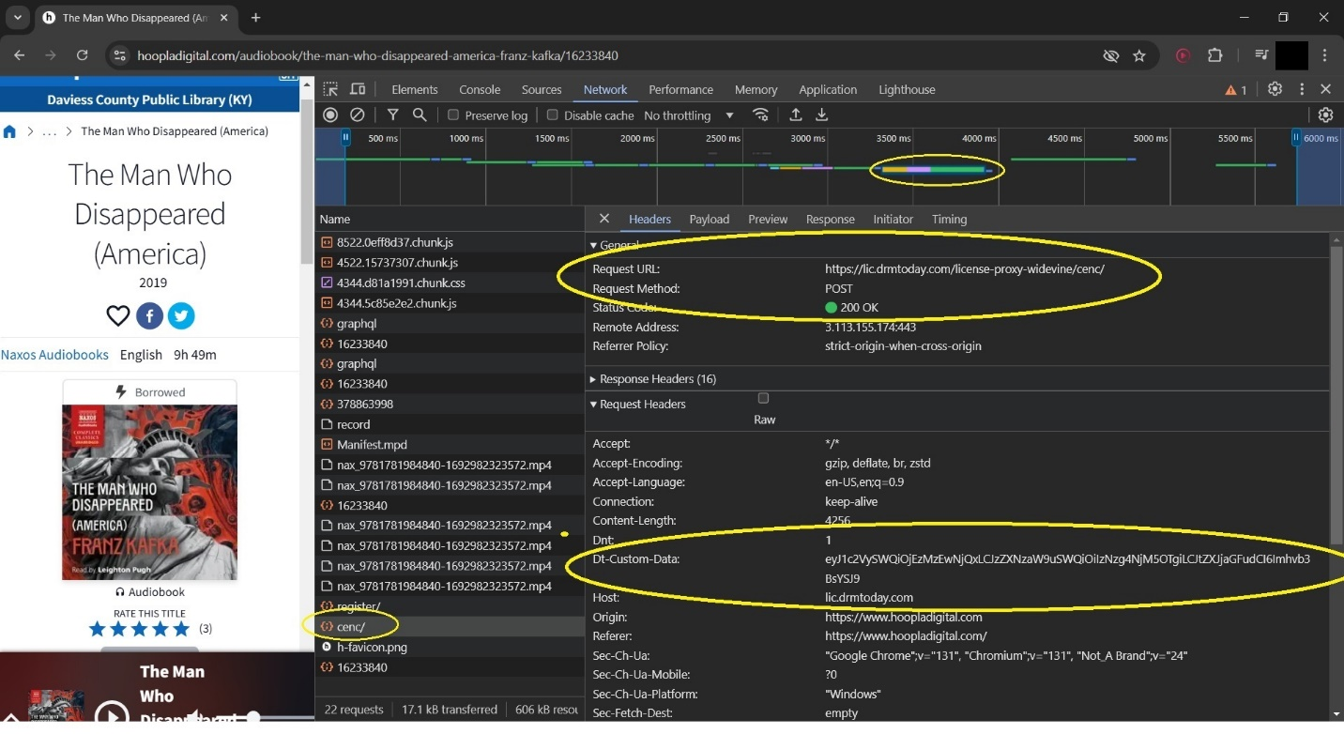

Figure 3

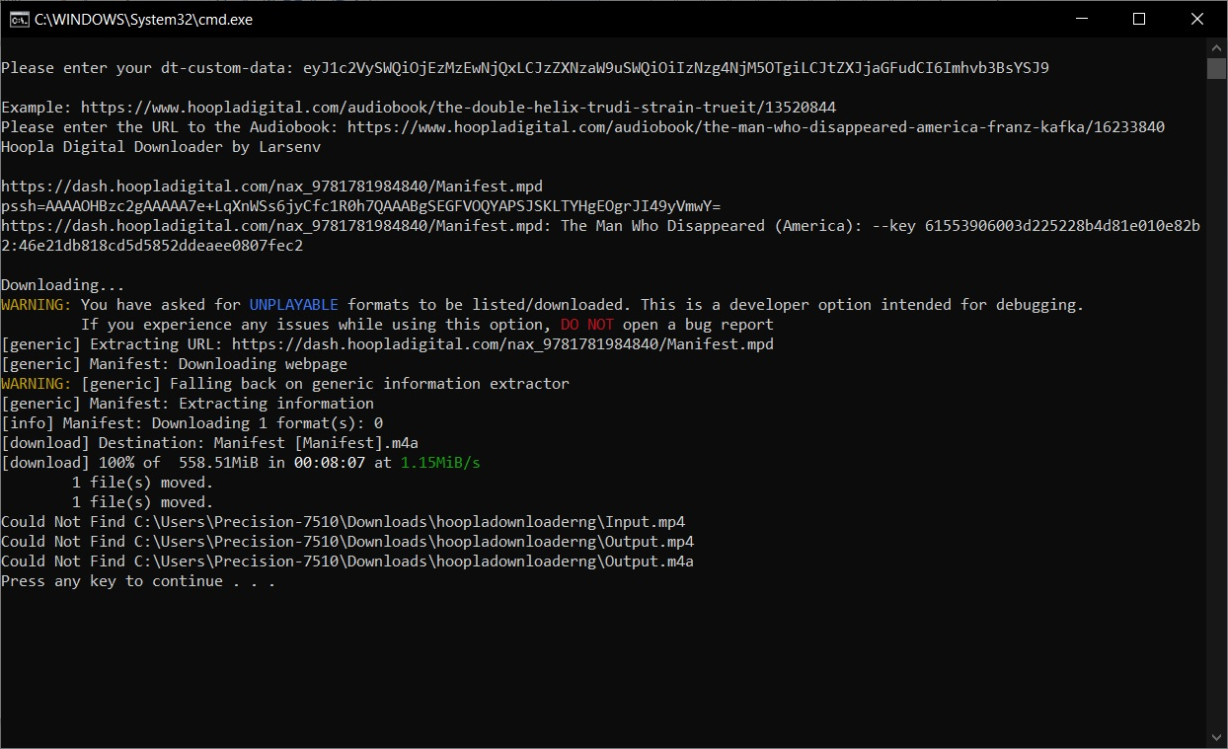

Figure 4