1. Instruction

1.1 node type

|  |  |
| --- | --- |
| C:\Users\yueyue\AppData\Roaming\Tencent\Users\894922713\QQ\WinTemp\RichOle\WEDQWR1O6CDV%W[0E@~CVY0.jpg | 1. represent the node that has been added |
| C:\Users\yueyue\AppData\Roaming\Tencent\Users\894922713\QQ\WinTemp\RichOle\@S@11OKT~V2B~XLF)~OX(AE.jpg | **B．leaf node ,can be added to mashup** |
| C:\Users\yueyue\AppData\Roaming\Tencent\Users\894922713\QQ\WinTemp\RichOle\X213)(WQL9@I5$D4M`PE71K.jpg | **C．the node currently focused on** |
| C:\Users\yueyue\AppData\Roaming\Tencent\Users\894922713\QQ\WinTemp\RichOle\F65%G8_D0OPE4PZ(S`Q51%M.jpg | **D．represent class- instance ,cann’t be added to mashup** |

* 1. Panel for all Services

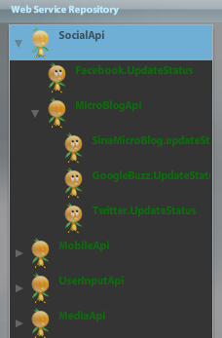

This is a list of all web services organized in class-instance architecture.

Users can select the first node from the list by double-clicking the item with the iconD:\flex_workspace\Mashup\mashupBuild\assets\imgs\tree_leaf.png. The node and recommended nodes will be shown on the right panel in a tree view.

If user double-click the item with the iconD:\flex_workspace\Mashup\mashupBuild\assets\imgs\tree_folder.png ,it will Alert “This item is a class ,can not get recommendation”.

* 1. Panel for degress of Separation

C:\Users\yueyue\AppData\Roaming\Tencent\Users\894922713\QQ\WinTemp\RichOle\JKIKN`5EB8_93J`EVQABI6B.jpg

Move the [scrollbar](dict://key.0895DFE8DB67F9409DB285590D870EDD/scrollbar) , it will extend or shrink both parent and children node levels of the node focused on ( as node type C ),which can stretch to at most 10 level, or shrink to 1 level.

* 1. In the Edit mode ,double Click node
     1. 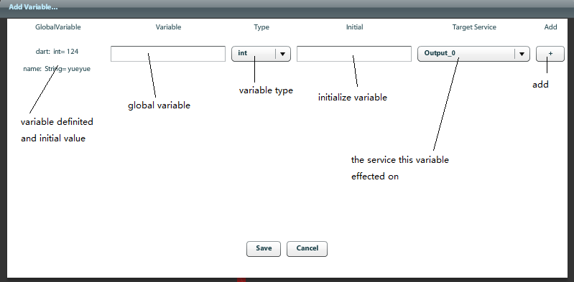Double click the root node, snapshot as here ,used for global Variable definition
     2. 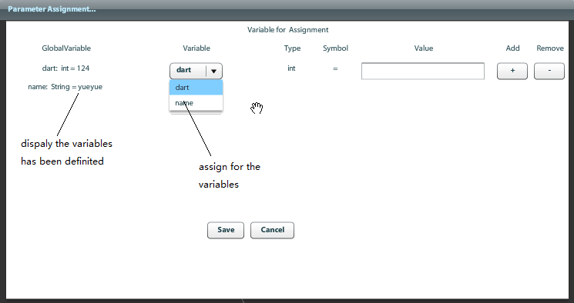Double click the node except for the root node , snapshot as here , used for global variable assignment .
  2. In the “ Edit” mode ,double click edge

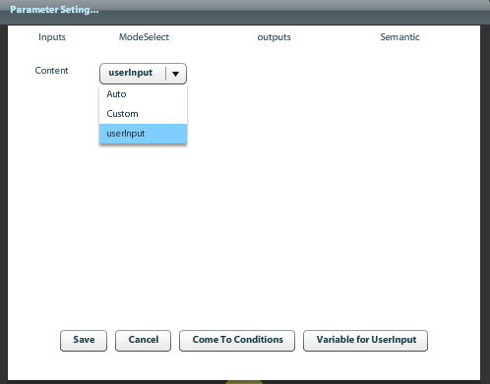

Parameter setting is on this panel ,***”Inputs”*** represents inputs of the end points of edge ,and “***Output***” represents outputs of the start point of edge.”***Semantic***” represents semantic relationship of input and output. Besides , we also can see three mode “Auto”、”Custom”、”userInput” to choose. User can choose mode ”Auto” to let the parameter matched automatically, or use the default value with mode “Custom”, or even can type it by themselves with mode “userInput”.

With the click of the button titled with “Come To Conditons”,Conditon Panel is presented here.

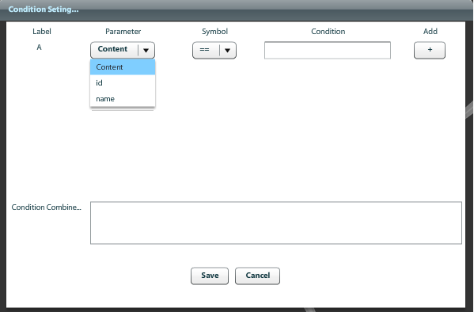It is used for setting flow control ,mainly for condition setting .”Parameter” contains the both “Inputs” in the parameter setting panel and all the global variables .If the corresponding edge is a loop edge ,this condition is “WHILE” condition ,and if the edge is a common edge ,this condition is “IF” condition.

User can set condition on the above panel ,then type the combination of conditions ,each condition can be represented with label ,such as “A”,”B”…

e.g

(A &&B) ||C

1. Operation

2.1 operation “double click ”of Node

(a) green node (B.) , add the corresponding service to mashup

(b) yellow node (A.), recommendation of this service ,but no add occurs.

(c) red node(C.) ,no operation

(d)purple node(D.), display this node in central

* 1. click the button “next” on right bottom

enter the “Edit” mode .Operations “setting parameter ”,”flow control ”, ”variable definition” function in ”Edit” mode.

* 1. Operation “add Edge”

Select two nodes as the start node and end node with key Ctrl . Notice that the node first selected as start point and second selected as end point.

* 1. Operation “remove Edge”

Select the edge which will be deleted by clicking the red square on the edge ,then click the button on the upper right corner.

* 1. Operation “Save”

Click the button “Save” to convert the current mashup graph to mashup description file, then download an APP package to the mobile device and install the APP on the device.

1. Here is an demonstration ,download the video about how to create mashup ,