


LEADING AUSTRALIAN CORPORATE SOLUTIONS PROVIDER
INCORP ADVISORY PROPOSAL
{{ cover_for }} InCorp Proposal
For {{ cover_for }}



Table of Contents

- About InCorp Advisory
- InCorp Group & International Affiliation
- Key Accreditation & Partners
- Scope of Services
- Fee Proposal
- Terms and Conditions (Appendix A)

About InCorp Advisory

For over 30 years, InCorp Advisory Australia has established itself as a leading boutique advisory practice to emerging and growth stage businesses in Australia and beyond. We employ outstanding and diverse professional staff, with offices headquartered in Sydney, Melbourne & Perth.

Our team has a celebrated list of clientele, including small to medium-sized businesses, ASX-listed companies, subsidiaries of multinational corporations, not for profits, and high net worth individuals.

Our reputable team of 140+ full-time individuals come from a range of backgrounds across accounting, finance, science, engineering and technology. This breadth of skills and background enables us to provide a responsive and high-quality business advisory and compliance service that is always tailored to specific accounting needs.

TAXATION AND ADVISORY SERVICES

Our proficient accounting and tax advisory services for individuals, companies, trusts and SMSFs include strategic tax planning and optimisation, statutory accounting and financial reporting in line with IFRS standards, transaction support, and more. Our aim is to become your partner—not just another add-on service. We provide bespoke solutions suited to your exact goals, and we take a proactive, hands-on approach working with you to achieve your commercial goals.

FINANCE FUNCTION SERVICES

Maximise your financial potential with our comprehensive finance services. From banking and reconciliations to payroll management, compliance, and specialised projects, our expert team ensures seamless accounts receivable/accounts payable processes, detailed management reporting, and smooth systems integration. We provide a comprehensive range of services for businesses looking for a scalable and integrated solution across finance requirements, CFO, and special project services. This bespoke solution gives businesses access to experienced professionals and resources without the burden of hiring insourced finance teams.

GOVERNMENT INCENTIVE SERVICES

The Australian government offers various grants to support SMEs. These include R&D Tax Incentives, Export Market Development Grant & Early Stage Innovation Company status. We ensure a seamless process to help you obtain the R&D Tax Incentive. Out grant experts have secured more than $450 million in grants for our clients to date.

AUDIT AND ASSURANCE SERVICES

As businesses develop and grow, your organisation’s responsibilities for governance and risk management increase accordingly. Our professional team will deliver highly accurate financial statement audits and meet all Australian compliance regulations. Incorp Advisory understands the increased responsibilities businesses now have to manage their reporting needs to meet higher regulatory and qualitative requirements. Usually with relatively limited internal resources. So, we invest a considerable amount of our time into understanding your business during the audit process.

CORPORATE GOVERNANCE SERVICES

Our corporate governance services include a thorough audit of your current governance processes, seamless corporatisation of governance practices through creation and enactment, and expert evaluation of management structures, identifying roles and responsibilities while documenting authority and duties. We also help develop business charters, internal policies, and procedures for a strong foundation and optimal performance.

SECRETARIAL AND COMPLIANCE SERVICES

Stay compliant effortlessly with our comprehensive secretarial and compliance services. Our team handles corporate secretarial tasks, business permit renewals, business registration amendments, and ensures strict regulatory compliance.

More information about our firm and services is available at https://australia.incorp.asia/services/

INCORP GROUP & INTERNATIONAL AFFILIATION
InCorp Group is a leading provider of a wide range of professional corporate solutions and services across Asia Pacific. Our reach across the region allows us to provide a seamless client delivery experience across these jurisdictions:
 |  |  |  |  |  |  | 
Australia | Hong Kong | India | Indonesia | Malaysia | Philippines | Singapore | Vietnam

Our award-winning capabilities and resources provide organisations and individuals a full suite of comprehensive services to help them turn their “Vision To Reality”.

Snapshot
- Pan-Asia player anchored in Singapore
- #1 corporate services provider in the region
- Presence across key countries in Asia Pacific region
- 30+ years of operating track record
- Services MNCs, large corporates, SMEs, startups, family offices, funds
- An independent member of PrimeGlobal, an award-winning association of independent accounting and advisory firms



1,200+
Employees
15,000+
Clients

20,000+ Entities
incorporated over the last 10 years

12,000+ Compliance Transactions per year
Strategic Partnerships
with several government entities in Asia, professional firms, fintech firms, accelerators, funds and law firms

1,200+ Employees
across APAC led by professional
management team and industry
experts across multiple disciplines
and platforms

Proprietary in-house Tech
Portal System
which drives industry leading operational and financial metrics

Award-winning Group
and recognized platform in Singapore and Southeast Asia set-up to offer
full suite of comprehensive services
to customers

Locations
SINGAPORE (HQ)
30 Cecil Street, #19-08 Prudential Tower, Singapore 049712.

INDONESIA
AXA Tower 36th floor, Kuningan City, Jl. Prof. Dr. Satrio Kav. 18, Kuningan, Jakarta Selatan 12940, Indonesia.

INDIA
1602, B – Wing, One BKC, Bandra Kurla Complex, Mumbai – 400051, India.

VIETNAM
The Galleria Office Building, 258 Nam Ky Khoi Nghia Street, Vo Thi Sau Ward, District 3, Ho Chi Minh City, Vietnam 72408.

HONG KONG
Unit 1307A, 13/F, Two Harbourfront, 22 Tak Fung Street, Hunghom, Kowloon, Hong Kong.

PHILIPPINES
8th Floor, Marajo Tower, 312 26th St. West corner 4th Ave., Bonifacio Global City, Taguig, Philippines 1634.

AUSTRALIA
Level 1, 6-10 O’Connell Street, Sydney NSW 2000, Australia.

MALAYSIA
D-8-3A, Menara SuezCap 1, KL Gateway, 59200 Kuala Lumpur.

Our Full Range of Corporate Services ACROSS ASIA PACIFIC

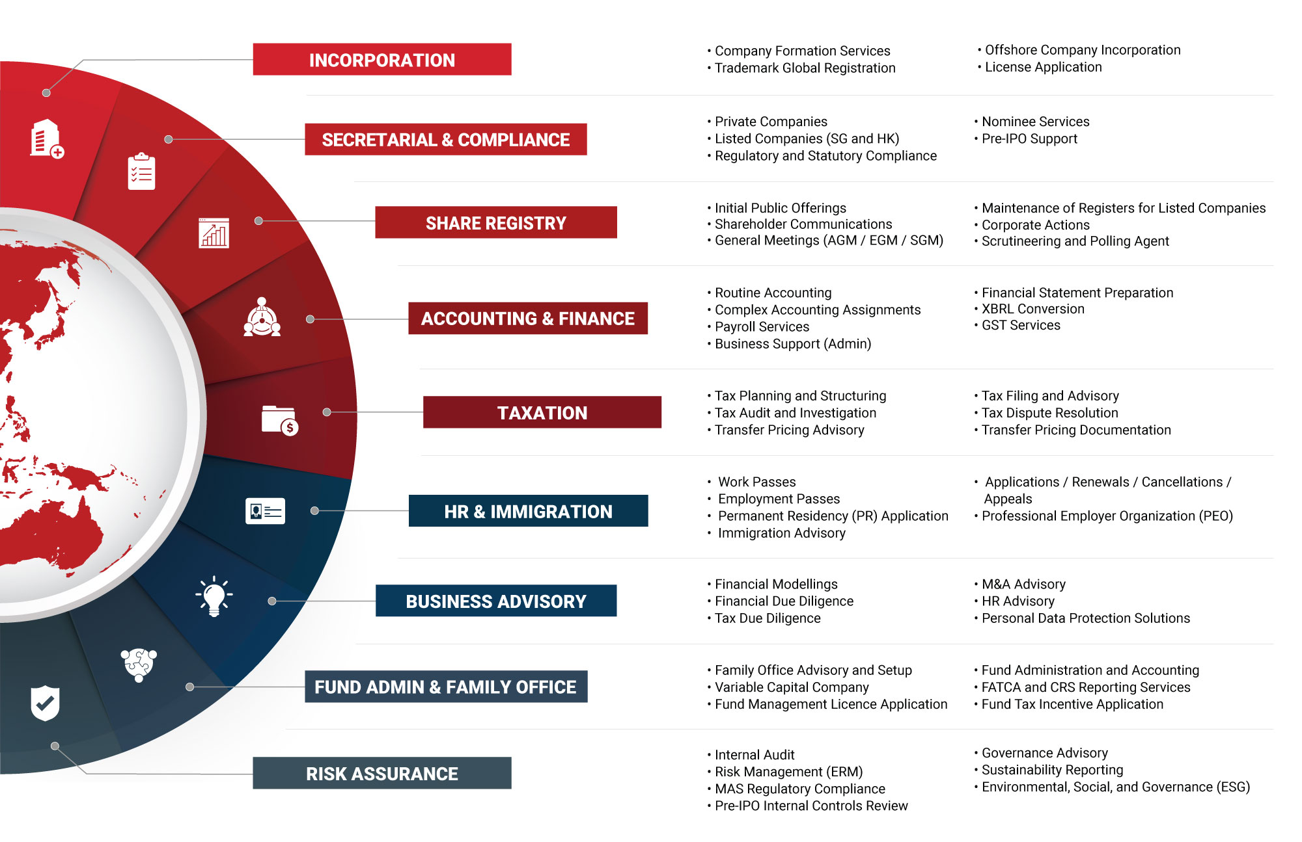

Key Accreditations And Partners

 | 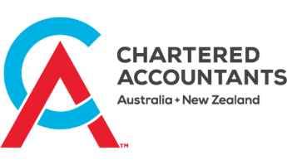 | 

 |  | ENTERPRISE  SINGAPORE |  | 

Fees
{% if sections.solution_and_fees.intro.has_content %}
{{ sections.solution_and_fees.intro }}
{% endif %}

{% if fee_tables.has_groups %}
{% for group in fee_tables.groups %}
{{ group.display_name }} | Monthly | Quarterly | Annual | Once-Off | Total
{%tr for row in group.rows %}
{{row.preview_primary}}  {{row.scope_of_work_display}} | {{ row.frequency_columns_display.monthly }} | {{ row.frequency_columns_display.quarterly }} | {{ row.frequency_columns_display.annual }} | {{ row.frequency_columns_display.once_off }} | {{ row.display.total_display }}
{%tr endfor %}
{% endfor %}

{% endif %}{% if sections.payment_options.enabled and payment_options.has_options %}{% if sections.payment_options.intro.has_content %}Fee SUMMARY
{{ sections.payment_options.intro }}

{% endif %}
{% for option in payment_options.options %}
Option | Monthly Fees | Quarterly Fees | Annual Fees | Once-Off Fees | Total Fees (Annualised)
{%tr for row in option.rows %}
{{ row.label }} | {{ row.monthly_display }} | {{ row.quarterly_display }} | {{ row.annual_display }} | {{ row.once_off_display }} | {{ row.total_display }}
{%tr endfor %}
Once-Off Fees |  |  |  |  | {{ option.summary.once_off_total_display }}
Annualised Total Fees (billed on completion, with monthly, quarterly & annual fees associated) |  |  |  |  | {{ option.summary.recurring_annualized_total_display }}

{% endfor %}

{% endif %}{% if sections.appendices.enabled and sections.appendices.items %}{{ sections.appendices.title }}

{% for item in sections.appendices.items %}
{{ item.title }}
{{ item.plain }}

{% endfor %}{% endif %}



In.Corp Advisory (AU) Pty Ltd
Level 1 6-10 O’Connell Street
SYDNEY NSW 2000
Australia

Main Line: +61 2 8999 1199

Email: team@incorpadvisory.au
Web: australia.incorp.asia




FOLLOW US ON:


Copyright ©2023 In.Corp Advisory (AU) Pty Ltd. All rights reserved.

