


LEADING ASIA PACIFIC CORPORATE SOLUTIONS PROVIDER

INCORP GLOBAL PROPOSAL
{{ cover_for }}

Table of Contents

- About InCorp
- Scope of Services
- Fees Proposal
- Terms and Conditions

About InCorp
InCorp Global, a member of the Ascentium Group, is a leading provider of professional corporate solutions and services across Asia Pacific with a strong regional presence in 9 markets:
 |  |  |  |  |  |  |  | 
Australia | Hong Kong SAR | India | Indonesia | Mainland China | Malaysia | Philippines | Singapore | Vietnam

Our award-winning capabilities and resources provide organisations and individuals a full suite of comprehensive services to help them turn their “Vision To Reality”.

Snapshot
- Pan-Asia player anchored in Singapore
- #1 corporate services provider in Singapore
- Presence across key countries in Asia Pacific region
- 30+ years of operating track record
- Services MNCs, large corporates, SMEs, startups, family offices, funds
- An independent member of PrimeGlobal, an award-winning association of independent accounting and advisory firms



1,500+
Employees
20,000+
Clients

20,000+ Entities
incorporated over the last 10 years

12,000+ Compliance Transactions per year
Strategic Partnerships
with several government entities in Asia, professional firms, fintech firms, accelerators, funds and law firms

1,500+ Employees
across APAC led by professional
management team and industry
experts across multiple disciplines
and platforms

Proprietary In-house Tech
Portal System
which drives industry leading operational and financial metrics

Award-winning Group
and recognized platform in Singapore and Southeast Asia set-up to offer
full suite of comprehensive services
to customers

Locations
AUSTRALIA
Level 1, 6-10 O’Connell Street, Sydney NSW 2000, Australia.

INDONESIA
AXA Tower 36th floor, Kuningan City, Jl. Prof. Dr. Satrio Kav. 18, Kuningan, Jakarta Selatan 12940, Indonesia.

PHILIPPINES
8th Floor, Marajo Tower, 312 26th St. West corner 4th Ave., Bonifacio Global City, Taguig, Philippines 1634.

HONG KONG
Unit 1307A, 13/F, Two Harbourfront, 22 Tak Fung Street, Hunghom, Kowloon, Hong Kong.

MAINLAND CHINA
R-C, 40F, Huangting Center,
No.350 Fuhua Road, Shenzhen.

VIETNAM
The Galleria Office Building, 258 Nam Ky Khoi Nghia Street, Vo Thi Sau Ward, District 3, Ho Chi Minh City, Vietnam 72408.

SINGAPORE (HQ)
36 Robinson Road, #20-01 City House, Singapore 068877.

INDIA
1602, B – Wing, One BKC, Bandra Kurla Complex, Mumbai – 400051, India.

MALAYSIA
D-8-3A, Menara SuezCap 1, KL Gateway, 59200 Kuala Lumpur.

Our Full Range of Corporate Services ACROSS ASIA PACIFIC

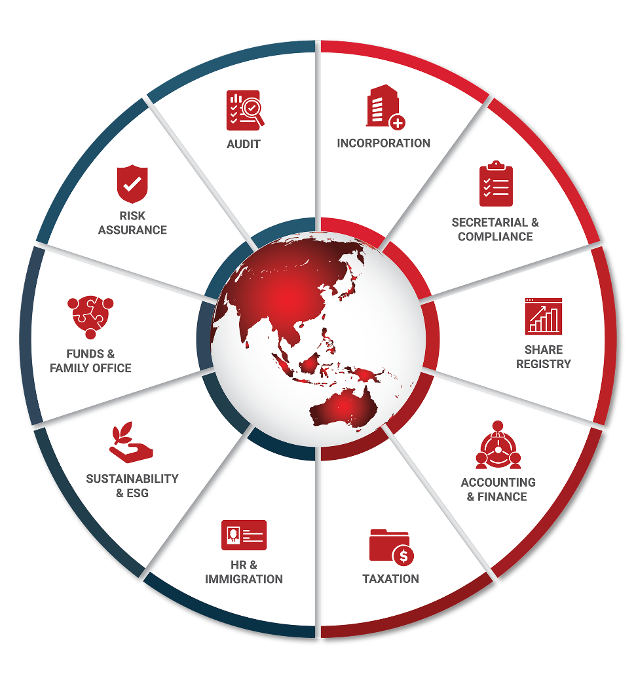

Key Accreditations And Partners

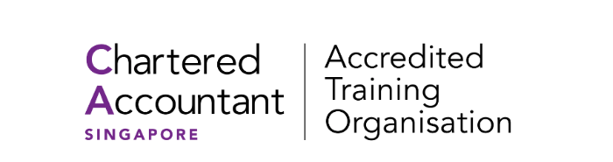 |  |  | ECONIMIC  DEVELOPMENT  BOARD (EDB) | Connections  Concierge  Partner

ENTERPRISE  SINGAPORE |  |  | MINISTRY OF MANPOWER  (EA - 11C3030) | 

28 May 2026

{{ client.contract_email}}

Attention: {{ client.contract_name }}

{{ sections.executive_summary}}

Ping Qian

{% if sections.scope_of_service.has_content %}

SCOPE OF SERVICES AND FEES
{{ sections.scope_of_service }}
{% endif %}
{% if sections.solution_and_fees.intro.has_content %}
Solution and professional service
{{ sections.solution_and_fees.intro }}
{% endif %}

{% if fee_tables.has_groups %}
{% for group in fee_tables.groups %}
{{ group.display_name }}
Service | One-off | Recurring
{%tr for row in group.rows %}
{{ row.preview_primary }}  {{ row.scope_of_work_display }} | {{ row.once_off_display }} | {{ row.recurring_display }}
{%tr endfor %}

{% endfor %}
{% endif %}

{% if sections.first_invoice.enabled and first_invoice.has_rows %}
{{ sections.first_invoice.title }}
Description | Price | Tax | Total
{%tr for row in first_invoice.rows %}
{{ row.description }} | {{ row.price_display }} | {{ row.tax_display }} | {{ row.total_display }}
{%tr endfor %}

Subtotal: {{ first_invoice.subtotal_display }}
{{ first_invoice.tax_label }}: {{ first_invoice.tax_display }}
Total: {{ first_invoice.total_display }}

{% endif %}
{% if sections.appendices.enabled and sections.appendices.items %}

{{ sections.appendices.title }}

{% for item in sections.appendices.items %}
{{ item.title }}
{{ item.plain }}

{% endfor %}
{% endif %}

Terms & Conditions

Formal Service Agreements
- Formal service agreements are to be executed between In.Corp and the Company post the acceptance of this proposal letter by way of a written email.
- Additional fees will be charged for services rendered in connection with matters outside the scope of services outlined above and for services rendered where time costs exceed the fees quoted above.
- Our fees are based on current regulations and market practices. Should there be changes which impact our scope of services or effort involved, we will be pleased to discuss them with you to arrive at a mutually agreeable solution.

Termination
- Either Party may terminate the above-mentioned services with two (2) month’s prior written notice thereof. In the event that this engagement is terminated, we shall still be entitled to our fee and out-of- pocket expenses accrued up to the date of the end of service.

MISC Terms
- All out of pocket expenses reasonably incurred by us on your behalf will be borne by your Company, where prior consent will be obtained from you. The fees and expenses do not include GST. The GST (if applicable) will be included in our invoices as a separate item.

Governing Law
- This Letter shall be governed by and construed in accordance with the laws of Singapore and the parties hereto submit to the exclusive jurisdiction of the Courts of Singapore over any disputes, which may arise out of or in accordance with it.

We hope to hear from you favourably on our proposal. Please do not hesitate to let us know if you need further clarifications.



In.Corp Global Pte Ltd.
36 Robinson Road,
#20-01 City House,
Singapore 068877.

Main Line: +65 6990 8220
Email: info@incorp.asia
Web: www.incorp.asia




FOLLOW US ON:

Copyright ©2024 In.Corp Global Pte Ltd.

All rights reserved.

