Advanced Searching
We have created a job on 18/12/2025 for RQA9732154 and a job note has been issued and stored under the planning Folder (PDF). 18/12/2025
I have completed the job
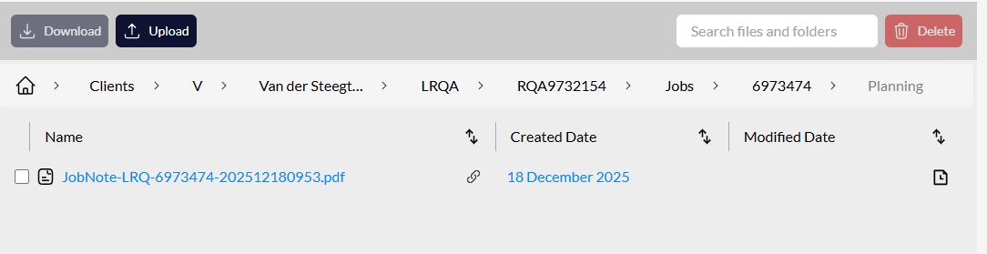
I have completed the job and an audit report has also been uploaded under the audit reports folder. (PDF) 18/12/2025
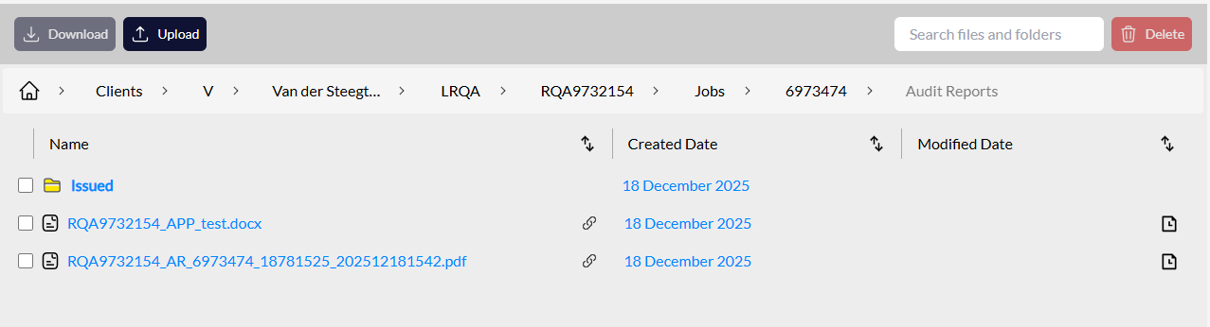

Advanced searching to look for PDFs into this Contract with a start date 15/12/2025

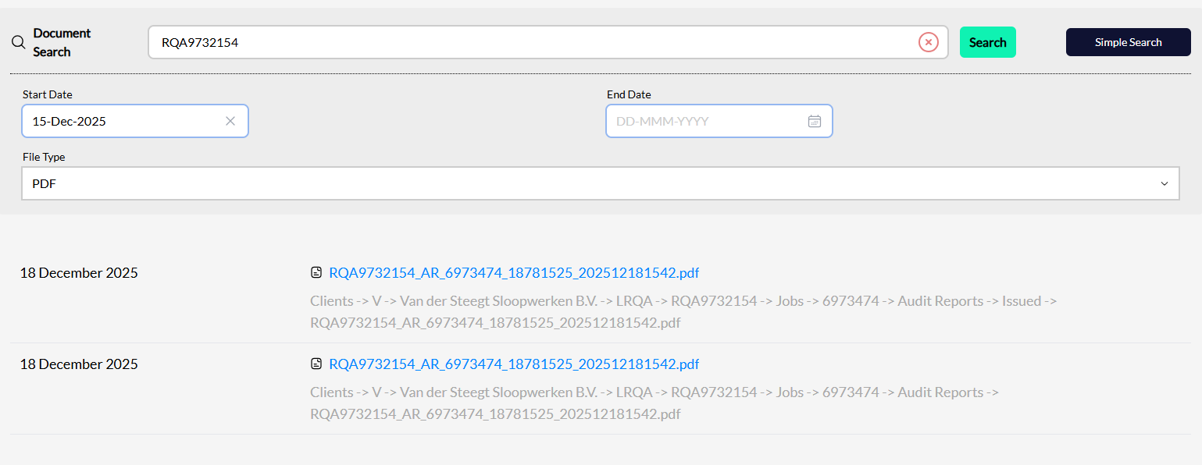

The job note is not populated into the files that File explorer found.

