


LEADING AUSTRALIAN CORPORATE SOLUTIONS PROVIDER
INCORP ADVISORY PROPOSAL
Australian Incorporation
Thinkvibes



Table of Contents

- About InCorp Advisory
- InCorp Group & International Affiliation
- Key Accreditation & Partners
- Executive Summary
- Scope of Services
- Fee Proposal
- Terms and Conditions (Appendix A)

About InCorp Advisory

For over 30 years, InCorp Advisory Australia has established itself as a leading boutique advisory practice to emerging and growth stage businesses in Australia and beyond. We employ outstanding and diverse professional staff, with offices headquartered in Sydney, Melbourne & Perth.

Our team has a celebrated list of clientele, including small to medium-sized businesses, ASX-listed companies, subsidiaries of multinational corporations, not for profits, and high net worth individuals.

Our reputable team of 140+ full-time individuals come from a range of backgrounds across accounting, finance, science, engineering and technology. This breadth of skills and background enables us to provide a responsive and high-quality business advisory and compliance service that is always tailored to specific accounting needs.

TAXATION AND ADVISORY SERVICES

Our proficient accounting and tax advisory services for individuals, companies, trusts and SMSFs include strategic tax planning and optimisation, statutory accounting and financial reporting in line with IFRS standards, transaction support, and more. Our aim is to become your partner—not just another add-on service. We provide bespoke solutions suited to your exact goals, and we take a proactive, hands-on approach working with you to achieve your commercial goals.

FINANCE FUNCTION SERVICES

Maximise your financial potential with our comprehensive finance services. From banking and reconciliations to payroll management, compliance, and specialised projects, our expert team ensures seamless accounts receivable/accounts payable processes, detailed management reporting, and smooth systems integration. We provide a comprehensive range of services for businesses looking for a scalable and integrated solution across finance requirements, CFO, and special project services. This bespoke solution gives businesses access to experienced professionals and resources without the burden of hiring insourced finance teams.

GOVERNMENT INCENTIVE SERVICES

The Australian government offers various grants to support SMEs. These include R&D Tax Incentives, Export Market Development Grant & Early Stage Innovation Company status. We ensure a seamless process to help you obtain the R&D Tax Incentive. Out grant experts have secured more than $450 million in grants for our clients to date.

AUDIT AND ASSURANCE SERVICES

As businesses develop and grow, your organisation’s responsibilities for governance and risk management increase accordingly. Our professional team will deliver highly accurate financial statement audits and meet all Australian compliance regulations. Incorp Advisory understands the increased responsibilities businesses now have to manage their reporting needs to meet higher regulatory and qualitative requirements. Usually with relatively limited internal resources. So, we invest a considerable amount of our time into understanding your business during the audit process.

CORPORATE GOVERNANCE SERVICES

Our corporate governance services include a thorough audit of your current governance processes, seamless corporatisation of governance practices through creation and enactment, and expert evaluation of management structures, identifying roles and responsibilities while documenting authority and duties. We also help develop business charters, internal policies, and procedures for a strong foundation and optimal performance.

SECRETARIAL AND COMPLIANCE SERVICES

Stay compliant effortlessly with our comprehensive secretarial and compliance services. Our team handles corporate secretarial tasks, business permit renewals, business registration amendments, and ensures strict regulatory compliance.

More information about our firm and services is available at https://australia.incorp.asia/services/

INCORP GROUP & INTERNATIONAL AFFILIATION
InCorp Group is a leading provider of a wide range of professional corporate solutions and services across Asia Pacific. Our reach across the region allows us to provide a seamless client delivery experience across these jurisdictions:
 |  |  |  |  |  |  | 
Australia | Hong Kong | India | Indonesia | Malaysia | Philippines | Singapore | Vietnam

Our award-winning capabilities and resources provide organisations and individuals a full suite of comprehensive services to help them turn their “Vision To Reality”.

Snapshot
- Pan-Asia player anchored in Singapore
- #1 corporate services provider in the region
- Presence across key countries in Asia Pacific region
- 30+ years of operating track record
- Services MNCs, large corporates, SMEs, startups, family offices, funds
- An independent member of PrimeGlobal, an award-winning association of independent accounting and advisory firms



1,200+
Employees
15,000+
Clients

20,000+ Entities
incorporated over the last 10 years

12,000+ Compliance Transactions per year
Strategic Partnerships
with several government entities in Asia, professional firms, fintech firms, accelerators, funds and law firms

1,200+ Employees
across APAC led by professional
management team and industry
experts across multiple disciplines
and platforms

Proprietary in-house Tech
Portal System
which drives industry leading operational and financial metrics

Award-winning Group
and recognized platform in Singapore and Southeast Asia set-up to offer
full suite of comprehensive services
to customers

Locations
SINGAPORE (HQ)
30 Cecil Street, #19-08 Prudential Tower, Singapore 049712.

INDONESIA
AXA Tower 36th floor, Kuningan City, Jl. Prof. Dr. Satrio Kav. 18, Kuningan, Jakarta Selatan 12940, Indonesia.

INDIA
1602, B – Wing, One BKC, Bandra Kurla Complex, Mumbai – 400051, India.

VIETNAM
The Galleria Office Building, 258 Nam Ky Khoi Nghia Street, Vo Thi Sau Ward, District 3, Ho Chi Minh City, Vietnam 72408.

HONG KONG
Unit 1307A, 13/F, Two Harbourfront, 22 Tak Fung Street, Hunghom, Kowloon, Hong Kong.

PHILIPPINES
8th Floor, Marajo Tower, 312 26th St. West corner 4th Ave., Bonifacio Global City, Taguig, Philippines 1634.

AUSTRALIA
Level 1, 6-10 O’Connell Street, Sydney NSW 2000, Australia.

MALAYSIA
D-8-3A, Menara SuezCap 1, KL Gateway, 59200 Kuala Lumpur.

Our Full Range of Corporate Services ACROSS ASIA PACIFIC

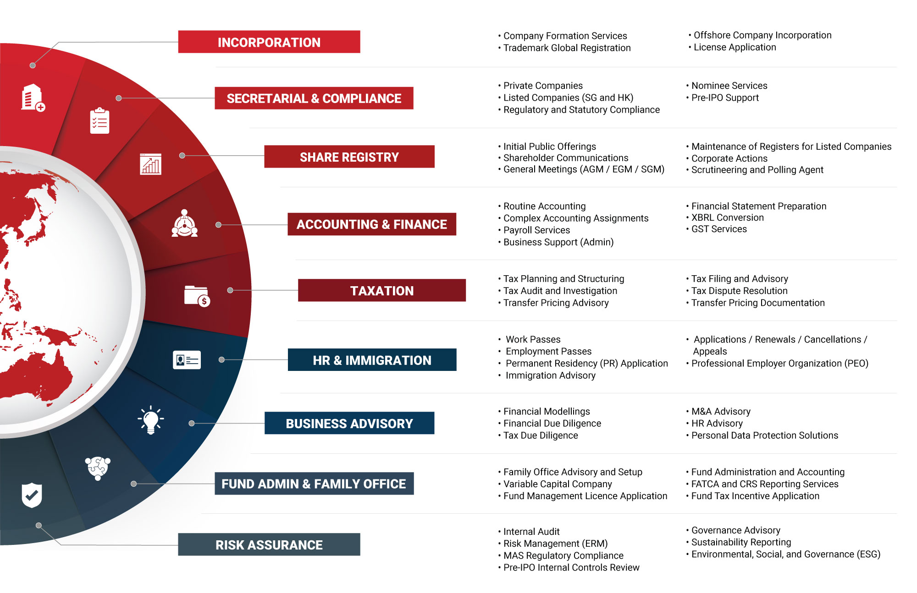

Key Accreditations And Partners

 | 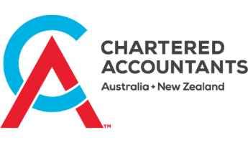 | 

 |  | ENTERPRISE  SINGAPORE |  | 

23 July 2026

Anirudh Dua

Thinkvibes

Dear Anirudh Dua,

RE: Fee Proposal
We are pleased to present our proposal to Thinkvibes in support of your planned expansion into Australia. Based on our discussions, we understand that Thinkvibes is an India-based IT development company with an established client base in the US and UK, and existing operations in India and Dubai. As part of your international growth strategy, you are now looking to establish a presence in Australia, with a view to building local operations and hiring staff in the market.

Our team will support Thinkvibes through the key stages of Australian market entry, including entity incorporation, registration requirements, resident director support, registered office solutions, and ongoing corporate, tax, accounting, and compliance obligations. We also understand the importance of maintaining an efficient and practical structure, and our approach is designed to provide clear guidance on regulatory requirements while ensuring that operational control remains with your leadership team.

In addition to the initial setup, we are well positioned to support Thinkvibes on an ongoing basis with corporate secretarial services, tax compliance, financial reporting, audit relief applications where available, and advisory matters such as GST, payroll, and transfer pricing considerations as your Australian operations grow. As a firm committed to long-term partnerships, we aim to serve as a single, coordinated point of support for your Australia entry and future international expansion plans.

The following pages outline the scope of services tailored to Thinkvibes’ requirements, together with the proposed fees, timelines, and documentation requirements. We trust this proposal addresses your current objectives and provides a clear pathway for establishing your Australian presence. We look forward to the opportunity to work with you and build a strong, long-term relationship with Thinkvibes.

Yours Sincerely and on behalf of In.Corp,

Saief Hoque
Business Development Executive

Fees
This section outlines InCorp Advisory's proposed services and estimated fees for your company. Our fee structure includes initial setup fees, as well as ongoing charges that may be billed monthly, quarterly, or annually. Additionally, fees may be incurred based on the time spent on specific tasks or on a per-instance basis.

For any additional services not encompassed by this proposal that may incur additional charges, we will receive your approval before any work commences. Please note that all fees mentioned are in Australian Dollars, exclusive of the prevailing 10% Goods and Services Tax (GST).
All fees quoted are in AUD, and exclude our 2.5% disbursement charge and 10% GST.

1. Initial Structuring - One-off Costs | Monthly | Quarterly | Annual | Once-Off | Total
1.1 Assistance with company incorporation, including:  • Incorporation with the Australian Securities & Investments Commission (“ASIC”);  • Attending to various registrations including Australian Registered Business Number (“ARBN”);  • Attending to various registrations including Australian Business Number (“ABN”), Tax File Number (“TFN”), Goods & Services Tax (“GST”) and Pay As You Go Withholding (“PAYG)”;  • Provision of corporate register including company constitution, directors’ minutes, consents and share certificates; and  • Registration as agent for ASIC and ATO purposes. |  |  |  | $2,500.00 | $2,500.00
1.2 Application for audit relief, excusing the trading entity from annual audit obligations imposed on foreign controlled companies, if required |  |  |  | $900.00 | $900.00
1.3 Application to synchronise the Australian entity’s fiscal year-end to the Parent entity’s foreign reporting period. |  |  |  | $750.00 | $750.00
1.4 Setup of an Australian bank account in the name of the newly incorporated entity with our preferred neo-banking provider |  |  |  | $1,500.00 | $1,500.00
1.5 Setup of Xero (cloud-based accounting package) including Chart of Accounts and linking to the Australian bank account detailed above, if required |  |  |  | $500.00 | $500.00

2. Corporate Secretarial - Ongoing Costs | Monthly | Quarterly | Annual | Once-Off | Total
2.1 Appointment of one of our member team to act as Resident Director and Public Officer of the newly incorporated company, including the preparation and execution of relevant documentation in respect of ongoing indemnification/warranties.  Note: Payment is required upfront prior to the appointment (billed annually – cannot be offered as monthly retainer).  (fee reverts to $9,500 if InCorp do not handle tax compliance) |  |  | $7,500.00 |  | $7,500.00
2.2 InCorp Advisory to act as ASIC agent and Registered Office of the company, including handling all statutory correspondence (ATO & ASIC) on the company’s behalf and actioning items as and when required. This includes review of ASIC company statement and invoice, and preparation of annual solvency resolution.  Note: Payment is required upfront prior to the appointment (billed annually – cannot be offered as monthly retainer). |  |  | $600.00 |  | $600.00
2.3 Provision of a professional virtual business address for the newly incorporated company, including mail handling and forwarding services. This service ensures a credible business presence and efficient management of correspondence.  Payment is required upfront prior to the appointment in full or on monthly fee. |  |  | $350.00 |  | $350.00

3. Tax & Advisory Services | Monthly | Quarterly | Annual | Once-Off | Total
3.1 Outsourced tax compliance services, including:  • Periodic review of accounting file prepared by bookkeeper, including key account reconciliations, adjusting journals and feedback; and  • Preparation and lodgement of quarterly Business Activity Statement (“BAS”) returns with the Australian Taxation Office. |  | $500.00 |  |  | $2,000.00
3.2 Preparation and electronic lodgement of annual financial statements and company income tax return, including the following:  • Preparation of special purpose financial statements;  • Preparation and lodgement of company tax return; and  • Year-end review of shareholder loans and dividend payments (where necessary), including preparation of dividend statements and resolutions.  Note: Invoice issued upon completion of work, alternatively we recommend rolling into a monthly retainer fee. |  |  | $4,500.00 |  | $4,500.00

Fee SUMMARY
Please note that all fees mentioned are in Australian Dollars, exclusive of the prevailing 10% Goods and Services Tax (GST).
All fees quoted below exclude our 2.5% disbursement charge and 10% GST

Payment Option A (Progressive billing)
Option A (Progressive billing) | Monthly Fees | Quarterly Fees | Annual Fees | Once-Off Fees | Total Fees (Annualised)
1. Initial Structuring - One-off Costs |  |  |  | $6,150.00 | $6,150.00
2. Corporate Secretarial - Ongoing Costs |  |  | $8,450.00 |  | $8,450.00
3. Tax & Advisory |  | $500.00 | $4,500.00 |  | $6,500.00
Once-Off Fees |  |  |  |  | $6,150.00
Annualised Total Fees (billed on completion, with monthly, quarterly & annual fees associated) |  |  |  |  | $14,950.00

Payment Option B (Tax monthly retainer)
Option B (Tax monthly retainer) | Monthly Fees | Quarterly Fees | Annual Fees | Once-Off Fees | Total Fees (Annualised)
1. Initial Structuring - One-off Costs |  |  |  | $6,150.00 | $6,150.00
2. Corporate Secretarial - Ongoing Costs |  |  | $8,450.00 |  | $8,450.00
3. Tax & Advisory |  | $500.00 | $4,500.00 |  | $6,500.00
Once-Off Fees |  |  |  |  | $6,150.00
Annualised Total Fees (billed on completion, with monthly, quarterly & annual fees associated) |  |  |  |  | $14,950.00




In.Corp Advisory (AU) Pty Ltd
Level 1 6-10 O’Connell Street
SYDNEY NSW 2000
Australia

Main Line: +61 2 8999 1199

Email: team@incorpadvisory.au
Web: australia.incorp.asia




FOLLOW US ON:

Copyright ©2023 In.Corp Advisory (AU) Pty Ltd. All rights reserved.

