


LEADING ASIA PACIFIC CORPORATE SOLUTIONS PROVIDER
INCORP GROUP PROPOSAL

Mili Kale

Table of Contents

- About InCorp
- Scope of Services
- Fee Proposal
- Fees
- Terms and Conditions

About InCorp
InCorp is a leading provider of a wide range of professional corporate solutions and services across Asia Pacific. We are the only Singapore-based corporate solutions company to have a presence in 8 countries:
 |  |  |  |  |  |  | 
Australia | Hong Kong | India | Indonesia | Malaysia | Philippines | Singapore | Vietnam

Our award-winning capabilities and resources provide organisations and individuals a full suite of comprehensive services to help them turn their “Vision To Reality”.

Snapshot
Pan-Asia player anchored in Singapore
#1 corporate services provider in Singapore
Presence across key countries in Asia Pacific region
30+ years of operating track record
Services MNCs, large corporates, SMEs, startups, family offices, funds
An independent member of PrimeGlobal, an award-winning association of independent accounting and advisory firms




15,000+
Clients

1,200+
Employees

Strategic Partnerships
with several government entities in Asia, professional firms, fintech firms, accelerators, funds and law firms

1,200+ Employees
across APAC led by professional
management team and industry
experts across multiple disciplines
and platforms

Proprietary in-house Tech
Portal System
which drives industry leading operational and financial metrics

Award-winning Group
and recognized platform in Singapore and Southeast Asia set-up to offer
full suite of comprehensive services
to customers

20,000+ Entities
incorporated over the last 10 years

12,000+ Compliance Transactions per year

Locations
INDIA
1602, B – Wing, One BKC, Bandra Kurla Complex, Mumbai – 400051, India.

VIETNAM
The Galleria Office Building, 258 Nam Ky Khoi Nghia Street, Vo Thi Sau Ward, District 3, Ho Chi Minh City, Vietnam 72408.

AUSTRALIA
Level 1, 6-10 O’Connell Street, Sydney NSW 2000, Australia.

MALAYSIA
D-8-3A, Menara SuezCap 1, KL Gateway, 59200 Kuala Lumpur.

HONG KONG
Unit 1307A, 13/F, Two Harbourfront, 22 Tak Fung Street, Hunghom, Kowloon, Hong Kong.

PHILIPPINES
8th Floor, Marajo Tower, 312 26th St. West corner 4th Ave., Bonifacio Global City, Taguig, Philippines 1634.

SINGAPORE (HQ)
30 Cecil Street, #19-08 Prudential Tower, Singapore 049712.

INDONESIA
AXA Tower 36th floor, Kuningan City, Jl. Prof. Dr. Satrio Kav. 18, Kuningan, Jakarta Selatan 12940, Indonesia.

Our Full Range of Corporate SWIPices ACROSS ASIA PACIFIC
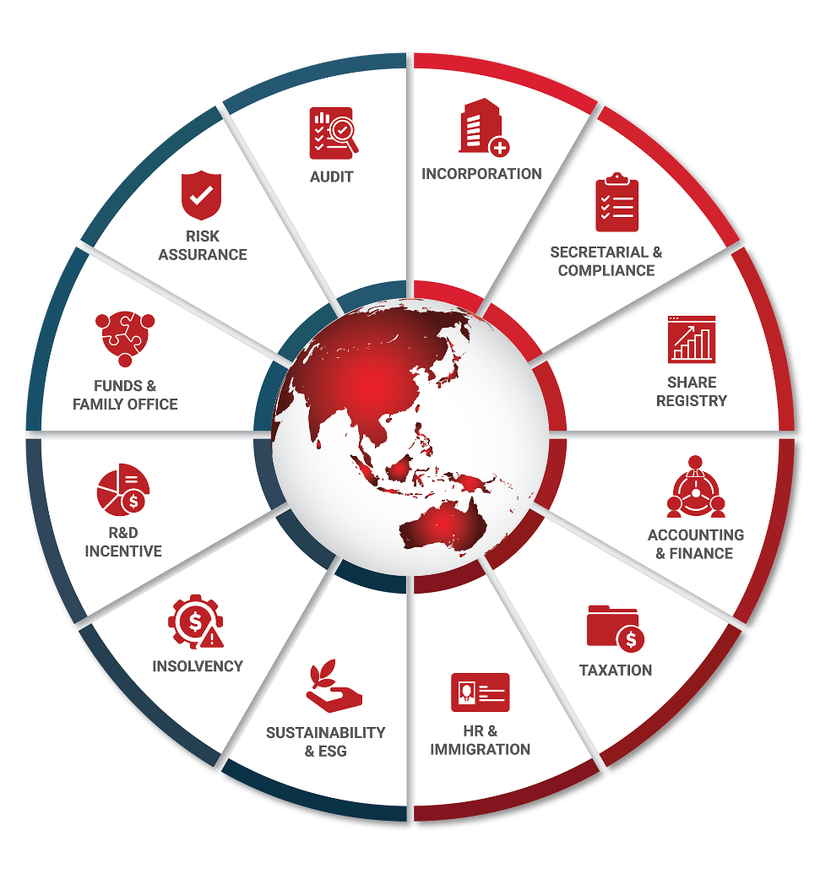

Key Accreditations And Partners

 |  |  | ECONIMIC  DEVELOPMENT  BOARD (EDB) | Connections  Concierge  Partner

ENTERPRISE  SINGAPORE |  |  | MINISTRY OF MANPOWER  (EA - 11C3030) | 

07 July 2026
Mili Kale

Dear Mili Kale,

RE: FEE PROPOSAL

On behalf of In.Corp,

Sherwin Urbano
Commercial Director

SERVICES AND FEES
This section provides a comprehensive overview of InCorp’s Professional Fees, along with other incidental expenses and the estimated government fees, which are calculated either based on specific tasks or on a per-case basis. Please note that any work will commence only upon receipt of your written approval to proceed.

All fees mentioned are in Philippine Pesos, exclusive charges of remitting, intermediary, and receiving banks.

Out-of-pocket and Transportation costs are at a fixed charge for the entire visa process within NCR and Cebu.

Other Services
Services | Monthly | Annually | Total | Signature
Corporate Secretary / Resident Agent  Professional Fee (Billed quarterly):Provision of Corporate Secretary or Resident Agent services. Note: Appointed officers and nominee services we may require a refundable cash deposit of P200,000 or a Director/Officer liability insurance. | 15,000 |  | 180,000
Out-of-pocket Deposit for Corporate Secretarial Services |  | 24,000 | 24,000

SERVICE SLAs

CORPORATE SECRETARIAL AND RESIDENT Agent SERVICES

Maintaining a Corporate Secretary (CS) is mandatory under Philippine Corporate Law for the execution and certification of documents and proceedings of the Board of Directors. The absence of a CS can result in the corporation being placed under SEC Monitoring and fines.

SCOPE OF SERVICE

- Preparation of minutes of meetings of the stockholders and board of directors;
- Issuance of corporate secretary’s certificates, board resolutions, other certifications;
- Documentation and reporting of constitutional changes such as changes in the company name, principal address, financial year, increase in capital stock, etc.;
- Documentation of simple share transfers, reversions of trust, and issuance of shares;
- Preparation and filing of annual General Information of Sheet or any amendment thereof with the Philippine Securities and Exchange Commission;
- Preparation of documents to release the audited financial statements (if applicable);
- Maintenance of stock and transfer book;
- Printing of stock certificates subject to a separate fee;
- Regular communication and updates; and
- Communication on compliance requirements under Philippine Law.

EXCLUSIONS OF SERVICE

- Appointment as Corporate Treasurer;
- Signing of monthly, quarterly, and annual tax reports for the Bureau of Internal Revenue;
- Signing of Statement of Management Responsibility for Financial Statements and Income Tax;
- Signing of monthly contributions and other related reports to Social Security System, Philippine Health Insurance Corporation, and Home Development Mutual Fund; and
- Work requiring extensive study and/or documentation or legal opinions.
- Attendance in hearings with judicial and quasi-judicial bodies of the government for internal matters of the Corporation.
- Signing of any document or paper that relates to the operations of the company

TERMS

- This service should be available for a minimum one (1) year and shall commence on the first day of the month provided in the Certificate of Incorporation or on the first day of the month from the signing of the proposal. IN.CORP PH will bill CS services quarterly in advance and the client shall pay for the same quarterly. In case of pre-termination initiated by the Client, there shall be a pre-termination fee equivalent to twenty-five percent (25%) of the service fee for the unexpired term of the agreement.
- The service shall only begin upon receipt of full payment of initial CS service fee, related initial deposit for expenses for the first year, and after InCorp PH’s due diligence has been completed.
- The highest-ranking officer of the company shall sign an undated acceptance to the resignation letter of the Corporate Secretary;
- Client must post a refundable Cash Deposit of PHP200,000.00 upon engagement for Corporate Secretarial Services. This deposit may be refunded once the Client submits a Director/Officer Liability Insurance Policy. The cash deposit shall be returned six (6) months after the termination of the service or upon submission of the duly filed General Information Sheet (GIS) reflecting the new corporate secretary, whichever comes first;
- All documents requested by the Client shall be provided to the Client in PDF form;
- Either party may terminate this agreement at any time for any reason, upon thirty (30) days written notice to the other party. However, invoices will continue to be sent to Client until we receive the SEC filed General Information Sheet reflecting the new Corporate Secretary.
- This proposal shall be valid within six (6) months from the issuance thereof.

INDEMNITY

Under Philippine Corporate Law, corporate officers (President, Treasurer, Secretary, etc.) may be held administratively, civilly, and/or criminally responsible for any unlawful act or omission committed by the corporation through its various agents, regardless if the position/s is/are occupied merely as an accommodation or with a fee. Accordingly, the Client undertakes to indemnify InCorp PH and/or the specific person appointed by the Client to hold the position from all liabilities, costs or expenses arising from any and against all actions, proceedings, claims, or demands of any nature which may be made against InCorp PH or on account of being elected as an officer of the Client, or by reason of any act, deed or any matter done or omitted to be done in his/her capacity as officer under the Client’s instructions. The Client (or its lawful representatives) further commits to inform in writing InCorp PH and the person/s concerned of any event or change of circumstance that may affect the appointment, such as, without limitation, change of principal, retirement of business, et. al.

UNIFIED TERMS AND CONDITIONS

PRE-TERMINATION

Both InCorp PH and the Client shall have the right to terminate the engagement for any reason upon due notice. In the event that the Client decides to terminate the engagement after the signing of this proposal, InCorp PH shall have the right to bill the work done and time spent from the commencement of engagement up to termination of service subject to its Refund Policy. which forms an in integral part of this engagement. Actual expenses incurred by InCorp PH will be charged to the Client.

FREEZEWORK

In the event that the Client fails to make timely payments as stipulated in this Agreement, the Service Provider reserves the right to freeze all work related to the Client until outstanding payments are received in full. The freezing of work shall commence upon written notice to the Client detailing the outstanding amounts owed and the actions required for the resumption of work.

Should the Client fail to rectify outstanding payments within 30 working days of receiving notice of the work freeze, the Service Provider reserves the right to terminate this Agreement with immediate effect, without prejudice to any other rights or remedies available under law or equity.

DATA PRIVACY

By signing this proposal, the Client, as a Data Subject, expressly gives their consent to InCorp PH to collect, process, endorse, share, store, retain, update, and retrieve information, personal or otherwise, provided solely for the purpose of performing the services described in this proposal. The Client also consents to the sharing of their data with InCorp PH’s affiliates unless expressly stated otherwise. The Client confirms that they were made aware that the data collected are necessary for the effective performance of the services described in this proposal and that said data will be securely stored by InCorp PH for as long it deems necessary, and it will be destroyed upon express request and consent of the Client. The processing of the collected information may be made through an internal database, online, cloud storage, or through a sub-contractor. Finally, the Client confirms that they were made aware of their rights under the Data Privacy Act and other pertinent laws.

GOVERNING LAW

This agreement is to be interpreted in accordance with the laws of the Republic of the Philippines.

VENUE AND JURISDICTION

Any dispute or controversy arising under or in connection with this agreement shall be settled solely and exclusively in the proper court of Taguig City, to the exclusion of all other courts.

LIABILITY

The total aggregate liability of InCorp PH, for loss or damage (including indirect and consequential loss or damage) caused by, or resulting from, or in relation to, the services, including, whether arising from breach of contract, negligence, or any other tort, in equity or otherwise, and whether InCorp PH was advised of the possibility of such loss or damage, shall be limited to the fees paid to InCorp PH for the portion of the service/s or work product/s giving rise to such liability.

In case of default in payments, all costs and expenses shall be required to be paid to InCorp PH, including reasonable attorney fees, preceding and subsequent to judgment which may arise or accrue from enforcing this agreement whether such remedy is pursued by filing a suit or otherwise.

Should you find the terms of this proposal acceptable, please indicate your agreement by signing the space provided below. If, however, you have any questions on this proposal, we will be pleased to discuss the matter with you. You may contact us at (+632) 8424-1350 or via e-mail to the Director at esther@incorp.ph.

We look forward to a mutually beneficial relationship with you.

Client Conforme:

_____________________________
Name:
Date:

Sherwin Urbano
Commercial Director

In.Corp Corporate Services Philippines, Inc.
8th Floor, Marajo Tower, 312 26th Street West corner
4th Avenue, Bonifacio Global City, Taguig, Philippines 1634

Main Line: +632 8 424 1350
Email: info@incorp.ph
Web: philippines.incorp.asia




FOLLOW US ON:

Copyright ©2025 In.Corp Global Pte Ltd.
All rights reserved.

May not be needed depending on the Local Government Unit (LGU)
Office lessor/owner may provide
Office lessor/owner may provide
InCorp PH attendance is USD 125 per day.
If required, we can assist via a separate engagement
Could be applied for via a separate engagement from our Financial and Tax Compliance Department
Could be applied for via a separate engagement from our Financial and Tax Compliance Department
Could be applied for via a separate engagement from our Financial and Tax Compliance Department
Could be applied for via a separate engagement from our Payroll team
Could be applied for via a separate engagement from our Payroll team
Could be applied for via a separate engagement from our Payroll team
Could be applied for via a separate engagement from our Payroll team
Could be applied for via a separate engagement from our Payroll team
Could be applied for via a separate engagement from our Payroll team
Amendments to the Articles of Incorporation and By-Laws are considered separate engagements.
InCorp PH will not certify the contents of the Audited Financial Statements or sign for the Statement of Management Responsibility.

