


LEADING ASIA PACIFIC CORPORATE SOLUTIONS PROVIDER
South Spring Development, Inc.
INCORP GROUP PROPOSAL



TABLE OF CONTENTS

- About InCorp
- Scope of Services
- Fee Proposal
- Fees
- General Terms and Conditions

ABOUT INCORP
InCorp is a leading provider of a wide range of professional corporate solutions and services across Asia Pacific. We are the only Singapore-based corporate solutions company to have a presence in 8 countries:
 |  |  |  |  |  |  | 
Australia | Hong Kong | India | Indonesia | Malaysia | Philippines | Singapore | Vietnam

Our award-winning capabilities and resources provide organisations and individuals a full suite of comprehensive services to help them turn their “Vision To Reality”.

Snapshot
Pan-Asia player anchored in Singapore
#1 corporate services provider in Singapore
Presence across key countries in Asia Pacific region
30+ years of operating track record
Services MNCs, large corporates, SMEs, startups, family
offices, funds
An independent member of PrimeGlobal, an award winning association of independent accounting and advisory firms




15,000+
Clients

1,200+
Employees

20,000+ Entities
incorporated over the last 10 years

12,000+ Compliance Transactions per year

Strategic Partnerships
with several government entities in Asia, professional firms, fintech firms, accelerators, funds and law firms

1,200+ Employees
across APAC led by professional
management team and industry
experts across multiple disciplines
and platforms

Proprietary in-house Tech
Portal System
which drives industry leading operational and financial metrics

Award-winning Group
and recognized platform in Singapore and Southeast Asia set-up to offer
full suite of comprehensive services
to customers

LOCATIONS
HONG KONG
Unit 1307A, 13/F, Two Harbourfront, 22 Tak Fung Street, Hunghom, Kowloon, Hong Kong.

PHILIPPINES
8th Floor, Marajo Tower, 312 26th St. West corner 4th Ave., Bonifacio Global City, Taguig, Philippines 1634.

INDIA
1602, B – Wing, One BKC, Bandra Kurla Complex, Mumbai – 400051, India.

VIETNAM
The Galleria Office Building, 258 Nam Ky Khoi Nghia Street, Vo Thi Sau Ward, District 3, Ho Chi Minh City, Vietnam 72408.

SINGAPORE (HQ)
30 Cecil Street, #19-08 Prudential Tower, Singapore 049712.

INDONESIA
AXA Tower 36th floor, Kuningan City, Jl. Prof. Dr. Satrio Kav. 18, Kuningan, Jakarta Selatan 12940, Indonesia.

AUSTRALIA
Level 1, 6-10 O’Connell Street, Sydney NSW 2000, Australia.

MALAYSIA
D-8-3A, Menara SuezCap 1, KL Gateway, 59200 Kuala Lumpur.

OUR FULL RANGE OF CORPORATE SERVICES ACROSS ASIA PACIFIC

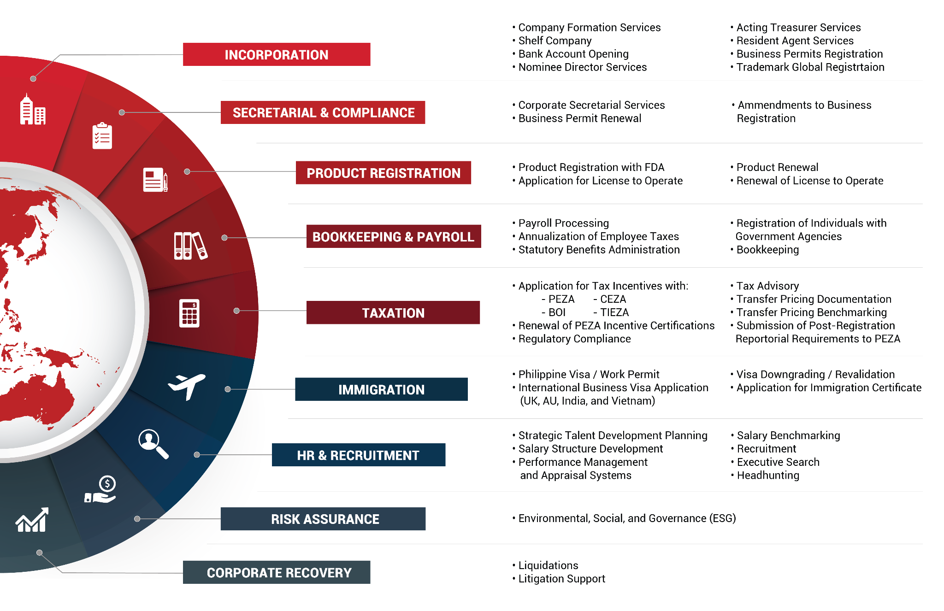

INDUSTRY PARTNERS







13 July 2026
Client Name: Rovee Shane Abion
Client Company Name: South Spring Development, Inc.
Client Company Address : Centennial Garden, National Highway, Bgy. Makabling, Sta. Rosa, Laguna

Dear Mr./Mrs. Rovee Shane Abion

RE: FEE PROPOSAL

On behalf of In.Corp,

Lea Soliman Galera
Director of Recruitment and Executive Search

SERVICES AND FEES
This section provides a comprehensive overview of InCorp’s Professional Fees, along with other incidental expenses and the estimated government fees, which are calculated either based on specific tasks or on a per-case basis. Please note that any work will commence only upon receipt of your written approval to proceed.

All fees mentioned are in Philippine Pesos, exclusive charges of remitting, intermediary, and receiving banks.

Out-of-pocket and Transportation costs are at a fixed charge for the entire visa process within NCR and Cebu.

Other Services
Services | One-off | Signature
Recruitment and Executive Search  Recruitment and Executive Search | 18% of Gross Annual Salary for R&F to Supervisory Roles 20% of Gross Annual Salary for Managerial and Above Roles, IT Roles

RECRUITMENT AND EXECUTIVE SEARCH

FEES, MISCELLANEOUS EXPENSES AND SERVICE SCOPE
This section outlines the estimated fees for InCorp's services of your Philippine-based company. Fees may be incurred based on the time spent on specific tasks or on a per-instance basis. For any additional services not encompassed by this proposal that may incur additional charges, we will receive your approval before any work commences. Please note that all fees mentioned are in Philippine Pesos, exclusive of the prevailing Value-Added Tax (VAT) if applicable.

Based on our understanding of your needs, the following shall be the scope of our services:

RECRUITMENT AND EXECUTIVE SEARCH
Process | Details |  | Timetable

Sourcing and Shortlisting | Talent Mapping  Job Advertisement (Company Website, Job Portals, Social Media, et. al)  Database Search  Headhunting | 1-3 days
Interviewing and Profiling | Conducting in-depth skills-based and behavioral interview methods  Assessment of interest level, salary expectation, and availability of candidate(s)  Creating and submission of candidate profile(s) with Consultant’s notes and recommendations for client | 3-4 days after Sourcing and Shortlisting
Account Management | Scheduling of interviews and/or exams, meetings, job offers  Assisting and answering client’s inquiries regarding job market and salary analysis  Relaying necessary and important information between client and candidate(s)  Assist in negotiations when necessary | ---

Note: Average turnaround time for completion of work is 30-45 days. Number of days may vary depending on complexity of role and availability of talent in the market.

GUARANTEE PERIOD
If the candidate resigns or is terminated by the Client for reasons other than retrenchment, redundancy, unlawful or constructive dismissal before completing three (3) months of service for full-time roles, ITS shall provide a single replacement candidate, whether for the same role or a different role for as long as this Agreement is valid. Difference of cost from the original invoice to the replaced candidate shall be billed accordingly. In cases of termination, the Client is expected to have exercised due process according to the provisions of the Philippine Labor Law. ITS’s commitment to this context is the replacement of the successful candidate and not a refund of any portion of the professional search fee. If, for some reason, the client decides to waive the option of requiring a replacement, ITS shall be relieved of said commitment.

- PAYMENT
ITS Account Statements are payable seven (7) days from the start date of the successful placement and is subject to 3% interest per month for late payment. The Account Statements shall be generated upon the signing of job offer. Referral can be by mail or by electronic means.

Sincerely,

Lea Soliman Galera
Director of Recruitment and Executive Search

CLIENT’S CONFORME:

I hereby acknowledge that I have carefully read and understood the above terms and conditions, and, with my signature below, agree on and consent to such terms and conditions.

___________________________
Signature Above Printed Name
Date Signed:

CLIENT DETAILS

Company Name:
Company Address:
Point of Contact (POC) and Designation:
Email:
Billing and Collections POC:
Email:
Telephone / Mobile No.:

LIST OF DOCUMENTS FOR SUBMISSION TO ITS FOR CDD PURPOSES

SEC Certificate (Original with actual Date of Incorporation) with Articles of Incorporation and ByLaws
General Information Sheet (GIS)
BIR 2303
Valid / Government-Issued ID of Authorized Signatory in Service Agreement

Note: Failure to comply with the submission of documents will regard this Agreement as void or invalid.

GENERAL TERMS AND CONDITIONS

- INFORMATION AND CONFIDENTIALITY
  - The Client is bound to furnish ITS with any potentially important information that might reasonably relate to the employment of candidates referred. All information shall be treated as confidential.
  - The Client is obliged to comply with the Philippine Labor and Employment laws with respect to the treatment of the candidate referred by ITS and shall treat the information provided on account of said candidate as confidential.
  - ITS and the Client are obliged to keep confidential all information, which has been indicated as such in writing, that was obtained from each other in the framework of their agreement, or from another source.

- INDEPENDENCE
  - The client shall independently ascertain the suitability of the candidate before entering into an employment contract. ITS will take all reasonable precautions prior to and during the selection, but this does not absolve the Client of its investigational obligation.

- TERM AND VALIDITY
1. This Agreement shall be valid for one (1) year from effective date and will auto-renew to the next year unless a written notice from either party is received by the other at least thirty (30) days before intended date of termination or there are changes in the respective signatories..
2. In case the Client hires a candidate referred by ITS within twelve (12) months from the date of endorsement, this shall be considered as ITS’s placement and will be subject to professional fee.
3. ITS reserves the right to refuse to furnish a replacement candidate if the payment terms under this Agreement are not met.

- NON-SOLICITATION
1. ITS shall refrain from approaching the client's employee(s) with the intention of soliciting such employee(s) for another employer, unless such employee takes the initiative by demonstrably making it known that he/she wishes to accept a position elsewhere.
2. The Client shall, for the duration of this Agreement and for a period of one (1) year from its termination, refrain from approaching ITS’s employee(s) with the intention of soliciting such employee(s). The Parties agree that the solicitation of ITS employee(s) shall be cause for liquidated damages in the amount of three (3) times the cost of the recruitment for said employee(s).

- RESTRAINT OF TRADE
- If the Client declines to accept the candidate(s) presented by ITS or the candidate(s) refuses the Client’s offer within twelve (12) months from date of endorsement, and an employment contract is nevertheless concluded between candidate and Client, thus shall be considered as ITS’s placement and the Client shall be liable to pay the professional fee, which will not affect the right of ITS to claim additional compensation where additional damage can be proven.
- The Client is prohibited from passing or introducing candidates on to third parties. If the Client violates this prohibition, he shall be obliged to pay liquidated damages in the amount of double the professional fee. This is applicable from the time of the initial contact between the Client and the third party, even before the actual assignment commences.

- FEES
1. In case the Client hires the candidate as an independent contractor. Consultant or on project-based employment, other than a direct hire, the Client agrees to pay 25% of the estimated earnings for the entire project, which is exclusive of other benefits, monetary or otherwise.
2. In case the Client hires the candidate on a full-time employment on or after the lapse of the consultancy or project term, the Client agrees to pay 18%/20% for respective roles and levels stated in Section of the remaining months of the 12-month period that will serve as basis for imposing the fee of ITS.
3. In case the Client decides to cancel the hiring of ITS’s candidate for reasons other than negative reference checks, health conditions, criminal records, and/or falsification of supporting documents (transcript of records, COE, etc.), after the candidate has formally signed a job offer, the Client agrees to pay ITS a professional fee equivalent to two (2) months’ salary based on the selected candidate’s offer to cover operational costs, as well as one (1) month salary to be paid to the candidate.

- DUPLICATION
- In order to avoid duplication of candidates between ITS and the Client, the Client agrees to inform ITS after one (1) business day from receipt of endorsements if the candidate(s) are already in the Client’s database and is currently undergoing the Client’s recruitment process. The Client and ITS agree to recognize that the candidate(s) are tagged as ITS’s should they fall under the following conditions:
  - Candidate submitted application to Client but has not received acknowledgment and/or invitation for interview;
  - Candidate was invited by Client but has declined or has withdrawn his/her application altogether;
  - Candidate was processed but has decided to withdraw his/her application;
  - Candidate submitted application and was processed by Client but has never received any communication thereafter; and/or
  - Candidate’s application was processed but has not received any communication for the last six (6) months.

- DATA PRIVACY
  - By signing this proposal, the Client, as a Data Subject, expressly gives their consent to ITS to collect, process, endorse, share, store, retain, update, and retrieve information, personal or otherwise, provided solely for the purpose of performing the services described in this proposal. The Client also consents to the sharing of their data with ITS’ affiliates unless expressly stated otherwise. The Client confirms that they were made aware that the data collected are necessary for the effective performance of the services described in this proposal and that said data will be securely stored by ITS for as long it deems necessary, and it will be destroyed upon express request and consent of the Client. The processing of the collected information may be made through an internal database, online, cloud storage, or through a sub-contractor. Finally, the Client confirms that they were made aware of their rights under the Data Privacy Act and other pertinent laws.

- GOVERNING LAW
This agreement is to be interpreted in accordance with the laws of the Republic of the Philippines.

- VENUE AND JURISDICTION
Any dispute or controversy arising under or in connection with this agreement shall be settled solely and exclusively in the proper court of Taguig City, to the exclusion of all other courts.

- LIABILITY
ITS is in no way liable for damages and losses caused by candidates who were hired through its services.

ANNEX

Position Title(s):
Salary Range(s):
Benefits: (HMO, leave credits, allowances, etc.)
Work Set-up (office based, hybrid, remote)
Interview Process: (no. of interviews, assessments, etc)
Non-negotiable Skills:
Job Description:



Lea Soliman Galera
Director of Recruitment and Executive Search

In.Corp Global Talent Solutions, Inc.

8th Floor, Marajo Tower, 312 26th Street West corner
4th Avenue, Bonifacio Global City, Taguig, Philippines 1634

Tel: +632 8 424 1350

Email: info@incorp.ph
Web: www.kcrecruitment.com


FOLLOW US ON:

Copyright © 2024 InCorp Philippines. All rights reserved

