


LEADING ASIA PACIFIC CORPORATE SOLUTIONS PROVIDER
IN.CORP GLOBAL PROPOSAL
For Juuuno

Table of Contents

- About In.Corp
- Scope of Services
- Fees
- Terms and Conditions

About In.Corp
In.Corp Global, an Ascentium Company, is a leading provider of professional corporate solutions and services across Asia Pacific with a strong regional presence in 9 markets:
 |  |  |  |  |  |  |  | 
Australia | Hong Kong SAR | India | Indonesia | Mainland China | Malaysia | Philippines | Singapore | Vietnam

Our award-winning capabilities and resources provide organisations and individuals a full suite of comprehensive services to help them turn their “Vision To Reality”.

Snapshot
- Pan-Asia player anchored in Singapore
- #1 corporate services provider in Singapore
- Presence across key countries in Asia Pacific region
- 40+ years of operating track record
- Services MNCs, large corporates, SMEs, startups, family offices, funds
- An independent member of PrimeGlobal, an award-winning association of independent accounting and advisory firms


1,500+
Employees
20,000+
Clients

20,000+ Entities
incorporated over the last 10 years

12,000+ Compliance Transactions per year
Strategic Partnerships
with several government entities in Asia, professional firms, fintech firms, accelerators, funds and law firms

1,500+ Employees
across APAC led by professional
management team and industry
experts across multiple disciplines
and platforms

Proprietary In-house Tech
Portal System
which drives industry leading operational and financial metrics

Award-winning Group
and recognized platform in Singapore and Southeast Asia set-up to offer
full suite of comprehensive services
to customers

Locations
AUSTRALIA
Level 1, 6-10 O’Connell Street, Sydney NSW 2000, Australia.

INDONESIA
AXA Tower 36th floor, Kuningan City, Jl. Prof. Dr. Satrio Kav. 18, Kuningan, Jakarta Selatan 12940, Indonesia.

PHILIPPINES
8th Floor, Marajo Tower, 312 26th St. West corner 4th Ave., Bonifacio Global City, Taguig, Philippines 1634.

HONG KONG SAR
16/F, Wing On Centre,
111 Connaught Road Central,
Hong Kong.

MAINLAND CHINA
R-C, 40F, Huangting Center,
No.350 Fuhua Road, Shenzhen.

VIETNAM
The Galleria Office Building, 258 Nam Ky Khoi Nghia Street, Vo Thi Sau Ward, District 3, Ho Chi Minh City, Vietnam 72408.

SINGAPORE (HQ)
36 Robinson Road, #20-01 City House, Singapore 068877.

INDIA
1602, B – Wing, One BKC, Bandra Kurla Complex, Mumbai – 400051, India.

MALAYSIA
Level 5, Guoco Tower, 6 Jalan Damanlela, Damansara City, Bukit Damansara, 50490, Kuala Lumpur

Our Full Range of Corporate Services ACROSS ASIA PACIFIC

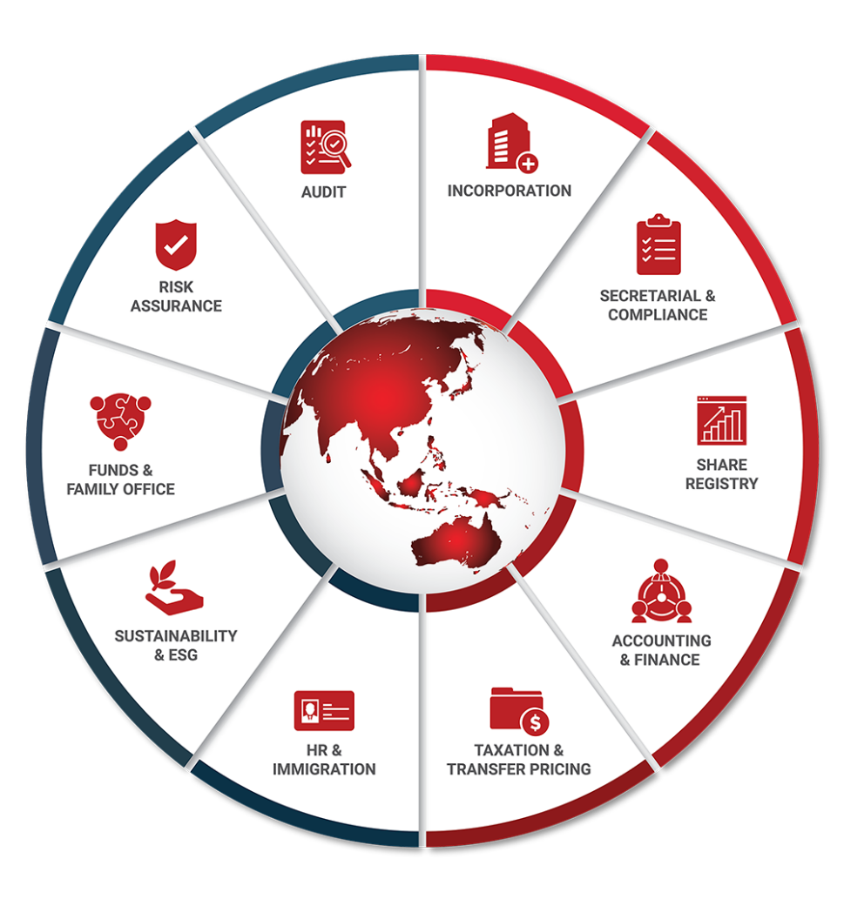

Key Accreditations And Partners

 |  | MINISTRY OF  MANPOWER  (EA - 11C3030) | 

 |  |  |  | ENTERPRISE  SINGAPORE

16 July 2026

Aritra Nandi

Juuuno

Dear Aritra Nandi,

RE: Fee Proposal
We are pleased to be presenting our proposal to you.
Our team of experienced professionals work very closely with clients on various corporate, accounting, compliance and governance matter and identify the unique requirements of individual organizations. As a strong believer of long-term partnerships, we are committed to providing tailored solutions that not only meet our clients’ objectives, but also giving them a peace of mind to focus on their core businesses.
The following pages outline our services tailor made to you and we trust that our proposal meets your expectations. We are excited to work with you and look forward to a long and mutually beneficial working relationship with you and the Company.
Yours Sincerely and on behalf of In.Corp,

Chloe Koo
Senior Manager - Business Development

SCOPE OF SERVICES
InCorp offers a complete, end-to-end solution to establish and maintain your corporate presence in Singapore. Our proposed solution includes providing Singapore Corporate Secretarial Compliance Services (Incorporation), Employment Pass Application Services, Annual Compliance Services - Accounting/Tax/Payroll, Other Services.

FEES
This section outlines the estimated fees for In.Corp's services. Our fee structure includes initial setup fees, as well as ongoing charges that may be billed monthly, quarterly, or annually. Additionally, fees may be incurred based on the time spent on specific tasks or on a per-instance basis. For any additional services not encompassed by this proposal that may incur, additional charges, we will receive your approval before any work commences. Please note that all fees mentioned are in Singapore Dollars unless otherwise stated, exclusive of the prevailing Goods and Services Tax (GST).

Singapore Corporate Secretarial Compliance Services (Incorporation)
Services | One-off Fee (SGD) | Recurring Fee (SGD)
Incorporation  • Includes govt filing fees of SGD315  • Includes assistance in bank account opening fees  • Administrative fee to perform due diligence | 1200 per entity | -
Company Secretarial services  • Provision of a named company secretary  • Preparation of annual returns and other secretarial documents relating to the holding of AGM;  • Preparation and filing of the annual return with ACRA via BizFile (excluding preparation of XBRL file);  • Attending to the Company’s auditors on their annual audit of the statutory registers and minutes books and preparing the representation letter as to minutes for statutory audit purposes;  • Setup and Maintenance of Registers of Registrable Controllers, Register of Nominee Directors and Register of Nominee Shareholders (required by law)  • Updating and maintenance of statutory registers and minutes books of the Company; and  • General advice on filing deadlines, penalties and other corporate secretarial matters. | - | 800 Annual
Registered office service  • Includes scanning and re-direction of mails (excludes postage charges) | - | 600 Annual
Nominee Director Services  • Provision of a nominee resident director;  - A refundable Security deposit per nominee @4500 applies;  - Refundable upon cessation of Nominee Director Service | - | 4500 Annual
CorpPass setup and Administration  • CorpPass is a corporate digital identity for companies to transact with Government agencies online, mandatory to be setup  • Annual fee includes set-up fee, Incorp acting as administrator and up to 3 changes in users/services per year  • Optional service in the event Company’s local resident director applies for this directly with the Registrar | - | 300 Annual

Employment Pass Application Services
Services | One-off Fee (SGD) | Recurring Fee (SGD)
Employment Pass Application  • Advising, reviewing of required documents.  • Preparing, submission of application including progress-tracking, follow-up with MOM.  • Completion of Appointment formalities.  • Reviewing and submission of additional documents request by Ministry of Manpower.  • Not inclusive of appeal on rejection  • Not inclusive of education verification (if requires) | 2000 per application | -
Dependent Pass Application (For spouse and children of EP holder)  • Advising, reviewing of required documents.  • Preparing, submission of application including progress-tracking, follow-up with MOM.  • Completion of Appointment formalities.  • Reviewing and submission of additional documents request by Ministry of Manpower.  • Not inclusive of appeal on rejection | 860 per application | -
Immigration-related services referenced in this proposal will be provided exclusively by RIKVIN PTE. LTD., a fully owned subsidiary of InCorp Group, acting as an independent service provider. RIKVIN PTE. LTD. is registered under UEN: 200708442E and holds an Employment Agency Licence No.: 11C3030, issued by the Ministry of Manpower, Singapore.

Annual Compliance Services - Accounting/Tax/Payroll
Services | One-off Fee (SGD) | Recurring Fee (SGD)
Initial Set-up/ Understanding  • Advisory and implementation of Xero accounting system and its supporting ecosystem  • Customisation of the chart of accounts to align with the Company’s business and reporting requirements  • Design and configuration of one (1) customised invoice template  • OR  • Initial familiarisation with the Client’s accounting systems, operations and process flows, including an understanding of reporting requirements, chart of accounts structure and existing system configurations. | 350 Per set up | -
Bookkeeping *  • Record and maintain all business transactions based on the source documents provided, ensuring proper classification in accordance with applicable accounting standards and client’s requirements.  • Perform bank reconciliations, identifying and resolving any discrepancies between bank statements and accounting records  • Prepare and post periodic adjusting entries, including accruals, prepayments, depreciation etc, where applicable.  • Prepare a complete set of financial accounts and supporting schedules, including:  - trial balance;  - detailed income statement;  - detailed balance sheet;  - general ledger; and  - balance sheet schedules (where applicable) | - | 500 Monthly Subject to the total transaction volume
Unaudited Financial Statements **  • Provision of professional services for the preparation of unaudited financial statements, including:  - Compilation of information based on approved management or financial accounts  - Preparation of financial statements in compliance with Singapore Financial Reporting Standards (SFRS)  - Inclusion of all required notes to the accounts | - | 1000 Annual
eXtensible Business Reporting Language (XBRL) #  • Convert the financial statements in eXtensible Business Reporting Language (“XBRL”) format for the Company. | - | 800 Annual
Corporate Tax  • Corporate tax computation.  • Preparation of tax return (Form C/C-S) and related tax schedules.  • Filing of tax return with Inland Revenue Authority of Singapore (IRAS). | - | 1500 Annual
Payroll  • Payroll Initial Setup | 150 Per set up | -
Payroll  • Payroll Processing (Monthly), includes:  - Computation of Salaries with calculation of Skill Development Levy (SDL) & other statutory deductions including Central Provident Fund (CPF), if applicable  - Preparation of itemised monthly pay slips  - Monthly summary of payroll expenses for employer records | - | 150 Per headcount
* Our Bookkeeping fees are based on the estimated transaction volume, comprising income, expenditure and bank movements, as well as the nature and complexity of the Client's transactions, based on information made available to us at the date of this engagement.
Fees are subject to review and adjustment should the actual transaction volumes, scope of services, or complexity of the engagement differ materially from our initial estimate.
** Fee is quoted with the understanding that the Company (& the Group) is not eligible to be exempt from audit in Singapore & will be getting the books of accounts audited for filing in Singapore. Should the company have subsidiaries / investments - additional fees starting from 1,200/- will be applicable for consolidation / complexity in reporting requirements.
# XBRL Filing Requirements (Conditional — billed only if and when applicable)
Companies incorporated in Singapore that qualify as Exempt Private Companies (EPCs) — defined as companies with fewer than 20 individual shareholders and no corporate shareholders — are generally exempt from filing financial statements with ACRA. However, where the financial statements reflect negative equity (net liabilities), the EPC exemption ceases to apply and XBRL filing becomes mandatory.
The applicable fee will be confirmed and billed upon finalisation of the Balance Sheet and Profit & Loss Account by our Accounting & Finance Operations team. All fees exclude prevailing GST and disbursements.

Other Services
Services | One-off Fee (SGD) | Recurring Fee (SGD)
Company Secretarial services  • Provision of a named company secretary  • Preparation of annual returns and other secretarial documents relating to the holding of AGM;  • Preparation and filing of the annual return with ACRA via BizFile (excluding preparation of XBRL file);  • Attending to the Company’s auditors on their annual audit of the statutory registers and minutes books and preparing the representation letter as to minutes for statutory audit purposes;  • Setup and Maintenance of Registers of Registrable Controllers, Register of Nominee Directors and Register of Nominee Shareholders (required by law)  • Updating and maintenance of statutory registers and minutes books of the Company; and  • General advice on filing deadlines, penalties and other corporate secretarial matters. | - | 800 Annual

In.Corp Global Pte Ltd.
36 Robinson Road, #20-01 City House, Singapore 068877.
Reg No: 201504530W

Presented to:
Aritra Nandi

aritra.nandi@juuuno.com
Juuuno

Terms & Conditions All prices and services correct at the time the proposal was created.

Terms & Conditions

Formal Service Agreements
- Formal service agreements are to be executed between In.Corp and the Company post the acceptance of this proposal letter by way of a written email.
- Additional fees will be charged for services rendered in connection with matters outside the scope of services outlined above and for services rendered where time costs exceed the fees quoted above.
- Our fees are based on current regulations and market practices. Should there be changes which impact our scope of services or effort involved, we will be pleased to discuss them with you to arrive at a mutually agreeable solution.

Termination
- Either Party may terminate the above-mentioned services with two (2) month’s prior written notice thereof. In the event that this engagement is terminated, we shall still be entitled to our fee and out-of- pocket expenses accrued up to the date of the end of service.

MISC Terms
- All out of pocket expenses reasonably incurred by us on your behalf will be borne by your Company, where prior consent will be obtained from you. The fees and expenses do not include Goods and Services Tax (“GST”).The GST (if applicable) will be included in our invoices as a separate item.

Governing Law
- This Letter shall be governed by and construed in accordance with the laws of Singapore and the parties hereto submit to the exclusive jurisdiction of the Courts of Singapore over any disputes, which may arise out of or in accordance with it.

We hope to hear from you favourably on our proposal. Please do not hesitate to let us know if you need further clarifications.



In.Corp Global Pte Ltd.
36 Robinson Road,
#20-01 City House,
Singapore 068877.

Main Line: +65 6990 8220
Email: info@incorp.asia
Web: www.incorp.asia




FOLLOW US ON:

Copyright © In.Corp Global Pte Ltd. All rights reserved.


