


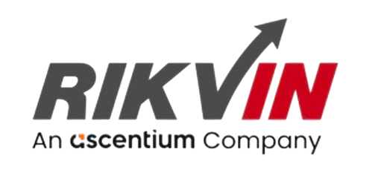

LEADING ASIA PACIFIC CORPORATE SOLUTIONS PROVIDER
IN.CORP GLOBAL PROPOSAL
For NA

Table of Contents

- About In.Corp
- Scope of Services
- Fee Proposal
- Fees
- Terms and Conditions

About In.Corp
In.Corp Global, an Ascentium Company, is a leading provider of professional corporate solutions and services across Asia Pacific with a strong regional presence in 9 markets:
 |  |  |  |  |  |  |  | 
Australia | Hong Kong SAR | India | Indonesia | Mainland China | Malaysia | Philippines | Singapore | Vietnam

Our award-winning capabilities and resources provide organisations and individuals a full suite of comprehensive services to help them turn their “Vision To Reality”.

Snapshot
- Pan-Asia player anchored in Singapore
- #1 corporate services provider in Singapore
- Presence across key countries in Asia Pacific region
- 40+ years of operating track record
- Services MNCs, large corporates, SMEs, startups, family offices, funds
- An independent member of PrimeGlobal, an award-winning association of independent accounting and advisory firms


1,500+
Employees
20,000+
Clients

20,000+ Entities
incorporated over the last 10 years

12,000+ Compliance Transactions per year
Strategic Partnerships
with several government entities in Asia, professional firms, fintech firms, accelerators, funds and law firms

1,500+ Employees
across APAC led by professional
management team and industry
experts across multiple disciplines
and platforms

Proprietary In-house Tech
Portal System
which drives industry leading operational and financial metrics

Award-winning Group
and recognized platform in Singapore and Southeast Asia set-up to offer
full suite of comprehensive services
to customers

Locations
AUSTRALIA
Level 1, 6-10 O’Connell Street, Sydney NSW 2000, Australia.

INDONESIA
AXA Tower 36th floor, Kuningan City, Jl. Prof. Dr. Satrio Kav. 18, Kuningan, Jakarta Selatan 12940, Indonesia.

PHILIPPINES
8th Floor, Marajo Tower, 312 26th St. West corner 4th Ave., Bonifacio Global City, Taguig, Philippines 1634.

HONG KONG SAR
16/F, Wing On Centre,
111 Connaught Road Central,
Hong Kong.

MAINLAND CHINA
R-C, 40F, Huangting Center,
No.350 Fuhua Road, Shenzhen.

VIETNAM
The Galleria Office Building, 258 Nam Ky Khoi Nghia Street, Vo Thi Sau Ward, District 3, Ho Chi Minh City, Vietnam 72408.

SINGAPORE (HQ)
36 Robinson Road, #20-01 City House, Singapore 068877.

INDIA
1602, B – Wing, One BKC, Bandra Kurla Complex, Mumbai – 400051, India.

MALAYSIA
Level 5, Guoco Tower, 6 Jalan Damanlela, Damansara City, Bukit Damansara, 50490, Kuala Lumpur

Our Full Range of Corporate Services ACROSS ASIA PACIFIC

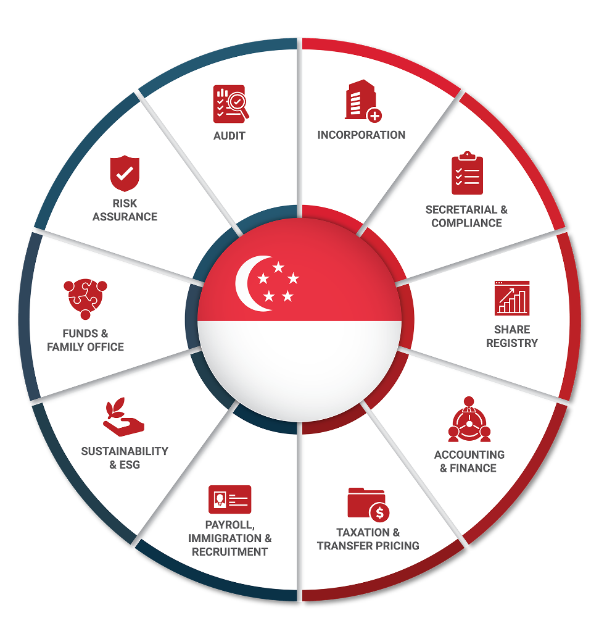

Key Accreditations And Partners

 |  | MINISTRY OF  MANPOWER  (EA - 11C3030) | 

 |  |  | 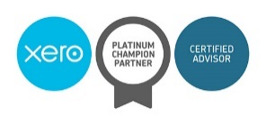 | ENTERPRISE  SINGAPORE

21 July 2026

Atif Ali
Mr
NA
NA

Dear Atif Ali,

RE: Fee Proposal
We are pleased to be presenting our proposal to you.
Our team of experienced professionals work very closely with clients on various corporate, accounting, compliance and governance matter and identify the unique requirements of individual organizations. As a strong believer of long-term partnerships, we are committed to providing tailored solutions that not only meet our clients’ objectives, but also giving them a peace of mind to focus on their core businesses.
The following pages outline our services tailor made to you and we trust that our proposal meets your expectations. We are excited to work with you and look forward to a long and mutually beneficial working relationship with you and the Company.
Yours Sincerely and on behalf of In.Corp,

Irfan Ashiddiq Azman
Associate, Immigration

SCOPE OF SERVICES
InCorp offers a complete, end-to-end solution to establish and maintain your corporate presence in Singapore. Our proposed solution includes providing DP Services, Other Services, PEP Services.

FEES
This section outlines the estimated fees for In.Corp's service. Our fee structure includes initial setup fees, as well as ongoing charges that may be billed monthly, quarterly, or annually. Additionally, fees may be incurred based on the time spent on specific tasks or on a per-instance basis. For any additional services not encompassed by this proposal that may incur, additional charges, we will receive your approval before any work commences. Please note that all fees mentioned are in Singapore Dollars unless otherwise stated, exclusive of the prevailing Goods and Services Tax (GST).

DP Services
Services | One-off Fee (SGD) | Recurring Fee (SGD)
Dependent Pass Application (For spouse and children of EP holder)  • Advising, reviewing of required documents.  • Preparing, submission of application including progress-tracking, follow-up with MOM.  • Completion of Appointment formalities.  • Reviewing and submission of additional documents request by Ministry of Manpower.  • Not inclusive of appeal on rejection | 860 per application | -
Submission of Long Term Visit Pass Application  • Employment Agency Fee - Submission of Long Term Visit Pass application  • Preparing, submission of application including progress- tracking, follow-up  • Reviewing and submission of additional documents request by Ministry of Manpower  • Completion of pass formalities.  • One Time Appeal  • Card Collection | 860 per application | -
Immigration-related services referenced in this proposal will be provided exclusively by RIKVIN PTE. LTD., a fully owned subsidiary of InCorp Group, acting as an independent service provider. RIKVIN PTE. LTD. is registered under UEN: 200708442E and holds an Employment Agency Licence No.: 11C3030, issued by the Ministry of Manpower, Singapore.

PEP Services
Services | One-off Fee (SGD) | Recurring Fee (SGD)
Submission of ONE Pass Application  • Employment Agency Fee - Submission of One Pass application Preparing, submission of application including progress- tracking, follow-up Reviewing and submission of additional documents request by Ministry of Manpower Completion of pass formalities. One Time Appeal Card Collection | 2000 | -
Immigration-related services referenced in this proposal will be provided exclusively by RIKVIN PTE. LTD., a fully owned subsidiary of InCorp Group, acting as an independent service provider. RIKVIN PTE. LTD. is registered under UEN: 200708442E and holds an Employment Agency Licence No.: 11C3030, issued by the Ministry of Manpower, Singapore.

Other Services
Services | One-off Fee (SGD) | Recurring Fee (SGD)
Submission of Education Verification Application  • Employment Agency Fee - Submission of Education Verification per Certificate  • Fees in accordance to which country the certificate was issued (Exclusive of verification fees) | from 140 | -
Immigration-related services referenced in this proposal will be provided exclusively by RIKVIN PTE. LTD., a fully owned subsidiary of InCorp Group, acting as an independent service provider. RIKVIN PTE. LTD. is registered under UEN: 200708442E and holds an Employment Agency Licence No.: 11C3030, issued by the Ministry of Manpower, Singapore.

In.Corp Global Pte Ltd.
Rikvin Pte. Ltd.
36 Robinson Road, #20-01 City House, Singapore 068877.
Reg No: 201504530W

Presented to:
Atif Ali
Mr
atif.ali@appistoki.com
NA
NA

Terms & Conditions All prices and services correct at the time the proposal was created.

Terms & Conditions

Formal Service Agreements
- Formal service agreements are to be executed between In.Corp and the Company post the acceptance of this proposal letter by way of a written email.
- Additional fees will be charged for services rendered in connection with matters outside the scope of services outlined above and for services rendered where time costs exceed the fees quoted above.
- Our fees are based on current regulations and market practices. Should there be changes which impact our scope of services or effort involved, we will be pleased to discuss them with you to arrive at a mutually agreeable solution.

Termination
- Either Party may terminate the above-mentioned services with two (2) month’s prior written notice thereof. In the event that this engagement is terminated, we shall still be entitled to our fee and out-of- pocket expenses accrued up to the date of the end of service.

MISC Terms
- All out of pocket expenses reasonably incurred by us on your behalf will be borne by your Company, where prior consent will be obtained from you. The fees and expenses do not include Goods and Services Tax (“GST”).The GST (if applicable) will be included in our invoices as a separate item.

Governing Law
- This Letter shall be governed by and construed in accordance with the laws of Singapore and the parties hereto submit to the exclusive jurisdiction of the Courts of Singapore over any disputes, which may arise out of or in accordance with it.

We hope to hear from you favourably on our proposal. Please do not hesitate to let us know if you need further clarifications.



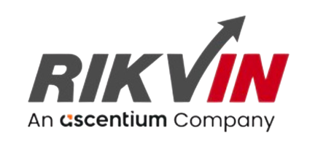

In.Corp Global Pte Ltd.
Rikvin Pte. Ltd.
36 Robinson Road,
#20-01 City House,
Singapore 068877.

Main Line: +65 6990 8220
Email: ep@rikvin.com
Web: www.rikvin.com




FOLLOW US ON:

Copyright © In.Corp Global Pte Ltd. All rights reserved.


