


LEADING ASIA PACIFIC CORPORATE SOLUTIONS PROVIDER
IN.CORP GLOBAL PROPOSAL
For Walkghost LTD

Table of Contents

- About In.Corp
- Scope of Services
- Fees
- Terms and Conditions

About In.Corp
In.Corp Global, an Ascentium Company, is a leading provider of professional corporate solutions and services across Asia Pacific with a strong regional presence in 9 markets:
 |  |  |  |  |  |  |  | 
Australia | Hong Kong SAR | India | Indonesia | Mainland China | Malaysia | Philippines | Singapore | Vietnam

Our award-winning capabilities and resources provide organisations and individuals a full suite of comprehensive services to help them turn their “Vision To Reality”.

Snapshot
- Pan-Asia player anchored in Singapore
- #1 corporate services provider in Singapore
- Presence across key countries in Asia Pacific region
- 40+ years of operating track record
- Services MNCs, large corporates, SMEs, startups, family offices, funds
- An independent member of PrimeGlobal, an award-winning association of independent accounting and advisory firms


1,500+
Employees
20,000+
Clients

20,000+ Entities
incorporated over the last 10 years

12,000+ Compliance Transactions per year
Strategic Partnerships
with several government entities in Asia, professional firms, fintech firms, accelerators, funds and law firms

1,500+ Employees
across APAC led by professional
management team and industry
experts across multiple disciplines
and platforms

Proprietary In-house Tech
Portal System
which drives industry leading operational and financial metrics

Award-winning Group
and recognized platform in Singapore and Southeast Asia set-up to offer
full suite of comprehensive services
to customers

Locations
AUSTRALIA
Level 1, 6-10 O’Connell Street, Sydney NSW 2000, Australia.

INDONESIA
AXA Tower 36th floor, Kuningan City, Jl. Prof. Dr. Satrio Kav. 18, Kuningan, Jakarta Selatan 12940, Indonesia.

PHILIPPINES
8th Floor, Marajo Tower, 312 26th St. West corner 4th Ave., Bonifacio Global City, Taguig, Philippines 1634.

HONG KONG SAR
16/F, Wing On Centre,
111 Connaught Road Central,
Hong Kong.

MAINLAND CHINA
R-C, 40F, Huangting Center,
No.350 Fuhua Road, Shenzhen.

VIETNAM
The Galleria Office Building, 258 Nam Ky Khoi Nghia Street, Vo Thi Sau Ward, District 3, Ho Chi Minh City, Vietnam 72408.

SINGAPORE (HQ)
36 Robinson Road, #20-01 City House, Singapore 068877.

INDIA
1602, B – Wing, One BKC, Bandra Kurla Complex, Mumbai – 400051, India.

MALAYSIA
Level 5, Guoco Tower, 6 Jalan Damanlela, Damansara City, Bukit Damansara, 50490, Kuala Lumpur

Our Full Range of Corporate Services ACROSS ASIA PACIFIC

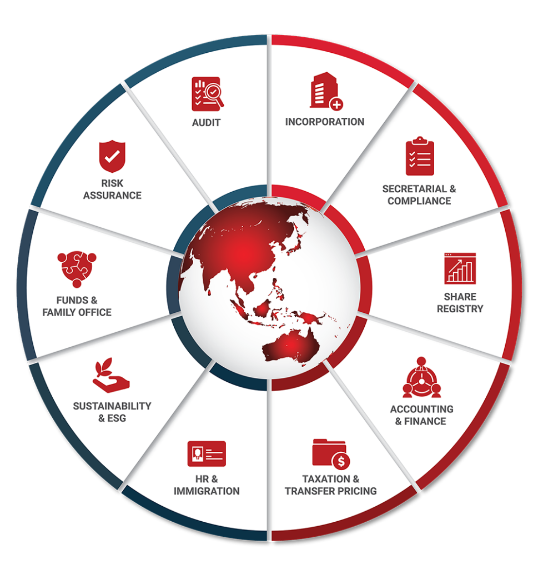

Key Accreditations And Partners

 |  | MINISTRY OF  MANPOWER  (EA - 11C3030) | 

 |  |  |  | ENTERPRISE  SINGAPORE

26 July 2026

Sara

Walkghost LTD

Dear Sara,

RE: Fee Proposal
We are pleased to be presenting our proposal to you.
Our team of experienced professionals work very closely with clients on various corporate, accounting, compliance and governance matter and identify the unique requirements of individual organizations. As a strong believer of long-term partnerships, we are committed to providing tailored solutions that not only meet our clients’ objectives, but also giving them a peace of mind to focus on their core businesses.
The following pages outline our services tailor made to you and we trust that our proposal meets your expectations. We are excited to work with you and look forward to a long and mutually beneficial working relationship with you and the Company.
Yours Sincerely and on behalf of In.Corp,

Ping Qian

SCOPE OF SERVICES
InCorp offers a complete, end-to-end solution to establish and maintain your corporate presence in Singapore. Our proposed solution includes providing Annual Compliance Services - Accounting/Tax/Payroll, Full Finance Function Support Package.

FEES
This section outlines the estimated fees for In.Corp's services. Our fee structure includes initial setup fees, as well as ongoing charges that may be billed monthly, quarterly, or annually. Additionally, fees may be incurred based on the time spent on specific tasks or on a per-instance basis. For any additional services not encompassed by this proposal that may incur, additional charges, we will receive your approval before any work commences. Please note that all fees mentioned are in Singapore Dollars unless otherwise stated, exclusive of the prevailing Goods and Services Tax (GST).

Annual Compliance Services - Accounting/Tax/Payroll
Services | One-off Fee (SGD) | Recurring Fee (SGD)
Bookkeeping *  • Record and maintain all business transactions based on the source documents provided, ensuring proper classification in accordance with applicable accounting standards and client’s requirements.  • Perform bank reconciliations, identifying and resolving any discrepancies between bank statements and accounting records  • Prepare and post periodic adjusting entries, including accruals, prepayments, depreciation etc, where applicable.  • Prepare a complete set of financial accounts and supporting schedules, including:  - trial balance;  - detailed income statement;  - detailed balance sheet;  - general ledger; and  - balance sheet schedules (where applicable) | - | 600 Annually subject to the total transaction volume
Bookkeeping *  • Record and maintain all business transactions based on the source documents provided, ensuring proper classification in accordance with applicable accounting standards and client’s requirements.  • Perform bank reconciliations, identifying and resolving any discrepancies between bank statements and accounting records  • Prepare and post periodic adjusting entries, including accruals, prepayments, depreciation etc, where applicable.  • Prepare a complete set of financial accounts and supporting schedules, including:  - trial balance;  - detailed income statement;  - detailed balance sheet;  - general ledger; and  - balance sheet schedules (where applicable) | - | 800 Monthly Subject to the total transaction volume
Bookkeeping / Bookkeeping Review *  • Record and maintain all business transactions based on the source documents provided, ensuring proper classification in accordance with applicable accounting standards and client’s requirements.  • Perform bank reconciliations, identifying and resolving any discrepancies between bank statements and accounting records  • Prepare and post periodic adjusting entries, including accruals, prepayments, depreciation etc, where applicable.  • Prepare a complete set of financial accounts and supporting schedules, including:  - trial balance;  - detailed income statement;  - detailed balance sheet;  - general ledger; and  - balance sheet schedules (where applicable)  • OR (Review Engagement)  • Review the accounting records and transaction postings for consistency, completeness and appropriate classification in accordance with applicable accounting standards and the Client’s reporting requirements.  • Review bank reconciliation schedules and investigate significant or unusual reconciling items identified.  • Review key adjusting entries, including accruals, prepayments and depreciation, for reasonableness and consistency.  • Perform a high-level review of the financial accounts and supporting schedules, including:  - trial balance;  - detailed income statement;  - detailed balance sheet;  - general ledger; and  - balance sheet schedules (where applicable). | - | 600 Quarterly subject to the total transaction volume
Bookkeeping *  • Record and maintain all business transactions based on the source documents provided, ensuring proper classification in accordance with applicable accounting standards and client’s requirements.  • Perform bank reconciliations, identifying and resolving any discrepancies between bank statements and accounting records  • Prepare and post periodic adjusting entries, including accruals, prepayments, depreciation etc, where applicable.  • Prepare a complete set of financial accounts and supporting schedules, including:  - trial balance;  - detailed income statement;  - detailed balance sheet;  - general ledger; and  - balance sheet schedules (where applicable) | - | 600 Semi-annually subject to the total transaction volume
Audit Liaison  • Professional services to support and coordinate the audit process, including liaison with auditors and assistance with audit-related requirements.  • Scope of Services may include:  - Audit Query Assistance: Respond to accounting-related queries raised by auditors, providing explanations and preparing supporting schedules as required.  - Preparation of Draft Financial Statements (If Required): Assist in the preparation of draft financial statements in accordance with Singapore Financial Reporting Standards (SFRS) where requested by the auditors or management for audit purposes.  - Review of Audit Adjustments: Review and discuss proposed audit adjustments with auditors and management, and implement agreed adjustments where applicable.  - Finalisation Support: Coordinate the review and circulation of draft audited financial statements for management approval prior to finalisation and submission. | - | 800 Annual
Initial Set-up/ Understanding  • Advisory and implementation of Xero accounting system and its supporting ecosystem  • Customisation of the chart of accounts to align with the Company’s business and reporting requirements  • Design and configuration of one (1) customised invoice template  • OR  • Initial familiarisation with the Client’s accounting systems, operations and process flows, including an understanding of reporting requirements, chart of accounts structure and existing system configurations. | 500 Per set up | -
GST Returns  • Provision of professional GST return support services, including:  - Preparation of GST schedules on a quarterly basis, based on approved accounts or equivalent, for review and approval  - Submission of GST returns to the Comptroller of GST  - Addressing queries in relation to the GST returns  - Liaison with the Inland Revenue Authority of Singapore (IRAS) regarding the GST returns | - | 800 Quarterly
GST Registration  • Provision of professional GST registration support services, including:  - Review and understanding of the Client’s business operations and revenue model  - Assessment of the appropriate GST registration type (compulsory or voluntary)  - Assistance with the submission of the GST Registration Application and GIRO application form for GST payment and refund, where applicable  - Collation and submission of supporting documentation for the GST Registration Application  - Addressing Client's queries related to the GST Registration Application  - Liaison with the Inland Revenue Authority of Singapore (IRAS) regarding the GST Registration Application | 1200 per registration | -
Unaudited Financial Statements **  • Provision of professional services for the preparation of unaudited financial statements, including:  - Compilation of information based on approved management or financial accounts  - Preparation of financial statements in compliance with Singapore Financial Reporting Standards (SFRS)  - Inclusion of all required notes to the accounts | - | 800 Annual
eXtensible Business Reporting Language (XBRL) #  • Convert the financial statements in eXtensible Business Reporting Language (“XBRL”) format for the Company. | - | 800 Annual
Payroll  • Payroll Initial Setup | 150 Per set up | -
Payroll  • Payroll Processing (Monthly), includes:  - Computation of Salaries with calculation of Skill Development Levy (SDL) & other statutory deductions including Central Provident Fund (CPF), if applicable  - Preparation of itemised monthly pay slips  - Monthly summary of payroll expenses for employer records | - | 150 Per headcount
CPF Registration  • CPF Registration | 150 per registration | -
Employee Personal Tax Return  • Personal Income tax submission for Employee | - | 500 Annual
Employee Tax Clearance  • Preparation & Submission of Tax Clearance Application ( IR21 ) | 500 Per clearance | -
HR Services  • HR Consultancy Services | - | 300 Monthly
Corporate Tax (ECI)  • Estimated Chargeable Income (ECI) preparation and filing. | - | 350 per calculation
Corporate Tax  • Corporate tax computation.  • Preparation of tax return (Form C/C-S) and related tax schedules.  • Filing of tax return with Inland Revenue Authority of Singapore (IRAS). | - | 1500 Annual
* Our Bookkeeping fees are based on the estimated transaction volume, comprising income, expenditure and bank movements, as well as the nature and complexity of the Client's transactions, based on information made available to us at the date of this engagement.
Fees are subject to review and adjustment should the actual transaction volumes, scope of services, or complexity of the engagement differ materially from our initial estimate.
** Fee is quoted with the understanding that the Company (& the Group) is not eligible to be exempt from audit in Singapore & will be getting the books of accounts audited for filing in Singapore. Should the company have subsidiaries / investments - additional fees starting from 1,200/- will be applicable for consolidation / complexity in reporting requirements.
# XBRL Filing Requirements (Conditional — billed only if and when applicable)
Companies incorporated in Singapore that qualify as Exempt Private Companies (EPCs) — defined as companies with fewer than 20 individual shareholders and no corporate shareholders — are generally exempt from filing financial statements with ACRA. However, where the financial statements reflect negative equity (net liabilities), the EPC exemption ceases to apply and XBRL filing becomes mandatory.
The applicable fee will be confirmed and billed upon finalisation of the Balance Sheet and Profit & Loss Account by our Accounting & Finance Operations team. All fees exclude prevailing GST and disbursements.

Full Finance Function Support Package
Services | One-off Fee (SGD) | Recurring Fee (SGD)
Bookkeeping *  • Record and maintain all business transactions based on the source documents provided, ensuring proper classification in accordance with applicable accounting standards and client’s requirements.  • Perform bank reconciliations, identifying and resolving any discrepancies between bank statements and accounting records  • Prepare and post periodic adjusting entries, including accruals, prepayments, depreciation etc, where applicable.  • Prepare a complete set of financial accounts and supporting schedules, including:  - trial balance;  - detailed income statement;  - detailed balance sheet;  - general ledger; and  - balance sheet schedules (where applicable) | - | 800 Monthly Subject to the total transaction volume
Audit Liaison  • Professional services to support and coordinate the audit process, including liaison with auditors and assistance with audit-related requirements.  • Scope of Services may include:  - Audit Query Assistance: Respond to accounting-related queries raised by auditors, providing explanations and preparing supporting schedules as required.  - Preparation of Draft Financial Statements (If Required): Assist in the preparation of draft financial statements in accordance with Singapore Financial Reporting Standards (SFRS) where requested by the auditors or management for audit purposes.  - Review of Audit Adjustments: Review and discuss proposed audit adjustments with auditors and management, and implement agreed adjustments where applicable.  - Finalisation Support: Coordinate the review and circulation of draft audited financial statements for management approval prior to finalisation and submission. | - | 800 Annual
Initial Set-up/ Understanding  • Advisory and implementation of Xero accounting system and its supporting ecosystem  • Customisation of the chart of accounts to align with the Company’s business and reporting requirements  • Design and configuration of one (1) customised invoice template  • OR  • Initial familiarisation with the Client’s accounting systems, operations and process flows, including an understanding of reporting requirements, chart of accounts structure and existing system configurations. | 500 Per set up | -
Xero subscription /Any Other Software Subscription Recharge  • Xero subscription charge based on prevailing market rates, with a 10% discount applied. | - | 80
AR/ AP Support Services (including expense claims)  • "Accounts Receivable (AR) Support Services  • Provision of professional AR support services, including:  - Familiarisation with the Company’s revenue recognition and billing policies  - Timely issuance of invoices in the correct billing periods  - Accurate recording of all billing details in the accounting system  - Monitoring compliance with internal standard operating procedures (SOPs)  - Generation of monthly AR ageing reports, highlighting long outstanding balances  - Follow-up on outstanding receivables  - Maintenance and monthly updates of the Customer Master File, where applicable  • Accounts Payable (AP) Support Services  • Provision of professional AP support services, including:  - Familiarisation with the Company’s purchasing policies and approval matrix  - Verification of supporting documentation for all purchases to ensure compliance with SOPs  - Implementation of automation tools for invoice data extraction and accurate entry by dimension and cost code  - Scheduling of monthly payment runs via the banking platform, with appropriate controls  - Establishment of contingency protocols for urgent or ad-hoc payments  - Maintenance and monthly updates of the Vendor Master File, including identification of inactive vendors for review, where applicable" | - | 500
GST Returns  • Provision of professional GST return support services, including:  - Preparation of GST schedules on a quarterly basis, based on approved accounts or equivalent, for review and approval  - Submission of GST returns to the Comptroller of GST  - Addressing queries in relation to the GST returns  - Liaison with the Inland Revenue Authority of Singapore (IRAS) regarding the GST returns | - | 800 Quarterly
eXtensible Business Reporting Language (XBRL) #  • Convert the financial statements in eXtensible Business Reporting Language (“XBRL”) format for the Company. | - | 800 Annual
Outsourced CFO/ Outsourced FM - Recurring  • Provision of outsourced Chief Financial Officer / Finance Manager services in relation to the Client’s finance and reporting functions, in accordance with the scope of work mutually agreed with the Client. | - | 4000
* Our Bookkeeping fees are based on the estimated transaction volume, comprising income, expenditure and bank movements, as well as the nature and complexity of the Client's transactions, based on information made available to us at the date of this engagement.
Fees are subject to review and adjustment should the actual transaction volumes, scope of services, or complexity of the engagement differ materially from our initial estimate.
# XBRL Filing Requirements (Conditional — billed only if and when applicable)
Companies incorporated in Singapore that qualify as Exempt Private Companies (EPCs) — defined as companies with fewer than 20 individual shareholders and no corporate shareholders — are generally exempt from filing financial statements with ACRA. However, where the financial statements reflect negative equity (net liabilities), the EPC exemption ceases to apply and XBRL filing becomes mandatory.
The applicable fee will be confirmed and billed upon finalisation of the Balance Sheet and Profit & Loss Account by our Accounting & Finance Operations team. All fees exclude prevailing GST and disbursements.

In.Corp Global Pte Ltd.
36 Robinson Road, #20-01 City House, Singapore 068877.
Reg No: 201504530W

Presented to:
Sara

sara@abc.com
Walkghost LTD

Terms & Conditions All prices and services correct at the time the proposal was created.

ESTIMATED FIRST INVOICE VALUE
Services | Price (SGD) | GST (SGD) (9%) | Total (SGD)
Bookkeeping | 600 | 54 | 654
Bookkeeping | 800 | 72 | 872
Bookkeeping / Bookkeeping Review | 600 | 54 | 654
Bookkeeping | 600 | 54 | 654
Audit Liaison | 800 | 72 | 872
Initial Set-up/ Understanding | 500 | 45 | 545
GST Returns | 800 | 72 | 872
GST Registration | 1,200 | 108 | 1,308
Unaudited Financial Statements | 800 | 72 | 872
eXtensible Business Reporting Language (XBRL) | 800 | 72 | 872
Payroll | 150 | 13.50 | 163.50
Payroll | 150 | 13.50 | 163.50
CPF Registration | 150 | 13.50 | 163.50
Employee Personal Tax Return | 500 | 45 | 545
Employee Tax Clearance | 500 | 45 | 545
HR Services | 300 | 27 | 327
Corporate Tax (ECI) | 350 | 31.50 | 381.50
Corporate Tax | 1,500 | 135 | 1,635
Bookkeeping | 800 | 72 | 872
Audit Liaison | 800 | 72 | 872
Initial Set-up/ Understanding | 500 | 45 | 545
Xero subscription /Any Other Software Subscription Recharge | 80 | 7.20 | 87.20
AR/ AP Support Services (including expense claims) | 500 | 45 | 545
GST Returns | 800 | 72 | 872
eXtensible Business Reporting Language (XBRL) | 800 | 72 | 872
Outsourced CFO/ Outsourced FM - Recurring | 4,000 | 360 | 4,360
Total | 19,380 | 1,744.20 | 21,124.20

Terms & Conditions

Formal Service Agreements
- Formal service agreements are to be executed between In.Corp and the Company post the acceptance of this proposal letter by way of a written email.
- Additional fees will be charged for services rendered in connection with matters outside the scope of services outlined above and for services rendered where time costs exceed the fees quoted above.
- Our fees are based on current regulations and market practices. Should there be changes which impact our scope of services or effort involved, we will be pleased to discuss them with you to arrive at a mutually agreeable solution.

Termination
- Either Party may terminate the above-mentioned services with two (2) month’s prior written notice thereof. In the event that this engagement is terminated, we shall still be entitled to our fee and out-of- pocket expenses accrued up to the date of the end of service.

MISC Terms
- All out of pocket expenses reasonably incurred by us on your behalf will be borne by your Company, where prior consent will be obtained from you. The fees and expenses do not include Goods and Services Tax (“GST”).The GST (if applicable) will be included in our invoices as a separate item.

Governing Law
- This Letter shall be governed by and construed in accordance with the laws of Singapore and the parties hereto submit to the exclusive jurisdiction of the Courts of Singapore over any disputes, which may arise out of or in accordance with it.

We hope to hear from you favourably on our proposal. Please do not hesitate to let us know if you need further clarifications.



In.Corp Global Pte Ltd.
36 Robinson Road,
#20-01 City House,
Singapore 068877.

Main Line: +65 6990 8220
Email: info@incorp.asia
Web: www.incorp.asia




FOLLOW US ON:

Copyright © In.Corp Global Pte Ltd. All rights reserved.


