<http://iopscience.iop.org/article/10.3847/1538-3881/aac6db/meta>

near-infrared

Radius Ratio Rp/Rsstarf 0.1646 ± 0.0012

2.7% transit depth in WASP photometry

[http://iopscience.iop.org/article/10.3847/1538-3881/aad4a8/meta#ajaad4a8s4-3-2](http://iopscience.iop.org/article/10.3847/1538-3881/aad4a8/meta" \l "ajaad4a8s4-3-2)

infrared

transit depth: 0.027460410476191 ~ 0.027=2.7%

refer to the calculation below:

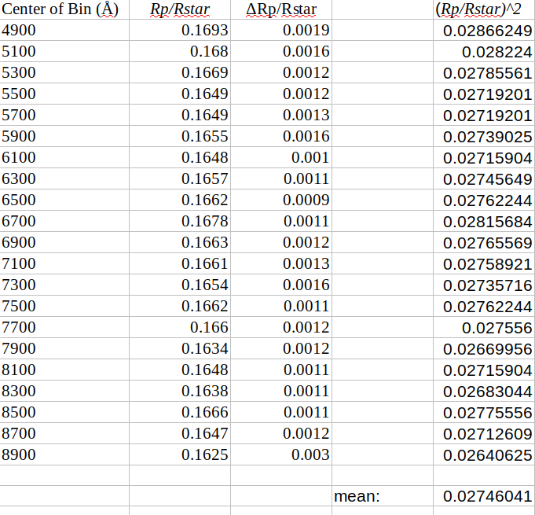

<https://academic.oup.com/mnras/article/470/1/742/3752458>

near-infrared

radius ratio (night 1): 0.1741+0.0063 −0.0054

transit depth: ~ 0.0303

radius ratio (night 2): 0.1639+0.0030−0.003

transit depth: ~ 0.0269

<https://academic.oup.com/mnras/article/465/1/843/2628059>

luminance Near Infrared (LNIR) filter

radius ratio: 0.1625 ± 0.0044

transit depth: ~ 0.0263