The electron temperature indicated by [O III] is about 12,500 K

[O III] line ratio 101.5

Nε ~3000 cm-3, as suggested by [Ar IV];

[Ar IV] line ratio 1.020 [4711/4740]

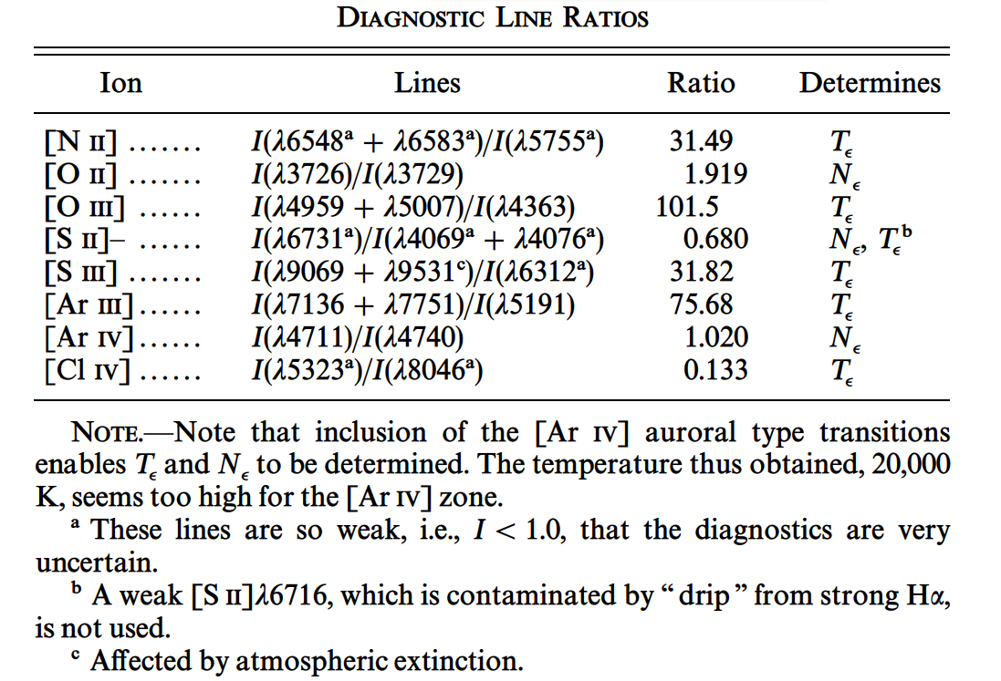

for calculating line ratio

λobs λlab Element Multiplet kλ I(Ham) F(Ham) rms(%)

4958.71 ...... 4958.92 [O III] (1F) -0.023 368.71 370.68 10.3

5006.73 ...... 5006.84 [O III] (1F) -0.034 1223.5 1233.1 8.1

4363.24 ...... 4363.21 [O III] (2F) 0.124 15.68 15.24 3.7

4711.26 ...... 4711.34 [Ar IV] (1F) 0.036 6.392 6.34 6.1

4740.13 ...... 4740.20 [Ar IV] (1F) 0.029 6.265 6.22 6.0

@article{0004-637X-491-1-242,

author={Siek Hyung and Lawrence H. Aller},

title={The High-Excitation Planetary Nebula NGC 7662},

journal={The Astrophysical Journal},

volume={491},

number={1},

pages={242},

url={http://iopscience.iop.org/article/10.1086/304948/pdf},

year={1997},

}

electron temperature shown by [O III] is about 12,800 K

observed ratio 0.0133

electron density shown by [Ar IV] is 3000 cm-3

observed line ratio 0.98 [4740/4711]

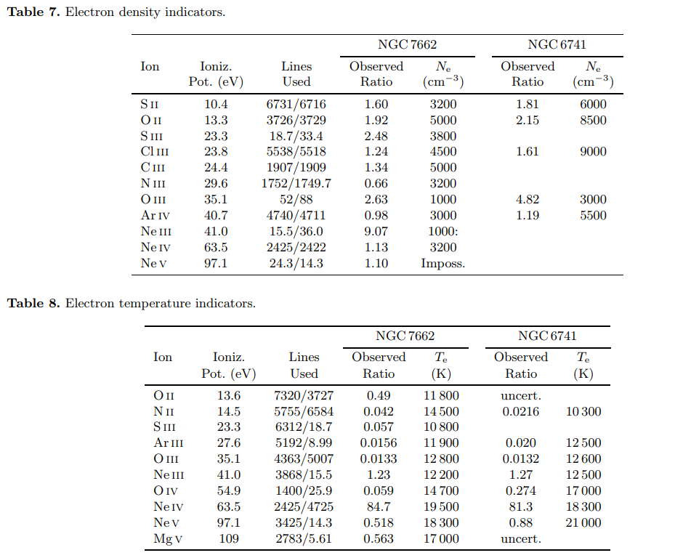

@ARTICLE{2001A&A...380..684P,

author = {{Pottasch}, S.~R. and {Beintema}, D.~A. and {Bernard Salas}, J. and

{Feibelman}, W.~A.},

title = "{Abundances of planetary nebulae <ASTROBJ>NGC 7662</ASTROBJ> and <ASTROBJ>NGC 6741</ASTROBJ>}",

journal = {\aap},

keywords = {ISM: ABUNDANCES, PLANETARY NEBULAE: INDIVIDUAL: NGC 7662},

year = 2001,

month = dec,

volume = 380,

pages = {684-694},

doi = {10.1051/0004-6361:20011480},

adsurl = {https://www.aanda.org/articles/aa/pdf/2001/47/aa1829.pdf},

adsnote = {Provided by the SAO/NASA Astrophysics Data System}

}

PN Ion Diagnostic Te(K)

NGC 7662 [O III] (λ4959+λ5007)/λ4363 13700

@article{1742-6596-771-1-012030,

author={Evaria Puspitaningrum and Hakim Lutfi Malasan and Hideyo Kawakita},

title={Spectroscopy and Photoionization Model of Planetary Nebulae: NGC 6543 and NGC 7662},

journal={Journal of Physics: Conference Series},

volume={771},

number={1},

pages={012030},

url={http://stacks.iop.org/1742-6596/771/i=1/a=012030},

year={2016},

}