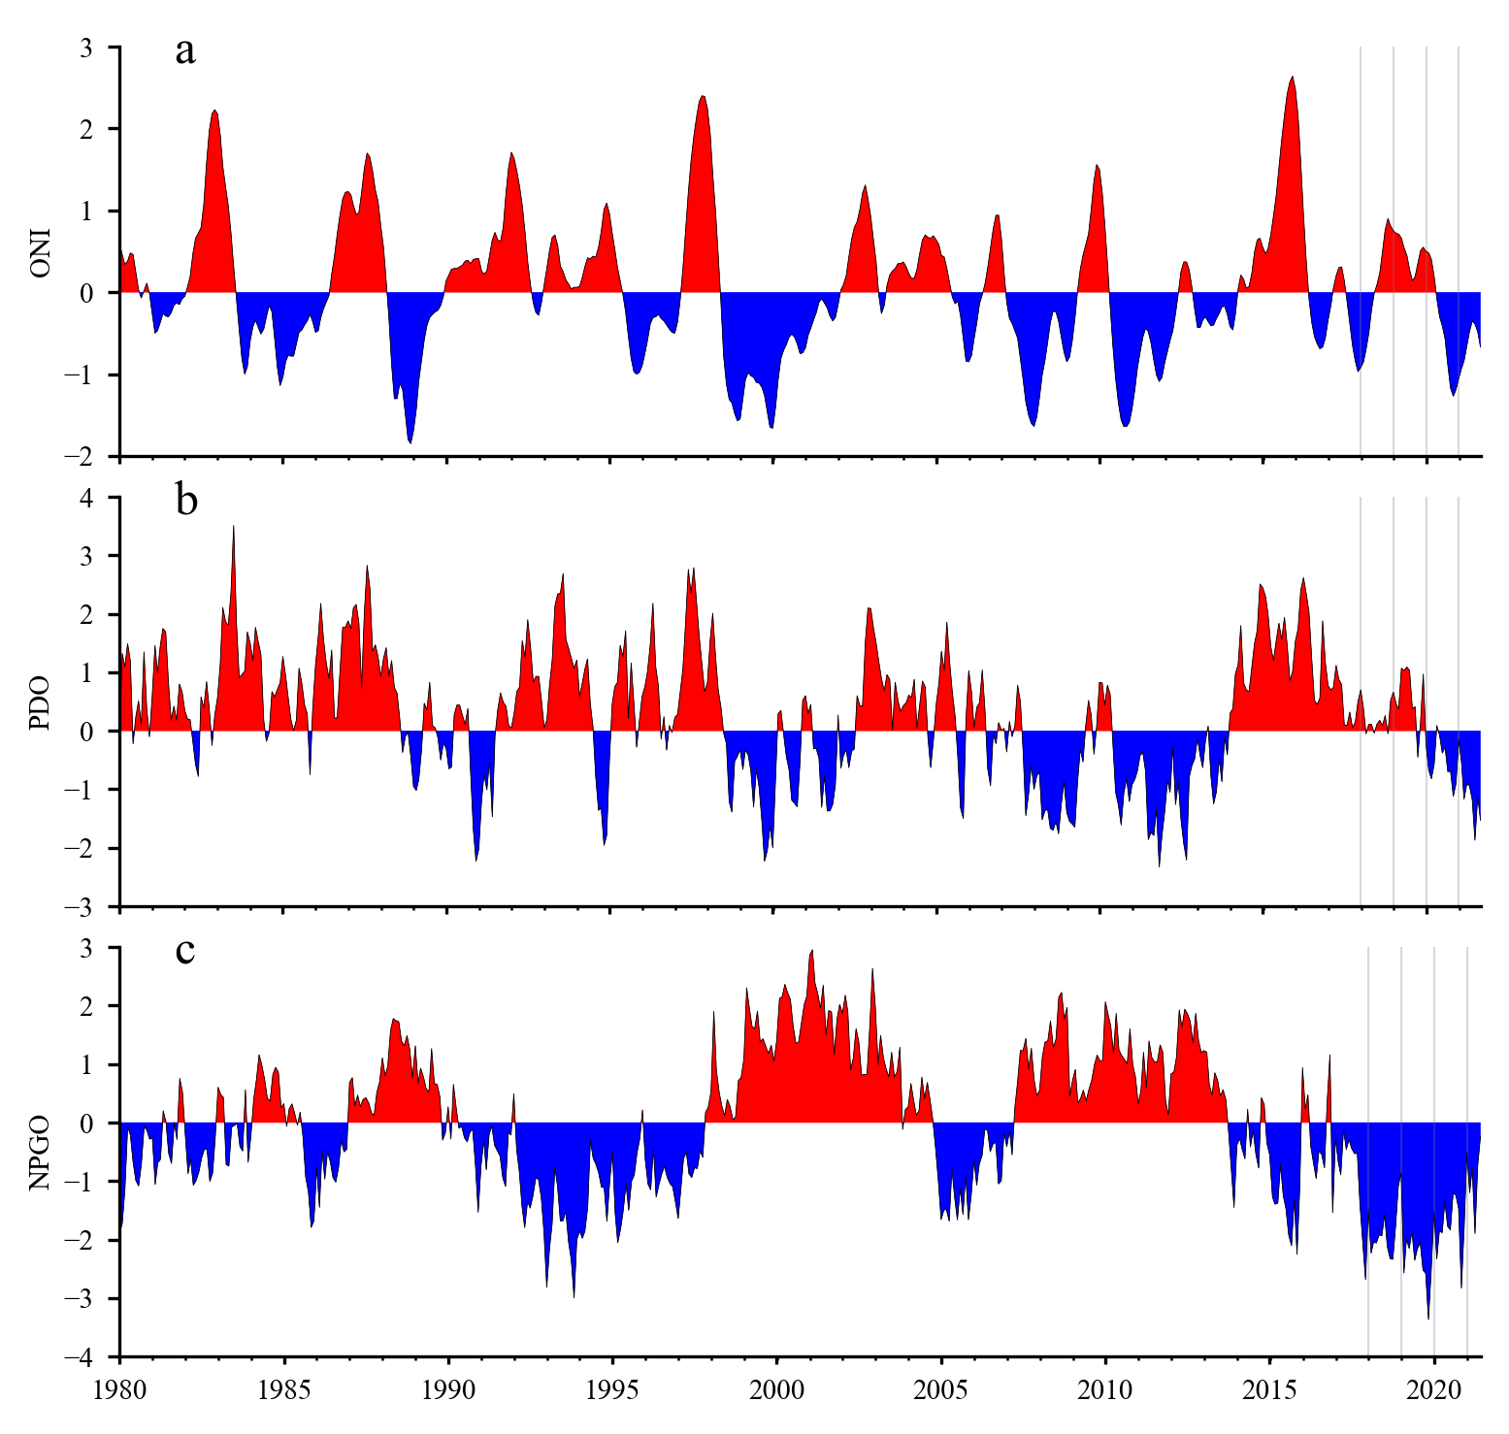

Figure 1: Time series of monthly values for three ocean indices especially relevant to the California Current: 1) Oceanic Niño Index (ONI), b) Pacific Decadal Oscillation (PDO), and c) North Pacific Gyre Oscillation (NPGO). Vertical lines mark January 2017-21. Indices can be obtained from <https://www.integratedecosystemassessment.noaa.gov/regions/california-current/cc-indicator-status-trends>.

* ONI and PDO goes to Sep 2021 and NPGO goes to Jun 2021
* La Niña from Aug 2020 to May 2021, presently La Niña conditions have developed
* La Niña is expected to continue with an 87% chance in December 2021-February 2022,
* <https://www.cpc.ncep.noaa.gov/products/analysis_monitoring/lanina/enso_evolution-status-fcsts-web.pdf>

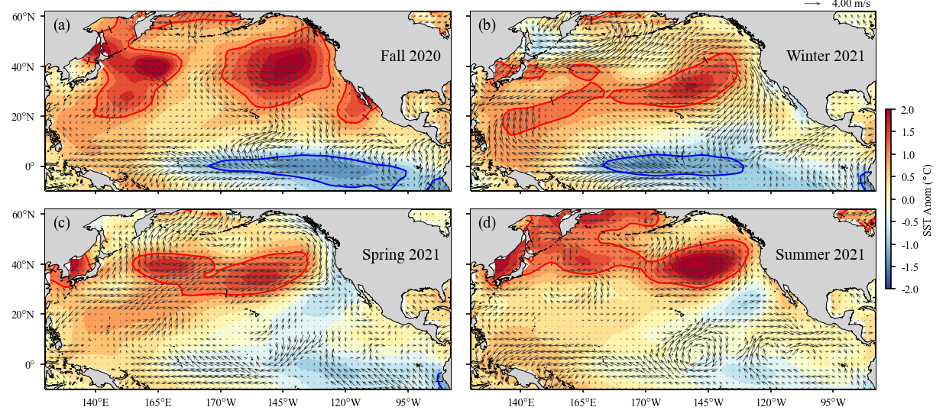

Figure 2: Surface wind velocity and sea surface temperature anomalies in the North Pacific Ocean for fall (September-November) 2020, winter (December-February) 2021, spring (March-May) 2021, and summer (June-August) 2021. Arrows denote magnitude and direction of wind anomaly (scale arrow at top). Contours denote temperature anomaly. Shading interval is 0.25°C and contour intervals at plus/minus 1°C are shown in red and blue, respectively. Climatology period is 1980-2010 for both data sets. Wind NCEP/NCAR Reanalysis data and NOAA Extended Reconstructed SST V5 data were obtained from http://www.esrl.noaa.gov.

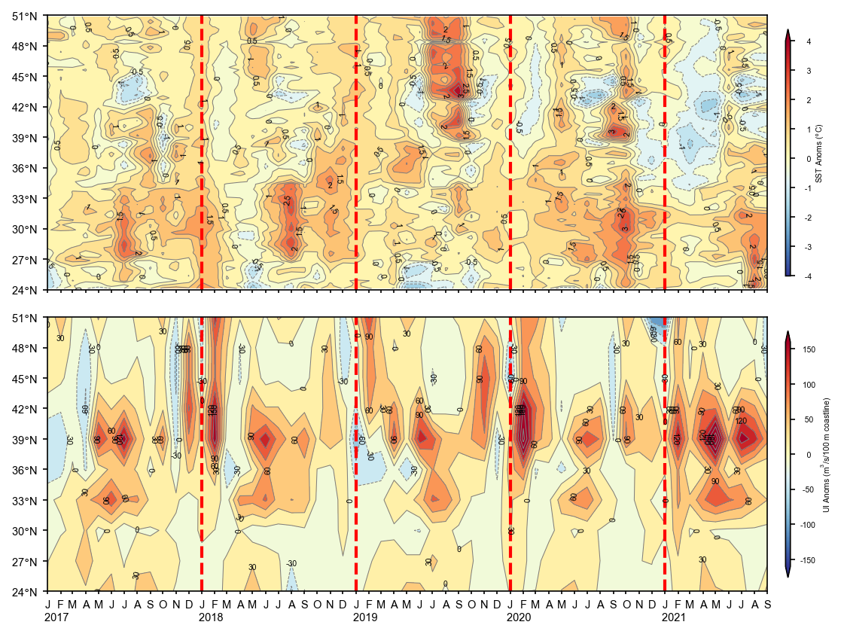Figure 3: Monthly sea surface tperature (SST) anomalies (top) and Bakun upwelling index (UI) anomalies (bottom) for January 2017 – September 2021. The SST anomalies are averaged from the coast to 75 km offshore. Positive and negative upwelling anomalies denote greater than average upwelling or downwelling (usually during the winter), respectively. Anomalies are relative to 1982-2010 monthly means. Daily optimum AVHRR SST data obtained from <https://coastwatch.pfeg.noaa.gov/erddap/griddap/ncdcOisst2Agg>.

* The coastal temperatures during the winter and spring 2021 are the coolest since 2013.

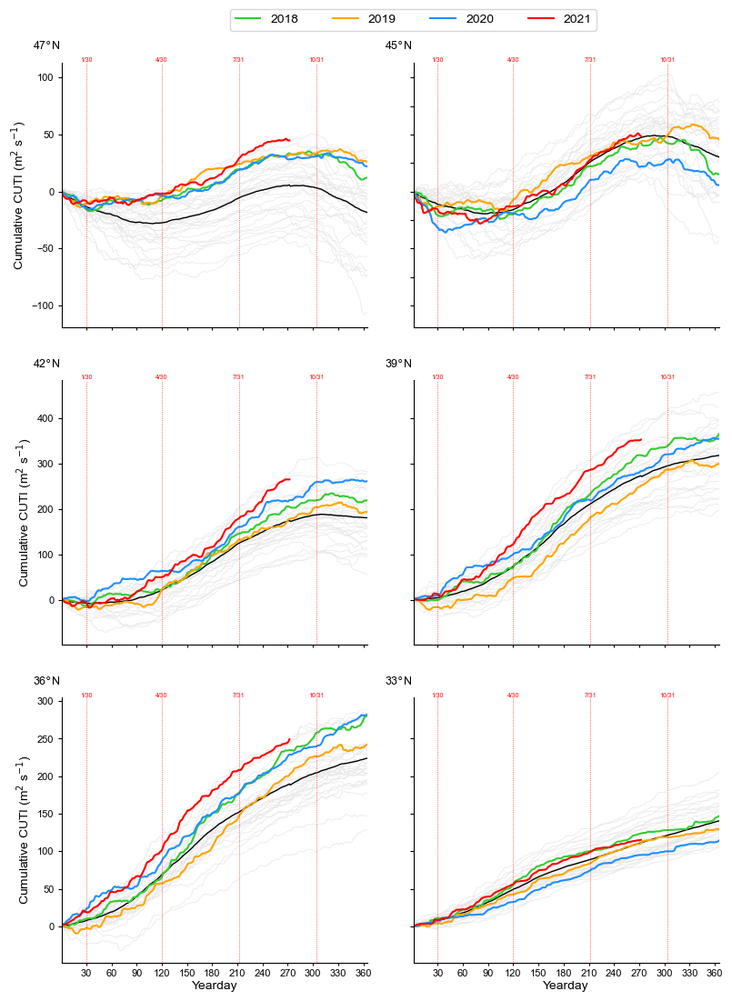

Figure 4: Yearly curves of the cumulative Coastal Upwelling Transport Index (CCUTI) starting on January 1 calculated from daily CUTI at locations along the west coast of North America. Grey lines are all yearly CCUTI for the years 1988-2018, colored curves are for the years 2018-21. The black line is the climatological mean. The red dashed vertical lines mark the end of January, April, July, and October. Daily CUTI data obtained from <https://oceanview.pfeg.noaa.gov/upwelling/>.

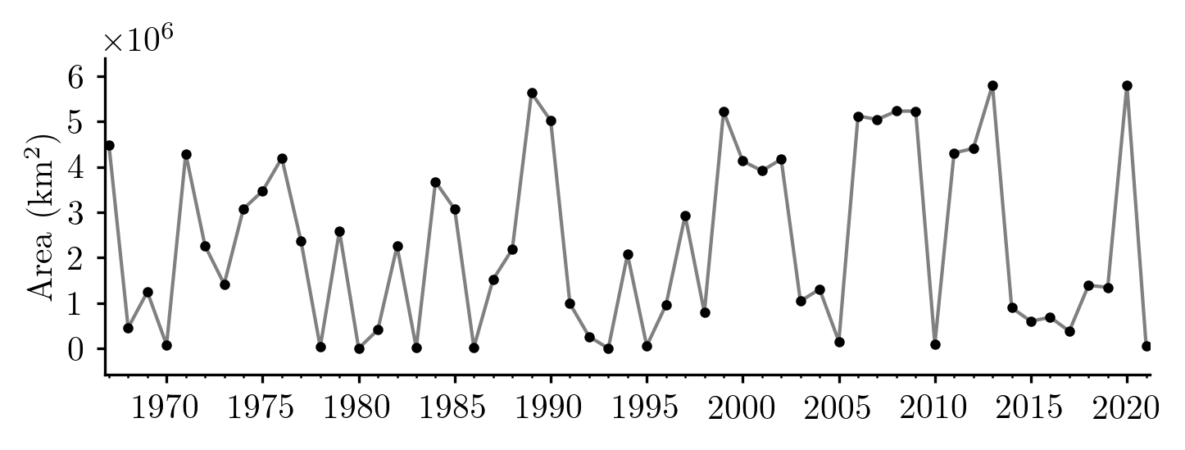

Figure 5: Area of high atmospheric pressure of the North Pacific High averaged over January and February each year. The area is the areal extent of the 1021 hPa isobar located in the eastern North Pacific. FNMOC six-hourly data used to find the area of the NPH is located at <https://coastwatch.pfeg.noaa.gov/erddap/griddap/erdlasFnPres6>.

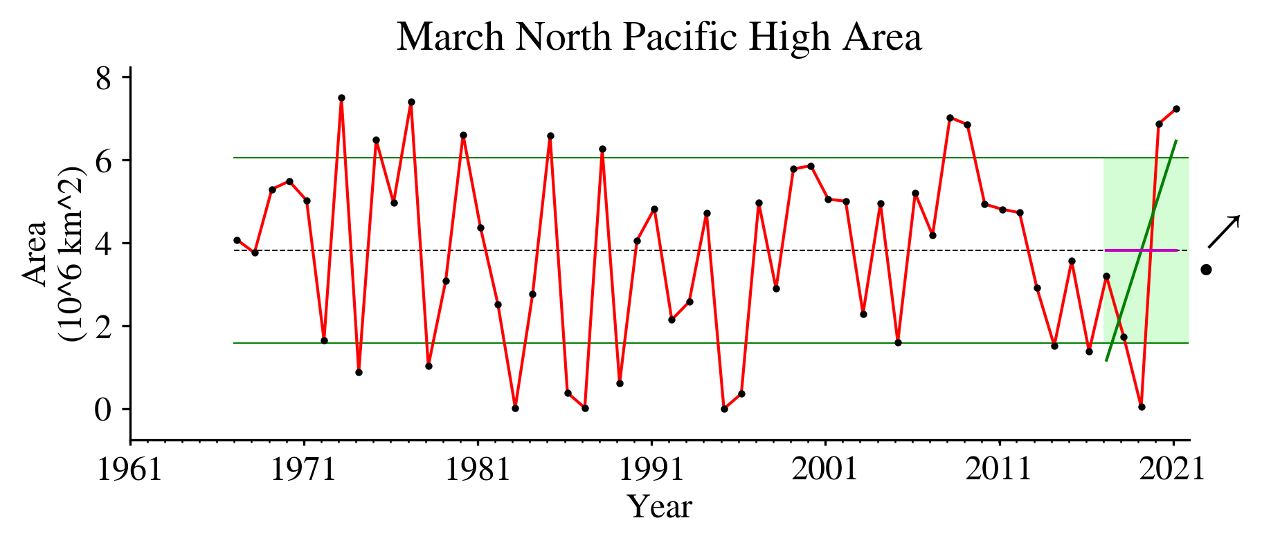

* Jan-Feb NPH area usually is high during La Niña, however it was low during 2021 do to episodic low pressure events
* However, the March NPH area was very high, one of the largest over the entire record

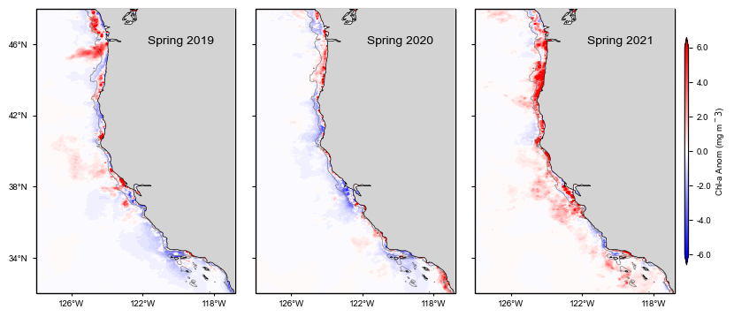

Figure 6: Chlorophyll *a* anomalies from Aqua MODIS over spring (March- May) 2019-2021. Monthly anomalies were averaged onto a 0.1° x 0.1° grid and the climatology was based on the 2003-21 time period. The data were obtained from <https://coastwatch.pfeg.noaa.gov/erddap/griddap/erdMH1chlamday>.